UNITED STATES
SECURITIES AND EXCHANGE COMMISSION
Washington, D.C. 20549

FORM 8-K

CURRENT REPORT
Pursuant to Section 13 or 15(d)
of the Securities Exchange Act of 1934
Date of Report (Date of earliest event reported): February 25, 2025 (February 24, 2025)

FLYWIRE CORPORATION
(Exact name of Registrant as specified in its charter)

Delaware |  | 001-40430 |  | 27-0690799
(State or other jurisdiction  of incorporation) |  | (Commission  File No.) |  | (IRS Employer  Identification No.)

141 Tremont St #10
Boston, MA 02111
(Address of principal executive offices and zip code)
Registrant’s telephone number, including area code: (617) 329-4524
Not Applicable
(Former Name or Former Address, if Changed Since Last Report)

Check the appropriate box below if the Form 8-K filing is intended to simultaneously satisfy the filing obligation of the registrant under any of the following provisions:

☐ | Written communications pursuant to Rule 425 under the Securities Act (17 CFR 230.425)

☐ | Soliciting material pursuant to Rule 14a-12 under the Exchange Act (17 CFR 240.14a-12)

☐ | Pre-commencement communications pursuant to Rule 14d-2(b) under the Exchange Act (17 CFR 240.14d-2(b))

☐ | Pre-commencement communications pursuant to Rule 13e-4(c) under the Exchange Act (17 CFR 240.13e-4(c))
Securities registered pursuant to Section 12(b) of the Act:

Title of each class |  | Trading  Symbol(s) |  | Name of each exchange  on which registered
Voting Common Stock, $0.0001 par value per share |  | FLYW |  | The Nasdaq Stock Market LLC  (Nasdaq Global Select Market)
Indicate by check mark whether the registrant is an emerging growth company as defined in Rule 405 of the Securities Act of 1933 (§230.405 of this chapter) or Rule 12b-2 of the Securities Exchange Act of 1934 (§240.12b-2 of this chapter).
Emerging growth company ☐
If an emerging growth company, indicate by check mark if the registrant has elected not to use the extended transition period for complying with any new or revised financial accounting standards provided pursuant to Section 13(a) of the Exchange Act. ☐

Item 1.01. | Entry into a Material Definitive Agreement.
On February 24, 2025, Flywire Corporation (“Flywire” or the “Company”) entered into a Purchase and Sale Agreement (the “Agreement”) with S Legacy Holdco, Inc., an Illinois corporation (the “Seller”) and each of the shareholders of Seller, pursuant to which Flywire acquired all of the issued and outstanding limited liability company interests of Sertifi LLC (“Sertifi”) for upfront cash consideration of $330 million, subject to certain post-closing adjustments set forth in the Agreement, and contingent consideration of up to $10 million upon the completion or satisfaction of certain technical and commercial milestones by Sertifi. Pursuant to the Agreement, Flywire also agreed to issue a number of restricted stock units with an aggregate value equal to $10 million to certain of the continuing employees of Sertifi on the terms and conditions set forth in the Agreement.
Sertifi is a vertical software and payments platform digitizing hospitality-specific workflows and associated payments. The closing of the acquisition (the “Closing”) occurred simultaneously with the execution of the Agreement, and upon the Closing, Sertifi became a wholly owned subsidiary of Flywire. Flywire paid the upfront cash consideration through a combination of cash on hand and a portion of the $125 million borrowed from its existing credit facility. The Agreement contains various representations, warranties and covenants of the parties that are customary in transactions of this type. In connection with the Closing, Flywire bound a representations and warranties insurance policy insuring breaches of Seller’s representations and warranties in the Agreement and certain indemnifiable tax matters under the policy.
A copy of the Agreement is filed with this Current Report on Form 8-K and is incorporated herein by reference. The foregoing summary of the material terms of the Agreement does not purport to be a complete description thereof and is qualified in its entirety by the full text of the agreement, which is attached as Exhibit 10.1 to this Current Report on Form 8-K and is incorporated herein by reference. The Agreement is included to provide investors and security holders with information regarding its terms. It is not intended to provide any other factual information about the parties thereto. The representations and warranties of each party set forth in the Agreement have been made solely for the benefit of the other parties to the Agreement and such representations and warranties should not be relied on by any other person. In addition, such representations and warranties (i) have been qualified by disclosures made to the other parties thereto, (ii) are subject to the materiality standards that may differ from what may be viewed as material by investors, and (iii) were made only as of the date of the Agreement or such other date as is specified in the agreement.

Item 2.01. | Completion of Acquisition or Disposition of Assets.
The information set forth in Item 1.01 above with respect to the Agreement is incorporated by reference into this Item 2.01.

Item 2.02. | Results of Operations and Financial Condition.
On February 25, 2025, Flywire issued a press release (the “Press Release”) and is holding a conference call regarding its preliminary and unaudited financial results for the quarter and year ended December 31, 2024. The Press Release is furnished as Exhibit 99.1 to this Current Report on Form 8-K and is incorporated by reference herein.

Item 2.05 | Costs Associated with Exit or Disposal Activities.
On February 23, 2025, the board of directors of the Company approved a restructuring plan that is designed to improve operational efficiencies, reduce operating costs and better align the Company’s workforce with current business needs, top strategic priorities and key growth opportunities (collectively, the “Restructuring Plan”). The Restructuring Plan includes reduction of the Company’s workforce by approximately 10%.
The Company estimates that it will incur approximately $7-9 million in charges in connection with the Restructuring Plan, consisting of cash expenditures for employee transition, notice period and severance payments and employee benefits and related facilitation costs, as well as non-cash expenditures related to acceleration of vesting of share-based awards. Of this amount, approximately $5-6 million is expected to result in future cash outlays. The Company expects that the majority of the restructuring charges will be incurred in the first quarter of 2025 and that the execution of the Restructuring Plan, including cash payments, will be substantially complete by the end of the third quarter of 2025.
Potential position eliminations in each country are subject to local law and consultation requirements, which may extend this process beyond the second quarter of 2025 in certain countries. The charges that we expect to incur are subject to a number of assumptions, including local law requirements in various jurisdictions, and actual expenses may differ materially from the estimates disclosed above.

Item 7.01. | Regulation FD Disclosure.
On February 25, 2025, the Company announced that it was undertaking an operational and business portfolio review. The operational review will help ensure we are efficient and effective, with a focus on driving productivity and optimizing investments across all areas. The comprehensive business portfolio review will focus on Flywire’s core strengths - such as complex, large-value payment processing, our global payment network, and verticalized software. This review is expected to encompass geographies, products, verticals, and cost structure, and explore various options. The Company has not set a deadline or definitive timetable for the completion of the operational and portfolio reviews, and there can be no assurance that these processes will result in any particular outcome.
On February 25, 2025, the Company provided an investor presentation that will be made available on the investor relations section of the Company’s website at https://ir.flywire.com/. The investor presentation is furnished as Exhibit 99.2 to this Current Report on Form 8-K and is incorporated by reference herein.
This information in this Item 7.01 of this Current Report on Form 8-K, including the associated exhibit, shall not be deemed “filed” for purposes of Section 18 of the Securities Exchange Act of 1934, as amended (the “Exchange Act”), or otherwise subject to the liabilities of that Section, or incorporated by reference in any filing under the Securities Act of 1933, as amended, or the Exchange Act, except as shall be expressly set forth by specific reference in any such filing.
Various statements contained in this Current Report on Form 8-K or to be made during the conference call are “forward-looking statements” within the meaning of the Private Securities Litigation Reform Act of 1995, including, but not limited to, statements regarding the outcome of the operational and business portfolio reviews; the costs, cash outlays, benefits, timing and financial impacts of the actions that may be taken or transactions entered into in connection with the operational and business portfolio reviews and the Restructuring Plan; the expected benefits and synergies of the acquisition of Sertifi LLC; Flywire’s future operating results and financial position, Flywire’s business strategy and plans, market growth; and Flywire’s objectives for future operations. Flywire intends such forward-looking statements to be covered by the safe harbor provisions for forward-looking statements contained in Section 21E of the Securities Exchange Act of 1934 and the Private Securities Litigation Reform Act of 1995. In some cases, you can

identify forward-looking statements by terms such as, but not limited to, “believe,” “may,” “will,” “potentially,” “estimate,” “continue,” “anticipate,” “intend,” “could,” “would,” “project,” “target,” “plan,” “expect,” or the negative of these terms, and similar expressions intended to identify forward-looking statements. Such forward-looking statements are based upon current expectations that involve risks, changes in circumstances, assumptions, and uncertainties. Important factors that could cause actual results to differ materially from those reflected in Flywire’s forward-looking statements include, among others, Flywire’s future financial performance, including its expectations regarding FX-Neutral GAAP Revenue Growth, FX-Neutral Revenue Less Ancillary Services Growth, Adjusted EBITDA Margin Growth and foreign exchange rates. Risks that may cause actual results to differ materially from these forward looking statements include, but are not limited to: Flywire’s ability to execute its business plan and effectively manage its growth; Flywire’s cross-border expansion plans and ability to expand internationally; anticipated trends, growth rates, and challenges in Flywire’s business and in the markets in which Flywire operates; the sufficiency of Flywire’s cash and cash equivalents to meet its liquidity needs; political, economic, foreign currency exchange rate, inflation, tariffs, banking, legal, immigration, social and health risks that may affect cross-border commerce, education and travel, Flywire’s business or the global economy; Flywire’s beliefs and objectives for future operations; Flywire’s ability to develop and protect its brand; Flywire’s ability to maintain and grow the payment volume that it processes; Flywire’s ability to further attract, retain, and expand its client base; Flywire’s ability to develop new solutions and services and bring them to market in a timely manner; Flywire’s expectations concerning relationships with third parties, including financial institutions and strategic partners; the effects of increased competition in Flywire’s markets and its ability to compete effectively; recent and future acquisitions or investments in complementary companies, products, services, or technologies; Flywire’s ability to enter new client verticals, including its relatively new business-to-business sector; Flywire’s expectations regarding anticipated technology needs and developments and its ability to address those needs and developments with its solutions; Flywire’s expectations regarding litigation and legal and regulatory matters; Flywire’s expectations regarding its ability to meet existing performance obligations and maintain the operability of its solutions; Flywire’s expectations regarding the effects of existing and developing laws and regulations, including with respect to payments and financial services, taxation, privacy and data protection; economic and industry trends, projected growth, or trend analysis; the effects of global events and geopolitical conflicts, including without limitation the continuing hostilities in Ukraine and involving Israel; Flywire’s ability to adapt to changes in U.S. federal income or other tax laws or the interpretation of tax laws, including the Inflation Reduction Act of 2022; Flywire’s ability to attract and retain qualified employees; Flywire’s ability to maintain, protect, and enhance its intellectual property; Flywire’s ability to maintain the security and availability of its solutions; the increased expenses associated with being a public company; the future market price of Flywire’s common stock; and other factors that are described in the “Risk Factors” and “Management’s Discussion and Analysis of Financial Condition and Results of Operations” sections of Flywire’s Annual Report on Form 10-K for the year ended December 31, 2023, and Quarterly Report on Form 10-Q for the quarter ended September 31, 2024, which are on file with the Securities and Exchange Commission (SEC) and available on the SEC’s website at https://www.sec.gov/. Additional factors may be described in those sections of Flywire’s Annual Report on Form 10-K for the year ended December 31, 2024, expected to be filed with the SEC in the first quarter of 2025. The information conveyed in this Current Report on Form 8-K is provided only as of the date hereof, the information conveyed on the conference call is provided only as of the date of the conference call, and Flywire undertakes no obligation to update any forward-looking statements presented herein or during the conference call on account of new information, future events, or otherwise, except as required by law.

Item 9.01. | Financial Statements and Exhibits.
(d) Exhibits

Exhibit  No. |  | Description
2.1# |  | Purchase and Sale Agreement, dated as of February 24, 2025, by and among Flywire Corporation, S Legacy Holdco, Inc., an Illinois corporation (the “Seller”), and each of the shareholders of Seller, signatory thereto.
99.1 |  | Flywire Corporation Press Release dated February 25, 2025.
99.2 |  | Flywire Corporation Investor Presentation dated February 25, 2025.
104 |  | Cover Page Interactive Data File (embedded within the Inline XBRL document)

# | Schedules (or similar attachments) have been omitted pursuant to Item 601(a)(5) of Regulation S-K and will be provided to the Securities and Exchange Commission upon request.

SIGNATURE
Pursuant to the requirements of the Securities Exchange Act of 1934, the registrant has duly caused this report to be signed on its behalf by the undersigned hereunto duly authorized.

FLYWIRE CORPORATION
By: |  | /s/ Cosmin Pitigoi
Name: |  | Cosmin Pitigoi
Title: |  | Chief Financial Officer
Dated: February 25, 2025
Exhibit 2.1
PURCHASE AND SALE AGREEMENT
by and among
S LEGACY HOLDCO, INC.,
THE SHAREHOLDERS OF S LEGACY HOLDCO, INC.,
and
FLYWIRE CORPORATION
Dated as of February 24, 2025

TABLE OF CONTENTS

 |  |  |  |  |  |  |  | Page
ARTICLE 1 DEFINITIONS |  |  |  |  |  |  |  |  | 1
 |  |  | Section 1.01 |  |  | Definitions |  |  | 1
 |  |  | Section 1.02 |  |  | Cross-References to Other Defined Terms |  |  | 13
ARTICLE 2 PURCHASE AND SALE |  |  |  |  |  |  |  |  | 15
 |  |  | Section 2.01 |  |  | Estimated Closing Purchase Price |  |  | 15
 |  |  | Section 2.02 |  |  | The Transaction |  |  | 15
 |  |  | Section 2.03 |  |  | The Closing |  |  | 15
 |  |  | Section 2.04 |  |  | Post-Closing Adjustment |  |  | 16
 |  |  | Section 2.06 |  |  | Withholding Rights |  |  | 18
 |  |  | Section 2.07 |  |  | Earn-Out Payment |  |  | 19
ARTICLE 3 REPRESENTATIONS AND WARRANTIES REGARDING THE COMPANY |  |  |  |  |  |  |  |  | 21
 |  |  | Section 3.01 |  |  | Organization and Qualification |  |  | 21
 |  |  | Section 3.02 |  |  | Subsidiaries; Securities Owned |  |  | 22
 |  |  | Section 3.03 |  |  | Capitalization and Related Matters |  |  | 22
 |  |  | Section 3.04 |  |  | Authority of the Company |  |  | 23
 |  |  | Section 3.05 |  |  | Compliance with Laws |  |  | 24
 |  |  | Section 3.06 |  |  | Advisory and Other Fees |  |  | 25
 |  |  | Section 3.07 |  |  | Taxes |  |  | 25
 |  |  | Section 3.08 |  |  | Litigation |  |  | 28
 |  |  | Section 3.09 |  |  | Financial Statements |  |  | 29
 |  |  | Section 3.10 |  |  | Transactions with Affiliates |  |  | 30
 |  |  | Section 3.11 |  |  | Real Properties |  |  | 30
 |  |  | Section 3.12 |  |  | Absence of Material Adverse Effect |  |  | 31
 |  |  | Section 3.13 |  |  | Absence of Certain Changes |  |  | 31
 |  |  | Section 3.14 |  |  | Tangible Personal Property |  |  | 34
 |  |  | Section 3.15 |  |  | Intellectual Property; Data Privacy |  |  | 34
 |  |  | Section 3.16 |  |  | Contracts |  |  | 40
 |  |  | Section 3.17 |  |  | Insurance |  |  | 43
 |  |  | Section 3.18 |  |  | Permits |  |  | 43
 |  |  | Section 3.19 |  |  | Employee Benefit Plans |  |  | 43
 |  |  | Section 3.20 |  |  | Employees; Labor Matters |  |  | 46
 |  |  | Section 3.21 |  |  | Environmental Matters |  |  | 49
 |  |  | Section 3.22 |  |  | Customers and Suppliers |  |  | 50
 |  |  | Section 3.26 |  |  | No Other Representations and Warranties |  |  | 51

i

ARTICLE 4 REPRESENTATIONS AND WARRANTIES OF THE SELLER AND THE SHAREHOLDERS |  |  |  |  |  |  |  |  | 51
 |  |  | Section 4.01 |  |  | Authorization |  |  | 51
 |  |  | Section 4.02 |  |  | Governmental Authorization |  |  | 52
 |  |  | Section 4.03 |  |  | Non-contravention |  |  | 52
 |  |  | Section 4.04 |  |  | Actions and Proceedings |  |  | 52
 |  |  | Section 4.07 |  |  | No Other Representations and Warranties |  |  | 53
ARTICLE 5 REPRESENTATIONS AND WARRANTIES OF THE BUYER |  |  |  |  |  |  |  |  | 53
 |  |  | Section 5.01 |  |  | Existence and Power |  |  | 53
 |  |  | Section 5.02 |  |  | Organizational Authorization |  |  | 53
 |  |  | Section 5.03 |  |  | Governmental Authorization |  |  | 54
 |  |  | Section 5.04 |  |  | Non-contravention |  |  | 54
 |  |  | Section 5.05 |  |  | Funds Available |  |  | 54
 |  |  | Section 5.06 |  |  | Purchase for Investment |  |  | 54
 |  |  | Section 5.07 |  |  | Actions and Proceedings |  |  | 54
 |  |  | Section 5.08 |  |  | Finders Fees |  |  | 55
 |  |  | Section 5.09 |  |  | No Other Representations and Warranties |  |  | 55
ARTICLE 6 COVENANTS OF THE BUYER |  |  |  |  |  |  |  |  | 55
 |  |  | Section 6.01 |  |  | Access |  |  | 55
 |  |  | Section 6.02 |  |  | Director and Officer Liability, Indemnification and Insurance |  |  | 55
 |  |  | Section 6.03 |  |  | Employment and Benefit Arrangements |  |  | 56
 |  |  | Section 6.04 |  |  | Restricted Stock Units |  |  | 57
 |  |  | Section 6.05 |  |  | WARN Act Notice |  |  | 57
 |  |  | Section 6.06 |  |  | Representation and Warranty Insurance Policy |  |  | 57
 |  |  | Section 6.07 |  |  | Acknowledgment by the Buyer |  |  | 58
ARTICLE 7 ADDITIONAL COVENANTS OF THE PARTIES |  |  |  |  |  |  |  |  | 58
 |  |  | Section 7.01 |  |  | Further Assurances |  |  | 58
 |  |  | Section 7.02 |  |  | Public Announcements |  |  | 59
 |  |  | Section 7.03 |  |  | Tax Matters |  |  | 59
 |  |  | Section 7.04 |  |  | Disclosure Generally |  |  | 63
 |  |  | Section 7.05 |  |  | Conflicts and Privilege |  |  | 63
 |  |  | Section 7.06 |  |  | Restrictive Covenants |  |  | 64
 |  |  | Section 7.07 |  |  | Release of Claims |  |  | 65
 |  |  | Section 7.08 |  |  | Other Covenants and Agreements |  |  | 66
ARTICLE 8 CLOSING DELIVERIES |  |  |  |  |  |  |  |  | 66
 |  |  | Section 8.01 |  |  | Seller Closing Deliveries |  |  | 66
ARTICLE 9 MISCELLANEOUS |  |  |  |  |  |  |  |  | 67
 |  |  | Section 9.01 |  |  | Notices |  |  | 67
 |  |  | Section 9.02 |  |  | Amendments and Waivers |  |  | 68
 |  |  | Section 9.03 |  |  | Construction; Severability; Remedies |  |  | 68
 |  |  | Section 9.04 |  |  | Expenses |  |  | 69
 |  |  | Section 9.05 |  |  | Successors and Assigns |  |  | 69

ii

 |  |  | Section 9.06 |  |  | Governing Law |  |  | 69
 |  |  | Section 9.07 |  |  | Jurisdiction |  |  | 69
 |  |  | Section 9.08 |  |  | Specific Performance |  |  | 70
 |  |  | Section 9.09 |  |  | Waiver of Jury Trial |  |  | 70
 |  |  | Section 9.10 |  |  | Reliance |  |  | 70
 |  |  | Section 9.11 |  |  | Prevailing Party |  |  | 70
 |  |  | Section 9.12 |  |  | Counterparts; Electronic Signature; Third Party Beneficiaries |  |  | 71
 |  |  | Section 9.13 |  |  | Entire Agreement |  |  | 71
 |  |  | Section 9.14 |  |  | No Survival; Certain Waivers |  |  | 71
Exhibits:

 |  | Exhibit A |  | Illustrative Calculation of Net Working Capital

iii

PURCHASE AND SALE AGREEMENT
THIS PURCHASE AND SALE AGREEMENT (this Agreement) is made as of February 24, 2025, by and among (i) S Legacy Holdco, Inc., an Illinois corporation (the Seller), (ii) each of the shareholders of Seller signatory hereto (collectively, the Shareholders and each, a Shareholder), and (iii) Flywire Corporation, a Delaware corporation (the Buyer). Unless otherwise provided, capitalized terms used herein are defined in Article 1 below.
WHEREAS, prior to the Pre-Closing Restructuring (as defined below), the Shareholders owned all of the issued and outstanding shares of the common stock of Sertifi Inc., an Illinois corporation;
WHEREAS, prior to the Closing, the Shareholders have engaged in the restructuring steps related to Sertifi Inc. as described in Schedule A (the Pre-Closing Restructuring), including the consummation of the Conversion (as defined therein), pursuant to which Seller caused Sertifi Inc. to convert from an Illinois corporation to an Illinois limited liability company named Sertifi LLC (together with the pre-conversion entity, Sertifi Inc., an Illinois corporation, the Company);
WHEREAS, upon the terms and subject to the conditions set forth herein, Seller desires to sell, convey, assign, transfer and deliver to the Buyer all of Sellers limited liability company interests in the Company (the Purchased Shares), and the Buyer desires to acquire and accept the Purchased Shares (the Share Purchase), such that following the Share Purchase, the Buyer shall hold all of the issued and outstanding Equity interests of the Company; and
WHEREAS, concurrently with the execution and delivery of this Agreement, as a material inducement to the Buyer to enter into this Agreement: each Key Employee is accepting an offer letter from the Buyer (collectively, the Key Employee Offer Letters), all of which Key Employee Offer Letters will be effective at and as of the Closing.
NOW, THEREFORE, in consideration of the mutual covenants contained herein and other good and valuable consideration, the receipt and sufficiency of which are hereby acknowledged, the parties hereto agree as follows:
ARTICLE 1
DEFINITIONS
Section 1.01 Definitions.
The following terms, as used herein, have the following meanings:
Accounting Principles means the application of GAAP.
Accrued Employee Amounts means all unpaid and/or accrued bonuses and commissions for the period prior to the Closing (with any discretionary bonuses being calculated as the greater of (a) the aggregate amount of such discretionary bonuses that are accrued or (b) the aggregate accrued bonus entitlement for all Employees as of the Closing Date, calculated on a prorated straight-line basis based on calendar days elapsed from the applicable accrual start date to the Closing Date) and other accrued but unpaid compensation and benefits of any Employee (including any fringe benefits and any outstanding deferred compensation program for the Companys executives) as of the Closing Date.

Action means any action, suit, charge, claim, complaint, demand, citation, summons, lawsuit, litigation, investigation, hearing, inquiry, examination, audit, notice of violation, proceeding (including any civil, criminal, administrative, investigative or appellate proceeding), arbitration or other similar dispute by or before, or otherwise involving, any court or other Governmental Authority.
Adjustment Holdback Amount means $3,000,000.
Adjustment Holdback Fund means the funds held back by Buyer from the Closing Consideration in an amount equal to the Adjustment Holdback Amount.
Affiliate means, as to any Person, any other Person which, directly or indirectly, controls, or is controlled by, or is under common control with, such Person. As used in this definition, control (including, with its correlative meanings, controlled by and under common control with) means the possession, directly or indirectly, of the power to direct or cause the direction of management or policies of a Person, whether through the ownership of securities or partnership or other ownership interests, by contract or otherwise.
Business Day means any day other than a Saturday or Sunday or a day on which banks in Chicago, Illinois are not permitted to be open for business.
Buyer Closing Date Transaction means any transaction outside the Ordinary Course engaged in by the Company on the Closing Date, which occurs after the Closing or at the direction of the Buyer including any transaction engaged in by the Buyer or the Company in connection with financing any obligation of the Buyer or the Company to make a payment under this Agreement.
Cash means, with respect to any Person and without duplication, cash and cash equivalents (including marketable securities, money market or similar accounts and short-term investments, in each case, which are convertible into cash without penalty within five (5) Business Days), in each case, calculated in accordance with the Accounting Principles; provided, that, Cash shall include checks and drafts received from third parties and deposited for the account of such Person as of the Measurement Time that are not yet cleared so long as such checks or drafts subsequently clear and exclude all checks and drafts sent from such Person as of the Measurement Time to third parties that are not yet cleared so long as such checks or drafts subsequently clear; provided, however, that Cash shall not include any of the following: (a) any cash which is not freely transferable or usable by such Person because it is subject to restrictions, limitations, Contracts or otherwise (including security deposits and amounts held in escrow); (b) any other cash of such Person held as a cash security deposit or collateral posted with third parties, including in respect of outstanding letters of credit or otherwise (except to the extent a corresponding amount is included in the computation of the Indebtedness Amount); (c) any insurance proceeds or indemnification payments received, or other funds held, by a Person with respect to any casualty loss or otherwise in respect of liabilities that have not been discharged prior to the Closing; and (d) any restricted cash amounts set forth on Schedule 1.01(a).

2

Cash Amount means the aggregate Cash held by the Company, in each case, as of the Measurement Time.
Code means the Internal Revenue Code of 1986, as amended, and any reference to any particular Code section shall be interpreted to include any revision of or successor to that section regardless of how numbered or classified.
Company Contract shall mean any Contract to which the Company is a party or by which the Company is bound.
Company IT Assets means all software, systems, servers, computers, hardware, firmware, middleware, networks, data communications lines, routers, hubs, switches and all other information technology equipment, and all associated documentation, in each case, used or held for use in connection with conducting the business of the Company.
Company IP Contract shall mean any Company Contract that contains any assignment or license of, or any covenant not to assert or enforce, or any other right to use or exploit, any past, present or future Owned Intellectual Property.
Company Option Plan means the Sertifi Inc. 2010 Stock Incentive Plan, as amended, as assumed by Seller.
Company Options means the Companys incentive stock options and non-qualified stock options granted pursuant to the Company Option Plan that are outstanding and unexercised as of immediately prior to Closing, which were assumed by Seller in connection with and in accordance with the Contribution.
Company Product shall mean each product (including software and databases) or service performed, offered, owned, made, produced, manufactured, marketed, developed, distributed, made available, imported, licensed, or sold by or on behalf of the Company and any product or service currently under development by or for the Company, or that the Company currently intends to perform, offer, make, manufacture, produce, market, develop, distribute, make available, import, license or sell.
Contract means any contract, statement of work, mortgage, lease (including any Real Property Leases), deed, license, covenant, insurance policy, note, indenture, agreement, instrument or other legally binding arrangement, obligation or commitment, whether written or oral.
COVID-19 means SARS-CoV-2 or COVID-19, and any evolutions, variants or derivatives thereof or related or associated epidemics, pandemic or disease outbreaks.
Current Assets means the total current assets (not including any amounts including the computation of Cash or any amounts arising from the items set forth in clauses (a)-(d) in the proviso in the definition of Cash, calculated on a basis net of any allowance of doubtful accounts including with respect to those accounts set forth on Schedule 1.01(a), and excluding any Tax assets, whether current or deferred) of the Company as determined in accordance with the Accounting Principles. An illustrative example of the determination of Current Assets as of December 31, 2024 is set forth on Exhibit A. For the avoidance of doubt, Current Assets shall not include any accounts receivable of the Company that have been outstanding for more than one hundred and twenty (120) days.

3

Current Liabilities means the total current liabilities (not including any amounts included in the computation of the Indebtedness Amount or Transaction Expenses Amount, and excluding, for the avoidance of doubt, any Tax liabilities, whether current or deferred) of the Company as determined in accordance with the Accounting Principles. An illustrative example of the determination of Current Liabilities as of December 31, 2024 is set forth on Exhibit A.
Earn-Out Offset Cap means an amount equal to $1,000,000.
Employee means any current or former employee, consultant, individual independent contractor or individual service provider of the Company or any Subsidiary of the Company or any ERISA Affiliate.
Employee Agreement means each management, employment, severance, separation, settlement, consulting, contractor, relocation, change of control, retention, bonus, repatriation or loan agreement, and any employment or individual service provider, offer letter, or any agreement providing for acceleration of Company Options, shares of restricted Company stock, or any other agreement providing for compensation or benefits or that is not terminable at will, between the Company and any employee or individual service provider thereof.
Employee Benefit Plan means each Employment Agreement, any employee benefit plan within the meaning of Section 3(3) of ERISA and each plan, program, policy, practice, contract, agreement or other arrangement providing for compensation, retirement, welfare, severance, termination pay, change of control, incentive or bonus, deferred compensation, profit sharing, vacation or paid-time-off, stock purchase, Equity or equity-related awards, health benefits or medical insurance, plan, program, agreement or arrangement, and any other material employee benefit plan, program or arrangement, other than statutorily-mandated plans or programs, that is sponsored, maintained or contributed to by the Company (excluding a multiemployer plan within the meaning of 3(37) of ERISA), whether or not subject to ERISA, which is or has been maintained, contributed to or required to be contributed to by the Company or any ERISA Affiliate for the benefit of any employee or individual service provider, or with respect to which the Company has or may have any liability or obligation (including in respect of an ERISA Affiliate), including any International Employee Plan.
Equity means, with respect to any Person, any and all shares or interests of such Persons capital stock, partnership interests, membership interests, limited liability company interests or other equivalent equity or ownership interests and any rights, warrants or options exchangeable or exercisable for or convertible into such capital stock or other equity or ownership interests.
Equity Rights means, with respect to any Person, (a) any options, warrants, convertible or exchangeable securities, subscriptions, commitments, preemptive rights, agreements, arrangements or calls, relating to the issuance, sale, registration or voting of, or outstanding securities convertible into or exchangeable for, any Equity of such Person; (b) any stock appreciation, phantom stock, profit participation or other equity-compensation or similar rights with respect to the Equity or the voting rights of such Person; and (c) any bonds, debentures, notes

4

or other indebtedness issued by such Person, the holders of which have the right to vote on matters of such Person or are otherwise convertible into, exchangeable for, or evidencing the right to subscribe for or acquire securities having the right to vote or the value of which is in any way based upon or derived from Equity or voting stock of such Person.
ERISA means the Employee Retirement Income Security Act of 1974, as amended.
ERISA Affiliate means any other Person under common control with the Company or that, together with the Company, could be deemed a single employer within the meaning of Section 4001(b)(1) of ERISA or within the meaning of Section 414(b), (c), (m) or (o) of the Code, and the regulations issued thereunder.
Exchange Act means the Securities Exchange Act of 1934, as amended, and any applicable rules and regulations promulgated thereunder, and any successor to such statute, rules or regulations.
Flow-Through Returns means, with respect to the Company or the Seller, as applicable, any income Tax Return for which income of the entity for which such Tax Return is filed flows through such entity to such entitys member(s)/shareholder(s) (or other owner(s) for Tax purposes), and any other Tax Return where any items reflected on such Tax Return would reasonably be expected to increase the Tax liability of the Shareholders.
Fraud means common law fraud under Delaware law (committed with scienter).
GAAP means United States generally accepted accounting principles, consistently applied.
Indebtedness means, with respect to any Person at any date, without duplication, (a) the amount of all liabilities and obligations of such Person (i) under leases (or other arrangement conveying the right to use) real or personal property, or a combination thereof, required to be capitalized in accordance with GAAP; (ii) for borrowed money, or in respect of loans or advances, whether current or funded, secured or unsecured, all obligations evidenced by bonds, debentures, notes or similar instruments (whether or not convertible into any other instrument), and all accrued interest, prepayment premiums or penalties, commitments and other fees reimbursements, indemnities and all other amounts on the foregoing which would be payable if such obligations were paid in full as of such date; (iii) for the deferred purchase price of goods, property, assets, businesses, securities or services (other than trade payables incurred in the Ordinary Course and reflected in the computation of the Net Working Capital Amount); (iv) evidenced by any letter of credit, bankers acceptance or similar credit transaction (but only to the extent drawn); (v) pursuant to conditional sale or other title retention agreements; (vi) arising out of any interest rate swap, currency swap, forward contract or other hedging or similar arrangements; (vii) pursuant to any under any non-qualified deferred compensation plan or arrangement or any unfunded or underfunded defined benefit or other pension liabilities or retiree health or welfare benefits; and (viii) to an Interested Party (other than any rights to payments pursuant to this Agreement, but including any declared but unpaid distributions or dividends payable to Seller or any Shareholder, and including any loans made to the Company by Seller, a Shareholder or Optionholder); (b) with respect to the Company, all Accrued Employee Amounts, including any accrued and unpaid

5

severance liabilities and other termination payments or benefits (but excluding any severance arising from the termination of any Employees terminated at the Buyers prior written request), or other expenses with respect to any termination of any Employee prior to the Closing and the employer portion of any payroll, employment or similar Taxes related thereto; (c) with respect to the Company, any and all unpaid Taxes of the Company for the Pre-Closing Tax Period (other than with respect to sales and use and non-resident withholding Taxes of the Company); (d) any customer overpayments; (e) any earn out or other similar payment obligations of such Person; (f) all guarantees by such Person of any liabilities of a third party of a nature similar to the types of liabilities described in clauses (a) through (e) above; (g) all interest, fees, change of control payments, termination, pre-payment or balloon or similar penalties or premiums and other expenses that are paid or become payable with respect to the indebtedness referred to in clauses (a) through (f) above; (h) deferred revenue (net of any accounts set forth in Schedule 1.01(b)); and (i) the amount set forth in Schedule 1.01(c) with respect to sales and use and non-resident withholding Taxes of the Company (which amount, for the avoidance of doubt, shall not be subject to adjustment under Section 2.04). For the avoidance of doubt, Indebtedness shall not include any amounts included in the computation of Current Liabilities in the Net Working Capital Amount or the Transaction Expense Amount.
Indebtedness Amount means, as of the Measurement Time, the aggregate amount of Indebtedness of the Company.
Intellectual Property means, in any and all jurisdictions throughout the world, all intellectual property and proprietary rights, including: (a) patents, industrial designs, utility models and patent applications for, and all renewals and extensions of, any of the foregoing, including all provisionals, continuations, continuations-in-part, divisions, reissues, re-examinations and extensions thereof, (b) trademarks, trade names, trade dress, service marks, logos, corporate names, slogans, Internet domain names, social media accounts and handles, and all other source or business identifiers or designators of origin (whether registered or unregistered), and any registrations and applications for registration of, and renewals and extensions of, any of the foregoing, and all common law rights in any of the foregoing, together with all goodwill associated with each of the foregoing, (c) registered and unregistered copyrights, works of authorship, websites, mask work rights, database rights and design rights (in each case whether registered or unregistered), registrations and applications for registration of, and all renewals and extensions of, any of the foregoing, and all moral rights associated with any of the foregoing, (d) right in computer software programs (including source code and object code), databases and data collections, (e) trade secrets and other proprietary and confidential information and data, including any inventions (whether or not patentable or reduced to practice), invention disclosures, ideas, developments, improvements, know-how, designs, drawings, algorithms, source code, methods, processes, techniques, formulae, research and development, compilations, compositions, manufacturing processes, production processes, devices, specifications, reports, analyses, data analytics, customer lists, supplier lists, pricing information, cost information, business plans, business proposals, marketing plans and marketing proposals, and (f) any rights recognized under applicable Laws that are equivalent or similar to any of the foregoing, including without limitation all causes of action and rights to sue or seek other remedies arising from or relating to the foregoing, including for any past or ongoing infringement or misappropriation.

6

International Employee Plan shall mean each Employee Benefit Plan or Employee Agreement that has been adopted or maintained by the Company or any ERISA Affiliate, whether formally or informally, or with respect to which the Company or any ERISA Affiliate has or may have any liability, with respect to employees or service providers who perform services outside the United States.
IRS means the United States Internal Revenue Service.
Key Employees means Nick Stojka, John Stojka, Chris Hostert, Joe Flynn and Stephan Nagy.
Knowledge when used in the phrase to the Knowledge of the Company or similar phrases means, and shall be limited to, the knowledge of the following individuals, following reasonable investigation or inquiry: Nick Stojka, John Stojka, Chris Hostert, Joe Flynn and Stephan Nagy.
Licensed IP shall mean (i) all Intellectual Property incorporated into, or used or otherwise practiced in the development, delivery, hosting or distribution of, the Company Products; and (ii) all other Intellectual Property used, practiced or held for use or practice in the conduct of the business of the Company, in each case that are not Owned Intellectual Property.
Licensed IP Contract shall mean any Company Contract pursuant to which the Company is granted a license, covenant not to sue, or other rights with respect to Licensed IP.
Lien means any lien, pledge, charge, claim, mortgage, assessment, hypothecation, deed of trust, option, right of first refusal, easement, right of way, security interest, preemptive right, transfer restriction or other encumbrance of any kind or character whatsoever.
Material Adverse Effect means any change, event, circumstance, condition or effect that, individually or in the aggregate, taking into account all other changes, events, circumstances, conditions or effects, has had, or would reasonably be expected to have, a material adverse effect on the condition (financial or otherwise), properties, assets (including intangible assets), liabilities, business, operations or results of operations of the Company; provided, however, that, to the extent any such change, event, circumstance, condition or effect that arises from or results from any of the following such change, event, circumstance, condition or effect will not constitute a Material Adverse Effect and will not be considered in determining whether a Material Adverse Effect has occurred or would reasonably be expected to occur: (a) changes in factors generally affecting the regional, national or world economy, the financial, credit, banking or securities markets in general or the industries or markets in which the Company operates; (b) any changes in social or political conditions generally; (c) any earthquake, hurricane, tsunami, tornado, flood, mudslide, fire or other natural disaster or act of God; (d) any epidemic, pandemic or disease outbreak (including COVID-19); (e) engagement by any Governmental Authority or non-governmental group or Person in hostilities, cybersecurity attacks that are not directed at the Company, or the escalation thereof or the occurrence or the escalation of any military or terrorist attack, including the current conflicts involving Ukraine and the Russian Federation, and Israel and Hamas, and any sanctions related thereto; (f) changes in Law or GAAP or any enforcement, implementation or interpretation thereof; (g) the announcement or disclosure of the Transactions; (h) the failure by the Company to (i)

7

achieve any internal or published estimates (including with respect to earnings, revenue or sales estimates), projections, forecasts or targets or (ii) make or meet any capital expenditure, expense or other budget requirements or objectives (it being understood that, to the extent not otherwise excluded by any other clause herein, the circumstances giving rise to such failure may be taken into account in determining whether a Material Adverse Effect has occurred); or (i) actions taken, or not taken, with the prior written consent of the Buyer; provided, that any change, event, circumstance, condition or effect described in any of clauses (a)-(f) may be taken into account to the extent the Company is disproportionately affected thereby relative to other companies in the industry in which the Company operates.
Measurement Time means 12:01 a.m. (Central Standard Time) on the Closing Date.
Net Working Capital means, without duplication, subject to the last two sentences hereof, an amount equal to (a) the Current Assets minus (b) the Current Liabilities. Net Working Capital shall be determined in accordance with the Accounting Principles and Exhibit A. An illustrative example of the determination of Net Working Capital as of December 31, 2024 is set forth on Exhibit A.
Net Working Capital Amount means the Net Working Capital as of the Measurement Time; provided that, solely for purposes of Sellers calculation of the Estimated Purchase Price, the Net Working Capital Amount shall be calculated as set forth on Schedule 1.01(d).
Non-Negotiated Vendor Contract shall mean a Contract that meets all of the following conditions: (a) such Contract grants to the Company (i) a non-exclusive license to download or use generally commercially available, non-customized software, in object code form only, or (ii) a non-exclusive right to access and use the functionality of such software on a hosted or software-as-a-service basis (and, in any case, does not include any other licenses of Intellectual Property except licenses to (A) Companys feedback and suggestions or (B) either partys trademark for inclusion on customer lists or use in the provision of services); (b) such Contract is a non-negotiable, non-negotiated shrink-wrap or click-through Contract; (c) the software licensed or made available under such Contract is not included, incorporated or embedded in, linked to, combined or distributed with, or used in the development, design, hosting, delivery, distribution or provision of any Company Product; (d) the Contract does not require the Company to pay any license fee, subscription fee, service fee or other amount except for a one-time license fee of no more than $100,000 or ongoing subscription or service fees of no more than $50,000 per year; and (e) the Contract is not a license for Open Source Software.
Non-Recourse Party means, with respect to a party, any of such partys former, current and future direct or indirect equityholders, controlling Persons, directors, officers, employees, agents, advisors, attorneys, representatives, Affiliates, members, managers, general or limited partners or assignees (or any former, current or future direct or indirect equityholder, controlling Person, director, officer, employee, agent, advisor, attorney, representative, Affiliate, member, manager, general or limited partner or assignee of any of the foregoing).

8

Open Source Software means (a) any software that is licensed under any free software or open source or similar license (including software licensed under the GNU General Public License, the GNU Lesser General Public License, the Affero General Public License, any Creative Commons ShareAlike license, or the Apache Software License), or pursuant to open source, copyleft or similar licensing and distribution models; and (b) any software that requires as a condition of use, modification and/or distribution of such software that such software or other software incorporated into, linked to, derived from or distributed with such software be disclosed or distributed in source code form, be licensed for the purpose of making derivative works or be redistributable at no or minimal charge.
Optionholder means each holder of a Company Option.
Order means any order, writ, judgment, injunction, decree, stipulation, ruling, edict, settlement or award, whether temporary, preliminary or permanent, enacted, issued, promulgated, enforced or entered by any Governmental Authority.
Ordinary Course means the usual, regular and ordinary course of business of the Company consistent with the past practices of the Company (including maintaining working capital and cash management practices, collecting receivables, paying payables and booking sales).
Owned Intellectual Property means all Intellectual Property owned or exclusively licensed or purported to be owned or exclusively licensed by the Company.
PCI-DSS means the Payment Card Industry Data Security Standard issued by the PCI Security Standards Council, as it may be amended from time to time.
Permitted Liens means any (a) Liens in respect of Taxes the validity of which is being contested in good faith by appropriate proceedings and for which appropriate reserves have been established in accordance with GAAP or statutory Liens in respect of Taxes not yet due and payable; (b) mechanics, carriers, workmens, repairmens, statutorily imposed or other similar Liens arising or incurred in the Ordinary Course for amounts which are not due and payable or the amount or validity of which is being contested in good faith by appropriate proceedings and for which appropriate reserves have been established in accordance with GAAP; (c) Liens arising under original purchase price conditional sales Contracts and equipment leases with third parties entered into in the Ordinary Course; (d) limitations on the rights of the Company under any Contract or Real Property Lease that are expressly set forth in such Contract or Real Property Lease; (e) survey exceptions, imperfections of title, Liens or other title matters affecting any tangible asset owned by the Company that would not materially detract from the value of the assets subject thereto or materially impair the operations of the Company; (f) with respect to the Leased Real Property, zoning, building codes and other land use Laws regulating the use or occupancy of such Leased Real Property or the activities conducted thereon that are imposed by any Governmental Authority having jurisdiction over such Leased Real Property, and any covenants, conditions, restrictions, easements and other similar matters of record affecting the Leased Real Property, in each case to the extent the same are not violated by the current use or occupancy of such Leased Real Property; (g) licenses of Intellectual Property or other proprietary rights in the Ordinary Course; (h) any Lien created under federal, state or foreign securities laws; and (i) any Lien listed in Schedule 1.01(e) hereto.

9

Person means an individual, corporation, partnership, limited liability company, association, joint stock company, trust, joint venture, unincorporated organization or other entity or organization, including a government or political subdivision or any department, agency, political subdivision or instrumentality thereof or other entity of any kind or nature.
Personal Information means, in addition to any data Processed by the Company that is defined, described as, or otherwise constitutes personal information personally identifiable information, PII, personal data or any analogous terms under applicable Privacy and Security Requirements, any piece of information that alone or in combination with other information directly or indirectly collected, held, or otherwise Processed by or for the Company that allows for the identification or location of, or contact with, a natural person, including social security number or tax identification number, drivers license number, passport number, credit card number, bank information, or customer or account number.
Pre-Closing Tax Period means any taxable period (or portion thereof) that ends on or prior to the Closing Date.
Privacy and Security Requirements means, to the extent applicable to the Company, (a) any provisions of Laws that regulate the Processing of Personal Information; (b) provisions of Contracts between the Company and any Person that relate to the Processing of Personal Information; (c) any standard, rule, requirement, code, principle, or policy of a self-regulatory organization, including requirements of the PCI-DSS, relating to privacy or restrictions or obligations related to the Processing of Personal Information and which are legally or contractually binding on the Company; and (d) all written policies relating to the Processing of Personal Information, including all representations and obligations set forth in any Privacy Policy.
Privacy Policy means external or internal, past or present privacy policy or privacy- or security-related representation, statement, notice, obligation or promise of the Company relating to the Processing of Personal Information, including any policy, representation, statement, notice, obligation, or promise regarding the privacy of any Persons whose Personal Information is Processed by the Company products, services, or websites operated by or on behalf of the Company.
Process means the creation, collection, use, storage, processing, transmission, receipt, import, export, protection, safeguarding, access, disposal or disclosure or other activity regarding data.
Purchase Price means (a) the Closing Purchase Price, plus (b) any amount of Earn-Out Payment made to the extent payable in accordance with Section 2.07 hereof.
Reference Date means January 1, 2022.
RICO means the Racketeer Influence and Corrupt Organizations Act of 1970.
Sanctioned Territory means any country or territory that is itself the subject of comprehensive Sanctions (currently, Crimea, Cuba, Iran, North Korea, Syria, and those portions of the Donetsk Peoples Republic or Luhansk Peoples Republic regions (and such other regions) of Ukraine over which any Sanctions authority imposes comprehensive Sanctions), or any country or territory whose government is the subject of Sanctions (currently, Venezuela) or that is otherwise the subject of broad Sanctions restrictions (including Afghanistan, Russia and Belarus).

10

Sanctions means trade and economic and financial sanctions administered, maintained or enforced by the United States (including the Treasury Departments Office of Foreign Assets Control, U.S. Department of State and U.S. Department of Commerce), United Kingdom, European Union, France, and United Nations Security Council.
Securities Act means the Securities Act of 1933, as amended.
Security Breach means any actual, reasonably suspected, or confirmed (a) unauthorized use, disclosure, acquisition of, or access to, Personal Information; (b) breach of the Companys information technology security safeguards; or (c) material breach of any Privacy Policy.
Seller Parties means, collectively, Seller and each Shareholder.
Standard Form IP Contract shall mean the following standard forms of Company IP Contracts currently used by the Company in the conduct of its business that has been delivered or otherwise made available to the Buyer or its legal counsel: (a) license and/or software as a service agreement; (b) Employee Proprietary Information Agreement; (c) Consultant Proprietary Information Agreement; and (d) confidentiality or nondisclosure agreements.
Straddle Period means any taxable period that includes, but does not end on, the Closing Date.
Subsidiary means, with respect to any Person, any other Person of which at least a majority of the securities or ownership interests having by their terms ordinary voting power to elect a majority of the board of directors or other Persons performing similar functions is directly or indirectly owned or controlled by such Person or by one or more of its Subsidiaries.
Target Net Working Capital Amount means the amount set forth on Schedule 1.01(f).
Tax (and, with correlative meaning, Taxes, Taxable and Taxing) means (a) any net income, capital gains, gross income, estimated gross receipts, sales, use, transfer, ad valorem, franchise, fringe benefit, share capital, profits, license, registration, capital, withholding, payroll, social security (or equivalent), employment, unemployment, disability, excise, severance, stamp, occupation, premium, property (real, tangible or intangible), escheat or unclaimed property, environmental or windfall profit tax, alternative or add-on minimum tax, value added, custom duty or other tax, governmental fee or other like assessment or charge (direct or reverse) in the nature of a tax, imposed by any Governmental Authority, together with any interest or any penalties, additions to tax or additional amounts incurred under Laws with respect to such taxes (whether disputed or not), (b) any liability for the payment of any amounts of the type described in clause (a) of this sentence as a result of being a member of an affiliated, consolidated, combined, unitary, aggregate or group (including any arrangement for group or consortium relief or similar arrangement) for any taxable period, and (c) any liability for the payment of any amounts of the type described in clause (a) or (b) of this sentence as a result of being a transferee of or successor to any Person or as a result of any express or implied obligation to assume such Taxes or to indemnify any other Person, or by operation of applicable Laws.

11

Tax Gross-Up Amount means the amount set forth on Schedule 1.01(g).
Tax Returns means any return, report, statement, declaration, estimate, schedule, notice, notification, form, election, certificate, information return or other document (including schedules or any related or supporting information) filed with or submitted to or required to be filed with or submitted to any Governmental Authority or other authority in connection with the determination, assessment or collection of any Tax or the administration, implementation or enforcement of or compliance with any Laws relating to any Tax, including any amendment thereof or attachment thereto and any related or supporting schedules or statements that are required to be filed or submitted.
Transaction Documents means this Agreement and all other agreements and certificates entered into by the Buyer, the Company, Seller or any of the Shareholders or Optionholders thereof in connection with the Transactions.
Transaction Expenses Amount means, to the extent unpaid as of the Closing (but calculated assuming consummation of the Share Purchase), (a) the aggregate of all fees and expenses payable by the Company in connection with the negotiation of, the execution and the performance under this Agreement and the other Transaction Documents and the consummation of the Transactions or related to the solicitation of any other potential buyers of the Company or the consideration of strategic alternatives, including all fees, costs and expenses of legal counsel (including W&S), investment bankers (including William Blair), financial advisors, brokers, finders or other representatives and consultants engaged by such party and appraisal fees, costs and expenses; (b) all bonus, severance, change in control, success, sale, retention, or similar bonuses or payments to current or former managers, directors, officers, employees, and consultants, which are triggered by and payable as a result of the consummation of the Share Purchase and the other Transactions (alone or in connection with any other event occurring on or before the Closing), in each case, including the employer portion of any Taxes payable or any other Taxes payable by the Company with respect to any of the foregoing; (c) with respect to the Company Options, the employer portion of any payroll, employment or similar Taxes related thereto; and (d) the costs and expenses of any D&O Tail Policies.
Transaction Tax Deductions means any item of loss, deduction or credit permitted under applicable Tax Laws (at a more likely than not level of comfort) with respect to (a) any fees, expenses or interest (including any amounts treated as interest for Tax purposes and any breakage fees or accelerated deferred financing fees) incurred by the Company with respect to the payment of any Indebtedness in connection with the Transactions, (b) the payment of the Transaction Expenses Amount, including, for this purpose, the payment of amounts that would be included in the Transaction Expenses Amount but that were paid prior to the Closing and (c) any other payments or expenses incurred by the Company in connection with the transactions subject to this Agreement to the extent economically borne by the Seller.
WARN Act means the Worker Adjustment and Retraining Notification Act of 1988, as amended.

12

Section 1.02 Cross-References to Other Defined Terms.
Each term listed below is defined in the Section of this Agreement listed opposite such term:

 |  | Term |  | Section
 |  | Actionable Fraud |  | 9.14(b)
 |  | Affiliate Agreements |  | 3.10
 |  | Agreement |  | Preamble
 |  | Annual Financial Statements |  | 3.09(a)(i)
 |  | Anti-Corruption Laws |  | 3.25
 |  | Anti-Discrimination Laws |  | 3.20(j)
 |  | Antitrust Laws |  | 3.04(b)(ii)
 |  | Approvals |  | 3.18
 |  | Buyer |  | Preamble
 |  | Closing |  | 2.03(a)
 |  | Closing Consideration |  | 2.03(b)(i)
 |  | Closing Date |  | 2.03(a)
 |  | Closing Purchase Price |  | 2.01(a)
 |  | Closing Statement |  | 2.01(a)
 |  | Company |  | Recitals
 |  | Competing Business |  | 7.06(a)
 |  | Consultant Proprietary Information Agreement |  | 3.15(h)(ii)
 |  | Contribution |  | Schedule A
 |  | Conversion |  | Schedule A
 |  | Continuing Employees |  | 6.03(a)
 |  | D&O Indemnitees |  | 6.02
 |  | D&O Tail Policies |  | 6.02
 |  | Deficit |  | 2.04(b)(ii)
 |  | Delivering Party |  | 2.04(a)
 |  | Draft Computation |  | 2.04(a)
 |  | Employee Proprietary Information Agreement |  | 3.15(h)(ii)
 |  | Earn-Out Cap |  | 2.07(a)
 |  | Earn-Out Objectives |  | 2.07(a)
 |  | Earn-Out Objection Notice |  | 2.07(c)
 |  | Earn-Out Payment |  | 2.07(a)
 |  | Earn-Out Statement |  | 2.07(b)
 |  | Environmental Requirements |  | 3.21
 |  | Equitable Exceptions |  | 3.04(a)
 |  | Estimated Closing Purchase Price |  | 2.01(a)
 |  | F Reorganization |  | Schedule A
 |  | FCPA |  | 3.25
 |  | Financial Statements |  | 3.09(a)(ii)
 |  | Firm |  | 2.04(a)
 |  | Generative AI Tools |  | 3.15(i)(ii)
 |  | Governmental Authority |  | 3.05(a)

13

 |  | Term |  | Section
 |  | HSR Act |  | 3.04(b)(ii)
 |  | Insurance Policies |  | 3.17
 |  | Intended Tax Treatment |  | 7.03(g)
 |  | Interested Party |  | 3.10
 |  | Interim Financial Statements |  | 3.09(a)(ii)
 |  | Key Employee Offer Letters |  | Recitals
 |  | Latest Balance Sheet |  | 3.09(a)(ii)
 |  | Laws |  | 3.05(a)
 |  | Leased Real Property |  | 3.11(b)
 |  | Loan Repayment Amount |  | 2.08
 |  | Material Contracts |  | 3.16(a)
 |  | Material Customers |  | 3.22
 |  | Material Suppliers |  | 3.22
 |  | Objection Notice |  | 2.04(a)
 |  | Organizational Documents |  | 3.01
 |  | Owned Software |  | 3.15(d)(ii)
 |  | PEO |  | 3.19(h)
 |  | Plan |  | 6.04
 |  | Pre-Closing Restructuring |  | Recitals
 |  | Purchased Shares |  | Recitals
 |  | Q Sub Election |  | Schedule A
 |  | Real Property Leases |  | 3.11(b)
 |  | Receiving Party |  | 2.04(a)
 |  | Registered Intellectual Property |  | 3.15(a)(i)
 |  | Releasing Parties |  | 7.07(a)
 |  | Restricted Period |  | 7.06(a)
 |  | Restricted Territory |  | 7.06(a)
 |  | Restructuring Documents |  | 3.03(c)
 |  | RSUs |  | 6.04
 |  | RSU Award Agreement |  | 6.04
 |  | RSU Recipient(s) |  | 6.04
 |  | RWI Policy |  | 6.05
 |  | Sales Taxes |  | 3.07(i)
 |  | Sanctions |  | 3.24
 |  | Schedule and Schedules |  | Article 3
 |  | Seller |  | Preamble
 |  | Seller Prepared Returns |  | 7.03(a)(i)
 |  | Seller Share Ownership Matters |  | 6.01
 |  | Share Purchase |  | Recitals
 |  | Shareholder or Shareholders |  | Recitals
 |  | Standards Organization |  | 3.15(b)(iv)
 |  | Tax Contest |  | 7.03(e)(i)
 |  | Transactions |  | 3.04(a)
 |  | Transfer Taxes |  | 7.03(d)
 |  | UKBA |  | 3.25

14

 |  | Term |  | Section
 |  | W&S |  | 2.03(a)
 |  | William Blair |  | 2.07(a)
 |  | William Blair Earn-Out Fee |  | 2.07(a)
ARTICLE 2
PURCHASE AND SALE
Section 2.01 Estimated Closing Purchase Price. Three (3) Business Days prior to the date hereof, the Company has delivered to the Buyer: a statement (the Closing Statement) including the Companys good faith estimate, prepared on a reasonable basis and in reasonable detail using the Companys then available financial information, of the Closing Purchase Price (such estimate is referred to as the Estimated Closing Purchase Price), including the Companys good faith estimate of the Cash Amount, the Indebtedness Amount, the Net Working Capital Amount and the Transaction Expenses Amount. For purposes of this Agreement, Closing Purchase Price means an amount equal to:

 | (1) | $330,000,000;

 | (2) | plus, the Cash Amount;

 | (3) | minus, the Indebtedness Amount;

 | (4) | (i) plus the excess of the Net Working Capital Amount over the Target Net Working Capital Amount, if any, or (ii) minus the excess of the Target Net Working Capital Amount over the Net Working Capital Amount, if any;

 | (5) | minus, the Transaction Expenses Amount; and

 | (6) | plus, the Tax Gross-Up Amount.
Section 2.02 The Transaction.
(a) Purchase and Sale. As of the Closing, upon the terms and subject to the conditions set forth in this Agreement, Seller shall sell, assign, transfer and convey to the Buyer, and the Buyer shall purchase and acquire from Seller, all of the Purchased Shares, free and clear of all Liens, for and in consideration of an amount in cash equal to (i) the Closing Purchase Price, plus (ii) solely to the extent achieved in accordance with Section 2.07 hereof, any Earn-Out Payment payable as provided in Section 2.07.
Section 2.03 The Closing.
(a) The closing of the Share Purchase (the Closing) shall take place by electronic exchange of the various documents to be delivered hereunder by transmission between the parties representatives at the law firm of Winston & Strawn LLP (W&S) in Chicago, Illinois at 10:00 a.m. Central Standard Time on the date hereof. The date of the Closing is referred to herein as the Closing Date.

15

(b) Upon the terms and subject to the conditions set forth in this Agreement, the parties hereto shall consummate the following transactions:
(i) at the Closing (or no later than one Business Day thereafter), the Buyer shall pay to Seller, an amount equal to (A) the Estimated Closing Purchase Price less (B) Adjustment Holdback Amount (such resulting figure, the Closing Consideration);
(ii) at the Closing (or no later than one Business Day thereafter), the Buyer shall pay or cause to be paid on behalf of the Company, all Indebtedness of the Company for which a payoff letter is delivered to the Buyer under Section 8.01(a);
(iii) as promptly as practicable following the Closing and receipt of such final invoice and corresponding IRS Form W-9, the Buyer shall pay or cause to be paid on behalf of the Company, the Transaction Expenses Amount for which a final invoice (including wire instructions) and corresponding IRS Form W-9 has previously been delivered to Buyer;
(iv) at the Closing, the Buyer shall hold back in the Adjustment Holdback Fund, an amount equal to the Adjustment Holdback Amount;
(v) at the Closing, Seller shall sell, assign, transfer and convey to the Buyer, all of the Purchased Shares, free and clear of all Liens and execute customary sale, assignment, transfer and conveyance documentation in a form acceptable to the Buyer with respect thereto; and
(vi) at the Closing, the Buyer, Seller and the Shareholders shall make such other deliveries as are required by it and in accordance with Article 8 hereof.
Notwithstanding the foregoing, to the extent that any amount that needs to be paid constitutes wages, such amount shall be deposited in the payroll account of the Company and such amount shall be remitted by the Company (net of applicable withholding Taxes) to the applicable payee.
Section 2.04 Post-Closing Adjustment.
(a) Post-Closing Determination. Within one hundred and twenty (120) days after the Closing Date, the Buyer shall prepare and deliver to the Seller: (i) the Buyers good faith determinations of the Cash Amount, the Indebtedness Amount, the Net Working Capital Amount and the Transaction Expenses Amount, and (ii) the Buyers calculation of the Closing Purchase Price (collectively, the Draft Computation). If the Buyer does not deliver the Draft Computation to the Seller within one hundred and twenty (120) days after the Closing Date, then at the election of the Seller, the Seller may (A) deliver the Draft Computation to the Buyer within ninety (90) days following the expiration of the initial one hundred and twenty (120) day period, (B) deem the Estimated Closing Purchase Price and the components of such Estimated Closing Purchase Price to be the final Closing Purchase Price and the components of such Closing Purchase Price hereunder or (C) exercise such other rights and remedies that are available to the Seller in law or in equity. The party which delivers the Draft Computation is referred to herein as the Delivering Party. The Draft Computation shall be prepared and the Cash Amount, the Indebtedness Amount,

16

the Net Working Capital Amount and the Transaction Expenses Amount shall be determined on a consolidated basis in accordance with the definitions set forth herein and the Accounting Principles and Exhibit A. The Buyer acknowledges and agrees that neither the Accounting Principles nor Exhibit A are intended to permit the introduction of different judgments, estimation techniques, accounting methods, policies, principles, practices, procedures, classifications or estimation methodologies. The Seller and Buyer will have the right to review during normal business hours all records, work papers and calculations that are related to or used to prepare the Draft Computation and reasonably requested by the Seller or the Buyer for the purpose of reviewing the calculation of the Estimated Closing Purchase Price and the Draft Computation; provided that Buyer will be entitled to withhold portions of any such books, records, documents or other information or access from Seller the provision of which would, or would reasonably be likely to, (i) cause the attorney-client privilege thereof to be waived or (ii) result in the breach of any confidentiality agreement to which Buyer or any of its Affiliates are bound. If the Seller (the Receiving Party), objects to any aspect of the Draft Computation, the Receiving Party may, within forty-five (45) days after receipt of the Draft Computation, deliver a notice (an Objection Notice) to the Delivering Party setting forth any discrepancy in, or disagreement with, the items reflected on the Draft Computation (and specifying the amount in dispute and setting forth in reasonable detail the basis for such discrepancy or disagreement). If the Receiving Party does not deliver an Objection Notice to the Delivering Party within forty-five (45) days after receipt of the Draft Computation or there are any components of the calculation of the Draft Computation which are not objected to within the Objection Notice, then the parties hereto will be deemed to have agreed to the Draft Computation and the components of such Draft Computation shall be deemed to be finally determined as set forth therein and/or any component of the calculation of the Draft Computation which are not objected to within the Objection Notice will be deemed to have been agreed upon by the parties hereto. The Buyer and the Seller shall use commercially reasonable efforts to resolve any disagreements as to the Draft Computation and the Objection Notice; provided, if they do not obtain a final resolution within forty-five (45) days after the Delivering Party has received the Objection Notice, the Buyer and the Seller shall jointly retain a dispute resolution group mutually agreeable to each of the Buyer and the Seller (the Firm) to resolve any remaining disagreements. The Buyer and the Seller shall direct the Firm to render a determination within thirty (30) days after its retention and the Buyer, the Seller and their respective agents shall reasonably cooperate with the Firm during its engagement. The Firm may consider only those items and amounts in the Draft Computation or Objection Notice which the Buyer and the Seller are unable to resolve. In resolving any disputed item, the Firm may not assign a value to any item greater than the greatest value for such item claimed by either party or less than the smallest value for such item claimed by either party. The Firms determination shall be based solely on written or oral submissions by the Buyer and the Seller (i.e., not on independent review) and on the definitions included herein. The determination of the Firm shall, absent manifest error or fraud, be conclusive and binding, non-appealable and enforceable upon the Buyer and Seller as an arbitration award in any court of competent jurisdiction under the terms of the Federal Arbitration Act or its state law equivalent. During such review process, no party shall engage in ex parte communications with the Firm. Until the Firm makes its determination, the costs and expenses of the Firm shall be borne equally by the Buyer, on the one hand, and Seller, on the other hand; provided that, when the Firm makes its determination, the costs and expenses of the Firm shall be allocated between Seller, on the one hand, and the Buyer, on the other hand, based upon the percentage which the portion of the contested amount not awarded to each party bears to the

17

amount actually contested by such party. For example, if the Seller claims the Net Working Capital Amount is $1,000 greater than the amount determined by the Buyer, and the Buyer contests only $500 of the amount claimed by the Seller, and if the Firm ultimately resolves the dispute by awarding the Seller $300 of the $500 contested, then the costs and expenses of the Firm will be allocated 60% (i.e., 300 ÷ 500) to the Buyer and 40% (i.e., 200 ÷ 500) to Seller.
(b) Post-Closing Adjustment.
(i) Payment by the Buyer. If the Closing Purchase Price as finally determined pursuant to Section 2.04(a) exceeds the Estimated Closing Purchase Price (the absolute value of such amount, the Surplus), within five (5) Business Days after such final determination thereof (A) the Buyer shall deliver to Seller an amount equal to the Surplus by wire transfer or delivery of other immediately available funds, and (B) the Buyer shall release from the Adjustment Holdback Fund the remainder of the funds held therein to Seller.
(ii) Payment on Behalf of the Seller. If the Closing Purchase Price as finally determined pursuant to Section 2.04(a) is less than the Estimated Closing Purchase Price (the absolute value of such amount, the Deficit), then within five (5) Business Days after such final determination thereof, (A) if the Deficit is less than the amount then remaining in the Adjustment Holdback Fund, the Buyer shall (1) reduce the Adjustment Holdback Fund by an aggregate amount equal to the Deficit from the Adjustment Holdback Fund and retain such Deficit solely for its own account and (2) thereafter release the remainder of the funds held in the Adjustment Holdback Fund to Seller, and (B) if the Deficit is more than the amount then remaining in the Adjustment Holdback Fund, the Buyer shall (1) retain in full the Adjustment Holdback Fund solely for its own account and (B) thereafter, may satisfy any then remaining balance of the Deficit by withholding and setting off such remaining balance against any Earn-Out Payment due to be paid pursuant to Section 2.07; provided that Buyer may not withhold and offset from any Earn-Out Payment due an amount in excess of the Earn-Out Offset Cap. The aggregate amount in the Adjustment Holdback Fund and Buyers right to withhold and offset an amount from any Earn-Out Payment not in excess of the Earn-Out Offset Cap shall be the Buyers sole and exclusive source of recovery for any amounts owing to the Buyer pursuant to this Section 2.04(b)(ii) and in no event shall the amount of such recovery exceed the sum of the Adjustment Holdback Amount plus the Earn-Out Offset Cap.
Section 2.05 [Intentionally Omitted].
Section 2.06 Withholding Rights. Notwithstanding anything in this Agreement to the contrary, the Buyer, the Company and their respective Affiliates shall be entitled to deduct and withhold from any amounts payable pursuant to this Agreement, such amounts as is required to be deducted or withheld under the Code or any applicable provision of state, local, or non-U.S. Tax Law. To the extent the Buyer (or any Affiliate thereof) determines any deduction or withholding is required with respect to any non-compensatory payment made pursuant to this Agreement, provided the Seller has delivered the certificate under Section 8.01(f), Buyer shall use commercially reasonable efforts to (a) calculate (or cause to be calculated) the amounts required to be so deducted or withheld under the Code or any applicable provision of state, local or non-

18

U.S. Tax Law, (b) shall provide prior written notice to the Seller of its intent to deduct or withhold, which notice shall certify such amounts and shall include a copy of the calculation described in clause (a), and (c) cooperate in good faith with the Seller to reduce or eliminate any such amounts. To the extent that amounts are so deducted or withheld by the Buyer, the Company or their respective Affiliates, such deducted or withheld amounts shall be treated for all purposes of this Agreement as having been paid to the Person in respect of which such deduction and withholding was made, and the Buyer, the Company or their respective Affiliates, as applicable, shall timely disburse such deducted or withheld amounts to the applicable Governmental Authority.
Section 2.07 Earn-Out Payment.
(a) As additional consideration for the Transactions, upon determination of the Buyer in good faith, that any Earn-Out Objectives have been achieved or satisfied, the Buyer shall pay the Earn-Out Payment associated with such Earn-Out Objectives in accordance with the terms of this Agreement and Schedule 2.07(a). As used in this Agreement, the following terms have the meanings ascribed thereto below:
Earn-Out Cap means an amount equal to $10,000,000.
Earn-Out Objectives means the applicable objectives, standards, revenue or other goals or objectives for the Company for the Earn-Out Period set forth on Schedule 2.07(a).
Earn-Out Payment means the sum of the applicable amounts associated with each Earn-Out Objective, in each case as set forth on Schedule 2.07(a); provided that in no event shall the Earn-Out Payment in the aggregate exceed the Earn-Out Cap.
Earn-Out Period means the period from the Closing Date through June 30, 2026.
William Blair Earn-Out Fee means, with respect to any Earn-Out Payment, the amount owed by the Company to William Blair, if any, in respect of such Earn-Out Payment pursuant to the that certain Engagement Letter by and between the Company and William Blair & Company, L.L.C. (William Blair), dated as of November 21, 2022 and amended on October 8, 2024, as in effect immediately prior to the Closing Date, as mutually agreed upon in good faith by the Seller and Buyer.
(b) Within sixty (60) days after the end of the Earn-Out Period, the Buyer shall prepare and deliver to the Seller a statement (the Earn-Out Statement) setting forth in reasonable detail the Buyers calculation of each Earn-Out Objective and the aggregate Earn-Out Payment for the Earn-Out Period, including an itemized calculation and/or detailed description of the achievement of the applicable Earn-Out Objectives. After delivery of the Earn-Out Statement, the Buyer shall give the Seller reasonable access during normal business hours to review the relevant books and records, work papers and other supporting documentation prepared or used by the Buyer in connection with the preparation of the Earn-Out Statement and shall otherwise reasonably cooperate with and respond to inquiries by the Seller in connection with its review of the Earn-Out Statement; provided that Buyer will be entitled to withhold portions of any such books, records, documents or other information or access from Seller the provision of which would, or would reasonably be likely to, (i) cause the attorney-client privilege thereof to be waived or (ii) result in the breach of any confidentiality agreement to which Buyer or any of its Affiliates are bound.

19

(c) The Seller shall have thirty (30) days within which to review the Earn-Out Statement after the Buyers delivery thereof. The Seller may object to the Earn-Out Statement (or any portion thereof) by providing written notice of such objection to the Buyer within thirty (30) days after the Buyers delivery of the Earn-Out Statement (an Earn-Out Objection Notice). If an Earn-Out Objection Notice is not provided within such thirty (30)-day period, the Earn-Out Statement shall be final and binding on the parties hereto.
(d) If the Seller provides an Earn-Out Objection Notice, then the Buyer and the Seller shall confer in good faith for a period of up to thirty (30) days following the Buyers receipt of such Earn-Out Objection Notice in an attempt to resolve any disputed matter set forth in such Earn-Out Objection Notice, and any resolution by them shall be in writing and shall be final and binding on the parties hereto. Any matter which is not disputed in such Earn-Out Objection Notice shall be final and binding on the parties hereto.
(e) If, after the thirty (30)-day period set forth in Section 2.07(d), the Buyer and the Seller cannot resolve any matter set forth in an Earn-Out Objection Notice, then the Buyer and the Seller shall engage the Firm to review only the matters in the Earn-Out Objection Notice that are still disputed by the Buyer and the Seller and the calculation of the Earn-Out Payment to the extent relevant thereto. After such review and a review of the Companys relevant books and records, the Firm shall promptly (and in any event within sixty (60) days following its engagement) determine the resolution of such remaining disputed matters, which determination shall (absent fraud or manifest error) be final and binding on the parties hereto, and the Firm shall provide the Buyer and the Seller with a calculation of the Earn-Out Payment, in accordance with such determination.
(f) Within five (5) Business Days following the final determination of the Earn-Out Payment, in accordance with Section 2.07(b), Section 2.07(c) and/or Section 2.07(d), as applicable, and subject to Section 2.07(i), the Buyer shall promptly wire an amount in cash equal to (A) the Earn-Out Payment to the Seller, less the William Blair Earn-Out Fee (as mutually agreed upon in good faith by Seller and Buyer) and (B) William Blair (following receipt of a final invoice with respect thereto and accompanying IRS Form W-9).
(g) During the Earn-Out Period, the Buyer will not intentionally take any action, or omit to take any action, whose sole purpose is to reduce the amount of any Earn-Out Payment payable to the Seller. However, each Shareholder and the Seller acknowledges and agrees that: (i) the Buyer may operate the business of itself and its direct and indirect Subsidiaries (including the Company) as it determines in its sole discretion is in their best interests, including business decisions with respect to (A) the ownership and operation of the assets used in connection with the business of the Company; (B) allocation of corporate resources (including personnel and budgets) among its various product lines and businesses; or (C) negotiations with potential purchasers of products and services (include those offered by the Company) regarding the terms upon which sales of such products and services may be made and no party hereto shall have any right to any claim in respect to any Earn-Out Payment as a result of such business decisions; (ii) the Earn-Out Payment is contingent upon satisfaction of the conditions provided for herein, which may not be satisfied, and as a result, some or all of such payment may never be paid; (iii) the obligations of the Buyer in respect of the Earn-Out Payment are only those expressly provided for in this Section 2.07, and no other express or implied covenants or duties shall apply; (iv) the possibility of

20

receiving the Earn-Out Payment in accordance with the terms set forth in this Section 2.07 constitutes sufficient consideration for entering into this Agreement; (v) no Person has made, and no party hereto has relied upon, any representations or warranties regarding the Earn-Out Payment other than as expressly set forth in Article 5 of this Agreement, and (vi) each Shareholder and the Seller hereby waives, disclaims and forever relinquishes any right to any claim in respect of any Earn-Out Payment based on any representation, warranty, covenant or agreement other than those expressly set forth in this Section 2.07 or Article 5 of this Agreement.
(h) Notwithstanding the foregoing, in the event that after the Closing Date and prior to the end of the Earn-Out Period, there occurs: (i) a sale, transfer or other disposition, in one transaction or a series of related transactions, of all or substantially all of the assets of the Company to any Person, or a merger, consolidation, recapitalization or other transaction which any Person other than the Buyer or any wholly owned Subsidiary or Affiliate of the Buyer becomes the beneficial owner, directly or indirectly, of 50% of more of the combined voting power of all interests in the Company, then Buyer shall cause such Person to execute a legally-binding Contract in favor of the Seller assuming the obligations of Buyer under this Section 2.07 and if Buyer fails to do so, then the Seller may in its sole discretion, upon notice to the Buyer, elect to have paid in full by the Buyer the full amount of the Earn-Out Payment in the amount of the Earn-Out Cap; or (ii) a liquidation, dissolution or winding up of the Company, the Seller may in its sole discretion, upon notice to the Buyer, elect to have paid in full by the Buyer the full amount of the Earn-Out Payment in the amount of the Earn-Out Cap.
(i) Buyer shall have the right, in its discretion, to withhold and set off against any Earn-Out Payment due to be paid pursuant to this Section 2.07, (A) any and all claims, damages, losses, royalties, deficiencies, Taxes, costs (including costs to remediate), interest, awards, judgments, settlements, penalties, Liabilities and expenses (including reasonable attorneys fees, other professionals and experts fees, costs of investigation, defending (including expenses of offensive actions taken in connection with any defensive strategy) against or settling any of the foregoing and court costs (including such fees and costs incurred in connection with enforcing this withholding and set off right)), arising out of, resulting from or in connection with the matters set forth on Schedule 2.07(i) and (B) any Deficit in excess of the Adjustment Holdback Amount in an amount not to exceed the Earn-Out Offset Cap.
ARTICLE 3
REPRESENTATIONS AND WARRANTIES
REGARDING THE COMPANY
Seller hereby represents and warrants to the Buyer that, except as set forth in the Schedules accompanying this Agreement (each a Schedule and, collectively, the Schedules) read in accordance with the terms and conditions set forth in Section 7.04:
Section 3.01 Organization and Qualification. The Company is duly incorporated, validly existing and in good standing under the Laws (as defined below) of its jurisdiction of incorporation. The Company has full limited liability power and authority to own or lease its assets and properties and to conduct its business in the manner and in the places where such assets and properties are owned or leased and where such business is currently conducted, except where the failure to have such power and authority would not, individually or in the aggregate, reasonably

21

be expected to be material to the Company. The copies of the Companys articles of organization and operating agreement (or equivalent organizational documents) (Organizational Documents), each as amended to date and each heretofore made available to the Buyer, are complete and correct, and no amendments thereto are pending. The Company is duly licensed and qualified to do business and in good standing in each jurisdiction in which the properties or assets owned or leased by it or the operation of its business makes such licensing or qualification to do business necessary, except as would not, individually or in the aggregate, reasonably be expected to be material to the Company. Schedule 3.01 accurately sets forth (i) the names of the members of the board of directors of the Company and (ii) the names and titles of the officers of the Company.
Section 3.02 Subsidiaries; Securities Owned. The Company has not ever had and does not have any direct or indirect Subsidiaries and does not own or hold the right to acquire any Equity securities of any other Person.
Section 3.03 Capitalization and Related Matters.
(a) Whereas, prior to the Pre-Closing Restructuring, the total authorized capital stock of the Company consists of 5,500,000 shares of common stock, 5,178,000 of which are issued and outstanding as of immediately prior to the Pre-Closing Restructuring. Schedule 3.03(a)(i) sets forth as of the date hereof, but immediately prior to the Pre-Closing Restructuring, for each Company Option, (i) the name of each Optionholder, (ii) the exercise price per share of such Company Option, (iii) the number of shares covered by such Company Option and the number of such shares that are vested or unvested, (iv) the vesting schedule and expiration date for such Company Option, (v) the date of grant of such Company Option, (vi) the vesting commencement date of such Company Option, (vii) whether such Company Option is an incentive stock option or non-statutory stock option under the Code, (viii) whether such Company Option was granted under the Company Option Plan, (ix) whether such Company Option is subject to any acceleration terms and a description of such terms, if any, (x) whether such Company Option has been early exercised and, if so, whether an election under Section 83(b) of the Code has been made with respect to such early exercised Company Option, (xi) the state or country of residence of the holder of such Company Option, and (xii) if such Company Option is held by a Person who is not an employee of the Company, the relationship of such Person to the Company. As of immediately following the Pre-Closing Restructuring and prior to the Closing, all of the shares of issued and outstanding capital stock of the Company were contributed to the Seller, and all of the Company Options were exchanged or otherwise converted into outstanding options of Seller, in each case with no further obligation or liability from the Company with respect thereto to the Shareholders or Optionholders prior to the Pre-Closing Restructuring. All of the issued and outstanding Purchased Shares and Equity securities of the Company have been duly and validly issued, are fully paid and non-assessable and are owned beneficially and of record by the holders thereof as set forth on Schedule 3.03(a)(i). Except as set forth on Schedule 3.03(a)(i) and Schedule 3.03(a)(ii) hereto, there are no other Equity securities of the Company authorized, issued, reserved for issuance or outstanding and there are no outstanding Equity Rights binding upon the Company. Except as set forth on Schedule 3.03(a)(ii) hereto, there is no (i) outstanding subscription, option, warrant, right, commitment, preemptive right, conversion privilege, put, call or other agreement, arrangement or commitment of any kind for or relating to the offer, issuance, purchase or redemption, exchange, conversion, sale, registration, voting or transfer of the Equity securities of the Company or other securities convertible into or exchangeable for the Equity securities of the Company (now, in the

22

future or upon the occurrence of any contingency), (ii) other commitment or agreement providing for the issuance of additional Equity interests, or for the repurchase or redemption of any Equity interests, in the Company, (iii) debt security, the holders of which have the right to vote (or that is convertible into, exchangeable for or evidencing the right to subscribe for or acquire Equity securities having the right to vote) with the holders of the Equity securities of the Company on any matter, or (iv) other obligation by the Company to make any payments based on the price or value of any securities described in the foregoing clauses (i) through (iii). Except as set forth on Schedule 3.03(a)(iii) hereto, none of the Shareholders, Seller, the Company or any of the holders of Equity securities of the Company are a party to any voting trusts, voting agreements, proxies, equityholder agreements or other agreements that may affect the voting or transfer of the Purchased Shares or Equity securities of the Company. There is no liability of the Company for any declared but unpaid dividends or distributions with respect to Purchased Shares or Equity securities of the Company.
(b) As of immediately following the Pre-Closing Restructuring and prior to the Closing, all of the issued and outstanding Equity securities of the Company shall be, or are, directly owned by Seller free and clear of all Liens, other than restrictions on transfer under applicable securities laws. The Purchased Shares constitute all of the issued and outstanding Equity securities of the Company.
(c) The Company, prior to the Closing, has engaged in the Pre-Closing Restructuring steps related to Sertifi Inc. and the Seller as described in Schedule A. The Company has the full right and requisite corporate or other power and authority to enter into and perform its obligations under any agreement, certificate, document or other instrument required to be executed and delivered by such Persons in connection with the Pre-Closing Restructuring (the Restructuring Documents) and to consummate the Pre-Closing Restructuring. The execution, delivery and performance by the Company of the Restructuring Documents, and the consummation of the Pre-Closing Restructuring by such Persons, have been duly and validly authorized by all corporate or other necessary action on the part of such Persons. The Pre-Closing Restructuring (i) does not and will not violate, conflict with or result in the breach of any provision of any term or provision of any Law, Order, Contract or Approval to which the Company is subject, and (ii) all consents, authorizations, waivers, notices, approvals of, filings or registrations with, and the expiration of all waiting periods imposed by, any Governmental Authority or any other Person which are required for or in connection with the Pre-Closing Restructuring shall have been obtained or made and shall be in full force and effect.
Section 3.04 Authority of the Company.
(a) The Company has the full right and all requisite corporate power and authority to enter into and perform its obligations under this Agreement and each other Transaction Document to which it is a party and to carry out the transactions contemplated hereby and thereby (the Transactions). The execution and delivery of this Agreement and the other Transaction Documents to which it is a party and the performance of the Companys obligations hereunder and thereunder and the consummation of the Transactions have been duly and validly authorized by all necessary corporate action on the part of the Company. This Agreement and each other Transaction Document to be executed and delivered by the Company pursuant to this Agreement constitute, or will when executed and delivered constitute, valid and binding obligations of the Company, enforceable in accordance with their respective terms, except as enforceability may be limited by applicable bankruptcy, insolvency, reorganization, moratorium and similar Laws affecting creditors rights generally, and subject, as to enforceability, to general principles of equity (regardless of whether enforcement is sought in a proceeding at law or in equity) (the Equitable Exceptions).

23

(b) The execution, delivery and performance by the Company of this Agreement and each other Transaction Document to which it is a party and the consummation of the Transactions:
(i) does not and will not violate, conflict with or result in the breach of any provision of the Organizational Documents of the Company;
(ii) does not and will not violate any Laws, or require the Company to give notice, obtain any notice, Order, Approval, consent or waiver of, or make any filing with, any Person (governmental or otherwise) that has not been obtained or made, which violation would, individually or in the aggregate, reasonably be expected to be material to the Company, except for any actions required under the Hart-Scott-Rodino Antitrust Improvements Act of 1976, as amended (the HSR Act) or other competition or anti-trust related legal or regulatory requirements of non U.S. jurisdictions, commissions or governing bodies (collectively, the Antitrust Laws);
(iii) do not and will not result in the creation or imposition of any Lien (other than a Permitted Lien) upon any of the assets of the Company; and
(iv) do not and will not result in a breach of, constitute a default under, accelerate any obligation under, or give rise to a right of termination of any Material Contract to which the Company is a party or by which the property or assets of the Company is bound, or require the consent of any Person (not including Governmental Authorities), except as otherwise set forth on Schedule 3.04(b)(iv) hereto.
Section 3.05 Compliance with Laws.
(a) Except as set forth on Schedule 3.05(a) hereto, the Company is (and since the Reference Date has at all times been) in compliance with all applicable laws, statutes, treaties, directives, administrative requirements, constitutions, ordinances, Orders, rules and regulations (Laws) promulgated or otherwise put into legal effect by any (a) nation, state, commonwealth, province, territory, county, municipality, district, or other jurisdiction of any nature, or any political subdivision thereof, (b) international, federal, state, local, municipal, foreign, or other government, or (c) governmental or quasi-governmental authority of any nature (including any governmental division, department, agency, commission, instrumentality, official, organization, contractor, regulatory body, or other entity and any court, arbitrator, or other tribunal) (each, a Governmental Authority) with respect to the operation of the business of the Company as presently or formerly conducted, except where failure to so comply would not, individually or in the aggregate, reasonably expected to be material to the Company. The Company has not, since the Reference Date, received any written notice or other communication from any Person (i) regarding any actual or possible violation, of, or failure to comply with, any Law applicable, (ii) requiring or threatening to require that the Company enter into an order with a Governmental Authority relating to the conduct of the Company or (iii) advising the Company that a Governmental Authority is contemplating issuing or requesting such order.

24

Section 3.06 Advisory and Other Fees. The Company has not incurred or engaged any Person entitled to, nor shall the Company have any obligation or become liable for, any advisory fee, brokers commission, investment bankers fee, finders fee or similar payment relating to or in connection with the Transaction, other than advisory fees payable to William Blair.
Section 3.07 Taxes.
(a) Each of the Company and the Seller has (i) properly and timely filed all Tax Returns required by applicable Law to be filed by the Company or the Seller, as applicable (taking into account any extensions of time to file) and such Tax Returns are true, correct and complete in all material respects and have been prepared in compliance with all applicable Laws; and (ii) duly and timely paid all Taxes due and payable (whether or not shown on any such Tax Return). Neither the Company nor the Seller is delinquent for any Tax that was due prior to the Closing Date. Each of the Company and the Seller has delivered to Buyer (A) true, correct, and complete copies of all Tax Returns for which the statute of limitations has not yet expired and (B) any examination reports and statements of deficiencies assessed against or agreed to by the Company or the Seller for all taxable periods for which the applicable statute of limitations has not yet expired or which have not otherwise been fully satisfied by payment or withdrawn. Neither the Company nor the Seller the beneficiary of any extension of time within which to file any Tax Return other than ordinary course extensions of time generally available to taxpayers and automatically granted.
(b) Each of the Company and the Seller has timely withheld all Taxes and amounts from payments to or required to be withheld from its employees, agents, contractors, consultants and nonresidents (including federal and state income and employment Taxes, Federal Insurance Contribution Act, Medicare, Federal Unemployment Tax Act, and relevant non-U.S. income and employment Tax withholding Laws) and timely remitted such amounts to the proper Governmental Authority, has complied in all material respects with all applicable Laws relating to the payment, reporting and withholding of Taxes (including withholding of Taxes pursuant to Sections 1441, 1442, 1445 and 1446 of the Code or similar provisions under any non-U.S. Laws) including filing withholding Tax Returns for all applicable periods.
(c) Neither the Company nor the Seller is liable for Taxes of any other Person as a result of transferee liability, successor liability, joint or several liability (including pursuant to Treasury Regulation Section 1.1502-6 or any similar provision of state, local or non-U.S. Law), by Contract (other than such agreements entered into in the ordinary course of business, the purpose of which is unrelated to Taxes) or by operation of applicable Laws or otherwise. Neither the Company nor the Seller is or has ever been, a party to or bound by any Tax indemnity agreement, Tax sharing agreement, Tax allocation agreement or similar Contract (other than such agreements entered into the ordinary course of business, the purpose of which is unrelated to Taxes), and after the Closing Date, neither the Company nor the Seller will be bound by any such agreement or similar arrangement or have any liability thereunder for any amounts.

25

(d) No Tax audits or other review or legal proceedings are pending, or to the Knowledge of the Company, threatened with regard to any Tax Returns or Taxes of the Company. No Tax Return of the Company has been examined or audited by any Governmental Authority within the past five (5) years. The Company has not received from any Governmental Authority any request for information related to any Tax Returns or Taxes of the Company, or notice of deficiency, contest of any refund claimed, proposed Tax adjustment, or any other similar document that has not since been satisfied by settlement or payment or withdrawn. No power of attorney that is currently in force has been granted with respect to any matter relating to Taxes that could affect the Company that will remain in effect after the Closing. There are no unsatisfied liabilities for Taxes with respect to any notice of deficiency or similar document received by the Company with respect to any Tax.
(e) There are no Liens for Taxes on any assets of the Company other than Permitted Liens.
(f) At all times prior to the Pre-Closing Restructuring, the Company was a validly electing S-corporation within the meaning of Sections 1361 and 1362 of the Code (and any corresponding provision of state or local law) or a qualified subchapter S subsidiary with the meaning of Section 1361(b)(3)(A) of the Code (and any corresponding provision of state or local law), and no Governmental Authority has challenged the effectiveness of such election(s). Since the consummation of the Pre-Closing Restructuring, the Company has been and will continue through the Closing to be a limited liability company that is disregarded for U.S. federal (and applicable state and local) income Tax purposes as an entity separate from its owner pursuant to Treasury Regulation Section 301.7701-3(b).
(g) At all times prior to the Pre-Closing Restructuring: (i) neither the Company nor the Seller has acquired an asset in which the acquirors basis in the asset was determined (in whole or in part) by reference to the basis of such asset (or any other property) in the hands of a C corporation, as described in Section 1374(c)(8)(A) of the Code, (ii) neither the Company nor the Seller has ever been subject to income Tax as a C corporation within the meaning of Section 1361(a) of the Code (or any corresponding or similar provision of state or local Law), (iii) each shareholder of the Company is, and has been during the period during which such shareholder held stock of the Company, eligible to be a shareholder of an S corporation under Section 1361(b)(1)(B) of the Code, (iv) the Company has not incurred any liability for income Taxes under Section 1374 of the Code (or any corresponding or similar provision of state or local Law) on the disposition or sale of any asset of the Company (whether actual or deemed), (v) the Company has no liability for Taxes under Section 1363(d) of the Code that is payable after the Closing Date, and (vi) the Company will not be liable for any Tax under Sections 1374 or 1375 of the Code or any similar provisions of state or local Law in connection with the Transactions contemplated by this Agreement.
(h) The Financial Statements accurately and fully accrue all actual and contingent liabilities for Taxes with respect to all periods through the dates thereof in accordance with GAAP. The Company will establish reserves adequate for the payment of all Taxes for the period from the date of the Latest Balance Sheet through the Closing Date. The Company has not incurred any liability for Taxes since the date of the Latest Balance Sheet other than in the ordinary course of business.

26

(i) The Company has not distributed stock of another Person, and the Company has not had its stock distributed by another Person, in a transaction that was purported or intended to be governed in whole or in part by Section 355 or Section 361 of the Code.
(j) Except as set forth on Schedule 3.07(j), each of the Company and the Seller has collected and remitted all sales, use, value added, ad valorem, personal property and similar Taxes (Sales Taxes) with respect to sales made or services provided and, for all sales or provision of services that are exempt from Sales Taxes and that were made without charging or remitting Sales Taxes, the Company or the Seller has received and retained any required Tax exemption certificates or other documentation qualifying such sale or provision of services as exempt.
(k) The Company is not currently, nor will it be for any period for which a Tax Return has not been filed, required to include any adjustment in taxable income for any taxable period (or portion thereof) pursuant to Section 481 or 263A of the Code (or any comparable provision under state, local or non-U.S. Tax Laws) as a result of transactions, events or accounting methods employed prior to the Closing Date.
(l) Except as set forth on Schedule 3.07(l): (i) there are no jurisdictions in which the Company is required to file a Tax Return other than the jurisdictions in which the Company has filed Tax Returns, (ii) the Company is not subject to Tax in any country other than its country of incorporation or formation by virtue of having a permanent establishment or other place of business in that country, and (iii) no claim has ever been made by a Governmental Authority in a jurisdiction where the Company does not file a particular type of Tax Return that a member of the Company is or may be subject to particular taxation by that jurisdiction.
(m) The Company has not consummated or participated in, nor is the Company currently participating in, any transaction which was or is a tax shelter transaction as defined in Section 6662 of the Code and the Treasury Regulations promulgated thereunder. The Company has not participated in, nor is currently participating in, a Listed Transaction or a Reportable Transaction within the meaning of Section 6707A(c) of the Code or Treasury Regulations Section 1.6011-4(b), or any transaction requiring disclosure under a corresponding or similar provision of state, local, or non-U.S. Law. The Company has disclosed on its Tax Returns any Tax reporting position taken in any Tax Return which could result in the imposition of penalties under Section 6662 of the Code (or any comparable provisions of state, local or non-U.S. Law).
(n) Neither the Company nor the Buyer will be required to include any item of income in, or exclude any item of deduction from, taxable income for any taxable period (or portion thereof) ending after the Closing Date as a result of any: (i) change in method of accounting made on or prior to the Closing Date or use of an improper method of accounting made on or prior to the Closing Date; (ii) closing agreement as described in Section 7121 of the Code executed on or prior to the Closing Date; (iii) installment sale or open transaction made on or prior to the Closing Date; or (iv) prepaid amount received or deferred revenue accrued on or prior to the Closing Date.
(o) The Company has not been a member of an affiliated, combined, consolidated or unified group (including within the meaning of Section 1504(a) of the Code) filing a consolidated federal income Tax Return (other than a group the common parent of which was the Company) or has been a party to any joint venture, partnership, or other agreement that could be treated as a partnership for Tax purposes.

27

(p) The Company is not, and has never been, a United States real property holding corporation within the meaning of Section 897(c)(2) of the Code.
(q) The Company is in compliance with all terms and conditions of any Tax exemption, Tax holiday or other Tax reduction Contract or Order (each, a Tax Incentive), and the consummation of the Transactions will not have any adverse effect on the continued validity and effectiveness of any such Tax Incentive. Buyer will not be liable to any Governmental Authority after the Closing for any amounts benefiting the Company before the Closing under or with respect to any such Tax Incentives (including as a result of a termination thereof or disqualification therefrom).
Section 3.08 Litigation. Schedule 3.08 hereto sets forth (a) each Action that is or has been pending in the past six (6) years, brought by, brought against, or otherwise affecting the Company or its assets or properties, and (b) each Action that is or has been in the past six (6) years, to the Knowledge of the Company, asserted against or threatened in writing against or by the Company or any of its directors, officers, or Key Employees, or concerning its properties or assets (tangible or intangible), in each case, at law or in equity, or before or by any Governmental Authority or arbitration or mediator. Except as set forth in Schedule 3.08, there is no and there has never been any, action of any nature pending, or to the Knowledge of the Company, threatened, against the Company, its properties or assets (tangible or intangible) or any of its directors, officers, or Key Employees, nor is there any reasonable basis therefor. No Governmental Authority has at any time challenged or questioned the legal right of the Company to conduct its operations as presently or previously conducted or as currently contemplated to be conducted. There is no Action of any nature pending or, to the Knowledge of the Company, threatened, against any Person who has a contractual right or a right pursuant to applicable legal obligations to indemnification from the Company related to facts and circumstances existing prior to the date of this Agreement, nor is there any reasonable basis therefor. To the Knowledge of the Company, there is no reasonable basis for any Person to assert a claim against the Company or any of their assets or directors, officers or employees based upon: (i) the Company entering into this Agreement, any of the Transactions or the agreements contemplated by this Agreement, including a claim that such director, officer or employee breached a fiduciary duty in connection therewith, (ii) any confidentiality or similar agreement entered into by the Company regarding its assets or (iii) any claim that the Company has agreed to sell or dispose of any of its assets to any party other than Buyer, whether by way of merger, consolidation, sale of assets or otherwise. Except as disclosed on Schedule 3.08, the Company has no, and the Company has not in the past six (6) years had any, Action pending against any other Person. The Company does not intend to initiate any Action against any other Person, nor is there any reasonable basis therefor.

28

Section 3.09 Financial Statements.
(a) Attached hereto as Schedule 3.09(a) are true, correct and complete copies of the following financial statements:
(i) the unaudited balance sheets of the Company as of December 31, 2022 and December 31, 2023, the unaudited statements of profit and loss of the Company for the fiscal years then ended, and the unaudited monthly statements of cash flows of the Company for each calendar month in 2022 and 2023 (which, for the avoidance of doubt, are presented on a monthly basis) (collectively, the Annual Financial Statements); and
(ii) the unaudited balance sheet of the Company as of December 31, 2024 (the Latest Balance Sheet), the unaudited statement of profit and loss of the Company for the twelve months ended December 31, 2024, and the unaudited monthly statements of cash flows of the Company for each calendar month in 2024 (which, for the avoidance of doubt, are presented on a monthly basis) (collectively, the Interim Financial Statements). The Annual Financial Statements together with the Interim Financial Statements are referred to herein as the Financial Statements.
(b) The Annual Financial Statements have been prepared in accordance with GAAP applied consistently during the periods covered thereby, are true and correct in all material respects, and present fairly the financial condition of the Company at the dates of said statements and the results of operations and cash flows of the Company for the periods covered thereby, except that the Annual Financial Statements do not contain the materials and disclosures to be found in notes to financial statements prepared in accordance with GAAP. The Interim Financial Statements have been prepared in accordance with GAAP applied consistently during the period covered thereby, are true and correct in all material respects, and present fairly the financial condition of the Company at the date of such statements and the results of operations and cash flows of the Company for the period covered thereby, except that the Interim Financial Statements do not contain the materials and disclosures to be found in notes to financial statements prepared in accordance with GAAP nor do they reflect year-end adjustments, which are not material in amount or significance in any individual case or in the aggregate.
(c) Except as set forth on Schedule 3.09(c) hereto, the Company does not have any liabilities that would be required to be reflected on a balance sheet prepared in accordance with GAAP, except for (i) the liabilities reflected or reserved against on the face of the Latest Balance Sheet and, in each case, are described in Schedule 3.09(c)(i); (ii) liabilities incurred in the Ordinary Course since the date of the Latest Balance Sheet; (iii) liabilities incurred in connection with the Transaction; (iv) liabilities or obligations under Contracts or commitments described on the Schedules or under Contracts and commitments which are not required to be disclosed thereon; (v) liabilities under any Employee Benefit Plans; or (vi) liabilities disclosed on the Schedules hereto. All reserves that are set forth in or reflected in the Financial Statements have been established in accordance with GAAP as consistently applied by the Company and are adequate.
(d) The Company has made available to Buyer an aging schedule with respect to the billed accounts receivable of the Company as of the date of the Latest Balance Sheet, indicating a range of days elapsed since invoice. All of the accounts receivable, whether billed or unbilled, of the Company arose in the Ordinary Course, are carried at values determined in accordance with GAAP consistently applied, are collectible in full (subject to any allowance for doubtful accounts established in accordance with GAAP), are not subject to any valid set-off or counterclaim, do not represent obligations for goods sold on consignment, on approval or on a sale-or-return basis and are not subject to any other repurchase or return arrangement. No Person has any Lien on any accounts receivable of the Company and no request or agreement for deduction or discount has been made with respect to any accounts receivable of the Company.

29

(e) The Company has established and maintains, adheres to and enforces a system of internal accounting controls which are effective in providing reasonable assurance regarding the reliability of financial reporting and the preparation of financial statements (including the Financial Statements), in accordance with GAAP, including policies and procedures that (i) require the maintenance of records that in reasonable detail accurately and fairly reflect the transactions and dispositions of the assets of the Company, (ii) provide assurance that transactions are recorded as necessary to permit preparation of financial statements in accordance with GAAP, and that receipts and expenditures of the Company are being made only in accordance with appropriate authorizations of management and the Board of Directors of the Company and (iii) provide assurance regarding prevention or timely detection of unauthorized acquisition, use or disposition of the assets of the Company. The Company (including any employee thereof) has not identified or been made aware of (x) any significant deficiency or material weakness in the system of internal accounting controls utilized by the Company, (y) any fraud, whether or not material, that involves the management or other employees of the Company who have a role in the preparation of financial statements or the internal accounting controls utilized by the Company or (z) any claim or allegation regarding any of the foregoing.
Section 3.10 Transactions with Affiliates. Except as set forth on Schedule 3.10 hereto, no Person who is an Affiliate, officer, director, Employee or shareholder of the Company (or to the Knowledge of the Company, any immediate family member or relative, Affiliate, officer or director of such Person, or any trust, partnership or corporation in which such Person has or has had an interest) (each, irrespective of whether or not the Company has Knowledge of such Person, an Interested Party) (a) owns any material properties or assets used in the operation of the business of the Company or (b) is a party to any transaction or Contract of any kind with the Company, whether in writing or not, other than employment Contracts.
Section 3.11 Real Properties.
(a) The Company does not own, and since the Reference Date has not owned, any real property.
(b) Schedule 3.11(b) hereto sets forth (i) each lease, sublease or other Contract under which the Company leases, subleases or has rights in any real property (the Real Property Leases) and (ii) the address of such real property which is the subject of each of the respective Real Property Leases (each individually, a Leased Real Property). True and complete copies of the Real Property Leases, together with any subleases, licenses, leasehold mortgages, collateral assignments or security agreements related thereto, have been made available to the Buyer. Except as set forth on Schedule 3.11(b) hereto, the Company has a valid and subsisting leasehold interest in each Leased Real Property. The Leased Real Property constitutes all of the real property currently leased, used, occupied or currently held for use by the Company. The Real Property Leases are valid, binding and enforceable obligations of the Company in accordance with their terms and are in full force and effect, except as enforceability may be limited by the Equitable Exceptions. With respect to each of the Real Property Leases: (A) neither the Company or, to the Knowledge of the Company, any other party to the Real Property Lease is in breach or default

30

under such Real Property Lease, and, no event has occurred or circumstance exists which, with the delivery of notice, the passage of time or both, would constitute such a breach or default; and (B) there are no Liens on the estate or interest created by such Real Property Lease, other than Permitted Liens. No material Approval or certificate of occupancy pertaining to the leasing or operation of any Leased Real Property, other than those which are transferable with such property, is required by any Governmental Authority. The Company has not subleased, licensed or given any other Person the right to use or occupy any Leased Real Property.
Section 3.12 Absence of Material Adverse Effect. Since the date of the Latest Balance Sheet, there has not been any Material Adverse Effect.
Section 3.13 Absence of Certain Changes. Since the Latest Balance Sheet date, other than as set forth on Schedule 3.13 hereto, the Company has not:
(a) (i) issued, granted, delivered or sold, or authorized or proposed the issuance, grant, delivery or sale of, pledge, encumber, or transfer any of its Equity securities or any Equity Rights, (ii) liquidated, dissolved, or effected any reorganization or recapitalization, (iii) acquired Equity securities of any other Person, or (iv) formed, entered into or committed to form or enter into any joint venture, partnership or profit-sharing Contract with any other Person or an subsidiary;
(b) amended its Organizational Documents in any material respect;
(c) declared, set aside, or paid any dividends on or made any other distributions (whether in cash, stock or property) in respect of any Equity securities of the Company or split, combined or reclassified any Equity securities of the Company or issued or authorized the issuance of any other Equity securities in respect of, in lieu of or in substitution for any other Equity securities of the Company, or directly or indirectly repurchased, redeemed or otherwise acquired any Equity securities of the Company or any Equity Rights, except in accordance with the agreements evidencing Equity Rights outstanding and as in effect on the date hereof;
(d) sold, encumbered or otherwise disposed of, or agreed to sell, encumber or otherwise dispose of, any of its assets other than sales of assets or obsolete equipment in the Ordinary Course;
(e) acquired any business or any portion of any business of any other Person (including any substantial portion of any business of any other Person) or otherwise acquired any material assets, other than acquisition of inventory or equipment in the Ordinary Course;
(f) proposed or adopted a plan of complete or partial liquidation, dissolution, merger, consolidation, restructuring, recapitalization or other reorganization of the Company (except, in each case, to the extent necessary to facilitate the Pre-Closing Restructuring);
(g) incurred any Indebtedness, issued or sold any debt securities, created a Lien over any asset of the Company or amended the terms of any outstanding loan agreement;
(h) assumed, guaranteed, endorsed or otherwise became liable or responsible (whether directly, contingently or otherwise) for the obligations of any other Person;

31

(i) made any loans, advances or capital contributions to, or investments in, any other Person, other than any loans or advances made to employees of the Company for reasonable travel and expenses in the Ordinary Course, purchased debt securities of any Person or guaranteed the Indebtedness of any Person;
(j) other than as required by Law or an existing Contract as in effect on the Latest Balance Sheet date, (i) granted any equity, equity-based, incentive, bonus, change of control, severance or similar compensation or award or other special remuneration to any Employee or other individual independent contractor, (ii) materially increased or agreed or made any other promise or commitment to materially increase the amount of compensation (including, but not limited to salary, commission, bonus), severance pay, fringe benefits or any other compensation or employee benefits of any Employee, individual independent contractor, director or executive officer other than in the Ordinary Course, (iii) terminated, amended or committed to amend or accelerate any rights under an Employee Benefit Plan, or adopted or made any commitment to adopt any material new Employee Benefit Plan or make any material contribution, other than regularly scheduled contributions, to any Employee Benefit Plan, (iv) entered into any employment (other than offer letters for at will employment) or severance agreement with Employees, (v) took any action to modify the amount of, or accelerated the vesting, funding or payment of, or modified the period of exercisability of, any payment or other compensation or benefit provided to any Employee or other individual service provider, or (vi) established, adopted, extended, modified, or terminated any collective bargaining agreement or recognized any labor union or labor organization as the bargaining representative for any Employees or other individual service providers;
(k) hired or promoted any Employee (i) at the executive level or higher or (ii) with annual compensation exceeding $150,000;
(l) terminated (without cause) the employment, changed the title, office or position, or materially reduced the responsibilities or terms and conditions of employment of any Employee of the Company (i) at the executive level or higher or (ii) with annual compensation exceeding $150,000;
(m) other than as required by Law or an existing Contract as in effect on the Latest Balance Sheet date, made any declaration, payment, commitment or obligation of any kind for the payment (whether in cash, equity or otherwise) of a severance payment or other change in control payment, termination payment, bonus or special remuneration to any Employee;
(n) made, changed or revoked any material election in respect of Taxes, adopted or changed any accounting method in respect of Taxes, entered into any agreement in respect of Taxes, settled any claim or assessment in respect of Taxes, changed any annual Tax accounting period, settled any audit, assessment, dispute, proceeding or investigation in respect of Taxes, surrendered any right to claim a Tax refund, consented to any extension or waiver of the limitation period applicable to any claim or assessment in respect of Taxes, made or requested any Tax ruling, entered into any Tax sharing or similar agreement or arrangement (except for agreements entered into in the Ordinary Course, the primary purpose of which does not relate to Taxes), amend any federal, state, or non-U.S. Tax Return,, or taken any other similar action relating to the filing of any Tax Return or the payment of any Tax if such similar action would have the effect of increasing

32

the Tax liability of Buyer or its Affiliates for any period ending after the Closing Date or decreasing any Tax attribute of the Company existing on the Closing Date (except, in respect of each item listed in this Section 3.13(o), to the extent any such item was undertaken in connection with the Pre-Closing Restructuring);
(o) made any capital expenditures, capital additions or capital improvements, that exceed $50,000 individually, or $100,000 in the aggregate;
(p) (i) except for any new Contract awards from new customers and any Contract renewals, negotiations and amendments, in each case, entered into in the Ordinary Course, entered into or became bound by any Contract that would have constituted a Material Contract had it been entered into prior to the date hereof, or (ii) terminated, amended, waived, or modified in any Material Contract in any material manner relative to such Contract or the Companys businesses or operations, or violate, the terms of any Material Contract;
(q) commenced, settled or compromised any Action, litigation, action, arbitration or proceeding or threat of any Action, litigation, action, arbitration or proceeding;
(r) paid, discharged, released, waived or satisfied any claims, rights or liabilities, other than the payment, discharge or satisfaction in the Ordinary Course of liabilities reflected on the Latest Balance Sheet or incurred in the ordinary course of business after the date of the Latest Balance Sheet;
(s) discounted any accounts receivable of the Company, or accelerated the collection of any accounts receivable or delayed the payment of any accounts payable, outside the Ordinary Course;
(t) modified or removed any Privacy Policy, or published or made available any new Privacy Policy;
(u) entered into any agreement, contract or commitment for the (i) sale, lease, license or transfer of any Owned Intellectual Property or any agreement, contract or commitment or modification or amendment to any agreement with respect to Owned Intellectual Property with any Person, except in connection with the provision of products and services to customers in the Ordinary Course, or (ii) purchase or license of any Intellectual Property or execution, modification or amendment of any agreement with respect to the Intellectual Property of any Person(excluding Non-Negotiated Vendor Contracts and Open Source Software);
(v) adopted or changed accounting methods or practices (including any change in depreciation or amortization policies or rates or any change to practices that would impact the methodology for recognizing revenue) other than as required by GAAP;
(w) cancelled, amended (other than in connection with the addition of customers and suppliers to such Insurance Policies from time to time in the ordinary course of business consistent with past practices) or failed to renew (on substantially similar terms) any Insurance Policy of the Company; or

33

(x) took, committed, or offered or proposed to take or commit, or agreed to take in writing or otherwise, any of the actions described in the preceding clauses of this Section 3.13 or any other action that would (i) prevent the Company from performing, or cause the Company not to perform, their respective covenants or agreements hereunder or (ii) cause or result in any of the representations and warranties made by the Company in this Agreement being untrue or incorrect.
Section 3.14 Tangible Personal Property. Except as set forth on Schedule 3.14 hereto, (a) the Company has good and valid title to, or a valid leasehold interest in or a valid license for, all of the items of tangible personal property reflected on the Latest Balance Sheet, except as sold or disposed of subsequent to the date thereof in the Ordinary Course and (b) all such tangible personal property is owned free and clear of all Liens except for Permitted Liens. The assets of the Company include all of the material tangible assets that are used in the operations of the Company as presently conducted and are adequate in all material respects to conduct the business of the Company as presently conducted. The material tangible assets of the Company, taken as a whole, are in good operating condition and repair, normal wear and tear excepted.
Section 3.15 Intellectual Property; Data Privacy.
(a) Registered Intellectual Property.
(i) Schedule 3.15(a)(i) hereto sets forth all (1) patents, trademark registrations, service mark registrations, domain name registrations, copyright registrations, and all applications for any of the foregoing, that are owned or purported to be owned by the Company (the Registered Intellectual Property), (2) the jurisdiction in which such item of Registered Intellectual Property has been issued, registered or filed and the applicable application, registration or serial number, date of application, registration, and/or issuance (as applicable), and the prosecution or registration status thereof, (3) for each domain name registration, the applicable domain name registrar, the expiration date for the registration, and name of the registrant, and (4) all actions that must be taken by the Company within six (6) months of the date hereof with respect to the Registered Intellectual Property, including the payment of any registration, maintenance or renewal fees or the filing of any documents, applications or certificates for the purposes of perfecting, maintaining or renewing any Registered Intellectual Property. Schedule 3.15(a)(ii) hereto sets forth all material unregistered trademarks owned or purported to be owned by the Company.
(ii) All of the Registered Intellectual Property has been maintained effective by the filing of all necessary filings, maintenance and renewals, and timely payment of requisite fees. No loss or expiration of any of the Registered Intellectual Property is threatened, pending or reasonably foreseeable, except for patents expiring at the end of their statutory terms, and not as a result of any act or omission by the Company (including failure by the Company to pay any required maintenance fees). All of the Registered Intellectual Property is subsisting, valid and enforceable.
(iii) No trademark or service mark (in each case, whether registered or unregistered), trade name, or domain name owned, used, or applied for by the Company conflicts or interferes with any trademark or service mark (in each case, whether registered or unregistered), trade name or domain name owned, used or applied for by any other Person.

34

(b) Company IP Contracts.
(i) Schedule 3.15(b)(i) hereto sets forth each Company IP Contract (other than (A) non-disclosure agreements, (B) nonexclusive licenses under and without material modification to the Standard Form IP Contracts that have been entered into in the Ordinary Course, and (C) rights granted to contractors or vendors to use Owned Intellectual Property for the sole benefit of the Company).
(ii) Each item of Intellectual Property owned or purported to be owned by the Company is solely and exclusively owned by the Company, free and clear of all Liens, except for Permitted Liens. The Company owns all right, title and interest in, or has a valid and enforceable written license or other permission to use, all Owned Intellectual Property and all Intellectual Property used or held for use in the operation of the business of the Company. The Owned Intellectual Property and the Licensed IP together constitute all of the Intellectual Property used, and necessary and sufficient, to operate the business of the Company as currently conducted.
(iii) The Company has not (A) assigned or otherwise transferred ownership of, or agreed to assign or otherwise transfer ownership of, or (B) granted, or agreed to grant, any exclusive rights to or under, any Intellectual Property to any other Person.
(iv) The Company has not made, directly or indirectly, any commitments, submissions, statements or declarations (including any membership commitments) that require or obligate the Company to grant, or offer to any other Person any license or right to, any Owned Intellectual Property to any standards-setting bodies (Standards Organizations), and no Standards Organization has any right, title or interest in or to any Owned Intellectual Property;
(v) Except with respect to licenses for Open Source Software and feedback provided by Company on the Companys use of generally commercially available, non-customized software, no Person that has licensed or provided Licensed IP to the Company has retained or obtained, or has the right to retain or obtain, sole ownership of, or an exclusive license to, any Intellectual Property in any improvements or derivative works that are made solely by the Company, or jointly by the Company together with any other Person;
(vi) All Owned Intellectual Property will be fully transferable and alienable by the Company following the consummation the Transaction without restriction and without payment of any kind to any Person;
(vii) No Owned Intellectual Property is subject to any Action that restricts in any manner the use, offer for sale, sale, license, practice and other exploitation thereof or any Action or other governmental prohibition or restriction that would reasonably be expected to have an adverse effect on the use, validity or enforceability thereof; and

35

(viii) The Company has the exclusive right to bring an Action against a third party for infringement or misappropriation of the Owned Intellectual Property.
(c) Open Source Software.
(i) No Open Source Software has been incorporated in, linked to, distributed with, or otherwise used in any manner that, with respect to any software that is Owned Intellectual Property or any portion of any Company Product (collectively, the Owned Software): (A) require the disclosure or distribution of Owned Software or the disclosure, licensing, or distribution of any source code for any portion of such Owned Software; or (B) impose any material restriction, limitation, condition or obligation on the right or ability of the Company to use, license, distribute or enforce the Owned Software other than such Open Source Software; or (C) fails to comply with all terms and conditions of each applicable Open Source Software, including all requirements pertaining to attribution and copyright notice.
(ii) The Company has taken sufficient steps, including by implementing and enforcing appropriate policies in accordance with industry standards, to (A) identify Open Source Software used by the Company or otherwise included in the Company Products, and (B) regulate the use, modification, and distribution of Open Source Software in connection with the businesses of the Company and the Company Products, in compliance with the applicable licenses for such Open Source Software. True, correct and complete copies of any written Open Source Software policies of the Company have been disclosed to the Buyer or its legal counsel. There has been no material deviation from or violation of the Companys policies with respect to Open Source Software.
(d) No Infringement of Third Party Intellectual Property Rights or Breach of Licensed IP. The Company and the conduct of the business of the Company and the products and services thereof (including the Company Products), including the manufacture, importation, use, offer for sale, sale, licensing, distribution and other commercial exploitation of such products and services, have not infringed, misappropriated or otherwise violated, and do not currently infringe, misappropriate or otherwise violate, any Intellectual Property rights or rights of publicity of any Person. The Company or, to the Knowledge of the Company, any other Person, is not in breach of any Company IP Contract, Licensed IP Contract, a license for Open Source Software or Non-Negotiated Vendor Contract. Except as set forth on Schedule 3.15(d), the Company is not the subject of any pending legal proceeding that either alleges a claim of infringement, misappropriation or other violation of any Intellectual Property rights or rights of publicity of any Person, or challenges the ownership, use, patenting, registration, validity or enforceability of any Owned Intellectual Property, and no such claims have been asserted or threatened against the Company in writing or to the Knowledge of the Company, otherwise. No Person has notified the Company in writing or, to the Knowledge of the Company, otherwise of (i) any allegations of unfair competition or trade practices in connection with the Companys business, (ii) that any of such Persons Intellectual Property rights or right of publicity are infringed, misappropriated or otherwise violated by the Company or that the Company requires a license to any of such Persons Intellectual Property rights, (iii) any other claim or allegation that if adversely determined, would adversely affect (A) the use or exploitation of such Licensed IP by the Company or (B) the distribution, hosting, provision, manufacture, delivery or sale of any Company Product.

36

(e) No Third-Party Infringement of Owned Intellectual Property. To the Knowledge of the Company, no Person has infringed, misappropriated or otherwise violated, or is currently infringing, misappropriating, breach or otherwise violating, any Owned Intellectual Property. No written claims alleging any infringement, misappropriation or other violation have been made against any Person by the Company, and, to the Knowledge of the Company, there do not exist any facts which could currently form the basis of any such claims.
(f) Confidentiality and Assignment of Owned Intellectual Property.
(i) The Company has taken commercially reasonable and appropriate measures to protect (A) the confidentiality of (1) all trade secrets and any other confidential information that is Owned Intellectual Property, (2) any confidential information owned by any Person to whom the Company has a confidentiality obligation, including Personal Information Processed by or on behalf of the Company, and (B) the security and integrity of the Company IT Assets. No such trade secrets or material confidential information have been disclosed by the Company to any Person other than pursuant to a written agreement restricting the disclosure and use of such trade secrets and confidential information by such Person. There have been no unauthorized intrusions or breaches of the security of the Company IT Assets or Owned Software, including any unauthorized disclosure to, or access by, any third party of any Personal Information. All Persons who have created any material Owned Intellectual Property for or on behalf of the Company have executed valid and enforceable written assignments of any such Owned Intellectual Property to the Company, or such material Owned Intellectual Property is owned by the Company by operation of law. To the Knowledge of the Company, no Person is in violation of any such confidentiality or assignment agreements.
(ii) Without limiting the generality of the foregoing, except as set forth on Schedule 3.15(f)(ii) each Employee who is or was involved in the authorship, invention, reduction to practice, creation, conception or development of any Intellectual Property for or on behalf of the Company has entered into a valid and enforceable written agreement (A) sufficient to irrevocably assign all such Intellectual Property to the Company, (B) containing a waiver of moral rights to the extent not prohibited under applicable Laws, (C) containing a nonexclusive, perpetual, irrevocable, royalty-free, sublicensable and transferable license to fully exploit any Intellectual Property owned or controlled by such Employee that is introduced into or necessary to use any Intellectual Property of the Company and not otherwise assigned to the Company, and (D) containing confidentiality provisions protecting the rights of the Company in trade secrets and other Company proprietary information and Owned Intellectual Property, with each such agreement on the Companys Standard Form IP Contract for employees (the Employee Proprietary Information Agreement) or on the Companys Standard Form IP Contract for individual consultants or individual independent contractors (the Consultant Proprietary Information Agreement), as applicable and, in each case, without modification thereto; or such Intellectual Property is owned by the Company by operation of law.
(iii) Except as set forth on Schedule 3.15(f)(iii), all right, title and interest, including all right, title and interest in Intellectual Property created by the Company founders (A) prior to the inception of the Company or (B) prior to their commencement of employment with the Company, have been irrevocably assigned to the Company pursuant to a Company IP Contract without any conflict or breach of any such Persons obligations to any third party.

37

(iv) The Company has made available a true, correct and complete copy of each Standard Form IP Contract currently and historically used by the Company and any Company IP Contract described in Section 3.15(b)(i).
(v) No Employee of or former employer of any Employee has any right, title, or interest (directly or indirectly, in whole or in part) to or in any Owned Intellectual Property.
(vi) The Company is not utilizing (A) any Intellectual Property authored, invented, created, conceived, developed or owned by any Employees or Persons the Company currently intends to hire, or (B) any confidential information of any other Persons to which such Employees or other Persons were exposed prior to their employment or engagement by the Company.
(vii) No Employee is in breach of any Contract with the Company or any former or concurrent employer or other Person concerning Intellectual Property, confidentiality, non-solicitation, noncompetition or otherwise.
(viii) No funding, facilities, resources or personnel of any Governmental Authority or university, college, other educational institution or research center were used in the creation or development of any Owned Intellectual Property. No Governmental Authority or any university, college, other educational institution or research center owns, purports to own, or has any right, title, or interest in or to any Owned Intellectual Property.
(g) Use of Generative AI Tools.
(i) Schedule 3.15(g)(i) hereto sets forth (A) all third-party Generative AI Tools (as defined below) used by Company and (B) the purposes for which the Company has used each such Generative AI Tool (including a general description of the types of outputs Company has generated and how it uses such outputs).
(ii) Except as set forth on Schedule 3.15(g)(ii), the Company has not used Generative AI Tools in the Companys business to generate any Intellectual Property, including in the development of any Company Products or Owned Intellectual Property. Company has not included any proprietary or confidential information, trade secrets or Owned Intellectual Property, including source code, in any prompts or inputs into any Generative AI Tools. Company uses all Generative AI Tools in compliance with the applicable license terms for such tools. As used herein Generative AI Tool means artificial intelligence technology or artificial intelligence tools that are capable of generating or producing various types of content outputs, including source code, text, images, audio, and synthetic data, based on user-supplied prompts of input data and information.

38

(h) Marketing Communications. With respect to communications initiated by or for the Company, the Company has obtained any and all legally-required consents from the recipient and has provided all legally-required notices to the recipient to receive such communications in accordance with Privacy and Security Requirements, and the Company and all Persons performing marketing services for the Company have at all times complied with all Privacy and Security Requirements, including, without limitation and to the extent applicable, e-Privacy Directive, the federal Controlling the Assault of Non-Solicited Pornography and Marketing Act of 2003, the Telephone Consumer Protection Act, state anti-spam laws, and all other Laws, including those relating to marketing, promotion, profiling, email harvesting, and the transmission of communications.
(i) The Company IT Assets (i) are functional and operational, have security, back-up and disaster recovery arrangements in place and have hardware and software capacity, support and maintenance consistent with commercially reasonable practice for entities of the type and size as the Company, (ii) are sufficient for and operate and perform in accordance with their documentation and functional specifications and otherwise as required in connection with the needs of the business of the Company as currently and foreseeably conducted, and (iii) have not, materially malfunctioned or failed and not been fully remediated. The Company has commercially reasonable disaster recovery, data back-up and security plans and procedures and has taken reasonable steps consistent with or exceeding industry standards to safeguard the availability, security and integrity of the Company IT Assets and all data and information stored thereon, including from unauthorized access and infection by malicious code. None of the Owned Software (A) contains any material bug, defect, vulnerability or error, including any back door, drop dead device, time bomb, Trojan horse, virus, malware, spyware or worm (as such terms are commonly understood in the software industry), or any other code designed or intended to adversely affect the use, functionality, security or performance of such Owned Software or any product or system containing or used in conjunction with such Owned Software or (B) fails to comply with any applicable warranty, service level agreement or other contractual commitment relating to the use, functionality, security or performance of such Owned Software or any product or system containing or used in conjunction with such Owned Software.
(j) The Company is and, since the Reference Date, has been in material compliance with all applicable Privacy and Security Requirements, including filings, registrations and certifications made with respect to such Privacy and Security Requirements, and has filed any required registrations with the applicable data protection authority. No statement on any Company product, service, or website, including in any Privacy Policy, has been misleading, deceptive, or in violation of any Privacy and Security Requirements. In connection with the Processing of Personal Information, the Company does and, since the Reference Date, has made all disclosures to, and obtained any necessary consents from, users, customers, employees, contractors, and other applicable Persons, and entered into Contracts, in each instance required by Privacy and Security Legal Requirements. Since the Reference Date, the Company has not (i) experienced any Security Breaches, (ii) received any written notices or complaints regarding any Security Breach; and (iii) there are no facts or circumstances that could constitute a reasonable basis to believe a Security Breach has occurred or is threatened. There has been no Order or government or third-party Action or settlement affecting the Processing of, or security of, any Personal Information by or for the Company. The Company has implemented commercially reasonable physical, technical and administrative safeguards that are designed to protect Personal Information from unauthorized

39

access. Without limiting the generality of the foregoing, the Company has implemented reasonable and appropriate security plans and measures that (A) identify internal and external risks to the security of the Companys confidential information and any Personal Information Processed by or for the Company; (B) implement, monitor and improve reasonable and appropriate safeguards to control those risks; and (C) comply with all Privacy and Security Requirements. The Company has not transferred or authorized the transfer of Personal Information outside of the country of residence of the individual to whom such Personal Information relates, except where such transfers have complied with the requirements of Privacy and Security Requirements. The Company has valid rights to Process all Personal Information that is Processed by or on behalf of the Company in connection with the operation of its business, and the execution or performance of this Agreement and the consummation of the Transaction will not affect these rights or violate any applicable Privacy and Security Requirements in any material respect. The Company has full rights, without necessity of separate consent, to transfer to Parent all Personal Information collected or otherwise maintained by or for the Company.
(k) Effects of the Transaction. Neither the execution, delivery or performance of this Agreement nor the consummation of the Transactions will, with or without notice or the lapse of time, result in or give any other Person the right or option to cause or declare: (1) a loss of, or Lien (other than a Permitted Lien) on, or other material and adverse impairment of, the Companys right to own any Owned Intellectual Property; (2) a breach of any Contract listed or required to be listed in Schedule 3.15 or Schedule 3.16 hereto; (3) the release, disclosure or delivery of any source code contained in the Owned Software by or to any escrow agent or other Person; (4) the grant, assignment or transfer to any other Person of any license, non-assert, covenant not to sue, or other right or interest under, to or in any of the Owned Intellectual Property or any Intellectual Property owned by Company; (5) payment of any royalties, license or other fees or amounts with respect to Intellectual Property of any other Person in excess of those payable by the Company in the absence of this Agreement or the Transaction; (6) that the Company, or Buyer or any of its Affiliates, are bound by or subject to, any exclusivity obligations, non-compete or other restriction on the operation or scope of their respective businesses; or (7) that the Company does not have all Intellectual Property used in or needed to conduct the business of such entity as currently conducted and currently planned by such entity to be conducted in substantially the same manner after the date hereof.
Section 3.16 Contracts.
(a) Except for Contracts listed on Schedule 3.16 hereto (such Contracts listed on Schedule 3.16 are referred to herein as the Material Contracts), as of the date hereof, the Company is not a party to or subject to:
(i) any Contract relating to pension, profit sharing, retirement, bonus, incentive, stock option, phantom equity, employee share purchase or other material plan or arrangement providing for deferred compensation (other than as identified than the Contracts listed on Schedule 3.19 hereto);

40

(ii) any employment Contract or Contract for services with an officer, Employee or individual performing services directly or indirectly as an independent contractor which (A) contemplates the payment of more than $150,000 annually in total cash compensation, (B) provides for incentive compensation (other than discretionary bonus opportunities), any severance, separation, post-termination payments (in cash or otherwise), change of control, or other non-standard payments or benefits, (C) with respect to a Contract with an employee or officer of the Company is not terminable at will without liability for any penalty or severance payment, or (D) with respect to a Contract with an independent contractor, is not terminable on 60 or fewer days notice by the Company without liability for any penalty or severance payment;
(iii) any collective bargaining agreement or any other Contract with any union, work council, personnel delegates or similar labor entity, respecting employment matters;
(iv) any Contract under which the Company has advanced or loaned, or agreed to advance or loan any material amount to any Person;
(v) any Contract imposing any impairment, limitation or restriction on the right or ability of the Company (or that would purport to impair, limit or restrict the freedom or Buyer or any of Buyers affiliates following the Closing): (A) to compete with any other Person, (B) to solicit the employment of, or hire, any potential employees, consultants or independent contractors, (C) to acquire any product, property or other asset (tangible or intangible), or any services, from any other Person, to sell any product or other asset to or perform any services for any other Person or to transact business or deal in any other manner with any other Person, or (D) to develop or distribute any technology or to exploit any of the Owned Intellectual Property (including any grants of exclusive rights or licenses);
(vi) any Contract relating to any mortgages, indentures, guarantees, loans or credit agreements, security agreements or other Contracts or instruments relating to Indebtedness or extension of credit or the creation of any Lien with respect to any asset of the Company;
(vii) Contracts with (A) Material Suppliers or (B) any other suppliers and vendors of the Company for the purchase or sale of goods or services that (1) involve aggregate annual payments in excess of $150,000 per year and (2) cannot be cancelled by the Company upon notice of 120 days or less;
(viii) Contracts with (A) Material Customers and (B) any other customers or clients of the Company for the provision of goods or services that (1) involve aggregate annual receipts in excess of $150,000 per year and (2) cannot be cancelled by the customer or client with less than 120 days notice;
(ix) any Contract (A) with exclusivity provisions, minimum purchase provisions, most favored nation provisions or other similar restrictive provisions, or (B) requiring the Company to purchase all or substantially all of its requirements of a particular product from a supplier;
(x) any Contract creating a partnership, at Law or a joint venture;

41

(xi) Contracts under which the Company has continuing material indemnification obligations, earn out or other contingent payment obligations to any Person, other than, with respect to Contracts containing indemnification obligations, those entered into in the Ordinary Course;
(xii) Contracts pursuant to which the Company has been (A) appointed a partner, reseller, distributor or OEM, or (B) appointed another party as a partner, reseller, distributor or OEM;
(xiii) any Contract entered into since January 1, 2020, relating to (A) the disposition of assets or business operations or Equity securities of the Company or (B) the acquisition of the assets or business operations or Equity securities of any business or Person by the Company, in each case, not including acquisition and sales of assets or inventory in the Ordinary Course;
(xiv) Contracts pursuant to which the Company has assigned or has an obligation to assign Intellectual Property (other than Non-Negotiated Vendor Contracts and Standard Form IP Agreements);
(xv) any Contract with any Governmental Authority;
(xvi) any Contract relating to the settlement of any Action;
(xvii) any Contracts (or series of related Contracts) obligating the Company to make capital expenditures in excess of $100,000;
(xviii) any Contract providing for the license of Intellectual Property between the Company and any third party that are material to the business of the Company (other than Non-Negotiated Vendor Contracts, Standard Form IP Agreements, off-the-shelf licenses, software as a service agreements, licenses for Open Source Software, non-exclusive implied licenses of Intellectual Property, agreements with employees, contractors and customers entered into in the Ordinary Course, and non-exclusive licenses granted by the Company to any Person in the Ordinary Course); and
(xix) any Affiliate Agreement.
(b) All Material Contracts are valid and in full force and effect and constitute legal, valid and binding obligations of the Company and, to the Knowledge of the Company, the other parties thereto, and are enforceable against the Company and the other parties thereto, in each case, in accordance with their respective terms, except as enforceability may be limited by the Equitable Exceptions. The Company and no other party is in default in complying with any material provisions of any Material Contract (with or without the giving of notice or lapse of time or both), nor has the Company received written notice or other communication of any such default, and no condition or event or facts exist or has occurred that, with notice, or lapse of time or both, would constitute a breach or violation or default by the Company under any Material Contract or, to the Knowledge of the Company, any other party thereto. A complete and accurate copy (in all material respects) of each Material Contract has been made available to the Buyer.

42

Section 3.17 Insurance. Schedule 3.17 hereto sets forth a description of all policies of insurance or fidelity bonds maintained by the Company as of the date hereof (the Insurance Policies), including indicating the type of such Insurance Policy. True and complete copies (in all material respects) of each Insurance Policy have been made available to the Buyer. Each of the Insurance Policies is in full force and effect and is a legal, valid, and binding obligation of the insurer, enforceable against such insurer, except to the extent that the enforceability thereof may be limited by the Equitable Exceptions, and neither the Company nor any other party to such policies, is in breach or default thereof (including with respect to its payment obligations under any such policies). As of the date hereof, the Company has not received any written notice or other communication of cancellation of, premium increase with respect to, or alteration of coverage under, any Insurance Policies which varies from the premiums and coverage currently in effect.
Section 3.18 Permits. As of the date hereof, (i) the Company has obtained and maintains all permits, registrations, operating authorities, licenses, franchises, certifications, authorizations and other approvals from Governmental Authorities as now or previously have been necessary or required to be held by the Company to conduct of its business as presently conducted or to own or operate any of its assets or properties (collectively, the Approvals), except where the failure to obtain such Approvals would not reasonably be expected to be material to the Company; (ii) each of the Approvals is valid and in full force and effect; (iii) none of such Approvals is subject to termination by its terms or will be adversely affected as a result of the execution of this Agreement by the Company or by the consummation of the Transactions; and (iv) the Company is not in default of any of the Approvals. The Company has not received (a) any written notice or other communication of any claim of default, with respect to any Approval or (b) any written revocation, withdrawal, suspension, cancellation, termination or modification of any Approval.
Section 3.19 Employee Benefit Plans. All Employee Agreements and Employee Benefit Plans sponsored or maintained as of the date hereof by the Company, or to which the Company is obligated to contribute, are listed on Schedule 3.19. Except as set forth on Schedule 3.19:
(a) accurate and complete copies have been made available to the Buyer, to the extent applicable, of (i) where the Employee Benefit Plan has been reduced to writing, the plan document together with all amendments; (ii) where the Employee Benefit Plan has not been reduced to writing, a written summary of all material plan terms; (iii) the most recent summary plan descriptions together with the summaries of material modifications thereto, if any, with respect to such Employee Benefit Plans; (iv) if any such Employee Benefit Plans is funded through a trust or any third-party funding vehicle or arrangement, an accurate and complete copy of the trust or other funding agreement (including all amendments thereto) and accurate and complete copies of the most recent financial statements thereof; (v) in the case of any Employee Benefit Plan that is intended to be qualified under Section 401(a) of the Code, the most recent determination, opinion or advisory letter from the Internal Revenue Service; (vi) in the case of any Employee Benefit Plan for which a Form 5500 is required to be filed, the three most recently filed copies of Form 5500, with schedules and financial statements attached; and (vii) all notices, letters or other correspondence related to such Employee Benefit Plan received from the Internal Revenue Service, Department of Labor, Pension Benefit Guaranty Corporation or other Governmental Authority within the past five (5) years;

43

(b) all such Employee Benefit Plans have been maintained, funded and administered in accordance in all material respects with its terms and in compliance in all material respects with all applicable Laws, including without limitation, ERISA and the Code;
(c) with respect to each Employee Benefit Plan, all contributions, distributions, reimbursements and premium payments that are due have been timely made in all material respects in accordance with the terms of such Employee Benefit Plan and in compliance in all material respects with the requirements of applicable Law;
(d) no such Employee Benefit Plan, or any trustee or administrator thereof nor any employee or any fiduciary has, to the Knowledge of the Company, engaged in any breach of fiduciary responsibility or any prohibited transaction (as such term is defined in Section 406 of ERISA or Section 4975 of the Code) to which Section 406 of ERISA or Section 4975 of the Code applies and which could subject any such Employee Benefit Plan or trustee or administrator thereof, or any party dealing with any such Employee Benefit Plan, to a material Tax or penalty on prohibited transactions imposed by Section 4975 of the Code;
(e) no Employee Benefit Plan and none of the Company nor any ERISA Affiliate, maintains, sponsors, participates in, or contributes to (nor has ever maintained, established, sponsored, participated in, or contributed to within the past five (5) years), (i) any plan subject to Section 412 of the Code or Title IV of ERISA, (ii) any multiemployer plan within the meaning of Section 3(37) of ERISA, (iii) any multiple employer plan or any plan described in Section 413 of the Code, (iv) any multiple employer welfare arrangement, as defined under Section 3(40)(A) of ERISA (without regard to Section 514(b)(6)(B) of ERISA), (v) any self-insured plan that provides benefits to Employees (including any such plan pursuant to which a stop-loss policy or contract applies), or (v) International Employee Plan;
(f) each Employee Benefit Plan intended to qualify under Section 401 of the Code is so qualified and has received a favorable determination letter from the Internal Revenue Service that such Employee Benefit Plan meets the requirements of Section 401(a) of the Code, the related trusts are exempt from Tax under Sections 401(a) and Section 501(a), respectively, of the Code, and, to the Knowledge of the Company, no event has occurred or facts or circumstances exist that could adversely affect or result in the revocation of any such determination or cause the imposition of any liability, penalty or Tax under ERISA or the Code with respect to such determination with respect to such Employee Benefit Plan;
(g) (i) no prohibited transaction, within the meaning of Section 4975 of the Code or Sections 406 and 407 of ERISA, and not otherwise exempt under Section 408 of ERISA, has occurred with respect to any Employee Benefit Plan; (ii) there are no actions, suits or claims pending or, to the Knowledge of the Company, threatened or reasonably anticipated (other than routine claims for benefits) against any Employee Benefit Plan or against the assets of any Employee Benefit Plan; (iii) each Employee Benefit Plan can be amended, terminated or otherwise discontinued after the Closing in accordance with its terms without liability to Buyer, the Company or any ERISA Affiliate (other than any ordinary costs and/or expenses associated with the amendment, termination or discontinuation of such Employee Benefit Plan); (iv) there are no audits, inquiries or proceedings pending or, to the Knowledge of the Company, threatened by the IRS, the United States Department of Labor, or any other Governmental Authority with respect to

44

any Employee Benefit Plan; (v) the Company has not incurred any liability or excise tax under Section 4980H of the Code; (vi) each current and former employee and other individual service provider who is or was classified as an independent contractor has been properly classified for purposes of participation and benefit accrual under each Employee Benefit Plan and (vii) the Company has not made any commitment (whether written or oral) to establish or enter into any new Employee Benefit Plan or to modify the terms of any Employee Benefit Plan;
(h) no Employee Benefit Plan is a plan, program, practice, or Contract that is sponsored by a professional employer organization or co-employer organization (each, a PEO) under which an employee of the Company may be eligible to receive compensation and/or benefits in connection with the Companys engagement of a PEO;
(i) the Company does not have any liability under any Employee Benefit Plan, or otherwise, to provide medical or death benefits with respect to current or former employees of the Company beyond their termination of employment (other than coverage mandated by Law), and there are no reserve assets, surplus or prepaid premiums under any such Employee Benefit Plan;
(j) the Company and its Subsidiaries are in compliance in all material respects with all of their respective bonus, commission and other compensation plans and has paid any and all amounts due and required to be paid under such plans, including any and all bonuses and commissions (or pro rata portion thereof) that may have accrued or been earned through the calendar quarter preceding the Closing Date and is not liable for any material payments, Taxes or penalties for failure to comply with any of the terms or conditions of such plans or the laws governing such plans;
(k) no Employee Benefit Plan or Employee Agreement provides, or reflects or represents any liability to provide, post-termination or retiree or post-employment life insurance, health or other employee welfare benefits to any person for any reason, except as may be required by COBRA, and neither the Company nor any Subsidiary of the Company has ever represented, promised or contracted (whether in oral or written form) to provide any Employee (either individually or to Employees as a group) or any other person with any such benefits; and
(l) neither the execution and delivery of this Agreement nor the consummation of the Share Purchase or the Transactions (alone or in connection with additional or subsequent events, including any termination of employment or service in connection therewith) will, other than pursuant to the Employee Benefit Plans listed on Schedule 3.19 or pursuant to actions taken by the Buyer, result in (i) any payment or benefit (including severance, golden parachute, bonus or otherwise) to any Employee to become due, (ii) any forgiveness of Indebtedness of any Employee, (iii) increase or enhance any payments or benefits otherwise payable or to be provided by the Company to any Employee or any ERISA Affiliate, (iv) result in the acceleration of the time of payment or vesting of any payments or benefits to any Employee or (v) increase the amount of compensation due to any Employee.

45

Section 3.20 Employees; Labor Matters.
(a) Schedule 3.20(a) sets forth a true and complete list, as a date within one (1) week prior to the date hereof, containing the name of each employee of the Company, and for each such employee: the employing entity, date(s) of hire, work location, position and title (if any), current annual salary or base wage (as applicable), commissions (as applicable, both commission target and earned commissions for the current year), bonus (target, maximum, and whether discretionary or non-discretionary), whether such person is classified as exempt or non-exempt for overtime pay purposes, work status (full-time, part-time, and/or temporary employee), accrued but unpaid vacation balance, and, with respect to employees who are on leave or who have advised the Company of an upcoming leave, the date the leave commenced or will commence, the nature of the leave of absence, and the anticipated return to work date.
(b) Schedule 3.20(b) sets forth a true and complete list, as a date within one (1) week prior to the date hereof, containing the name of each individual engaged by the Company performing services directly or indirectly as an independent contractor engaged by the Company, the date on which such engagement began, a general description of the services provided in connection with such engagement, the manner in which such individual is compensated (e.g. hourly, weekly, monthly, per project, etc.), and the rate of compensation.
(c) The Company (i) is not and since the Reference Date has not been materially delinquent in any payments to any of its employees for any wages, salaries, commissions, bonuses, severance, termination pay or other direct compensation for any services performed for it or amounts required to be reimbursed to such employees and (ii) is and since the Reference Date has been in material compliance with all Laws relating to the employment of labor, including without limitation all Laws relating to employment, employment practices, classification of workers as individual independent contractors, classification of employees as exempt or non-exempt under applicable wage and hour Laws, terms and conditions of employment, wages (including minimum wage and overtime obligations), hours of work, overtime, payroll and paystub documentation, employee scheduling, meal and rest break requirements, paid sick leave, prohibited discrimination, employee tax withholdings, social security contributions withholding, fair employment practices, pay equity, equal opportunity, collective bargaining, work authorization, immigration, human rights, accommodation obligations, occupational health and safety, employment documentation, and workers compensation. The Company is not a joint employer or co-employer with, or alter ego of, any other Person (and no claims to the contrary have been received by the Company). There are no grievances, complaints or charges that have been filed against the Company since the Reference Date or, to the Knowledge of the Company, have been threatened against the Company since the Reference Date under any dispute resolution procedure (including, but not limited to, any proceedings under any dispute resolution procedure under any collective bargaining agreement). The Company does not currently have a labor union, and to the Knowledge of the Company, there has not been any organizing activity involving any employees with respect to the Company within the past five (5) years. No collective bargaining agreements are in effect or are currently being negotiated by the Company. There are no Actions, labor disputes or grievances pending or, to the Knowledge of the Company, threatened or reasonably anticipated relating to any labor matters involving any employee of the Company, nor are there any pending or, to the Knowledge of the Company, threatened strikes, labor disputes, slowdowns, or work stoppages within the Company. The Company has not engaged in any unfair labor practices within the meaning of the National Labor Relations act or similar state labor Law.

46

(d) Since the Reference Date, the Company has not taken any action that would constitute a plant closing or mass layoff within the meaning of the WARN Act or equivalent state or local law, or issued any notification of a plant closing or mass layoff required by the WARN Act or equivalent state or local law. Schedule 3.20(d) sets forth a true and complete list of all employees who have been terminated or laid off by the Company, by date and location, in the ninety (90) day period preceding the date hereof.
(e) There are no pending or, to the Knowledge of the Company, threatened claims or Actions against the Company or any trustee under any workers compensation policy or long-term disability policy of the Company. The Company is not a party to a conciliation agreement, consent decree or other agreement or order with any Governmental Authority with respect to employment practices.
(f) With respect to each Employee of the Company, the Company as of the date hereof: (i) has withheld and reported all amounts required by applicable law and regulation or by agreement to be withheld or reported with respect to wages, salaries and other payments to employees, and (ii) is not materially liable for any arrears of wages, severance pay or any material taxes or social security contributions or any penalty for failure to comply with the foregoing, and (iii) is not materially liable for any payment to any trust or other fund governed by or maintained by or on behalf of any Governmental Authority, with respect to unemployment compensation benefits, social security or other benefits or obligations for employees (other than routine payments to be made in the normal course of business and consistent with past practice).
(g) The Company has paid in full to all their respective employees or adequately accrued in accordance with GAAP for all wages, salaries, commissions, bonuses, sick leave, vacation pay, other paid time off, benefits and other compensation due to employees as of the date hereof.
(h) Each individual who renders services to the Company who is classified by the Company as having the status of an individual independent contractor, consultant or other non-employee status for any purposes (including for purposes of taxation and tax reporting) is properly so characterized under applicable law and regulation, and would not be deemed an employee or common-law employee of the Company under any Employee Benefit Plan, the Company has not received any claim or notice from any Person or Governmental Authority to the effect that the Company has improperly classified the exempt/non-exempt status of any employee, or has improperly classified the individual independent contractor status of any service provider or individual independent contractor of the Company, and, to the Knowledge of the Company, there is no basis for any such claims.
(i) Except as set forth on Schedule 3.20(i), the services provided by the Companys employees are terminable at the will of the Company and any such termination would result in no liability to the Company (other than ordinary administration expenses or with respect to benefits, other than bonuses, commissions or amounts under other compensation plans, that were previously earned, vested or accrued under Employee Benefit Plans prior such termination).
(j) No Action, claim, charge, grievance, administrative proceeding, complaint, legal proceeding or suit by any current or former employee or individual engaged by the Company performing services directly or indirectly as an independent contractor of the Company is pending or, to the Knowledge of the Company, threatened against the Company, or is reasonably

47

anticipated to be brought against the Company. Since the Reference Date, no allegations of unlawful harassment, discrimination, or retaliation have been made to the Company against any employee, founder, director, officer or individual performing services director or indirectly as an individual independent contractor of the Company, and, to the Knowledge of the Company, there are no facts that would reasonably be expected to give rise to a claim of harassment, discrimination or retaliation, against or involving the Company or any employee, director or individual independent contractor thereof. Since the Reference Date, there have not been any allegations, reports, investigations or incidents by the Company or its current or former directors, officers, employees or individuals engaged by the Company performing services directly or indirectly as an independent contractors, relating to violations of any Laws concerning unlawful harassment, discrimination, or retaliation, including but not limited to Title VII of the Civil Rights Act of 1964, the Age Discrimination in Employment Act, the Americans with Disabilities Act, and other applicable foreign, federal, state, or local Laws prohibiting discrimination against employees (Anti-Discrimination Laws). Since the Reference Date, the Company has entered into any settlement agreement concerning or discussions concerning the settlement of potential or alleged violations of Anti-Discrimination Laws by any Person. The Company has made available to Buyer all employee manuals, handbooks, and policies in effect as of the date hereof.
(k) To the Knowledge of the Company, no director, officer, employee or individual independent contract of the Company is obligated under any contract or agreement, or subject to any judgment, decree, or order of any court or administrative agency that would interfere with such Persons efforts to carry out such Persons functions to promote the interests of the Company or that would otherwise interfere with the Companys business. Neither the execution nor delivery of this Agreement, nor the carrying on of the Companys business as presently conducted or proposed to be conducted, nor any activity of such officers, directors, employees or individual engaged by the Company performing services directly or indirectly as an independent contractors in connection with the carrying on of the Companys business as presently conducted or currently proposed to be conducted will, to the Knowledge of the Company, conflict with or result in a breach of the terms, conditions, or provisions of, or constitute a default under, any contract or agreement under which any of such officers, directors, employees, or individual engaged by the Company performing services directly or indirectly as an independent contractor is now bound. To the Knowledge of the Company, no employee of the Company is in violation of any term of any employment agreement, non-competition agreement, or other restrictive covenant with a former employer relating to any such employees employment with or activities on behalf of the Company, and the Company has not received any notice alleging that any employee is in violation of any term of any employment agreement, non-competition agreement, or other restrictive covenant with a former employer relating to any such employees employment with or activities on behalf of the Company. Except as set forth on Schedule 3.20(k), the Company is not a party to any Contract with any Employee that provides any additional compensation to such Employee in connection with any period of non-competition following the cessation of such Employees services to the Company. The Company has not (i) entered into any Contract that obligates or purports to obligate the Buyer to make an offer of or otherwise continue employment of any current or former employee or individual engaged by the Company who is currently performing or formerly performed services directly or indirectly as an independent contractor of the Company and/or (ii) promised or otherwise provided any assurances (contingent or otherwise) to any current or former employee or individual engaged by the Company who is currently performing or formerly performed services directly or indirectly as an independent contractor of the Company of any terms or conditions of employment or engagement (as applicable) with the Buyer following the Closing.

48

(l) The Company is in compliance, and has complied since the Reference Date, in all respects with the requirements of all federal, state, local and foreign laws regarding immigration, including the requirements under the federal Immigration Reform and Control Act of 1986 regarding verification of employment eligibility, documentation fraud, document retention, non-discrimination, and the prohibition against knowing employment of workers who are not authorized to work in the United States and each employee, service provider and individual engaged by the Company performing services directly or indirectly as an independent contractor of the Company, as applicable, currently provides services for the maximum period allowed under applicable law.
(m) Except as set forth on Schedule 3.20(m), neither the execution, delivery or performance of this Agreement, nor the consummation of the Transaction will, individually or in combination with the occurrence of any other event, (i) result in any payment or benefit (including severance, change of control payment, golden parachute, bonus, or otherwise) becoming due or payable, or required to be provided, to any Employee, (ii) increase the amount or value of any benefit or compensation otherwise payable or required to be provided to any Employee, (iii) result in the acceleration of the time of payment, vesting or funding of any such benefit or compensation, (iv) increase the amount of compensation due to any current or former Employee or individual engaged by the Company who is currently performing or has performed services directly or indirectly as an independent contractor or (v) result in the forgiveness in whole or in part of any outstanding loans made by the Company to any individual.
(n) The Company has not, and to the Knowledge of the Company no employee or individual engaged by the Company to perform services directly or indirectly as an individual independent contractor for the Company has, received any notice of any actual or threatened claim concerning the use, theft, or misappropriation by Company or any Person engaged by Company to provide services, of any trade secrets or confidential information of a Third Party.
(o) No officer or executive of the Company has provided notice to the Company that such Person will terminate such Persons employment or, as applicable, status as an officer or executive of the Company upon or in connection with the Closing, and to the Knowledge of the Company, no officer or executive of the Company has any plans to terminate such Persons employment or, as applicable, status as an officer or executive of the Company, except as provided by this Agreement.
Section 3.21 Environmental Matters. Except as set forth on Schedule 3.21 hereto, since the Reference Date, to the Knowledge of the Company, the Company has the Approvals required under applicable all Laws concerning pollution or protection of the environment, including all such Laws relating to the exposure to, emission, or discharge, release or threatened release by the Company of any pollutants, contaminants or hazardous materials, or toxic substances, petroleum, or wastes into air, surface water, groundwater or lands (Environmental Requirements). Except as set forth on Schedule 3.21, the Company has complied and is in compliance in all material respects with applicable Environmental Requirements. Neither the Company nor any of its predecessors has treated, stored, disposed of, arranged for or permitted the

49

disposal of, transported, handled, exposed any person to or released any substance, or owned or operated its respective businesses or any property or facility (and no such property or facility is contaminated by any such substance), so as to give rise to any liabilities (contingent or otherwise) or investigatory, corrective or remedial obligations pursuant to Environmental Requirements. Except as set forth on Schedule 3.21, since the Reference Date, the Company has not received any notice, report or other information regarding any violation of, or any liability (contingent or otherwise) or investigatory, corrective or remedial obligation under, any Environmental Requirement with respect to the Companys or its predecessors past or current operations, properties or facilities.
Section 3.22 Customers and Suppliers. Schedule 3.22 contains a true, correct and complete list of (a) the top twenty (20) largest customer of the Company (based on dollar amounts of services or products purchased from the Company) (the Material Customers) and (b) the top twenty (20) suppliers of the Company (based on gross expenditures by the Company) (the Material Suppliers), in each case, as of the twelve (12) month period ended on December 31, 2024. Except as set forth on Schedule 3.22(c), the Company has not received notice, nor does the Company have Knowledge, that any Material Customer or Material Suppliers (i) intends to cancel, or otherwise materially or adversely modify its relationship with the Company (whether related to payment, price or otherwise) on account of the Transactions or otherwise, or (ii) is threatened with bankruptcy or insolvency or is, or is reasonably likely to become, otherwise unable to, in the case of a Material Customer, purchase goods or services from the Company consistent with past custom and practice or, in the case of a Material Supplier, supply goods or services to the Company consistent with past custom and practice.
Section 3.23 Books and Records; Bank Accounts.
(a) The Company has made and kept business records, financial books and records, personnel records (including all earnings, overtime pay and vacation pay for employees), ledgers, sales accounting records, Tax records and related work papers and other books and records (collectively, the Books and Records) that are true, correct and complete in all material respects and accurately and fairly reflect, in all material respects, the business activities of the Company. At the Closing, all Books and Records will be in the possession of the Company.
(b) Schedule 3.23(b) provides the following information with respect to each account maintained by or for the benefit of the Company at any bank or other financial institution: (i) the name of the bank or other financial institution at which such account is maintained; (ii) the account number; and (iii) the type of account.
Section 3.24 Anti-Corruption Laws and Anti-Money Laundering Laws. Neither the Company nor any director, officer, employee, distributor, reseller, consultant, agent or other third party acting on behalf of the Company, has (x) provided, attempted to provide, or authorized the provision of anything of value (including but not limited to payments, meals, entertainment, travel expenses or accommodations, or gifts), directly or indirectly, to any person, including a foreign official, as defined by the Foreign Corrupt Practices Act (FCPA), which includes employees or officials working for state-owned or controlled entities, a foreign political party or candidate, any individual employed by or working on behalf of a public international organization, or any other person, for the purpose of (i) obtaining or retaining business; (ii) influencing any act or decision

50

of a foreign government official in their official capacity; (iii) inducing a foreign government official to do or omit to do any act in violation of their lawful duties; (iv) directing business to another; or (v) securing any advantage in violation of the FCPA or United Kingdom Bribery Act of 2010 (UKBA) or any applicable Law related to corruption or bribery (Anti-Corruption Laws); or (y) otherwise violated Anti-Corruption Laws or Anti-Money Laundering Laws. Neither the Company nor any director, officer, employee or agent of the Company has used any corporate funds to maintain any off-the-books funds or engage in any off-the-books transactions nor has any of the before-stated parties falsified any documents of the Company. The Company has not made any provisions to any person (including foreign government officials) that would constitute an improper rebate, commercial bribe, influence payment, extortion, kickback, or other improper payment in violation of the FCPA, UKBA, or any other applicable anticorruption law. The Company has instituted and maintains policies and procedures designed to ensure compliance by each member of the Company, and their respective directors, officers, employees, and agents with Anti-Corruption Laws and Anti-Money Laundering Laws, including (but not limited to) ensure the books and records of the Company are accurately maintained, and track any payments made to third parties and foreign government officials. There has not been and there are no pending or, to the Knowledge of the Company, threatened Action against the Company or any of its officers, directors, employees or agents, or any informal or formal investigation by the Company or its legal or other representatives or a Governmental Authority involving the foregoing, with respect to any potential or apparent noncompliance with any Anti-Corruption Laws or Anti-Money Laundering Laws; nor does a basis for any such Action exist.
Section 3.25 HSR Act. The Company is not engaged in manufacturing as defined by the HSR Act and related rules. The Company is its own ultimate parent entity as defined by and determined under the HSR Act and related rules. The Companys annual net sales in its most recent year are less than $252,900,000 and the Companys total assets are less than $25,300,000, in both cases as defined by and determined under the HSR Act and related rules.
Section 3.26 No Other Representations and Warranties. EXCEPT FOR THE REPRESENTATIONS AND WARRANTIES CONTAINED IN THIS ARTICLE 3 (AS QUALIFIED BY THE SCHEDULES), THE COMPANY DOES NOT MAKE ANY EXPRESS OR IMPLIED REPRESENTATION OR WARRANTY, AND THE COMPANY HEREBY DISCLAIMS ANY SUCH REPRESENTATION OR WARRANTY WITH RESPECT TO THE EXECUTION AND DELIVERY OF THIS AGREEMENT AND THE CONSUMMATION OF THE TRANSACTIONS CONTEMPLATED BY THIS AGREEMENT.
ARTICLE 4
REPRESENTATIONS AND WARRANTIES OF THE SELLER AND THE SHAREHOLDERS
Seller and each Shareholder hereby represents and warrants to the Buyer that:
Section 4.01 Authorization.
(a) Seller and such Shareholder has the full legal right, power, authority and capacity to enter into and perform its obligations under this Agreement and each other Transaction Document to which Seller and such Shareholder is a party and to carry out the Transactions. Seller

51

is duly formed, validly existing and in good standing under the Laws of the state of Illinois. Seller has all requisite power and authority to enter into, execute, deliver and perform its obligations under this Agreement and each of the Transaction Documents and to consummate the Transactions. This Agreement and each other Transaction Document to which Seller and such Shareholder is a party constitutes a valid and binding agreement of Seller and such Shareholder, enforceable against Seller and such Shareholder in accordance with their respective terms, except as enforceability may be limited by the Equitable Exceptions.
(b) The Seller, prior to the Closing, has engaged in the Pre-Closing Restructuring steps related to Sertifi Inc. and the Seller as described in Schedule A. Seller and the Shareholders have the full right and requisite corporate or other power and authority to enter into and perform its obligations under any Restructuring Documents and to consummate the Pre-Closing Restructuring. The execution, delivery and performance by Seller and the Shareholders of the Restructuring Documents, and the consummation of the Pre-Closing Restructuring by such Persons, have been duly and validly authorized by all corporate or other necessary action on the part of such Persons. The Pre-Closing Restructuring (i) does not and will not violate, conflict with or result in the breach of any provision of any term or provision of any Law, Order, Contract or Approval to which the Seller or the Shareholders are subject, and (ii) all consents, authorizations, waivers, notices, approvals of, filings or registrations with, and the expiration of all waiting periods imposed by, any Governmental Authority or any other Person which are required for or in connection with the Pre-Closing Restructuring shall have been obtained or made and shall be in full force and effect.
Section 4.02 Governmental Authorization. The execution, delivery and performance by Seller and such Shareholder of this Agreement and each other Transaction Document to which Seller and such Shareholder is a party and the consummation of the Transactions require no material action by or in respect of, or material filing with, any Governmental Authority, other than compliance with any applicable requirements of the Antitrust Laws and federal and state securities Laws.
Section 4.03 Non-contravention. The execution, delivery and performance by Seller and such Shareholder of this Agreement and each other Transaction Document to which Seller and such Shareholder is a party and the consummation of the Transactions do not and will not (i) violate, conflict with or result in the breach of any the governing documents of Seller or such Shareholder, (ii) assuming compliance with the matters referred to in Section 4.02, violate any Laws applicable to the Transactions or (iii) require any consent or other action by any Person under, constitute a default under, or give rise to any right of termination, cancellation or acceleration of any right or obligation of Seller or such Shareholder under any provisions of any material agreement or other material instrument binding upon Seller or such Shareholder.
Section 4.04 Actions and Proceedings. As of the date hereof, there are no Actions pending or threatened against Seller or such Shareholder, which have or would reasonably be expected to have a material adverse effect on the ability of Seller or such Shareholder to consummate the Transactions.

52

Section 4.05 Ownership of Securities. Immediately prior to the consummation of the transactions contemplated by the Pre-Closing Restructuring, such Shareholder is the record and beneficial owner of all of such Shareholders Equity securities of the Company, free and clear of any Lien, other than restrictions on transfer under applicable securities laws. As of immediately following the Pre-Closing Restructuring and prior to the Closing, Seller is the record and beneficial owner of all of the Purchased Shares, free and clear of any Lien, other than restrictions on transfer under applicable securities laws. None of Seller, the Shareholders, any Optionholder prior to the Pre-Closing Restructuring or any other Person owns any Equity of or Equity Rights in the Company other than the Purchased Shares which are owned solely by Seller. None of Seller, the Shareholders, any Optionholder prior to the Pre-Closing Restructuring or any other Person is a party to any option, warrant, purchase right or other contract that could require Seller, the Shareholders, the Company, any Optionholder prior to the Pre-Closing Restructuring or any other Person to sell, transfer or otherwise dispose of any Purchased Shares or Equity securities of the Company (other than pursuant to this Agreement). None of Seller, the Shareholders, any Optionholder prior to the Pre-Closing Restructuring or any other Person is a party to any voting trust, proxy or other agreement or understanding with respect to the voting of any Purchased Shares or Equity securities of the Company. At Closing, Seller will transfer to Buyer good and valid title to the Purchased Shares, free and clear of all Liens.
Section 4.06 Finders Fees. There is no investment banker, broker, finder or other intermediary which has been retained by or is authorized to act on behalf of Seller or such Shareholder who might be entitled to any fee or commission upon the consummation of the Transactions.
Section 4.07 No Other Representations and Warranties. EXCEPT FOR THE REPRESENTATIONS AND WARRANTIES CONTAINED IN THIS ARTICLE 4 (AS QUALIFIED BY THE SCHEDULES), NO SELLER OR SHAREHOLDER MAKES ANY OTHER EXPRESS OR IMPLIED REPRESENTATION OR WARRANTY, AND SELLER AND EACH SHAREHOLDER HEREBY DISCLAIMS ANY SUCH REPRESENTATION OR WARRANTY WITH RESPECT TO THE EXECUTION AND DELIVERY OF THIS AGREEMENT AND THE CONSUMMATION OF THE TRANSACTIONS CONTEMPLATED BY THIS AGREEMENT.
ARTICLE 5
REPRESENTATIONS AND WARRANTIES OF THE BUYER
The Buyer hereby represents and warrants to Seller that:
Section 5.01 Existence and Power. The Buyer has been duly incorporated, formed or organized, and is validly existing and is in good standing, where applicable, under the laws of its jurisdiction of incorporation, organization or formation, and has full corporate power and authority to own or lease all of its assets and properties and to conduct its business in the manner and in the places where such assets and properties are owned or leased and where such business is currently conducted.
Section 5.02 Organizational Authorization. The execution, delivery and performance by the Buyer of this Agreement and the consummation of the Transactions have been duly and validly approved and authorized by all necessary corporate action on the part of Buyer. This Agreement constitutes a valid and binding agreement of the Buyer, enforceable against the Buyer in accordance with its terms, except as enforceability may be limited by the Equitable Exceptions.

53

Section 5.03 Governmental Authorization. The execution, delivery and performance by the Buyer of this Agreement and the consummation of the Transactions require no material action by or in respect of, or material filing with, any Governmental Authority other than compliance with any applicable requirements of the Antitrust Laws listed on Schedule 5.03 hereto.
Section 5.04 Non-contravention. The execution, delivery and performance by the Buyer of this Agreement and the consummation of the Transactions do not and will not (a) violate the certificate of incorporation of the Buyer, (b) assuming compliance with the matters referred to in Section 5.03, violate any Laws or (c) require any material consent or other material action by any Person under, constitute a default under, or give rise to any right of termination, cancellation or acceleration of any right or obligation of the Buyer under any provisions of any material agreement or other material instrument binding upon the Buyer, except for such violations, consents, actions, defaults, which, would not materially impair Buyers ability to consummate the Transactions.
Section 5.05 Funds Available. The Buyer has and at all times required hereunder, will have sufficient cash on hand or other sources of immediately available funds to perform all obligations of the Buyer required to be performed at the Closing, including (a) payment of the Estimated Closing Purchase Price and any amounts which, by the terms of this Agreement, reduce the proceeds otherwise payable to Seller or the Shareholders hereunder, (b) satisfaction of all the other payment obligations of the Buyer contemplated hereunder, and (c) payment of all of the out-of-pocket costs of the Buyer arising out of or relating to the consummation of the Transaction.
Section 5.06 Purchase for Investment. The Buyer is acquiring the Purchased Shares from the Seller for investment for its own account and not with a view to, or for sale in connection with, any distribution thereof. The Buyer is an accredited investor and has sufficient knowledge and experience in financial and business matters so as to be capable of evaluating the merits and risks of its investment in the Purchased Shares and is capable of bearing the economic risks of such investment. The Buyer acknowledges that it is informed as to the risks of the transactions contemplated hereby and of ownership of the Purchased Shares. The Buyer acknowledges that none of the Purchased Shares have been registered under the Securities Act or any state or foreign securities laws and that the Purchased Shares may not be sold, transferred, offered for sale, pledged, hypothecated or otherwise disposed of unless such transfer, sale, assignment, pledge, hypothecation or other disposition is pursuant to the terms of an effective registration statement under the Securities Act and are registered under any applicable state or foreign securities laws or pursuant to an exemption from registration under the Securities Act and any applicable state or foreign securities laws.
Section 5.07 Actions and Proceedings. There are no (a) outstanding Orders against the Buyer or any of its Affiliates, which have or would reasonably be expected to have an adverse effect on the ability of the Buyer to consummate the Transactions or (b) Actions pending or, to the knowledge of the Buyer, threatened against the Buyer which have or would reasonably be expected to have a material adverse effect on the ability of the Buyer to consummate the Transactions.

54

Section 5.08 Finders Fees. There is no investment banker, broker, finder or other intermediary which has been retained by or is authorized to act on behalf of the Buyer who might be entitled to any fee or commission upon the consummation of the transactions contemplated by this Agreement.
Section 5.09 No Other Representations and Warranties. EXCEPT FOR THE REPRESENTATIONS AND WARRANTIES CONTAINED IN THIS ARTICLE 5 (AS QUALIFIED BY THE SCHEDULES) AND IN THE OTHER TRANSACTION DOCUMENTS, THE BUYER MAKES NO EXPRESS OR IMPLIED REPRESENTATION OR WARRANTY, AND THE BUYER HEREBY DISCLAIMS ANY SUCH REPRESENTATION OR WARRANTY WITH RESPECT TO THE EXECUTION AND DELIVERY OF THIS AGREEMENT AND THE CONSUMMATION OF THE TRANSACTIONS CONTEMPLATED BY THIS AGREEMENT.
ARTICLE 6
COVENANTS OF THE BUYER
Section 6.01 Access. For a period of three (3) years after the Closing, the Buyer shall, and shall cause the Company to, afford to the Seller and its representatives reasonable access, during normal business hours and on reasonable advance notice, to the books and records and employees of the Company to the extent necessary to facilitate any claims made by the Seller against a third party or against the Seller by a third party with respect to its ownership of the Purchased Shares (and for clarity, not the operational or commercial matters of the Company) during any period ending on or before the Closing Date (Seller Share Ownership Matters); provided, that, any such access by the Seller shall not unreasonably interfere with the conduct of the business of the Buyer or the Company and shall not result in the waiver of any privilege or breach of any confidentiality agreement. Unless otherwise consented to in writing by the Seller, the Buyer shall not, and shall cause the Company not to, for a period of three (3) years after the Closing Date, destroy, alter or otherwise dispose of any of the books and records of the Company for any period prior to the Closing Date that pertain to Seller Share Ownership Matters without first offering to surrender to the Seller such books and records or any portion thereof which the Buyer or the Company may intend to destroy, alter or otherwise dispose of.
Section 6.02 Director and Officer Liability, Indemnification and Insurance. For a period of six (6) years after the Closing Date, the Buyer shall not, and shall not permit the Company to amend, repeal or modify in a manner adverse to the beneficiary thereof any provision in the Companys articles of incorporation or bylaws or equivalent governing documents relating to the exculpation, indemnification or advancement of expenses with respect to any current or former officer, director or similar functionary of the Company and his or her heirs and representatives (collectively, the D&O Indemnitees) in respect to periods prior to the Closing Date in a manner that would be adverse to such D&O Indemnitees (unless required by applicable Law), it being the intent of the parties that the D&O Indemnitees shall continue to be entitled to such exculpation, indemnification and advancement of expenses to the fullest extent permitted under applicable Law. Prior to the Closing, the Company, at the Companys sole expense (counted in the Transaction Expenses Amount) (and at no expense to the beneficiaries thereof), shall obtain one or more non-cancellable tail insurance policies (the D&O Tail Policies) with claims periods of at least six (6) years following the Closing, and with substantially equivalent coverage and amounts as, and

55

containing terms no less favorable, in the aggregate, to the former D&O Indemnitees than, the Companys director and officer liability insurance as of the date of this Agreement, including coverage for acts and omissions of the individuals who were officers and/or directors of the Company (in such capacities) prior to the Closing with respect to matters arising at or prior to the Closing. If the Company or any of its successors or assigns (a) shall consolidate with or merge into any other Person and shall not be the continuing or surviving corporation or entity of such consolidation or merger or (b) shall transfer all or substantially all of its properties and assets to any Person, then, and in each such case, proper provisions shall be made so that the successors and assigns of the Company shall assume all of the obligations set forth in this Section 6.02. The provisions of this Section 6.02 are intended for the benefit of, and will be enforceable by, each D&O Indemnitee and are in addition to, and not in substitution for, any other rights to indemnification or contribution that any such person may have had by Contract or otherwise.
Section 6.03 Employment and Benefit Arrangements.
(a) The Buyer agrees that, for at least twelve (12) months following the Closing, each employee of the Company who continues employment with the Buyer or the Company after the Closing (the Continuing Employees) will be provided with cash compensation and bonus opportunities (and for the avoidance of doubt, inclusive of the value of any restricted stock award grants that are made by Buyer to Continuing Employees) that are no less favorable, in the aggregate, to the cash compensation, bonus opportunities provided by the Company to each such Continuing Employee immediately prior to the Closing; provided that this Section 6.03(a) shall not apply with respect to the Key Employee or the Key Employee Offer Letters. Notwithstanding the foregoing, nothing in this Section 6.03 shall prevent the Buyer from terminating any Continuing Employee during the twelve (12) months following the Closing or otherwise, and the Seller acknowledges and agrees that if the Buyer terminates any such Continuing Employee during the twelve (12) months following the Closing or otherwise, that nothing in this Section 6.03 will entitle such terminated Continuing Employee to any continuing compensation, bonus opportunities, or other payments or benefits from the Company or Buyer following the date of such termination.
(b) The Buyer shall cause any employee benefit plans which the Continuing Employees are entitled to participate in after the Closing to take into account for purposes of eligibility, vesting, level of benefits and benefit accrual (but not for benefit accrual purposes under any qualified defined benefit pension plan) thereunder, service for the Company as if such service were with the Buyer or its Affiliates, to the same extent such service was credited under a comparable plan of the Company (except to the extent it would result in a duplication of benefits with respect to the same period of service). The Buyer shall, and shall cause its Affiliates (including the Company) to, (i) waive all limitations as to preexisting conditions exclusions and all waiting periods with respect to participation and coverage requirements applicable to each Continuing Employee under any welfare benefit plan in which a Continuing Employee is eligible to participate on or after the Closing (except that, for insured benefit plans, to the extent permitted under the terms of the insurance policy) and (ii) credit each Continuing Employee for any co-payments, deductibles and other out-of-pocket expenses paid prior to the Closing under the terms of any corresponding Employee Benefit Plan in satisfying any applicable deductible, co-payment or out-of-pocket requirements for the plan year in which the Closing occurs under any welfare benefit plan in which the Continuing Employee participates on and after the Closing (except that, for insured benefit plans, to the extent permitted under the terms of the insurance policy).

56

(c) This Section 6.03 shall survive the Closing and will be binding upon and inure solely to the benefit of the parties to this Agreement, and with respect to the Shareholders, in their capacity as such. Nothing in this Section 6.03, express or implied, will confer upon any other Person any rights or remedies of any nature whatsoever (including third-party beneficiary rights) under or by reason of this Section 6.03. Nothing contained herein, express or implied, will be construed to establish, amend or modify any Employee Benefit Plan or any other benefit plan, program, agreement or arrangement or require the Buyer or any of its Affiliates to continue any Employee Benefit Plan or other compensation or benefit plan or arrangement or prevent the amendment, modification or termination thereof following the Closing (except as provided in Section 6.03(b) hereof). The parties hereto acknowledge and agree that the terms set forth in this this Agreement, including this Section 6.03 will not create any right in any employee, independent contractor, or any other Person to any continued employment with the Company, the Buyer, or any of their respective Affiliates and/or any employee benefits in favor of any employee, independent contractor, or any other Person or be construed to guarantee employment for any period of time for, or preclude the ability of the Buyer to terminate, any Continuing Employee.
Section 6.04 Restricted Stock Units. Within sixty (60) days of the Closing Date, the Buyer shall issue a number of restricted stock units equal to $10,000,000 (determined using the average daily closing price per share of the Buyers common stock for the twenty (20) trading days immediately preceding the grant date, rounded down to the nearest whole share) (the RSUs) to certain of the Continuing Employees. The Continuing Employees eligible to receive RSU grants (each, an RSU Recipient and collectively, the RSU Recipients) shall be determined by the Buyer, provided that the Buyer shall consult with Nick Stojka and John Stojka on determining the RSU Recipients. The RSUs will be subject to the terms and conditions of the Buyers 2021 Equity Incentive Plan (the Plan) and a notice of restricted stock unit award and restricted stock unit agreement (collectively, the RSU Award Agreement). Each RSU award will vest over a four (4) year period on terms customary for Buyers employees, as described more fully in the Plan and in the applicable RSU Award Agreement.
Section 6.05 WARN Act Notice. The Buyer shall be solely responsible for providing any notice or other filing required under the WARN Act or any similar Laws in respect of any termination of employment occurring after the Closing. The Buyer shall indemnify and hold the Seller, the Shareholders and their respective Non-Recourse Parties harmless from any liabilities, losses, damages, obligations, costs or expenses, arising as a result of or related to, in whole or in part, the Buyers failure to comply fully with this Section 6.04. The Buyer shall be solely responsible for complying with the requirements of Part 6 of Subtitle B of Title I of ERISA and Section 4980B of the Code for any individual who is an M&A qualified beneficiary as defined in Q&A-4 of Treas. Reg. §54.4980B-9 in connection with the Transaction.
Section 6.06 Representation and Warranty Insurance Policy. In the event the Buyer or any of its Affiliates elects to obtain a representations and warranties insurance policy in respect of the representations and warranties contained in this Agreement or in any other Transaction Document (such policy, a RWI Policy), the parties hereto hereby agree that: (a) all premiums, underwriting fees, brokers commissions and other costs and expenses related to such RWI Policy

57

shall be borne solely by the Buyer or such Affiliate, (b) such RWI Policy shall not provide for any seller retention (as such phrase is commonly used in the RWI Policy industry), (c) the Buyer shall provide the Seller a reasonable opportunity to review the RWI Policy and provide reasonable comments in advance of binding coverage, (d) the insurer under the RWI Policy shall have no, and shall waive and not pursue any and all, subrogation rights against Seller or any Non-Recourse Party of Seller, except for Fraud, (e) Seller and its respective Non-Recourse Parties shall be intended third-party beneficiaries of the RWI Policy (solely as and to the extent set forth therein), and (f) none of the Buyer or any of its Affiliates shall amend, waive, modify or otherwise revise the RWI Policy in any manner inconsistent with the foregoing subrogation rights, without the Sellers express prior written consent.
Section 6.07 Acknowledgment by the Buyer.
(a) The Buyer has conducted to its satisfaction an independent investigation and verification of the financial condition, results of operations, assets, liabilities, properties and projected operations of the Company and, in making its determination to proceed with the transactions contemplated by this Agreement, the Buyer has relied on (i) the results of its own independent investigation and verification and (ii) the representations and warranties expressly and specifically set forth in Articles 3 and 4 of this Agreement (as qualified by the Schedules). Such representations and warranties set forth in Articles 3 and 4 of this Agreement (as qualified by the Schedules) constitute the sole and exclusive representations and warranties of Seller and the Shareholders to the Buyer in connection with the transactions contemplated hereby, and the Buyer understands, acknowledges and agrees that all other representations and warranties of any kind or nature expressed or implied (including any relating to the future or historical financial condition, results of operations, assets or liabilities of the Company or the quality, quantity or condition of the assets of the Company) are specifically disclaimed by the Seller and the Shareholders. Other than the representations and warranties set forth in Articles 3 and 4 of this Agreement (as qualified by the Schedules), the Buyer is not relying on any other representations and warranties in connection with the consummation of the transactions contemplated hereby. The Seller and the Shareholders do not make or provide, and the Buyer hereby waives, any warranty or representation, express or implied, as to the quality, merchantability, fitness for a particular purpose, conformity to samples, or condition of the Companys assets or any part thereto, except to the extent expressly set forth in the representations and warranties set forth in Articles 3 and 4 of this Agreement (as qualified by the Schedules).
(b) Nothing in this Section 6.06 shall (i) limit a right of the Buyer to bring a claim for Fraud and, if successful, recover damages therefor (provided, that such claim for Fraud may be brought solely against the Person who committed such Fraud or any Person who has actual knowledge of Fraud by the perpetrator thereof) or (ii) limit amounts recoverable under the RWI Policy.
ARTICLE 7
ADDITIONAL COVENANTS OF THE PARTIES
Section 7.01 Further Assurances. From time to time, as and when requested by any party hereto and at such partys expense, any other party shall execute and deliver, or cause to be executed and delivered, all such documents and instruments and shall take, or cause to be taken, all such further or other actions as such other party may reasonably deem necessary or desirable to evidence and effectuate the Transactions.

58

Section 7.02 Public Announcements. No press release or other public announcement related to this Agreement or the Transactions shall be issued or made without the joint approval of the Buyer, on the one hand, and Seller, on the other hand, unless required by Law (in the reasonable opinion of counsel), in which case, to the extent practicable, the Buyer, on the one hand, and the Seller, on the other hand, shall be afforded a reasonable opportunity to review and comment on such public announcement prior to publication. The parties hereto agree to keep the terms of this Agreement confidential, except to the extent and to the Persons to whom disclosure is required by applicable Law or for purposes of compliance with Tax and financial reporting obligations; provided, that the parties hereto may disclose such terms to their respective employees, accountants, advisors and other representatives as necessary in connection with the ordinary conduct of their respective businesses (so long as such Persons agree to, or are bound by contract to, keep the terms of this Agreement confidential and so long as the parties shall be responsible to the other parties hereto for breach of this Section 7.02 or such confidentiality obligations by the recipients of its disclosure). Notwithstanding the foregoing, nothing in this Section 7.02 shall limit the ability of the Buyer to make disclosures (without advance consultation with the Seller) to the extent required under (i) the Securities Act, the Exchange Act or the rules and regulations promulgated thereunder or (ii) the rules and regulations of any securities exchange on which the shares of the Buyer are then listed.
Section 7.03 Tax Matters.
(a) Tax Returns.
(i) The Buyer shall prepare and timely file, or shall cause to be prepared and timely filed, all Tax Returns required to be filed by the Company after the Closing Date (other than, for the avoidance of doubt, the Seller Prepared Returns). All such Tax Returns relating to Pre-Closing Tax Periods or Straddle Periods shall be prepared on a basis consistent with existing procedures and practices and accounting methods of the Company and, to the extent applicable, the conventions and elections provided in Section 7.03(a)(iv), in each case, except as otherwise required by applicable Law. With respect to any Tax Return relating to a Pre-Closing Tax Period or a Straddle Period that would be reasonably expected to increase the Sellers liability for Taxes in a Pre-Closing Tax Period, the Buyer shall (A) at least fifteen (15) Business Days prior to the due date of such Tax Return (taking into account extensions received), deliver a copy of such Tax Return to the Seller for the Sellers review, comment and consent (such consent not to be unreasonably withheld, conditioned or delayed) and (B) shall consider in good faith any changes reasonably requested by the Seller.
(ii) For the avoidance of doubt, the Seller shall prepare and timely file, or shall cause to be prepared and timely filed, any Flow-Through Returns of the Company for any Pre-Closing Tax Period that are due after the Closing Date (the Seller Prepared Returns).

59

(iii) Without the prior written consent of the Seller (not to be unreasonably withheld, conditioned or delayed), the Buyer shall not, and shall not allow the Company to, amend any Flow-Through Return for a Pre-Closing Tax Period or Straddle Period or take any other action with respect to a Flow-Through Return for a Pre-Closing Tax Period to the extent such action would reasonably be expected to increase the Tax liability of the Seller of the Shareholders in respect of a Pre-Closing Tax Period.
(iv) The Seller and the Buyer agree with respect to certain Tax matters as follows to the extent permitted under applicable Law:
(A) to treat (and have the Company treat) any gains, income, deductions, losses, or other items realized by the Company on the Closing solely resulting from any Buyer Closing Date Transaction as occurring on the day after the Closing Date;
(B) to treat any payments to the Seller with respect to the Tax refunds under Section 7.03(f) as payments of additional Purchase Price for the Purchased Shares for all relevant Tax purposes;
(C) to report any Transaction Tax Deductions as occurring in the Pre-Closing Tax Period to the greatest extent permitted under applicable Law;
(D) to treat all indemnification payments made hereunder as adjustments to the Purchase Price for all relevant Tax purposes; and
(E) to treat the F Reorganization (as defined in Schedule A) as a reorganization within the meaning of Section 368(a)(1)(F) of the Code and Revenue Ruling 2008-18.
Unless otherwise required by applicable Law, a determination (as defined under Section 1313 of the Code or comparable provisions of state, local or non-U.S. Law) of a Governmental Authority, or as required by a Governmental Authority in connection with a Tax Contest or any other Tax audit or Tax proceeding following a good faith attempt to defend the intended tax treatment or position, neither the Seller nor the Buyer shall (and the Buyer shall cause the Company not to) (i) file a Tax Return that is inconsistent with any agreement pursuant to this Section 7.03(a)(iv), or (ii) take any position during the course of any Tax Contest or any other Tax audit or Tax proceeding that is inconsistent with any agreement pursuant to this Section 7.03(a)(iv).
(b) Straddle Period Allocation. The Parties agree to utilize the following conventions for determining the amount of Taxes attributable to the portion of the Straddle Period ending on the Closing Date: (i) in the case of property Taxes and other similar Taxes imposed on a periodic basis, the amount attributable to the portion of the Straddle Period ending on the Closing Date shall equal the Taxes for the entire Straddle Period multiplied by a fraction, the numerator of which is the number of calendar days in the portion of the period ending on (and including) the Closing Date and the denominator of which is the number of calendar days in the entire Straddle Period; and (ii) in the case of all other Taxes (including income Taxes, sales Taxes, employment Taxes and withholding Taxes), the amount attributable to the portion of the Straddle Period ending on the Closing Date shall be determined as if the Company filed a separate Tax Return with respect to such Taxes for the portion of the Straddle Period ending as of the end of the day on the Closing Date using a closing of the books methodology. For purposes of clauses (i) and (ii), all Taxes and items of income and gain and loss and deduction attributable to a Buyer Closing Date Transaction shall be allocated to the portion of the Straddle Period ending after the Closing Date.

60

(c) Cooperation. The Buyer and the Seller shall (and shall cause their respective Affiliates to) (i) assist in the preparation and timely filing of any Tax Return of the Company for a Pre-Closing Tax Period; (ii) assist in any audit or other legal proceeding with respect to Taxes or Tax Returns of the Company (whether or not a Tax Contest) for a Pre-Closing Tax Period; (iii) make available any information, records or other documents relating to any Taxes or Tax Returns of the Company (including copies of Tax Returns and related work papers) for a Pre-Closing Tax Period; and (iv) provide certificates or forms, and timely execute any Tax Return, that are necessary or appropriate to establish an exemption for (or reduction in) any Transfer Tax. Each of Buyer and the Seller shall retain all books and records in their possession with respect to Taxes for a period of at least seven (7) years following the Closing Date. Notwithstanding anything to the contrary in this Agreement, the Buyer shall not be required to disclose to the Seller or any Shareholder any consolidated, combined, affiliated or unitary Tax Return which includes the Buyer or any of its Affiliates or any Tax related work papers.
(d) Transfer Tax. All federal, state, local, non-U.S. transfer, excise, sales, use, value added, registration, stamp, recording, property and similar Taxes or fees applicable to, imposed upon, or arising out of the transfer of the Equity securities of the Company or any other transaction contemplated by this Agreement and all related interest and penalties (collectively, Transfer Taxes) shall be borne fifty percent (50%) by the Buyer and fifty percent (50%) by the Seller.
(e) Tax Contests.
(i) If any Governmental Authority issues to the Company a notice of intent to audit or conduct another legal proceeding with respect to a Seller Tax Return relating to a Pre-Closing Tax Period or a Straddle Period (a Tax Contest), the Buyer or the Seller, as applicable, shall notify the other party of its receipt of such notice from the Governmental Authority within thirty (30) Business Days of receipt and provide the applicable party with a copy of such notice within such timeframe; provided, that failure to provide notice of a Tax Contest shall not relieve any party of its obligations pursuant to this Agreement except to the extent such party was materially prejudiced by such failure.
(ii) The Seller shall control any Tax Contest relating to a Seller Prepared Return. The Buyer shall control any other Tax Contest; provided, however, that, to the extent such other Tax Contest relates to a Pre-Closing Tax Period or a Straddle Period which would be reasonably be expected to result in an increase of Sellers liability for Taxes (A) the Buyer shall keep the Seller reasonably and timely informed with respect to the commencement, status and nature of such Tax Contest, (B) the Seller shall have the right to participate, at its own expense, in any such Tax Contest, and (C) the Buyer shall consider any reasonable comments proposed by the Seller related to the defense of such Tax Contest.

61

(iii) If the Seller controls a Tax Contest in accordance with Section 7.03(e)(ii), (A) the Buyer shall promptly complete and execute, and promptly cause the Company to complete and execute, any powers of attorney or other documents that are necessary (or that the Seller reasonably requests) to allow the Seller to control such Tax Contest; (B) the Seller shall control such Tax Contest diligently and in good faith; and (C) while it controls a Tax Contest, if such Tax Contest could reasonably increase a Tax liability of the Buyer or the Company in a taxable period following the Closing, the Seller shall (1) keep the Buyer reasonably informed regarding the status of such Tax Contest; (2) allow the Buyer or the Company, at Buyers sole cost and expense, to participate in such Tax Contest; and (3) consider any reasonable comments proposed by the Buyer related to the defense of such Tax Contest.
(f) Tax Refunds. All cash refunds of Taxes of the Company for any Pre-Closing Tax Period (or portion of a Straddle Period ending on the Closing Date as determined in accordance with the same principles provided for in Section 7.03(b) listed on Schedule 7.03(f)) shall be the for the benefit of the Seller. To the extent that the Buyer or the Company receives a cash refund as described in the preceding sentence, the Buyer shall pay to the Seller the amount of such refund (inclusive of any interest received from the relevant Governmental Authority with respect to such refund). The amount due to the Seller shall be payable twenty (20) Business Days after receipt of the refund from the applicable Governmental Authority. The Buyer shall, and shall cause its Affiliates to, take all commercially reasonable actions necessary, or requested in writing by the Seller, to timely claim any refunds that will give rise to a payment under this Section 7.03(f).
(g) Purchase Price Allocation. The Buyer will prepare and deliver to the Seller an allocation of the Purchase Price (together with any other items properly treated as purchase price for U.S. federal income Tax purposes) among the assets of the Company, including for purposes of IRS Form 8594, in accordance with Section 1060 of the Code, the Treasury Regulations promulgated thereunder and the methodology set forth on Schedule 7.03(g) hereto (the Tax Allocation) within thirty (30) days after the a final purchase price true-up is agreed to between Buyer and Seller pursuant to Section 2.04. If the Seller does not object to the Tax Allocation within thirty (30) days after receipt thereof, the Tax Allocation shall be final and binding. If the Seller objects to the Tax Allocation within such period, the Seller shall promptly notify the Buyer in writing of such disagreement and the Seller and the Buyer shall cooperate in good faith to resolve such disagreements; provided, that if the parties are unable to agree on the Tax Allocation after thirty (30) days after the Seller provides such notice to the Buyer, any remaining disputes shall be submitted to the Firm as provided for under Section 2.04(a) hereof. The Seller agrees to cooperate with the Buyer, and to furnish the Buyer with such information as the Buyer reasonably requests, for purposes of determining the Tax Allocation. The Buyer and the Seller will file all Tax Returns in a manner consistent with the Tax Allocation (as finally determined pursuant to this Section 7.03(g)), and shall not take any position inconsistent with the Tax Allocation on any applicable Tax Return, in any Tax Contest or otherwise, except to the extent required by a determination within the meaning of Section 1313 of the Code or any similar provision of applicable Laws. Subject to this Section 7.03(g), the Seller will pay any Tax attributable to the purchase and sale of the Purchased Shares hereunder or arising from the Pre-Closing Restructuring (including any Taxes imposed under Section 1374 of the Code and any comparable forms under other applicable Law).

62

Section 7.04 Disclosure Generally. The disclosures on the Schedules are separately titled to correspond to the Sections of Article 3 or Article 4 and qualify such corresponding Sections of Article 3 or Article 4; provided that, any information set forth in any Schedule shall be considered to have been disclosed in each other section of the Schedules to the extent that the applicability of such disclosure is reasonably apparent on its face (without reference to extrinsic documentation or independent knowledge on the part of the reader), notwithstanding that a particular representation and warranty may not make a reference to the Schedules. Except as otherwise required by the express wording of a particular representation or warranty, the specification of any dollar amount in the representations and warranties contained in this Agreement or the inclusion of any specific item in the Schedules is not intended to imply that such amounts, or higher or lower amounts, or the items so included or other items, are or are not required to be disclosed or are within or outside of the Ordinary Course, and no party may use the fact of the setting of such amounts or the fact of the inclusion of any such item in the Schedules in any dispute or controversy with any party as to whether any obligation, item or matter not described herein or included in a Schedule is or is not required to be disclosed (including whether such amounts are required to be disclosed as material) or in the Ordinary Course for the purposes of this Agreement. In addition, matters reflected in the Schedules are not necessarily limited to matters required by this Agreement to be reflected in the Schedules. Such additional matters are set forth for informational purposes only and do not necessarily include other matters of a similar nature. The information contained in the Schedules is disclosed solely for the purposes of this Agreement, and no information contained therein shall be construed as, and shall not constitute, an admission by any party hereto to any third party of any matter whatsoever, including of any violation of Law or breach of any Contract. The information contained in the Schedules, when read together with the statements in Articles 3 and 4, are intended to qualify the representations and warranties made under Articles 3 and 4 for purposes of this Agreement.
Section 7.05 Conflicts and Privilege. It is acknowledged by each of the parties hereto that the Company, the Seller and the Shareholders have retained W&S to act as their counsel in connection with the Transactions and that W&S has not acted as counsel for any other party in connection with the transactions contemplated hereby and that none of the other parties has the status of a client of W&S for conflict of interest or any other purposes as a result thereof. Each of the Buyer, the Seller and the Shareholders hereby agree that, in the event that a dispute arises after the Closing between the Buyer and its Affiliates, on the one hand, and the Seller and the Shareholders, on the other hand, with respect to this Agreement, the other Transaction Documents or the transactions contemplated hereby and thereby, W&S may represent Seller or the Shareholders in such dispute even though the interests of such Seller or Shareholder may be directly adverse to the Buyer or the Company, and even though W&S may have represented the Company in connection with the negotiation, execution, delivery and performance of this Agreement, the Transaction Documents and the Transactions, or may be handling ongoing matters for the Buyer or the Company. The Buyer further agrees that, as to all communications among W&S and the Company, the Seller, the Shareholders, and/or the Optionholders (and any director, manger, officer or employee thereof) that relate to the Transactions (and not other matters regarding the Company or its business or operations), the attorney-client privilege and the expectation of client confidence belongs to the Seller and may be controlled by the Seller and shall not pass to or be claimed by the Buyer or the Company. Notwithstanding the foregoing, in the event that a dispute arises between the Buyer or the Company, on the one hand, and a third party other than a party to this Agreement, on the other hand, after the Closing, the Company may assert the attorney-client privilege to prevent disclosure of confidential communications by W&S to such third party; provided, however, that neither the Company nor the Buyer may waive such privilege without the prior written consent of the Seller (which consent shall not be unreasonably withheld, conditioned or delayed).

63

Section 7.06 Restrictive Covenants.
(a) Seller Party acknowledges that it is familiar with the trade secrets of the Company and other information concerning the business of the Company. Each Seller Party acknowledges and agrees that the Buyer and its Affiliates would be irreparably damaged if a Seller Party were to provide services to or otherwise participate in a Competing Business, and that any such competition by a Seller Party in violation of this Section 7.06 could result in a significant loss of goodwill by the Buyer in respect of the business of the Company. Each Seller Party acknowledges and agrees that the Buyer and its Affiliates would not obtain the benefit of the bargain set forth in this Agreement as specifically negotiated by the parties hereto if such Seller Party breached the provisions of this Section 7.06. Therefore, in further consideration of the Purchase Price and other good and valuable consideration, the sufficiency of which is hereby acknowledged, each Seller Party agrees that during the period beginning on the Closing Date and ending on the five (5)-year anniversary of the Closing Date (the Restricted Period), such Seller Party shall not, and shall cause its controlled Affiliates not to, directly or indirectly through any other Person, (i) whether as a sole proprietor, employee, consultant, advisor or otherwise, engage in, participate in, or permit such Persons name to be used by any enterprise engaging in, any business which may provide software or payment solutions competitive to the Companys existing products and solutions to hotels or accommodations merchants (the Competing Business) anywhere in the world (the Restricted Territory), or (ii) own, control, or participate in the ownership, management or control of, lend money or capital to or invest capital in, any business or Person that engages in a Competing Business anywhere in the Restricted Territory; provided, however, that no Seller Party shall be prohibited from owning (A) up to two percent (2%) of any class of securities of any Person that is publicly traded on a national or regional securities exchange or in the over-the-counter market so long as such Seller Party has no active participation in connection with the business of such corporation and/or (B) Equity in the Buyer.
(b) During the Restricted Period, no Seller Party shall (and shall cause its, his or her controlled Affiliates not to) directly, or indirectly through another Person, (i) induce or attempt to induce any employee of the Company to leave the employ or service of the Company or (ii) hire any person who was an employee of the Company at any time during the twelve (12)-month period immediately prior to the date on which such hiring would take place; provided, however, nothing in this Section 7.06 shall prohibit any general solicitation for employees that is not specifically targeted at employees of the Company or hiring resulting therefrom.
(c) Each Seller Party acknowledges that the restrictions, prohibitions and other provisions of this Section 7.06 are reasonable, fair and equitable in scope, terms and duration, are necessary to protect the legitimate business interests of the Buyer and are a material inducement to the Buyer to enter into the Transactions. Each Seller Party acknowledges and agrees that the Restricted Period, as it applies to such Seller Party in violation of this Section 7.06 only, shall be increased by the period of time beginning from the commencement of any violation of this Section 7.06 until such time the violation has been cured by such applicable Seller Party.

64

(d) It is the desire and intent of the parties to this Agreement that the provisions of this Section 7.06 shall be enforced to the fullest extent permissible under applicable Law and public policies applied in each jurisdiction in which enforcement is sought. Accordingly, if any particular provision of this Section 7.06 shall be adjudicated to be invalid or unenforceable, such provision shall be deemed amended to delete or modify (including to limit or reduce its duration, geographical scope, activity or subject) the portion adjudicated to be invalid or unenforceable, such deletion or modification to apply only with respect to the operation of such provision of this Section 7.06 in the particular jurisdiction in which such adjudication is made and to be made only to the extent necessary to cause the provision as amended to be valid and enforceable.
(e) Each Seller Party acknowledges and agrees that the provisions of this Section 7.06 are of a special and unique nature, the loss of which cannot be accurately compensated for in damages by an Action at law and that the breach of the provisions of this Section 7.06 would cause the Buyer irreparable harm. In the event of a breach or attempted breach by Seller or any of its controlled Affiliates of the provisions of this Section 7.06, the Buyer shall be entitled to seek an injunction restraining it from such breach or any further breach (without the necessity of posting a bond or other security). Nothing herein contained shall be construed as prohibiting the Buyer from pursuing any other remedies available for any breach of this Section 7.06, and the pursuit of an injunction or any other remedy shall not be deemed to be an exclusive election of such a remedy.
Section 7.07 Release of Claims.
(a) Effective as of the Closing, each Seller Party on behalf of himself or herself and each of his or her agents, trustees, beneficiaries, directors, officers, Affiliates, Subsidiaries, estate, successors, assigns, members, partners (the Releasing Parties) hereby forever waives, releases and discharges (and hereby agrees to direct, and use its reasonable best efforts to cause, each of its representatives to forever waive, release and discharge) with prejudice the Company and the Buyer from any and all claims, rights (including rights of indemnification, contribution and other similar rights, from whatever source, whether under contract, applicable Law or otherwise), causes of action, protests, suits, disputes, orders, obligations, debts, demands, proceedings, contracts, agreements, promises, liabilities, controversies, costs, expenses, fees (including attorneys fees), or damages of any kind, arising by any means (including subrogation, assignment, reimbursement, operation of law or otherwise), whether known or unknown, suspected or unsuspected, accrued or not accrued, foreseen or unforeseen, or mature or unmature related or with respect to, in connection with, or arising out of, directly or indirectly, any event, fact, condition, circumstance, occurrence, act or omission that was in existence (or that occurred or failed to occur) at or before the Closing; provided, however, this Section 7.07 shall not be construed as releasing (i) any Person from its obligations otherwise expressly set forth in this Agreement (including Section 6.02) or any agreement delivered pursuant hereto, or (ii) the Company from any obligation to pay to any Person any wages or benefits arising in the Ordinary Course solely from such Persons employment with the Company and accrued as of the Closing Date and included in the Indebtedness Amount (for clarity, other than any and all claims relating to any outstanding deferred compensation program for the Companys executives and any other Liabilities relating thereto which shall be forever waived, released and discharged in accordance with this Section 7.07). Each Seller Party on behalf of himself or herself and each of his or her Releasing Parties hereby expressly waives any and all provisions, rights and benefits conferred by §1542 of the California Civil Code (or any similar, comparable or equivalent provision or law) which section provides:

65

A GENERAL RELEASE DOES NOT EXTEND TO CLAIMS THAT THE CREDITOR OR RELEASING PARTY DOES NOT KNOW OR SUSPECT TO EXIST IN HIS OR HER FAVOR AT THE TIME OF EXECUTING THE RELEASE AND THAT, IF KNOWN BY HIM OR HER, WOULD HAVE MATERIALLY AFFECTED HIS OR HER SETTLEMENT WITH THE DEBTOR OR RELEASED PARTY.
(b) Each Seller Party on behalf of himself or herself and each of his or her Releasing Parties hereby irrevocably waives any right of first refusal, co-sale right and other similar rights and any and all rights it may have to notice in connection with such rights, the Share Purchase, the Transactions and the Pre-Closing Restructuring (including, without limitation, pursuant to the Companys bylaws and other Organizational Documents) effective as of, and contingent upon, the Closing.
Section 7.08 Other Covenants and Agreements. The Buyer and the Seller Parties hereby agree to the covenants and other agreements set forth on Schedule 7.08 (including for the avoidance of doubt to cause the Company to have taken any actions specified therein at such applicable times as are specified therein).
ARTICLE 8
CLOSING DELIVERIES
Section 8.01 Seller Closing Deliveries. At the Closing, Seller shall deliver to the Buyer (or caused to be delivered to the Buyer):
(a) a payoff letter in respect of each item of Indebtedness of the Company set forth on Schedule 8.01(a), indicating that, upon payment of the amount specified in such payoff letter, (A) all outstanding payment obligations of the Company arising under or related to the Indebtedness owed to the Persons thereunder shall be repaid and extinguished in full and (B) all Liens securing such Indebtedness will be released or satisfied;
(b) each of the Key Employee Offer Letters executed and delivered by each of the Key Employees (which shall be in full force and effect and shall not have been revoked, rescinded or otherwise repudiated by the respective signatories thereto);
(c) (i) final invoices from each payee of expenses included in the Transaction Expenses Amount, in form and substance reasonably satisfactory to Buyer, and (ii) an executed Internal Revenue Service Form W-9 (or appropriate version of Internal Revenue Service Form W-8, as applicable) is delivered to the Buyer from each Person providing a final invoice hereto;
(d) a duly executed IRS Form W-9 from Seller;
(e) a certificate from the Secretary of State of the State of Delaware dated no later than five (5) Business Days prior to the Closing Date, to the effect that the Company is in good standing in such jurisdiction;
(f) a resignation and release letter, in form and substance reasonably acceptable to the Buyer, from each of the directors and officers of the Company;

66

(g) evidence that the Company has bound, effective as of the Closing, the D&O Tail Policies;
(h) a certificate of the Secretary of the Company, reasonably satisfactory in form and substance to Buyer, certifying and attaching, (A) the Organizational Documents of the Company, (B) the resolutions adopted by the Company Board and the resolutions adopted by the Company stockholders, authorizing and approving this Agreement and the Transactions and (C) the Restructuring Documents; and
(i) evidence (reasonably satisfactory to Buyer) of the termination of any Company Employee Benefit Plan intended to be qualified under Section 401(a) of the Code, effective no later than one (1) Business Day prior to the Closing Date, including executed written resolutions duly adopted by the Company Board (A) terminating such Company Employee Benefit Plan, (B) ceasing contributions to such Company Employee Benefit Plan, and (C) fully vesting all participants thereunder, all of which to be effective as of at least one (1) Business Day prior to the Closing Date.
ARTICLE 9
MISCELLANEOUS
Section 9.01 Notices. All notices, requests and other communications to any party hereunder shall be in writing (including by electronic mail) and shall be given,
if to the Buyer, then to:
Flywire Corporation
141 Tremont St #10
Boston, MA, 02111
Attention: Peter Butterfield
Email: peter@flywire.com
with a copy (which shall not constitute notice) to:
Gunderson Dettmer Stough Villeneuve Franklin & Hachigian LLP
One Marina Park Drive, Suite 900
Boston, MA 02210
Attention: David Gammell; Andrew Luh; Keith Scherer; David Moore
Email: dgammell@gunder.com; aluh@gunder.com;
kscherer@gunder.com; dmoore@gunder.com

67

if to Seller or any Shareholder, then to:
with a copy (which shall not constitute notice) to:
Winston & Strawn LLP
35 W. Wacker Drive
Chicago, IL 60601
Attention: Steven J. Gavin; Charles Vargo
Email: sgavin@winston.com; cvargo@winston.com
All such notices, requests and other communications shall be deemed to have been given (a) if personally delivered, on the date of delivery, (b) if delivered by express courier service of national standing for next day delivery (with changes prepaid), on the Business Day following the date of delivery to such courier service, (c) if deposited in the United States mail, first-class postage prepaid, on the date of delivery, or (d) if delivered by electronic mail, on (i) the date of such transmission, if such transmission is completed on a Business Day prior to 5:00 p.m., local time of the recipient party, and (ii) the next Business Day following the date of transmission, if such transmission is completed after such time or on a day that is not a Business Day.
Section 9.02 Amendments and Waivers.
(a) Except as otherwise provided herein, any provision of this Agreement may be amended or waived if, but only if, such amendment or waiver is in writing and is signed, (i) in the case of an amendment, by the Buyer, on the one hand, and the Seller, on the other hand, or (ii) in the case of a waiver, by the party against whom the waiver is to be effective.
(b) No failure or delay by any party in exercising any right, power or privilege hereunder shall operate as a waiver thereof, nor shall any single or partial exercise thereof preclude any other or further exercise thereof or the exercise of any other right, power or privilege.
Section 9.03 Construction; Severability; Remedies.
(a) The language used in this Agreement shall be deemed to be the language chosen by the parties hereto to express their mutual intent, and no rule of strict construction shall be applied against any Person. The headings of the articles, sections and paragraphs of this Agreement have been inserted for convenience of reference only and shall in no way restrict or otherwise modify any of the terms or provisions hereof. Whenever possible, each provision of this Agreement shall be interpreted in such manner as to be effective and valid under applicable law or regulation, but if any provision of this Agreement is held to be prohibited by or invalid under applicable law or regulation, such provision shall be ineffective only to the extent of such prohibition or invalidity, without invalidating the remainder of such provision or the remaining provisions of this Agreement.
(b) Unless otherwise indicated: (i) references in this Agreement to $ or dollars are to U.S. dollars; (ii) references to items made available to the Buyer, provided to the Buyer or words or similar import shall mean that such items were uploaded into the dataroom hosted by Datasite in connection with the negotiation of this Agreement at least one (1) Business Day prior to the date of this Agreement; (iii) including means including without limiting the generality of any description preceding or succeeding such term; (iv) references to any Law means such Law as

68

amended, modified, supplemented, codified or reenacted, in whole or in part, and in effect from time to time, including rules and regulations promulgated thereunder and including any comparable successor Laws; (v) unless the context otherwise requires, the words hereof, hereby and herein and words of similar meaning when used in this Agreement refer to this Agreement in its entirety and not to any particular Section or provision hereof; (vi) unless the context otherwise requires, the term party when used in this Agreement means a party to this Agreement; (vii) except when used together with the word either or otherwise for the purpose of identifying mutually exclusive alternatives, the term or has the inclusive meaning represented by the phrase and/or; and (viii) words of the masculine or neuter gender will include the masculine, neuter and/or feminine gender, and words in the singular number or in the plural number will each include, as applicable, the singular number or the plural number.
(c) Any and all remedies herein expressly conferred herein upon a party hereto shall be deemed to be cumulative with, and not exclusive of, any other remedy conferred hereby, or by law or in equity upon such party, and the exercise by a party hereto of any one remedy will not preclude the exercise of any other remedy.
Section 9.04 Expenses. Except as otherwise provided herein, each party shall pay all of its own fees, costs and expenses; provided, that, (a) the Buyer shall pay any and all fees and expenses of the RWI Policy (and any related diligence fees) and (b) the Company shall pay any and all the premium and related expenses in respect of the D&O Tail Policies set forth in Section 6.02.
Section 9.05 Successors and Assigns. The provisions of this Agreement shall be binding upon and inure to the benefit of the parties hereto and their respective successors and assigns; provided that no party may assign, delegate or otherwise transfer any of its rights or obligations under this Agreement without the prior written consent of each other party hereto.
Section 9.06 Governing Law. All issues and questions concerning the construction, validity, interpretation and enforceability of this Agreement and the Schedules and Exhibits hereto shall be governed by and construed in accordance with the laws of the State of Delaware, without giving effect to any choice of law or conflict of law rules or provisions (whether of the State of Delaware or any other jurisdiction) that would cause the application of the laws of any jurisdiction other than the State of Delaware.
Section 9.07 Jurisdiction. Except as otherwise expressly provided in this Agreement (including Section 2.04, which shall govern any dispute arising thereunder), any suit, action or proceeding seeking to enforce any provision of, or based on any matter arising out of or in connection with, this Agreement or the transactions contemplated hereby may be brought in the United States District Court for the District of Delaware, the Delaware Court of Chancery of the State of Delaware or any other court of the State of Delaware, and each of the parties hereby consents to the jurisdiction of such courts (and of the appropriate appellate courts therefrom) in any such suit, action or proceeding and irrevocably waives, to the fullest extent permitted by law, any objection which it may now or hereafter have to the laying of the venue of any such suit, action or proceeding in any such court or that any such suit, action or proceeding which is brought in any such court has been brought in an inconvenient forum. Process in any such suit, action or proceeding may be served on any party anywhere in the world, whether within or without the jurisdiction of any such court. Without limiting the foregoing, each party agrees that service of process on such party as provided in Section 9.01 shall be deemed effective service of process on such party.

69

Section 9.08 Specific Performance. Notwithstanding anything in this Agreement to the contrary, the parties hereto agree that irreparable damage, for which monetary relief, even if available, would not be an adequate remedy, would occur in the event that any provision of this Agreement is not performed in accordance with its specific terms or is otherwise breached. It is accordingly agreed that (a) the parties hereto shall be entitled to an injunction or injunctions, specific performance or other equitable relief to prevent breaches of this Agreement and to enforce specifically the terms and provisions hereof in the courts described in Section 9.07 without proof of damages or otherwise, this being in addition to any other remedy to which they are entitled under this Agreement, and (b) the right of specific performance and other equitable relief is an integral part of the Transaction and without that right, none of the Seller Parties or the Buyer would have entered into this Agreement. The parties hereto agree not to assert that a remedy of specific performance or other equitable relief is unenforceable, invalid, contrary to law or inequitable for any reason, and not to assert that a remedy of monetary damages would provide an adequate remedy or that the parties otherwise have an adequate remedy at law. The parties hereto acknowledge and agree that any party seeking an injunction or injunctions to prevent breaches of this Agreement and to enforce specifically the terms and provisions of this Agreement in accordance with this Section 9.08 shall not be required to provide any bond or other security in connection with any such order or injunction.
Section 9.09 Waiver of Jury Trial. EACH OF THE PARTIES HERETO HEREBY IRREVOCABLY WAIVES ANY AND ALL RIGHT TO TRIAL BY JURY IN ANY LEGAL PROCEEDING ARISING OUT OF OR RELATED TO THIS AGREEMENT OR THE TRANSACTIONS CONTEMPLATED HEREBY.
Section 9.10 Reliance. Each of the parties hereto acknowledges that it has been informed by each other party that the provisions of Sections 9.07 and 9.09 constitute a material inducement upon which such party is relying and will rely in entering into this Agreement, and each such party agrees that any breach by such party of any of the provisions of Sections 9.07 or 9.09 would constitute a material breach of this Agreement.
Section 9.11 Prevailing Party. If any litigation or other court action, arbitration or similar adjudicatory proceeding is commenced by any party hereto to enforce its rights under this Agreement against any other party, all fees, costs and expenses, including reasonable attorneys fees and court costs, incurred by the prevailing party in such litigation, action, arbitration or proceeding shall be reimbursed by the losing party; provided, that if a party to such litigation, action, arbitration or proceeding prevails in part, and loses in part, the court, arbitrator or other adjudicator presiding over such litigation, action, arbitration or proceeding shall award a reimbursement of the fees, costs and expenses incurred by such party on an equitable basis.

70

Section 9.12 Counterparts; Electronic Signature; Third Party Beneficiaries. This Agreement may be signed in any number of counterparts, each of which shall be an original, with the same effect as if the signatures thereto and hereto were upon the same instrument. This Agreement shall become effective when each party hereto shall have received a counterpart hereof signed by the other party hereto. This Agreement may be executed by facsimile or PDF signature by any party hereto and such signature will be deemed binding for all purposes hereof without delivery of an original signature being thereafter required. Except as otherwise specifically set forth herein, no provision of this Agreement is intended, nor shall any of them be interpreted, to confer upon any Person other than the parties hereto any rights or remedies hereunder; provided, that Section 6.02 is intended to benefit the D&O Indemnitees. The foregoing shall not adversely affect any rights that any party may have under any other Transaction Document with any other Person.
Section 9.13 Entire Agreement. This Agreement, the Transaction Documents and the documents referred to herein contain the complete agreement between the parties hereto and supersede any other prior understandings, agreements or representations by or between the parties, written or oral, which may have related to the subject matter hereof in any way. The Schedules and Exhibits to this Agreement are hereby made a part hereof as if set out in full in this Agreement and any capitalized term used in the Schedules or Exhibits but not otherwise defined shall have the meaning set forth in this Agreement.
Section 9.14 No Survival; Certain Waivers.
(a) None of the representations and warranties of any party hereto contained in this Agreement or any of the other Transaction Documents shall survive the Closing (with the parties hereto agreeing to contractually shorten the applicable statutes of limitation by such non-survival). Unless otherwise indicated and as provided in Section 7.08, the covenants and agreements set forth in this Agreement which by their terms call for performance at or after the Closing shall survive the Closing until they have been performed or satisfied. Nothing in this Section 9.14 shall (i) limit a right of Buyer to bring a claim for Fraud and, if successful, recover damages therefor (provided, that such claim for Fraud may be brought solely against the Person who committed such Fraud or any Person who has actual knowledge of Fraud by the perpetrator thereof or (ii) limit amounts recoverable under the RWI Policy.
(b) The Buyer acknowledges and agrees that, except for claims against any party hereto for Fraud committed by such party hereto or committed by another Person but of which such party had actual knowledge (Actionable Fraud), from and after the Closing, the Buyers sole and exclusive remedy, whether in any individual, corporate or any other capacity, with respect to any and all claims relating (directly or indirectly) to the representations, warranties, covenants or agreements contained in this Agreement, regardless of the legal theory under which such liability or obligation may be sought to be imposed (whether sounding in contract or tort, or whether at law or in equity, on public policy grounds, under any Law (including under securities Laws or RICO)), shall be solely and exclusively (i) against a party to this Agreement for breach of any agreement or covenant of such party herein surviving, and requiring performance at or after, the Closing to the extent provided in Section 7.08 or Section 9.14(a) or (ii) to the RWI Policy (it being understood that nothing in this Section 9.14 will be deemed to limit amounts recoverable under the RWI Policy). In furtherance of the foregoing, except for claims for Actionable Fraud, the Buyer hereby waives, releases and covenants not to sue, to the fullest extent permitted under applicable Law, each Seller Party and each of their respective Non-Recourse Parties, whether in any individual, corporate or any other capacity, from and against any and all other rights, claims and causes of action the Buyer may have against any Seller Party or any of its respective Non-Recourse Parties

71

relating (directly or indirectly) to the representations, warranties, covenants or agreements contained in this Agreement, including whether arising under or based upon any Law or otherwise and including any rights to rescission of the transactions contemplated hereby and including any rights of contribution, indemnification, reimbursement or other similar rights, other than claims against any Seller Party or any of its respective Non-Recourse Parties for breach of any agreement or covenant herein surviving, and requiring performance by any Seller Party or any of its respective Non-Recourse Parties at or after, the Closing to the extent provided in Section 7.08 and Section 9.14(a). The parties hereto agree that the limits imposed on the Buyers remedies with respect to this Agreement and the transactions contemplated hereby (including this Section 9.14(b)) were specifically bargained for between sophisticated parties and were specifically taken into account in the determination of the amounts to be paid to the Seller.
[signature pages follow]

72

IN WITNESS WHEREOF, the parties hereto have caused this Agreement to be duly executed as of the day and year first above written.

Seller:
S LEGACY HOLDCO, INC.
By: |  | /s/ Nick Stojka
Name: Nick Stojka
Title: Secretary

Signatures Continue on Following Page.

SHAREHOLDERS:
/s/ Nick Stojka
Nick Stojka
/s/ John Stojka
John Stojka
/s/ Tim Stojka
Tim Stojka
/s/ Chris Hostert
Chris Hostert
/s/ Uday Valakatti
Uday Valakatti
/s/ Kevin Benham
Kevin Benham
/s/ Michael Dragilev
Michael Dragilev
/s/ Jessica Hughey
Jessica Hughey

Signatures Continue on Following Page.

Buyer:
FLYWIRE CORPORATION
By: |  | /s/ Michael Massaro
Name: Michael Massaro
Title: Chief Executive Officer
Exhibit 99.1
Flywire Reports Fourth Quarter and Fiscal-Year 2024 Financial Results
Fourth Quarter Revenue Increased 17.0% Year-over-Year
Fourth Quarter Revenue Less Ancillary Services Increased 17.4% Year-over-Year
Company Provides First Quarter and Fiscal-Year 2025 Outlook
Boston, MA  February 25, 2024: Flywire Corporation (Nasdaq: FLYW) (Flywire or the Company) a global payments enablement and software company, today reported financial results for its fourth quarter and fiscal-year ended December 31, 2024.
Our fourth quarter results capped off another strong year for Flywire as we continued to grow the business while navigating a complex macro environment with significant headwinds, said Mike Massaro, CEO of Flywire, We continued to focus on business and bottom line growth and generated 17% revenue growth and 680 bps adjusted EBITDA margin growth in the quarter.
Looking ahead, were focused on driving effectiveness and discipline throughout our global business. We will be undertaking an operational and business portfolio review. The operational review will help ensure we are efficient and effective, with a focus on driving productivity and optimizing investments across all areas. Our comprehensive business portfolio review will focus on Flywires core strengths - such as complex, large-value payment processing, our global payment network, and verticalized software.
One of the efficiency measures we are undertaking is a restructuring, which impacts approximately 10% of our workforce. It is difficult to say goodbye to so many FlyMates, and I want to thank them for their hard work as we endeavor to support them throughout this transition.
As we refocus our teams on areas that we believe will drive Flywires future growth, we are excited to announce the acquisition of Sertifi, which is expected to accelerate the expansion of our fast-growing Travel vertical. Sertifi augments our travel product offering with a leading dedicated hotel property management system integration and expands our footprint across more than 20,000 hotel locations worldwide.

Fourth Quarter 2024 Financial Highlights:
GAAP Results

 |  |  | Revenue increased 17.0% to $117.6 million in the fourth quarter of 2024, compared to $100.5 million in the fourth quarter of 2023.

 |  |  | Gross Profit increased to $74.3 million, resulting in Gross Margin of 63.2%, for the fourth quarter of 2024, compared to Gross Profit of $61.8 million and Gross Margin of 61.5% in the fourth quarter of 2023.

 |  |  | Net loss was ($15.9) million in the fourth quarter of 2024, compared to net income of $1.3 million in the fourth quarter of 2023.
Key Operating Metrics and Non-GAAP Results

 |  |  | Number of clients grew by 16%year-over-year, with over 180 new clients added in the fourth quarter of 2024.

 |  |  | Total Payment Volume increased 27.6% to $6.9 billion in the fourth quarter of 2024, compared to $5.4 billion in the fourth quarter of 2023.

 |  |  | Revenue Less Ancillary Services increased 17.4% to $112.8 million in the fourth quarter of 2024, compared to $96.1 million in the fourth quarter of 2023.

 |  |  | Adjusted Gross Profit increased to $75.6 million, up 19.1% compared to $63.5 million in the fourth quarter of 2023. Adjusted Gross Margin was 67.0% in the fourth quarter of 2024 compared to 66.1% in the fourth quarter of 2023.

 |  |  | Adjusted EBITDA increased to $16.7 million in the fourth quarter of 2024, compared to $7.7 million in the fourth quarter of 2023. Our adjusted EBITDA margins increased 680 bps year-over-year to 14.8% in the fourth quarter of 2024.
2024 Business Highlights:

 |  |  | We signed more than 800 new clients in fiscal-year 2024 surpassing the 700 new clients signed in fiscal-year 2023.

 |  |  | Our transaction payment volume grew by 23.6% year-over-year to $29.7 billion

 |  |  | Our global education vertical, continued to strengthen in a number of core geographies, with U.K. region outperformance driven by new clients and net revenue retention; accompanied by growth in our network of international recruitment agents to further connect our ecosystem of clients, agents and payers

 |  |  | Our travel vertical grew into our second largest vertical in terms of revenue less ancillary services, and we generated strong growth most notably with EMEA and APAC based Tour Operators and DMC providers, particularly in our new sub vertical of ocean experiences.

 |  |  | Our business-to-business vertical continued its strong organic growth, enhanced by the acquisition of Invoiced.

 |  |  | We further optimized our global payment network to enable vertical growth with a focus on new acceptance rails, market localization and expanded network coverage. This included continued support of our strategic payer markets like India and China, enhancing our offerings to digitize the disbursement of student loans from India and strengthening partnerships with Indias three largest banks.

 |  |  | We repurchased 2.3 million shares for approximately $44 million, inclusive of commissions, under our share repurchase program announced on August 6th, 2024.

First Quarter and Fiscal-Year 2025 Outlook:
Effective execution drove both revenue growth and margin expansion in 2024, in spite of significant macroeconomic challenges said Flywires CFO, Cosmin Pitigoi. For our 2025 financial outlook, we project revenue less ancillary services growth of 10-14% on an FX-neutral (constant currency) basis, and a 200-400 basis point increase in adjusted EBITDA margin. We expect approximately 3 percentage points of headwind from FX throughout the year. This guidance excludes the contributions from the Sertifi acquisition, as well as any potential lessening of the macroeconomic headwinds. We are particularly encouraged by the anticipated performance of our combined travel vertical, as well as the emerging B2B vertical, both of which are expected to exceed our historical growth rate for the applicable vertical
Based on information available as of February 25, 2025, Flywire anticipates the following results for the first quarter and fiscal-year 2025 excluding Sertifi.

 |  | Fiscal-Year 2025
FX-Neutral GAAP Revenue Growth |  | 9-13% YoY
FX-Neutral Revenue Less Ancillary Services Growth |  | 10-14% YoY
Adjusted EBITDA* Margin Growth |  | +200-400 bps YoY

 |  | First Quarter 2025
FX-Neutral GAAP Revenue Growth |  | 10-13% YoY
FX-Neutral Revenue Less Ancillary Services Growth |  | 11-14% YoY
Adjusted EBITDA* Margin Growth |  | +300-600 bps YoY

Based on Sertifis historical financials, we currently expect the acquisition to provide incremental revenue of $3.0-4.0 million and $30.0-40.0 million in revenue in the first quarter and fiscal year 2025, respectively. In addition, we currently expect the Sertifi acquisition to have a flat to slightly positive effect on adjusted EBITDA and positive (low singledigit million) effect on adjusted EBITDA, in the first quarter and fiscal year 2025, respectively, as we plan to invest in the combined solution during 2025.

* | Flywire has not provided a quantitative reconciliation of forecasted Adjusted EBITDA Margin growth to forecasted GAAP Net Income Margin growth within this earnings release because Flywire is unable, without making unreasonable efforts, to calculate certain reconciling items with confidence. These items include, but are not limited to income taxes which are directly impacted by unpredictable fluctuations in the market price of Flywires stock and in foreign currency exchange rates.
These statements are forward-looking and actual results may differ materially. Refer to the Safe Harbor Statement below for information on the factors that could cause Flywires actual results to differ materially from these forward-looking statements.
Conference Call
The Company will host a conference call to discuss fourth quarter and fiscal-year 2024 financial results today at 5:00 pm ET. Hosting the call will be Mike Massaro, CEO, Rob Orgel, President and COO, and Cosmin Pitigoi, CFO. The conference call can be accessed live via webcast from the Companys investor relations website at https://ir.flywire.com/. A replay will be available on the investor relations website following the call.
Note Regarding Share Repurchase Program
Repurchases under the Companys share repurchase program (the Repurchase Program) may be made from time to time through open market purchases, in privately negotiated transactions or by other means, including through the use of trading plans intended to qualify under Rule 10b5-1 under the Securities Exchange Act of 1934, as amended, in accordance with applicable securities laws and other restrictions, including

Rule 10b-18. The timing, value and number of shares repurchased will be determined by the Company in its discretion and will be based on various factors, including an evaluation of current and future capital needs, current and forecasted cash flows, the Companys capital structure, cost of capital and prevailing stock prices, general market and economic conditions, applicable legal requirements, and compliance with covenants in the Companys credit facility that may limit share repurchases based on defined leverage ratios. The Repurchase Program does not obligate the Company to purchase a specific number of, or any, shares. The Repurchase Program does not expire and may be modified, suspended or terminated at any time without notice at the Companys discretion.
Key Operating Metrics and Non-GAAP Financial Measures
Flywire uses non-GAAP financial measures to supplement financial information presented on a GAAP basis. The Company believes that excluding certain items from its GAAP results allows management to better understand its consolidated financial performance from period to period and better project its future consolidated financial performance as forecasts are developed at a level of detail different from that used to prepare GAAP-based financial measures. Moreover, Flywire believes these non-GAAP financial measures provide its stakeholders with useful information to help them evaluate the Companys operating results by facilitating an enhanced understanding of the Companys operating performance and enabling them to make more meaningful period to period comparisons. There are limitations to the use of the non-GAAP financial measures presented here. Flywires non-GAAP financial measures may not be comparable to similarly titled measures of other companies. Other companies, including companies in Flywires industry, may calculate non-GAAP financial measures differently, limiting the usefulness of those measures for comparative purposes.
Flywire uses supplemental measures of its performance which are derived from its consolidated financial information, but which are not presented in its consolidated financial statements prepared in accordance with GAAP. These non-GAAP financial measures include the following:

 |  |  | Revenue Less Ancillary Services. Revenue Less Ancillary Services represents the Companys consolidated revenue in accordance with GAAP after excluding (i) pass-through cost for printing and mailing services and (ii) marketing fees. The Company excludes these amounts to arrive at this supplemental non-GAAP financial measure as it views these services as ancillary to the primary services it provides to its clients.

 |  |  | Adjusted Gross Profit and Adjusted Gross Margin. Adjusted gross profit represents Revenue Less Ancillary Services less cost of revenue adjusted to (i) exclude pass-through cost for printing services, (ii) offset marketing fees against costs incurred and (iii) exclude depreciation and amortization, including accelerated amortization on the impairment of customer set-up costs tied to technology integration. Adjusted Gross Margin represents Adjusted Gross Profit divided by Revenue Less Ancillary Services. Management believes this presentation supplements the GAAP presentation of Gross Margin with a useful measure of the gross margin of the Companys payment-related services, which are the primary services it provides to its clients.

 |  |  | Adjusted EBITDA. Adjusted EBITDA represents EBITDA further adjusted by excluding (i) stock-based compensation expense and related payroll taxes, (ii) the impact from the change in fair value measurement for contingent consideration associated with acquisitions,(iii) gain (loss) from the remeasurement of foreign currency, (iv) indirect taxes related to intercompany activity, (v) acquisition related transaction costs, and (vi) employee retention costs, such as incentive compensation, associated with acquisition activities. Management believes that the exclusion of these amounts to calculate Adjusted EBITDA provides useful measures for period-to-period comparisons of the Companys business. We calculate adjusted EBITDA margin by dividing adjusted EBITDA by Revenue Less Ancillary Services.

 |  |  | Revenue Less Ancillary Services at Constant Currency. Revenue Less Ancillary Services at Constant Currency represents Revenue Less Ancillary Services adjusted to show presentation on a constant currency basis. The constant currency information presented is calculated by translating current period results using prior period weighted average foreign currency exchange rates. Flywire analyzes Revenue Less Ancillary Services on a constant currency basis to provide a comparable framework for assessing how the business performed excluding the effect of foreign currency fluctuations.

 |  |  | Non-GAAP Operating Expenses - Non-GAAP Operating Expenses represents GAAP Operating Expenses adjusted by excluding (i) stock-based compensation expense and related payroll taxes, (ii) depreciation and amortization, (iii) acquisition related transaction costs, if applicable, (iv) employee retention costs, such as incentive compensation, associated with acquisition activities and (v) the impact from the change in fair value measurement for contingent consideration associated with acquisitions.
These non-GAAP financial measures are not meant to be considered as indicators of performance in isolation from or as a substitute for the Companys revenue, gross profit, gross margin or net income (loss), or operating expenses prepared in accordance with GAAP and should be read only in conjunction with financial information presented on a GAAP basis. Reconciliations of Revenue Less Ancillary Services, Revenue Less Ancillary Services at Constant Currency, Adjusted Gross Profit, Adjusted Gross Margin,

Adjusted EBITDA and non-GAAP Operating Expenses to the most directly comparable GAAP financial measure are presented below. Flywire encourages you to review these reconciliations in conjunction with the presentation of the non-GAAP financial measures for each of the periods presented. In future fiscal periods, Flywire may exclude such items and may incur income and expenses similar to these excluded items. Flywire has not provided a quantitative reconciliation of forecasted Adjusted EBITDA Margin growth to forecasted GAAP Net Income growth within this earnings release because it is unable, without making unreasonable efforts, to calculate certain reconciling items with confidence. These items include but are not limited to income taxes which are directly impacted by unpredictable fluctuations in the market price of Flywires stock and in foreign exchange rates. For figures in this press release reported on an FX-Neutral basis, Flywire calculates the year-over-year impact of foreign currency movements using prior period weighted average foreign currency rates.
About Flywire
Flywire is a global payments enablement and software company. We combine our proprietary global payments network, next-gen payments platform and vertical-specific software to deliver the most important and complex payments for our clients and their customers.
Flywire leverages its vertical-specific software and payments technology to deeply embed within the existing A/R workflows for its clients across the education, healthcare and travel vertical markets, as well as in key B2B industries. Flywire also integrates with leading ERP systems, such as NetSuite, so organizations can optimize the payment experience for their customers while eliminating operational challenges.
Flywire supports approximately 4,500** clients with diverse payment methods in more than 140 currencies across 240 countries and territories around the world. Flywire is headquartered in Boston, MA, USA with global offices. For more information, visit www.flywire.com. Follow Flywire on X (formerly known as Twitter), LinkedIn and Facebook.

** | Excludes clients from Flywires Invoiced and Sertifi acquisitions
Safe Harbor Statement
This release contains forward-looking statements within the meaning of the Private Securities Litigation Reform Act of 1995, including, but not limited to, statements regarding Flywires future operating results and financial position, Flywires business strategy and plans, market growth, and Flywires objectives for future operations. Flywire intends such forward-looking statements to be covered by the safe harbor provisions for forward-looking statements contained in Section 21E of the Securities Exchange Act of 1934 and the Private Securities Litigation Reform Act of 1995. In some

cases, you can identify forward-looking statements by terms such as, but not limited to, believe, may, will, potentially, estimate, continue, anticipate, intend, could, would, project, target, plan, expect, or the negative of these terms, and similar expressions intended to identify forward-looking statements. Such forward-looking statements are based upon current expectations that involve risks, changes in circumstances, assumptions, and uncertainties. Important factors that could cause actual results to differ materially from those reflected in Flywires forward-looking statements include, among others, Flywires future financial performance, including its expectations regarding FX-Neutral GAAP Revenue Growth, FX-Neutral Revenue Less Ancillary Services Growth, and Adjusted EBITDA Margin Growth and foreign exchange rates. Risks that may cause actual results to differ materially from these forward looking statements include, but are not limited to: Flywires ability to execute its business plan and effectively manage its growth; Flywires cross-border expansion plans and ability to expand internationally; anticipated trends, growth rates, and challenges in Flywires business and in the markets in which Flywire operates; the sufficiency of Flywires cash and cash equivalents to meet its liquidity needs; political, economic, foreign currency exchange rate, inflation, legal, social and health risks, that may affect Flywires business or the global economy; Flywires beliefs and objectives for future operations; Flywires ability to develop and protect its brand; Flywires ability to maintain and grow the payment volume that it processes; Flywires ability to further attract, retain, and expand its client base; Flywires ability to develop new solutions and services and bring them to market in a timely manner; Flywires expectations concerning relationships with third parties, including financial institutions and strategic partners; the effects of increased competition in Flywires markets and its ability to compete effectively; recent and future acquisitions or investments in complementary companies, products, services, or technologies; Flywires ability to enter new client verticals, including its relatively new business-to-business sector; Flywires expectations regarding anticipated technology needs and developments and its ability to address those needs and developments with its solutions; Flywires expectations regarding its ability to meet existing performance obligations and maintain the operability of its solutions; Flywires expectations regarding the effects of existing and developing laws and regulations, including with respect to payments and financial services, taxation, privacy and data protection; economic and industry trends, projected growth, or trend analysis; the effects of global events and geopolitical conflicts, including without limitation the continuing hostilities in Ukraine and involving Israel; Flywires ability to adapt to changes in U.S. federal income or other tax laws or the interpretation of tax laws, including the Inflation Reduction Act of 2022; Flywires ability to attract and retain qualified employees; Flywires ability to maintain, protect, and enhance its intellectual property; Flywires ability to maintain the security and availability of its solutions; the increased expenses associated with being a public company; the future market price of Flywires common stock; and other factors that are

described in the Risk Factors and Managements Discussion and Analysis of Financial Condition and Results of Operations sections of Flywires Annual Report on Form 10-K for the year ended December 31, 2023, and Quarterly Report on Form 10-Q for the quarter ended September 30, 2024, which are on file with the Securities and Exchange Commission (SEC) and available on the SECs website at https://www.sec.gov/. Additional factors may be described in those sections of Flywires Annual Report on Form 10-K for the year ended December 31, 2024, expected to be filed in the first quarter of 2025. The information in this release is provided only as of the date of this release, and Flywire undertakes no obligation to update any forward-looking statements contained in this release on account of new information, future events, or otherwise, except as required by law.
Contacts
Investor Relations:
Masha Kahn
ir@Flywire.com
Media:
Sarah King
Media@Flywire.com

Condensed Consolidated Statements of Operations and Comprehensive Loss
(Unaudited) (Amounts in thousands, except share and per share amounts)

 |  | Three Months Ended  December 31, |  |  |  |  |  |  |  | Twelve Months Ended  December 31,
 |  | 2024 |  |  |  | 2023 |  |  |  | 2024 |  |  |  | 2023
Revenue |  | $ | 117,550 |  |  | $ | 100,545 |  |  | $ | 492,144 |  |  | $ | 403,094
Costs and operating expenses:
Payment processing services costs |  |  | 41,384 |  |  |  | 36,780 |  |  |  | 177,490 |  |  |  | 147,339
Technology and development |  |  | 17,370 |  |  |  | 16,898 |  |  |  | 66,636 |  |  |  | 62,028
Selling and marketing |  |  | 33,353 |  |  |  | 28,830 |  |  |  | 129,435 |  |  |  | 107,621
General and administrative |  |  | 31,218 |  |  |  | 28,065 |  |  |  | 125,838 |  |  |  | 107,624
Total costs and operating expenses |  |  | 123,325 |  |  |  | 110,573 |  |  |  | 499,399 |  |  |  | 424,612
Loss from operations |  | $ | (5,775 | ) |  | $ | (10,028 | ) |  | $ | (7,255 | ) |  | $ | (21,518 | )
Other income (expense):
Interest expense |  |  | (135 | ) |  |  | (92 | ) |  |  | (538 | ) |  |  | (372 | )
Interest income |  |  | 4,872 |  |  |  | 5,638 |  |  |  | 21,440 |  |  |  | 13,349
Gain (loss) from remeasurement of foreign currency |  |  | (13,866 | ) |  |  | 7,707 |  |  |  | (11,787 | ) |  |  | 4,189
Total other income (expense), net |  |  | (9,129 | ) |  |  | 13,253 |  |  |  | 9,115 |  |  |  | 17,166
Income (loss) before provision for income taxes |  |  | (14,904 | ) |  |  | 3,225 |  |  |  | 1,860 |  |  |  | (4,352 | )
Provision (benefit) for income taxes |  |  | 995 |  |  |  | 1,938 |  |  |  | (1,040 | ) |  |  | 4,214
Net Income (Loss) |  | $ | (15,899 | ) |  | $ | 1,287 |  |  | $ | 2,900 |  |  | $ | (8,566 | )
Foreign currency translation adjustment |  |  | (7,330 | ) |  |  | 3,731 |  |  |  | (3,594 | ) |  |  | 3,232
Unrealized losses on available-for-sale debt securities, net |  | $ | (441 | ) |  | $ |  |  |  | $ | 208 |  |  | $ | 
Total other comprehensive income (loss) |  | $ | (7,771 | ) |  | $ | 3,731 |  |  | $ | (3,386 | ) |  | $ | 3,232
Comprehensive income (loss) |  | $ | (23,670 | ) |  | $ | 5,018 |  |  | $ | (486 | ) |  | $ | (5,334 | )
Net loss attributable to common stockholders - basic and diluted |  | $ | (15,899 | ) |  | $ | 1,287 |  |  | $ | 2,900 |  |  | $ | (8,566 | )
Net loss per share attributable to common stockholders - basic |  | $ | (0.13 | ) |  | $ | 0.01 |  |  | $ | 0.02 |  |  | $ | (0.07 | )
Net loss per share attributable to common stockholders - diluted |  | $ | (0.12 | ) |  | $ | 0.01 |  |  | $ | 0.02 |  |  | $ | (0.07 | )
Weighted average common shares outstanding - basic |  |  | 124,463,252 |  |  |  | 121,690,938 |  |  |  | 124,269,820 |  |  |  | 114,828,494
Weighted average common shares outstanding - diluted |  |  | 128,924,166 |  |  |  | 128,877,877 |  |  |  | 129,339,462 |  |  |  | 114,828,494

Condensed Consolidated Balance Sheets
(Unaudited) (Amounts in thousands, except share amounts)

 |  | December 31, |  |  |  | December 31,
 |  | 2024 |  |  |  | 2023
Assets
Current assets:
Cash and cash equivalents |  | $ | 495,242 |  |  | $ | 654,608
Restricted cash |  |  |  |  |  |  | 
Short-term investments |  |  | 115,848 |  |  |  | 
Accounts receivable, net |  |  | 23,703 |  |  |  | 18,215
Unbilled receivables, net |  |  | 15,453 |  |  |  | 10,689
Funds receivable from payment partners |  |  | 90,110 |  |  |  | 113,945
Prepaid expenses and other current assets |  |  | 22,528 |  |  |  | 18,227
Total current assets |  |  | 762,884 |  |  |  | 815,684
Long-term investments |  |  | 50,125 |  |  |  | 
Property and equipment, net |  |  | 17,160 |  |  |  | 15,134
Intangible assets, net |  |  | 118,684 |  |  |  | 108,178
Goodwill |  |  | 149,558 |  |  |  | 121,646
Other assets |  |  | 24,035 |  |  |  | 19,089
Total assets |  | $ | 1,122,446 |  |  | $ | 1,079,731
Liabilities and Stockholders Equity
Current liabilities:
Accounts payable |  | $ | 15,353 |  |  | $ | 12,587
Funds payable to clients |  |  | 217,788 |  |  |  | 210,922
Accrued expenses and other current liabilities |  |  | 49,297 |  |  |  | 43,315
Deferred revenue |  |  | 7,337 |  |  |  | 6,968
Total current liabilities |  |  | 289,775 |  |  |  | 273,792
Deferred tax liabilities |  |  | 12,643 |  |  |  | 15,391
Other liabilities |  |  | 5,261 |  |  |  | 4,431
Total liabilities |  |  | 307,679 |  |  |  | 293,614
Commitments and contingencies (Note 16)
Stockholders equity:
Preferred stock, $0.0001 par value; 10,000,000 shares authorized as of December 31, 2024 and 2023; and no shares issued and outstanding as of December 31, 2024 and 2023 |  |  |  |  |  |  | 
Voting common stock, $0.0001 par value; 2,000,000,000 shares authorized as of December 31, 2024 and December 31, 2023; 126,853,852 shares issued and 122,182,878 shares outstanding as of December 31, 2024; 123,010,207 shares issued and 120,695,162 shares outstanding as of December 31, 2023 |  |  | 13 |  |  |  | 11
Non-voting common stock, $0.0001 par value; 10,000,000 shares authorized as of December 31, 2024 and December 31, 2023; 1,873,320 shares issued and outstanding as of December 31, 2024 and December 31, 2023 |  |  |  |  |  |  | 1
Treasury voting common stock, 4,670,974 and 2,315,045 shares as of December 31, 2024 and December 31, 2023, respectively, held at cost |  |  | (46,268 | ) |  |  | (747 | )
Additional paid-in capital |  |  | 1,033,958 |  |  |  | 959,302
Accumulated other comprehensive income |  |  | (2,066 | ) |  |  | 1,320
Accumulated deficit |  |  | (170,870 | ) |  |  | (173,770 | )
Total stockholders equity |  |  | 814,767 |  |  |  | 786,117
Total liabilities and stockholders equity |  | $ | 1,122,446 |  |  | $ | 1,079,731

Condensed Consolidated Statement of Cash Flows
(Unaudited) (Amounts in thousands)

 |  | Twelve Months Ended December 31,
 |  | 2024 |  |  |  | 2023
Cash flows from operating activities:
Net income (loss) |  | $ | 2,900 |  |  | $ | (8,566 | )
Adjustments to reconcile net loss to net cash used in operating activities:
Depreciation and amortization |  |  | 17,363 |  |  |  | 15,764
Stock-based compensation expense |  |  | 64,933 |  |  |  | 43,726
Amortization of deferred contract costs |  |  | 972 |  |  |  | 1,789
Change in fair value of contingent consideration |  |  | (978 | ) |  |  | 380
Deferred tax provision (benefit) |  |  | (8,794 | ) |  |  | 72
Provision for uncollectible accounts |  |  | (83 | ) |  |  | 326
Non-cash interest expense |  |  | 230 |  |  |  | 298
Non-cash interest income |  |  | (1,435 | ) |  |  | 
Changes in operating assets and liabilities, net of acquisitions:
Accounts receivable |  |  | (5,292 | ) |  |  | (2,082 | )
Unbilled receivables |  |  | (4,764 | ) |  |  | (5,394 | )
Funds receivable from payment partners |  |  | 23,835 |  |  |  | (50,975 | )
Prepaid expenses, other current assets and other assets |  |  | (5,322 | ) |  |  | (4,279 | )
Funds payable to clients |  |  | 6,867 |  |  |  | 86,616
Accounts payable, accrued expenses and other current liabilities |  |  | 3,302 |  |  |  | 5,548
Contingent consideration |  |  | (93 | ) |  |  | (467 | )
Other liabilities |  |  | (1,543 | ) |  |  | (1,260 | )
Deferred revenue |  |  | (630 | ) |  |  | (871 | )
Net cash provided by operating activities |  |  | 91,468 |  |  |  | 80,625
Cash flows from investing activities:
Acquisition of businesses, net of cash acquired |  |  | (45,230 | ) |  |  | (32,764 | )
Purchase of debt securities |  |  | (193,927 | ) |  |  | 
Sale of debt securities |  |  | 29,598 |  |  |  | 
Capitalization of internally developed software |  |  | (5,317 | ) |  |  | (5,004 | )
Purchases of property and equipment |  |  | (924 | ) |  |  | (1,009 | )
Net cash (used in) investing activities |  |  | (215,800 | ) |  |  | (38,777 | )
Cash flows from financing activities:
Proceeds from issuance of common stock under public offering, net of underwriter discounts and commissions |  |  |  |  |  |  | 261,119
Payments of costs related to public offering |  |  |  |  |  |  | (1,062 | )
Payment of debt issuance costs |  |  | (783 | ) |  |  | 
Contingent consideration paid for acquisitions |  |  | (1,032 | ) |  |  | (1,207 | )
Payments of tax withholdings for net settled equity awards |  |  | (797 | ) |  |  | (8,483 | )
Purchases of treasury stock |  |  | (43,740 | ) |  |  | 
Proceeds from the issuance of stock under Employee Stock Purchase Plan |  |  | 3,108 |  |  |  | 2,691
Proceeds from exercise of stock options |  |  | 5,613 |  |  |  | 10,360
Net cash provided by (used in) financing activities |  |  | (37,631 | ) |  |  | 263,418
Effect of exchange rates changes on cash and cash equivalents |  |  | 2,597 |  |  |  | (1,835 | )
Net increase (decrease) in cash, cash equivalents and restricted |  |  | (159,366 | ) |  |  | 303,431
Cash, cash equivalents and restricted cash, beginning of year |  | $ | 654,608 |  |  | $ | 351,177
Cash, cash equivalents and restricted cash, end of year |  | $ | 495,242 |  |  | $ | 654,608

Reconciliation of Non-GAAP Financial Measures
(Unaudited) (Amounts in millions, except percentages)

 |  | Three Months Ended  December 31, |  |  |  |  |  |  |  | Twelve Months Ended  December 31,
 |  | 2024 |  |  |  | 2023 |  |  |  | 2024 |  |  |  | 2023
Revenue |  | $ | 117.6 |  |  | $ | 100.5 |  |  | $ | 492.1 |  |  | $ | 403.1
Adjusted to exclude gross up for:
Pass-through cost for printing and mailing |  |  | (4.5 | ) |  |  | (4.0 | ) |  |  | (15.9 | ) |  |  | (19.4 | )
Marketing fees |  |  | (0.3 | ) |  |  | (0.4 | ) |  |  | (2.0 | ) |  |  | (2.2 | )
Revenue Less Ancillary Services |  | $ | 112.8 |  |  | $ | 96.1 |  |  | $ | 474.2 |  |  | $ | 381.5
Payment processing services costs |  |  | 41.4 |  |  |  | 36.8 |  |  |  | 177.5 |  |  |  | 147.3
Hosting and amortization costs within technology and development |  |  | 1.9 |  |  |  | 1.9 |  |  |  | 7.7 |  |  |  | 8.4
Cost of Revenue |  | $ | 43.3 |  |  | $ | 38.7 |  |  | $ | 185.2 |  |  | $ | 155.7
Adjusted to:
Exclude printing and mailing costs |  |  | (4.5 | ) |  |  | (4.0 | ) |  |  | (15.9 | ) |  |  | (19.4 | )
Offset marketing fees against related costs |  |  | (0.3 | ) |  |  | (0.4 | ) |  |  | (2.0 | ) |  |  | (2.2 | )
Exclude depreciation and amortization |  |  | (1.3 | ) |  |  | (1.7 | ) |  |  | (5.9 | ) |  |  | (6.7 | )
Adjusted Cost of Revenue |  | $ | 37.2 |  |  | $ | 32.6 |  |  | $ | 161.4 |  |  | $ | 127.4
Gross Profit |  | $ | 74.3 |  |  | $ | 61.8 |  |  | $ | 306.9 |  |  | $ | 247.4
Gross Margin |  |  | 63.2 | % |  |  | 61.5 | % |  |  | 62.4 | % |  |  | 61.4 | %
Adjusted Gross Profit |  | $ | 75.6 |  |  | $ | 63.5 |  |  | $ | 312.8 |  |  | $ | 254.1
Adjusted Gross Margin |  |  | 67.0 | % |  |  | 66.1 | % |  |  | 66.0 | % |  |  | 66.6 | %

 |  | Three Months Ended  December 31, 2024 |  |  |  |  |  |  |  |  |  |  |  | Twelve Months Ended  December 31, 2024
 |  | Transaction |  |  |  | Platform and  Other Revenues |  |  |  | Revenue |  |  |  | Transaction |  |  |  | Platform and  Other Revenues |  |  |  | Revenue
Revenue |  | $ | 95.3 |  |  | $ | 22.3 |  |  | $ | 117.6 |  |  | $ | 410.2 |  |  | $ | 81.9 |  |  | $ | 492.1
Adjusted to exclude gross up for:
Pass-through cost for printing and mailing |  |  |  |  |  |  | (4.5 | ) |  |  | (4.5 | ) |  |  |  |  |  |  | (15.9 | ) |  |  | (15.9 | )
Marketing fees |  |  | (0.3 | ) |  |  |  |  |  |  | (0.3 | ) |  |  | (2.0 | ) |  |  |  |  |  |  | (2.0 | )
Revenue Less Ancillary Services |  | $ | 95.0 |  |  | $ | 17.8 |  |  | $ | 112.8 |  |  | $ | 408.2 |  |  | $ | 66.0 |  |  | $ | 474.2
Percentage of Revenue |  |  | 81.0 | % |  |  | 19.0 | % |  |  | 100.0 | % |  |  | 83.4 | % |  |  | 16.6 | % |  |  | 100.0 | %
Percentage of Revenue Less Ancillary Services |  |  | 84.2 | % |  |  | 15.8 | % |  |  | 100.0 | % |  |  | 86.1 | % |  |  | 13.9 | % |  |  | 100.0 | %

 |  | Three Months Ended  December 31, 2023 |  |  |  |  |  |  |  |  |  |  |  | Twelve Months Ended  December 31, 2023
 |  | Transaction |  |  |  | Platform and  Other Revenues |  |  |  | Revenue |  |  |  | Transaction |  |  |  | Platform and  Other Revenues |  |  |  | Revenue
Revenue |  | $ | 81.9 |  |  | $ | 18.6 |  |  | $ | 100.5 |  |  | $ | 329.7 |  |  | $ | 73.4 |  |  | $ | 403.1
Adjusted to exclude gross up for:
Pass-through cost for printing and mailing |  |  |  |  |  |  | (4.0 | ) |  |  | (4.0 | ) |  |  |  |  |  |  | (19.4 | ) |  |  | (19.4 | )
Marketing fees |  |  | (0.4 | ) |  |  |  |  |  |  | (0.4 | ) |  |  | (2.2 | ) |  |  |  |  |  |  | (2.2 | )
Revenue Less Ancillary Services |  | $ | 81.5 |  |  | $ | 14.6 |  |  | $ | 96.1 |  |  | $ | 327.5 |  |  | $ | 54.0 |  |  | $ | 381.5
Percentage of Revenue |  |  | 81.5 | % |  |  | 18.5 | % |  |  | 100.0 | % |  |  | 81.8 | % |  |  | 18.2 | % |  |  | 100.0 | %
Percentage of Revenue Less Ancillary Services |  |  | 84.8 | % |  |  | 15.2 | % |  |  | 100.0 | % |  |  | 85.8 | % |  |  | 14.2 | % |  |  | 100.0 | %
FX Neutral Revenue Less Ancillary Services
(unaudited) (in millions)

 |  | Three Months Ended  December 31, |  |  |  |  |  |  |  | Growth Rate |  |  |  | Twelve Months Ended  December 31, |  |  |  |  |  |  |  | Growth  Rate
 |  | 2024 |  |  |  | 2023 |  |  |  |  |  |  |  | 2024 |  |  |  | 2023
Revenue |  | $ | 117.6 |  |  | $ | 100.5 |  |  |  | 17 | % |  | $ | 492.1 |  |  | $ | 403.1 |  |  |  | 22 | %
Ancillary services |  |  | (4.8 | ) |  |  | (4.4 | ) |  |  |  |  |  |  | (17.9 | ) |  |  | (21.6 | )
Revenue Less Ancillary Services |  |  | 112.8 |  |  |  | 96.1 |  |  |  | 17 | % |  |  | 474.2 |  |  |  | 381.5 |  |  |  | 24 | %
Effects of foreign currency rate fluctuations |  |  | (1.1 | ) |  |  |  |  |  |  |  |  |  |  | (2.3 | ) |  |  | 
FX Neutral Revenue Less Ancillary Services |  | $ | 111.7 |  |  | $ | 96.1 |  |  |  | 16 | % |  | $ | 471.9 |  |  | $ | 381.5 |  |  |  | 24 | %

EBITDA and Adjusted EBITDA
(Unaudited) (in millions)

 |  | Three Months Ended  December 31, |  |  |  |  |  |  |  | Twelve Months Ended  December 31,
 |  | 2024 |  |  |  | 2023 |  |  |  | 2024 |  |  |  | 2023
Net loss |  | $ | (15.9 | ) |  | $ | 1.3 |  |  | $ | 2.9 |  |  | $ | (8.6 | )
Interest expense |  |  | 0.1 |  |  |  | 0.1 |  |  |  | 0.5 |  |  |  | 0.4
Interest income |  |  | (4.8 | ) |  |  | (5.6 | ) |  |  | (21.4 | ) |  |  | (13.3 | )
Provision for income taxes |  |  | 1.0 |  |  |  | 1.9 |  |  |  | (1.0 | ) |  |  | 4.2
Depreciation and amortization |  |  | 5.0 |  |  |  | 4.3 |  |  |  | 18.5 |  |  |  | 16.4
EBITDA |  |  | (14.6 | ) |  |  | 2.0 |  |  |  | (0.5 | ) |  |  | (0.9 | )
Stock-based compensation expense and related taxes |  |  | 16.8 |  |  |  | 12.9 |  |  |  | 65.8 |  |  |  | 45.2
Change in fair value of contingent consideration |  |  | 0.0 |  |  |  |  |  |  |  | (1.0 | ) |  |  | 0.4
(Gain) loss from remeasurement of foreign currency |  |  | 13.9 |  |  |  | (7.7 | ) |  |  | 11.8 |  |  |  | (4.2 | )
Indirect taxes related to intercompany activity |  |  | 0.5 |  |  |  |  |  |  |  | 0.7 |  |  |  | 0.2
Acquisition related transaction costs |  |  | 0.1 |  |  |  | 0.4 |  |  |  | 0.6 |  |  |  | 0.4
Acquisition related employee retention costs |  |  |  |  |  |  | 0.1 |  |  |  | 0.5 |  |  |  | 0.9
Adjusted EBITDA |  | $ | 16.7 |  |  | $ | 7.7 |  |  | $ | 77.9 |  |  | $ | 42.0
Reconciliation of Non-GAAP Operating Expenses
(Unaudited) (in millions)

(in millions) |  | Three Months Ended  December 31, |  |  |  |  |  |  |  | Twelve Months Ended  December 31,
(in millions) |  | 2024 |  |  |  | 2023 |  |  |  | 2024 |  |  |  | 2023
GAAP Technology and development |  | $ | 17.4 |  |  | $ | 16.9 |  |  | $ | 66.6 |  |  | $ | 62
(-) Stock-based compensation expense and related taxes |  |  | (3.1 | ) |  |  | (2.5 | ) |  |  | (11.8 | ) |  |  | (9.2 | )
(-) Depreciation and amortization |  |  | (2.1 | ) |  |  | (2.3 | ) |  |  | (7.4 | ) |  |  | (8.4 | )
(-) Acquisition related employee retention costs |  |  |  |  |  |  | 0.3 |  |  |  |  |  |  |  | (0.5 | )
Non-GAAP Technology and development |  | $ | 12.2 |  |  | $ | 12.4 |  |  | $ | 47.4 |  |  | $ | 43.9
GAAP Selling and marketing |  | $ | 33.4 |  |  | $ | 28.8 |  |  | $ | 129.4 |  |  | $ | 107.6
(-) Stock-based compensation expense and related taxes |  |  | (4.8 | ) |  |  | (3.2 | ) |  |  | (18.3 | ) |  |  | (12.4 | )
(-) Depreciation and amortization |  |  | (2.2 | ) |  |  | (1.3 | ) |  |  | (8.2 | ) |  |  | (5.2 | )
(-) Acquisition related employee retention costs |  |  |  |  |  |  | (0.2 | ) |  |  | (0.5 | ) |  |  | (0.4 | )
Non-GAAP Selling and marketing |  | $ | 26.4 |  |  | $ | 24.1 |  |  | $ | 102.4 |  |  | $ | 89.6
GAAP General and administrative |  | $ | 31.2 |  |  | $ | 28.0 |  |  | $ | 125.8 |  |  | $ | 107.6
(-) Stock-based compensation expense and related taxes |  |  | (8.9 | ) |  |  | (7.2 | ) |  |  | (35.7 | ) |  |  | (23.6 | )
(-) Depreciation and amortization |  |  | (0.8 | ) |  |  | (0.7 | ) |  |  | (3.0 | ) |  |  | (2.8 | )
(-) Change in fair value of contingent consideration |  |  |  |  |  |  |  |  |  |  | 1.0 |  |  |  | (0.4 | )
(-) Acquisition related transaction costs |  |  | (0.1 | ) |  |  | (0.4 | ) |  |  | (0.6 | ) |  |  | (0.4 | )
Non-GAAP General and administrative |  | $ | 21.4 |  |  | $ | 19.7 |  |  | $ | 87.5 |  |  | $ | 80.4

Net Margin, EBITDA Margin and Adjusted EBITDA Margin
(Unaudited) (Amounts in millions, except percentages)

 |  | Three Months Ended  December 31, |  |  |  |  |  |  |  | Change |  |  |  | Twelve Months Ended  December 31, |  |  |  |  |  |  |  | Change
 |  | 2024 |  |  |  | 2023 |  |  |  |  |  |  |  | 2024 |  |  |  | 2023
Revenue (A) |  | $ | 117.6 |  |  | $ | 100.5 |  |  | $ | 17.1 |  |  | $ | 492.1 |  |  | $ | 403.1 |  |  | $ | 89.0
Revenue less ancillary services (B) |  |  | 112.8 |  |  |  | 96.1 |  |  |  | 16.7 |  |  |  | 474.2 |  |  |  | 381.5 |  |  |  | 92.7
Net loss (C) |  |  | (15.9 | ) |  |  | 1.3 |  |  |  | (17.2 | ) |  |  | 2.9 |  |  |  | (8.6 | ) |  |  | 11.5
EBITDA (D) |  |  | (14.6 | ) |  |  | 2.0 |  |  |  | (16.6 | ) |  |  | (0.5 | ) |  |  | (0.9 | ) |  |  | 0.4
Adjusted EBITDA (E) |  |  | 16.7 |  |  |  | 7.7 |  |  |  | 9.0 |  |  |  | 77.9 |  |  |  | 42.0 |  |  |  | 35.9
Net margin (C/A) |  |  | -13.5 | % |  |  | 1.3 | % |  |  | -14.8 | % |  |  | 0.6 | % |  |  | -2.1 | % |  |  | 2.7 | %
Net margin using RLAS (C/B) |  |  | -14.1 | % |  |  | 1.3 | % |  |  | -15.4 | % |  |  | 0.6 | % |  |  | -2.3 | % |  |  | 2.9 | %
EBITDA Margin (D/A) |  |  | -12.4 | % |  |  | 2.0 | % |  |  | -14.4 | % |  |  | -0.1 | % |  |  | -0.2 | % |  |  | 0.1 | %
Adjusted EBITDA Margin (E/A) |  |  | 14.2 | % |  |  | 7.6 | % |  |  | 6.6 | % |  |  | 15.8 | % |  |  | 10.4 | % |  |  | 5.4 | %
EBITDA Margin using RLAS (D/B) |  |  | -12.9 | % |  |  | 2.1 | % |  |  | -15.0 | % |  |  | -0.1 | % |  |  | -0.2 | % |  |  | 0.1 | %
Adjusted EBITDA Margin using RLAS (E/B) |  |  | 14.8 | % |  |  | 8.0 | % |  |  | 6.8 | % |  |  | 16.4 | % |  |  | 11.0 | % |  |  | 5.4 | %

Reconciliation of FX Neutral Revenue Growth Guidance to FX Neutral Revenue Less Ancillary Services Growth Guidance

 |  | Three Months Ended  March 31, 2025 |  |  |  |  |  |  |  | Year Ended  December 31, 2025
 |  | Low |  |  |  | High |  |  |  | Low |  |  |  | High
FX Neutral GAAP Revenue Growth |  |  | 10 | % |  |  | 13 | % |  |  | 9 | % |  |  | 13 | %
Adjustment for Ancillary Services |  |  | 1 | % |  |  | 1 | % |  |  | 1 | % |  |  | 1 | %
FX Neutral Revenue Less Ancillary Services Growth |  |  | 11 | % |  |  | 14 | % |  |  | 10 | % |  |  | 14 | %

Exhibit 99.2 Q4 2024 Earnings Supplement February 25, 2025

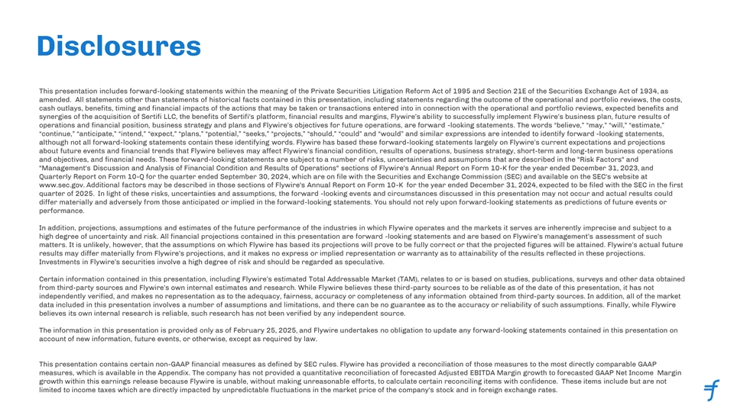
Disclosures This presentation includes forward-looking statements within the meaning of the Private Securities Litigation Reform Act of 1995 and Section 21E of the Securities Exchange Act of 1934, as amended. All statements other than statements of historical facts contained in this presentation, including statements regarding the outcome of the operational and portfolio reviews, the costs, cash outlays, benefits, timing and financial impacts of the actions that may be taken or transactions entered into in connection with the operational and portfolio reviews, expected benefits and synergies of the acquisition of Sertifi LLC, the benefits of Sertifi's platform, financial results and margins, Flywire’s ability to successfully implement Flywire’s business plan, future results of operations and financial position, business strategy and plans and Flywire’s objectives for future operations, are forward -looking statements. The words “believe,” “may,” “will,” “estimate,” “continue,” “anticipate,” “intend,” “expect,” “plans,” “potential,” “seeks,” “projects,” “should,” “could” and “would” and similar expressions are intended to identify forward -looking statements, although not all forward-looking statements contain these identifying words. Flywire has based these forward-looking statements largely on Flywire’s current expectations and projections about future events and financial trends that Flywire believes may affect Flywire’s financial condition, results of operations, business strategy, short-term and long-term business operations and objectives, and financial needs. These forward-looking statements are subject to a number of risks, uncertainties and assumptions that are described in the Risk Factors and Management's Discussion and Analysis of Financial Condition and Results of Operations sections of Flywire's Annual Report on Form 10-K for the year ended December 31, 2023, and Quarterly Report on Form 10-Q for the quarter ended September 30, 2024, which are on file with the Securities and Exchange Commission (SEC) and available on the SEC's website at www.sec.gov. Additional factors may be described in those sections of Flywire's Annual Report on Form 10-K for the year ended December 31, 2024, expected to be filed with the SEC in the first quarter of 2025. In light of these risks, uncertainties and assumptions, the forward -looking events and circumstances discussed in this presentation may not occur and actual results could differ materially and adversely from those anticipated or implied in the forward-looking statements. You should not rely upon forward-looking statements as predictions of future events or performance. In addition, projections, assumptions and estimates of the future performance of the industries in which Flywire operates and the markets it serves are inherently imprecise and subject to a high degree of uncertainty and risk. All financial projections contained in this presentation are forward -looking statements and are based on Flywire’s management’s assessment of such matters. It is unlikely, however, that the assumptions on which Flywire has based its projections will prove to be fully correct or that the projected figures will be attained. Flywire’s actual future results may differ materially from Flywire’s projections, and it makes no express or implied representation or warranty as to attainability of the results reflected in these projections. Investments in Flywire’s securities involve a high degree of risk and should be regarded as speculative. Certain information contained in this presentation, including Flywire’s estimated Total Addressable Market (TAM), relates to or is based on studies, publications, surveys and other data obtained from third-party sources and Flywire’s own internal estimates and research. While Flywire believes these third-party sources to be reliable as of the date of this presentation, it has not independently verified, and makes no representation as to the adequacy, fairness, accuracy or completeness of any information obtained from third-party sources. In addition, all of the market data included in this presentation involves a number of assumptions and limitations, and there can be no guarantee as to the accuracy or reliability of such assumptions. Finally, while Flywire believes its own internal research is reliable, such research has not been verified by any independent source. The information in this presentation is provided only as of February 25, 2025, and Flywire undertakes no obligation to update any forward-looking statements contained in this presentation on account of new information, future events, or otherwise, except as required by law. This presentation contains certain non-GAAP financial measures as defined by SEC rules. Flywire has provided a reconciliation of those measures to the most directly comparable GAAP measures, which is available in the Appendix. The company has not provided a quantitative reconciliation of forecasted Adjusted EBITDA Margin growth to forecasted GAAP Net Income Margin growth within this earnings release because Flywire is unable, without making unreasonable efforts, to calculate certain reconciling items with confidence. These items include but are not limited to income taxes which are directly impacted by unpredictable fluctuations in the market price of the company's stock and in foreign exchange rates.

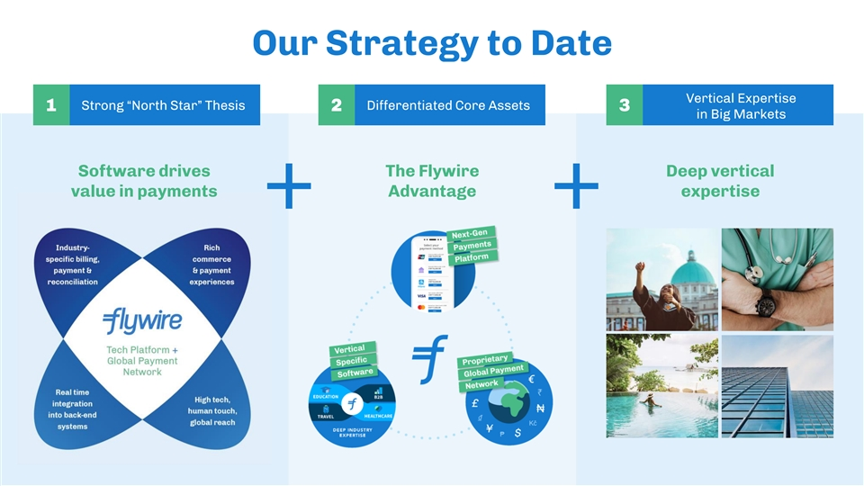
Our Strategy to Date Vertical Expertise Strong “North Star” Thesis Differentiated Core Assets 1 2 3 in Big Markets Software drives The Flywire Deep vertical value in payments Advantage expertise + +

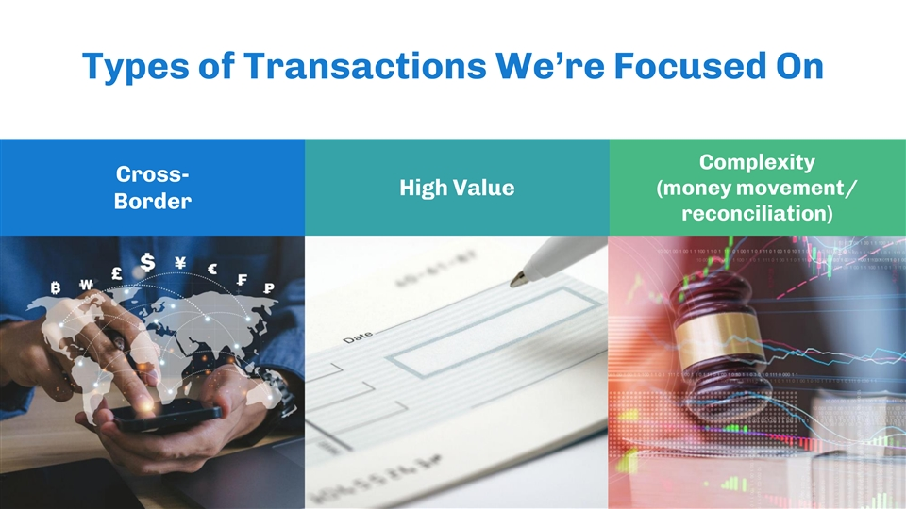
Types of Transactions We’re Focused On Complexity Cross- (money movement/ High Value Border reconciliation)

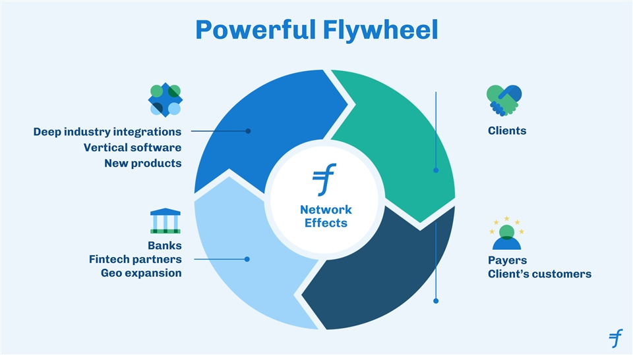
Powerful Flywheel Clients Deep industry integrations Vertical software New products Network Effects Banks Fintech partners Payers Geo expansion Client’s customers

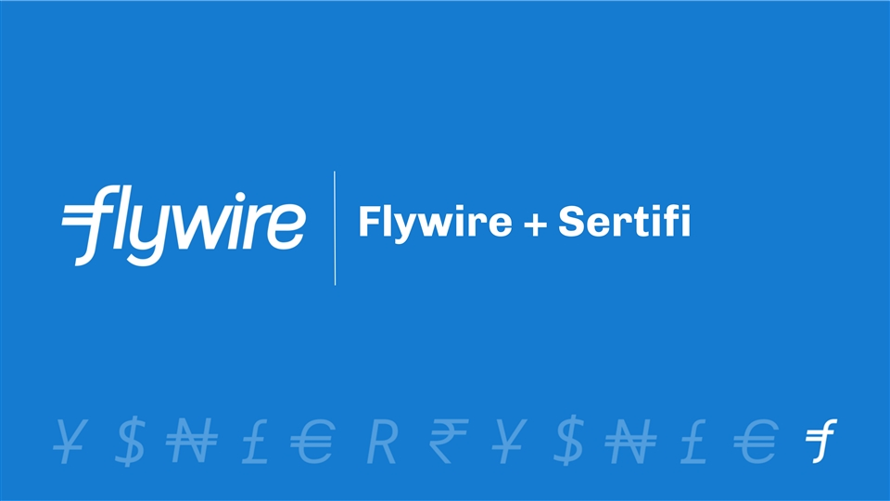
Flywire + Sertifi

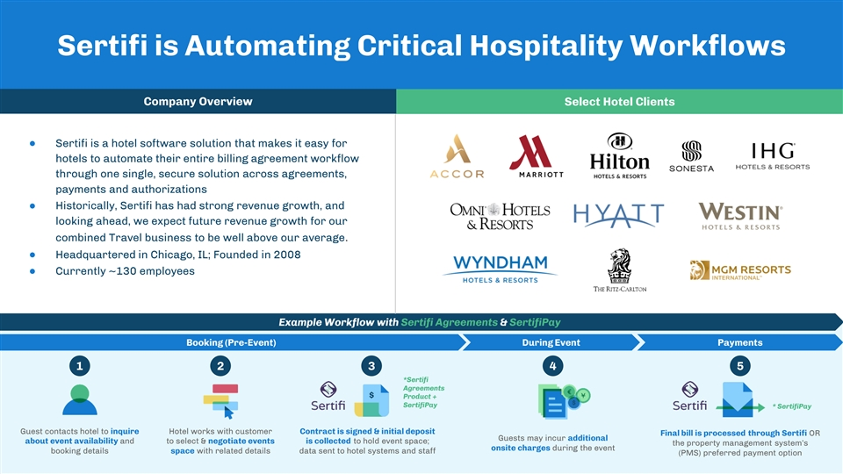
Sertifi is Automating Critical Hospitality Workflows Company Overview Select Hotel Clients ● Sertifi is a hotel software solution that makes it easy for hotels to automate their entire billing agreement workflow through one single, secure solution across agreements, payments and authorizations ● Historically, Sertifi has had strong revenue growth, and looking ahead, we expect future revenue growth for our combined Travel business to be well above our average. ● Headquartered in Chicago, IL; Founded in 2008 ● Currently ~130 employees Example Workflow with Sertifi Agreements & SertifiPay Booking (Pre-Event) During Event Payments 1 2 3 4 5 *Sertifi Agreements $ Product + SertifiPay * SertifiPay Guest contacts hotel to inquire Hotel works with customer Contract is signed & initial deposit Final bill is processed through Sertifi OR Guests may incur additional about event availability and to select & negotiate events is collected to hold event space; the property management system’s onsite charges during the event booking details space with related details data sent to hotel systems and staff (PMS) preferred payment option

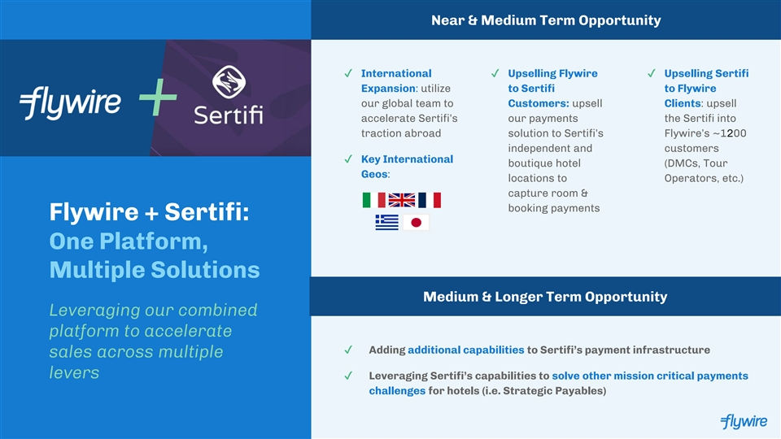
Near & Medium Term Opportunity ✔ International ✔ Upselling Flywire ✔ Upselling Sertifi Expansion: utilize to Sertifi to Flywire our global team to Customers: upsell Clients: upsell + accelerate Sertifi’s our payments the Sertifi into traction abroad solution to Sertifi’s Flywire’s ~1200 independent and customers ✔ Key International boutique hotel (DMCs, Tour Geos: locations to Operators, etc.) capture room & booking payments Flywire + Sertifi: One Platform, Multiple Solutions Medium & Longer Term Opportunity Leveraging our combined platform to accelerate ✔ Adding additional capabilities to Sertifi’s payment infrastructure sales across multiple levers ✔ Leveraging Sertifi’s capabilities to solve other mission critical payments challenges for hotels (i.e. Strategic Payables)

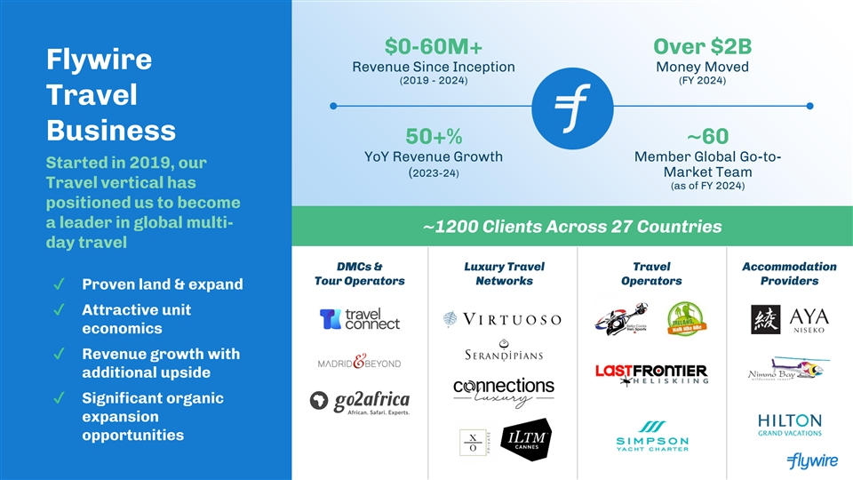
$0-60M+ Over $2B Flywire Revenue Since Inception Money Moved (2019 - 2024) (FY 2024) Travel Business 50+% ~60 YoY Revenue Growth Member Global Go-to- Started in 2019, our (2023-24) Market Team Travel vertical has (as of FY 2024) positioned us to become a leader in global multi- ~1200 Clients Across 27 Countries day travel DMCs & Luxury Travel Travel Accommodation Tour Operators Networks Operators Providers ✔ Proven land & expand ✔ Attractive unit economics ✔ Revenue growth with additional upside ✔ Significant organic expansion opportunities

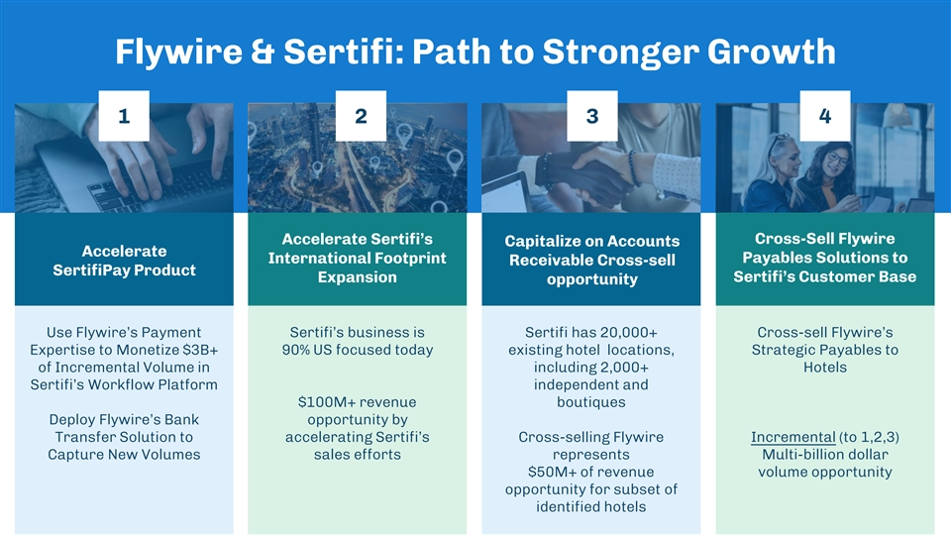
Flywire & Sertifi: Path to Stronger Growth 1 2 3 4 Accelerate Sertifi’s Cross-Sell Flywire Capitalize on Accounts Accelerate Payables Solutions to International Footprint Receivable Cross-sell SertifiPay Product Expansion Sertifi’s Customer Base opportunity Use Flywire’s Payment Sertifi’s business is Sertifi has 20,000+ Cross-sell Flywire’s Expertise to Monetize $3B+ 90% US focused today existing hotel locations, Strategic Payables to of Incremental Volume in including 2,000+ Hotels Sertifi’s Workflow Platform independent and $100M+ revenue boutiques Deploy Flywire’s Bank opportunity by Transfer Solution to accelerating Sertifi’s Cross-selling Flywire Incremental (to 1,2,3) Capture New Volumes sales efforts represents Multi-billion dollar $50M+ of revenue volume opportunity opportunity for subset of identified hotels

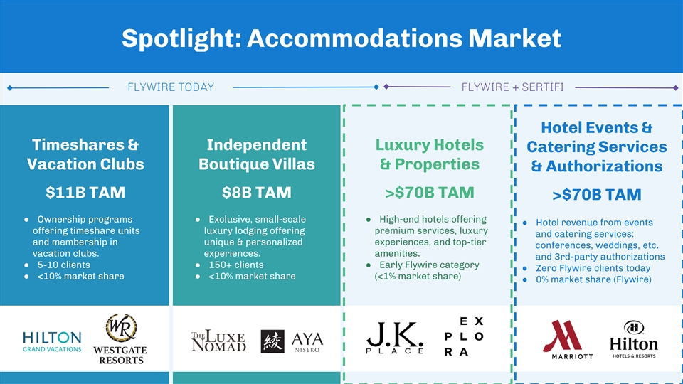
Spotlight: Accommodations Market FLYWIRE TODAY FLYWIRE + SERTIFI Hotel Events & Timeshares & Independent Luxury Hotels Catering Services Vacation Clubs Boutique Villas & Properties & Authorizations $11B TAM $8B TAM >$70B TAM >$70B TAM ● Ownership programs ● Exclusive, small-scale ● High-end hotels offering ● Hotel revenue from events offering timeshare units luxury lodging offering premium services, luxury and catering services: and membership in unique & personalized experiences, and top-tier conferences, weddings, etc. vacation clubs. experiences. amenities. and 3rd-party authorizations ● 5-10 clients● 150+ clients● Early Flywire category ● Zero Flywire clients today ● <10% market share● <10% market share (<1% market share) ● 0% market share (Flywire)

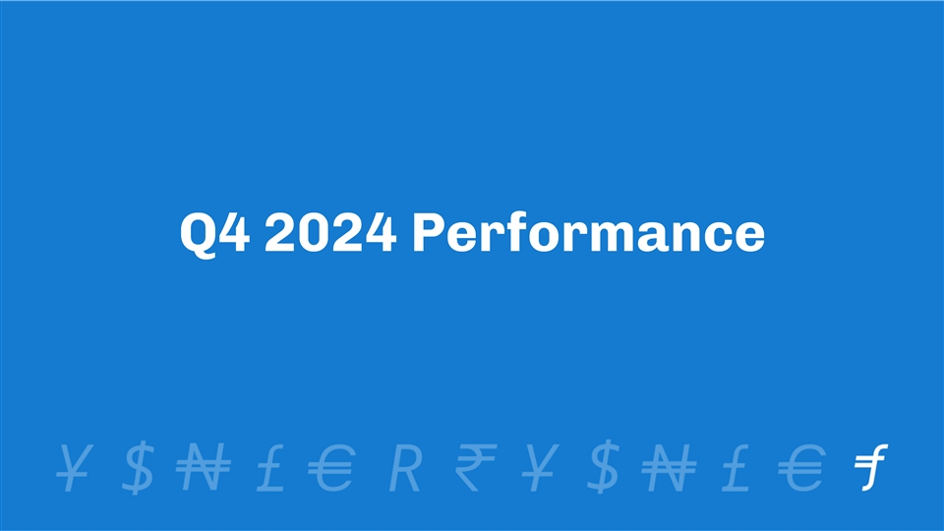
Q4 2024 Performance

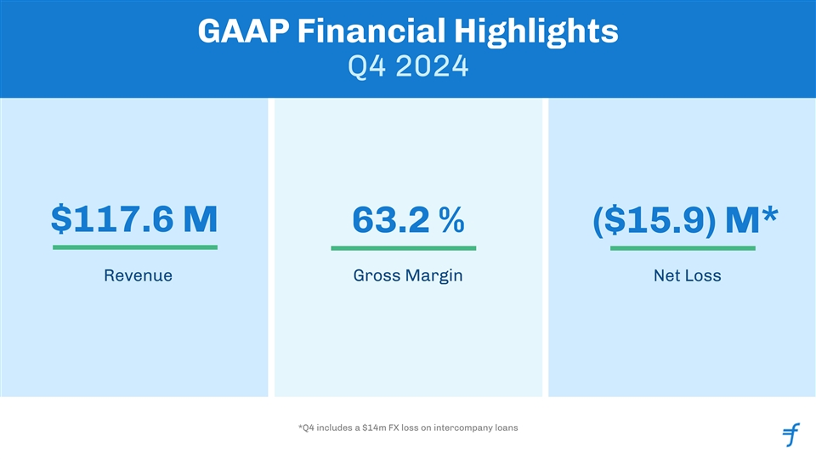
GAAP Financial Highlights Q4 2024 $117.6 M 63.2 % ($15.9) M* Revenue Gross Margin Net Loss *Q4 includes a $14m FX loss on intercompany loans

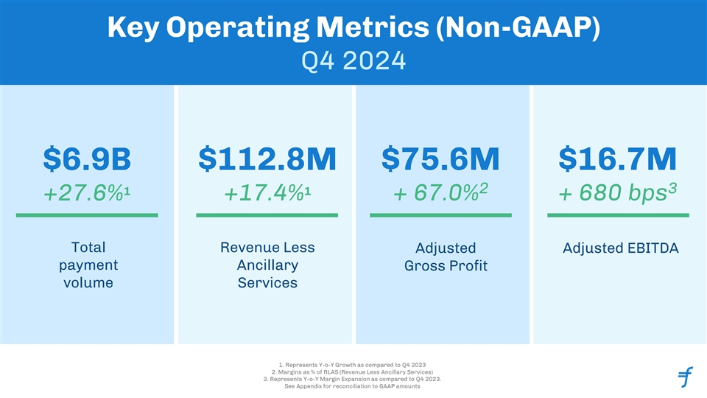
Key Operating Metrics (Non-GAAP) Q4 2024 $6.9B $112.8M $75.6M $16.7M 2 3 1 1 +27.6% +17.4% + 67.0% + 680 bps Total Revenue Less Adjusted Adjusted EBITDA payment Ancillary Gross Profit volume Services 1. Represents Y-o-Y Growth as compared to Q4 2023 2. Margins as % of RLAS (Revenue Less Ancillary Services) 3. Represents Y-o-Y Margin Expansion as compared to Q4 2023. See Appendix for reconciliation to GAAP amounts

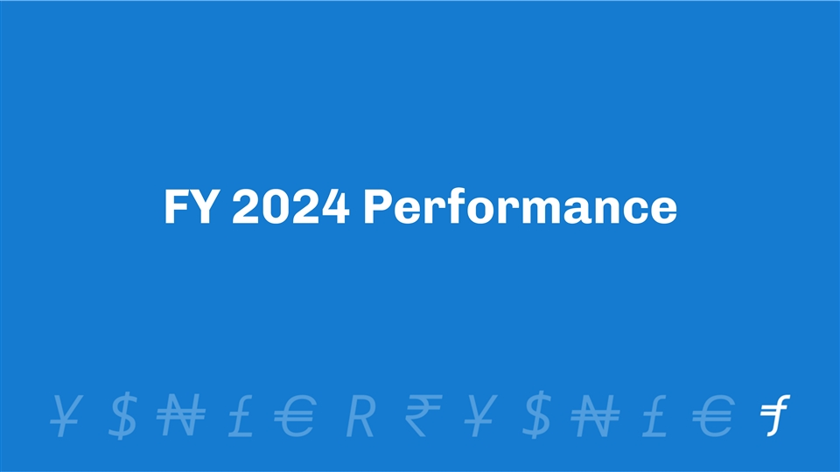
FY 2024 Performance

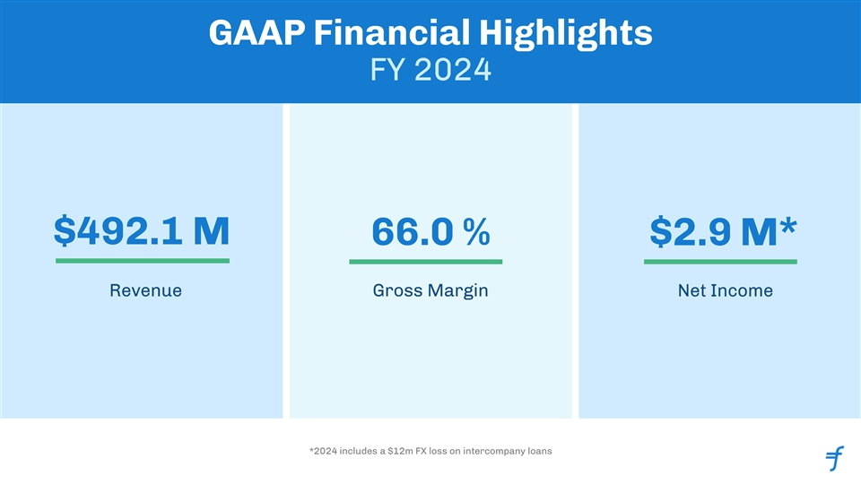
GAAP Financial Highlights FY 2024 $492.1 M 66.0 % $2.9 M* Revenue Gross Margin Net Income *2024 includes a $12m FX loss on intercompany loans

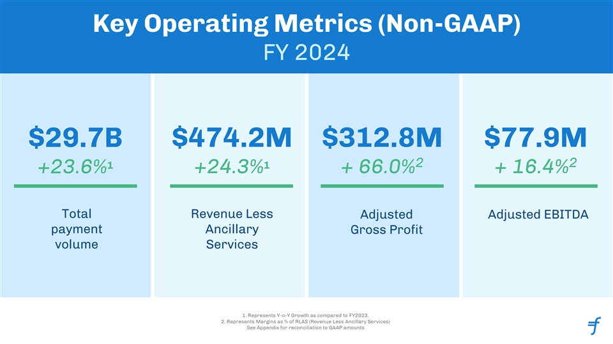
Key Operating Metrics (Non-GAAP) FY 2024 $29.7B $474.2M $312.8M $77.9M 2 2 1 1 +23.6% +24.3% + 66.0% + 16.4% Total Revenue Less Adjusted Adjusted EBITDA payment Ancillary Gross Profit volume Services 1. Represents Y-o-Y Growth as compared to FY2023. 2. Represents Margins as % of RLAS (Revenue Less Ancillary Services) See Appendix for reconciliation to GAAP amounts

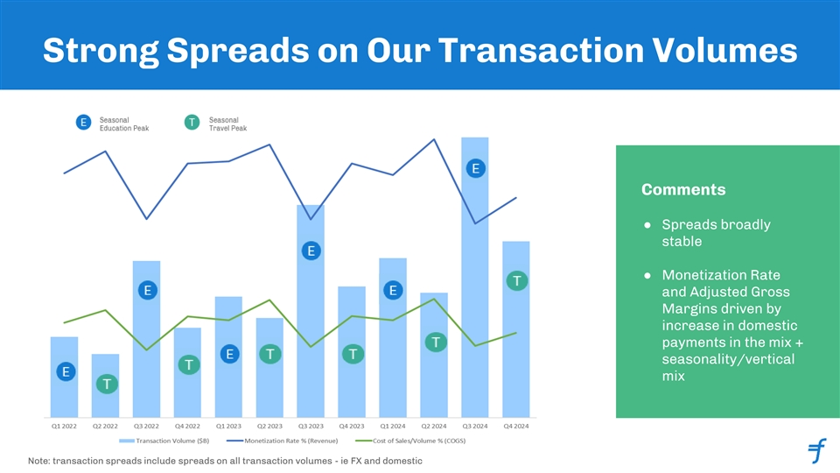
Strong Spreads on Our Transaction Volumes Comments ● Spreads broadly stable ● Monetization Rate and Adjusted Gross Margins driven by increase in domestic payments in the mix + seasonality/vertical mix Note: transaction spreads include spreads on all transaction volumes - ie FX and domestic

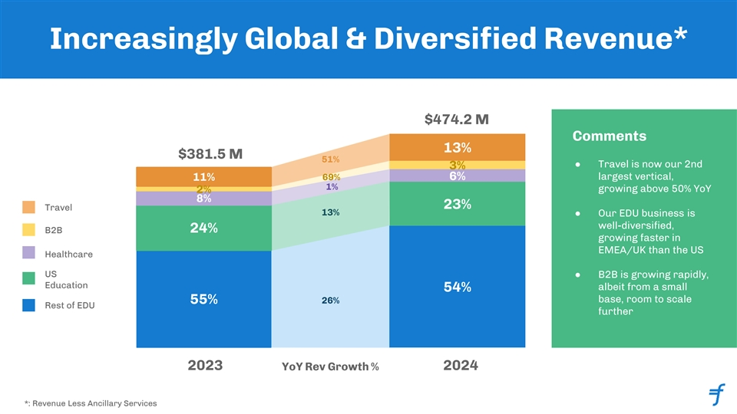
Increasingly Global & Diversified Revenue* $474.2 M Comments 13% 16% $381.5 M 51% ● Travel is now our 2nd 3% 6% 69% 6% largest vertical, 11% 1% growing above 50% YoY 2% 8% 23% 23% Travel 13% ● Our EDU business is well-diversified, B2B 24% growing faster in EMEA/UK than the US Healthcare US ● B2B is growing rapidly, Education albeit from a small 54% 54% base, room to scale 26% 55% Rest of EDU further 2023 2024 YoY Rev Growth % *: Revenue Less Ancillary Services

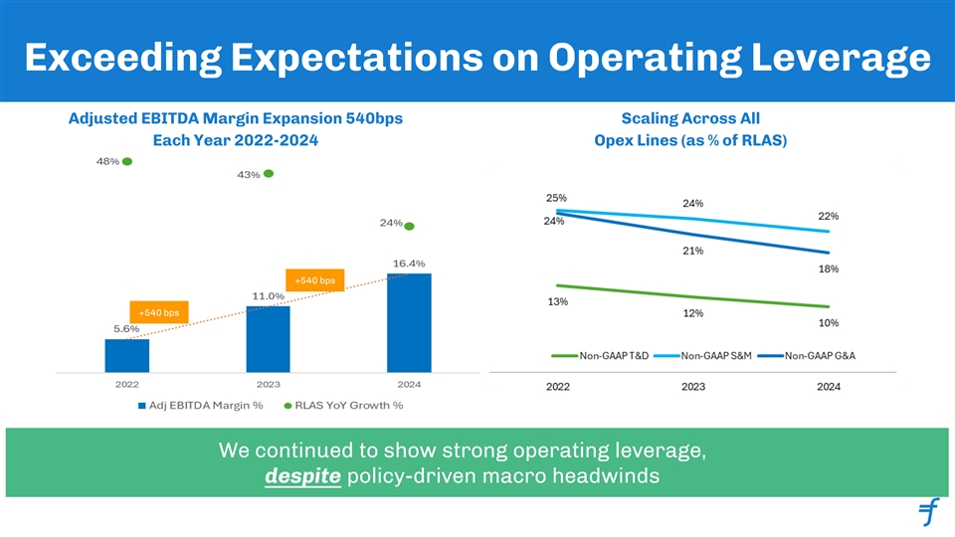
Exceeding Expectations on Operating Leverage Adjusted EBITDA Margin Expansion 540bps Scaling Across All Each Year 2022-2024 Opex Lines (as % of RLAS) +540 bps +540 bps We continued to show strong operating leverage, despite policy-driven macro headwinds

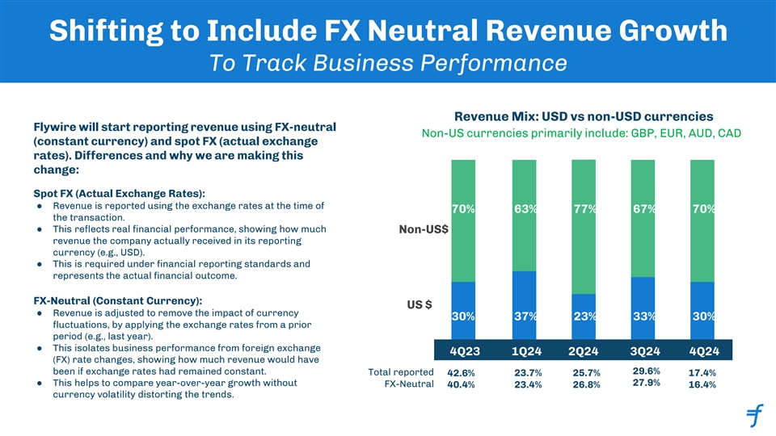
Shifting to Include FX Neutral Revenue Growth To Track Business Performance Revenue Mix: USD vs non-USD currencies Flywire will start reporting revenue using FX-neutral Non-US currencies primarily include: GBP, EUR, AUD, CAD (constant currency) and spot FX (actual exchange rates). Differences and why we are making this change: Spot FX (Actual Exchange Rates): ● Revenue is reported using the exchange rates at the time of 70% 63% 77% 67% 70% the transaction. ● This reflects real financial performance, showing how much Non-US$ revenue the company actually received in its reporting currency (e.g., USD). ● This is required under financial reporting standards and represents the actual financial outcome. FX-Neutral (Constant Currency): US $ ● Revenue is adjusted to remove the impact of currency 30% 37% 23% 33% 30% fluctuations, by applying the exchange rates from a prior period (e.g., last year). ● This isolates business performance from foreign exchange 4Q23 1Q24 2Q24 3Q24 4Q24 (FX) rate changes, showing how much revenue would have been if exchange rates had remained constant. 29.6% Total reported 42.6% 23.7% 25.7% 17.4% ● This helps to compare year-over-year growth without 27.9% FX-Neutral 23.4% 26.8% 16.4% 40.4% currency volatility distorting the trends.


Guidance Context & Forward Path

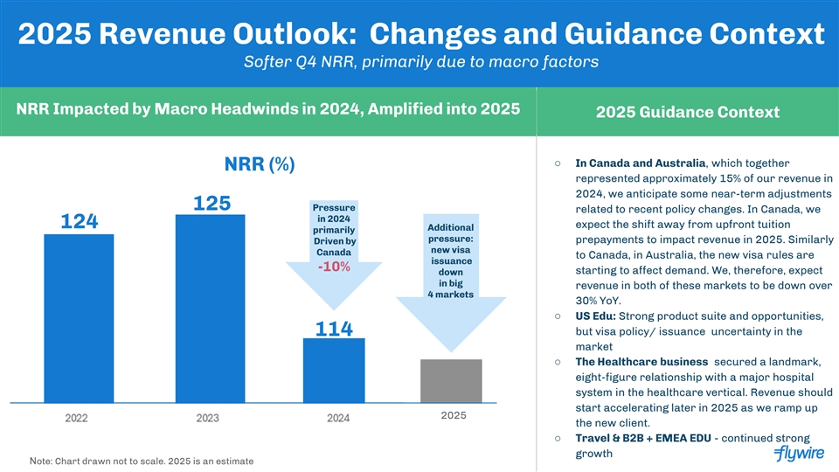
2025 Revenue Outlook: Changes and Guidance Context Softer Q4 NRR, primarily due to macro factors NRR Impacted by Macro Headwinds in 2024, Amplified into 2025 2025 Guidance Context ○ In Canada and Australia, which together NRR (%) represented approximately 15% of our revenue in 2024, we anticipate some near-term adjustments 12 125 Pressure related to recent policy changes. In Canada, we in 2024 124 % expect the shift away from upfront tuition Additional primarily 6% pressure: prepayments to impact revenue in 2025. Similarly Driven by % new visa Canada to Canada, in Australia, the new visa rules are issuance -10% starting to affect demand. We, therefore, expect down in big revenue in both of these markets to be down over 4 markets 30% YoY. ○ US Edu: Strong product suite and opportunities, 114 but visa policy/ issuance uncertainty in the market % ○ The Healthcare business secured a landmark, eight-figure relationship with a major hospital system in the healthcare vertical. Revenue should start accelerating later in 2025 as we ramp up 2025 the new client. ○ Travel & B2B + EMEA EDU - continued strong growth Note: Chart drawn not to scale. 2025 is an estimate

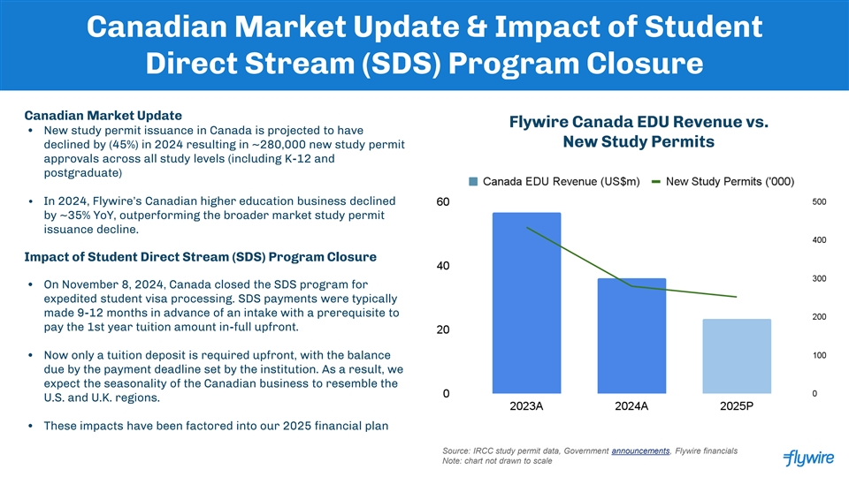
Canadian Market Update & Impact of Student Direct Stream (SDS) Program Closure Canadian Market Update Flywire Canada EDU Revenue vs. • New study permit issuance in Canada is projected to have New Study Permits declined by (45%) in 2024 resulting in ~280,000 new study permit approvals across all study levels (including K-12 and postgraduate) • In 2024, Flywire’s Canadian higher education business declined by ~35% YoY, outperforming the broader market study permit issuance decline. Impact of Student Direct Stream (SDS) Program Closure • On November 8, 2024, Canada closed the SDS program for expedited student visa processing. SDS payments were typically made 9-12 months in advance of an intake with a prerequisite to pay the 1st year tuition amount in-full upfront. • Now only a tuition deposit is required upfront, with the balance due by the payment deadline set by the institution. As a result, we expect the seasonality of the Canadian business to resemble the U.S. and U.K. regions. • These impacts have been factored into our 2025 financial plan Source: IRCC study permit data, Government announcements, Flywire financials Note: chart not drawn to scale

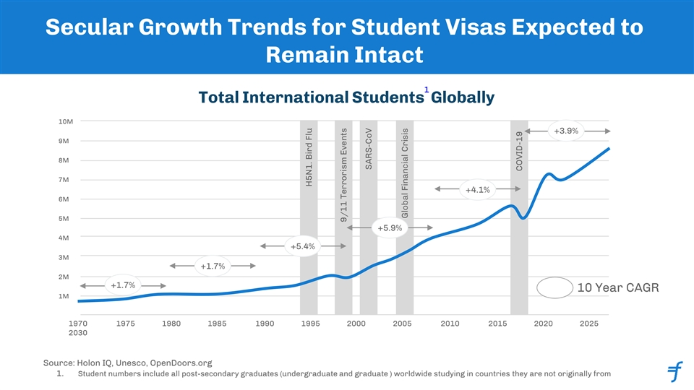
Secular Growth Trends for Student Visas Expected to Remain Intact 1 Total International Students Globally 10M +3.9% 9M 8M 7M +4.1% 6M 5M +5.9% 4M +5.4% 3M +1.7% 2M +1.7% 10 Year CAGR 1M 1970 1975 1980 1985 1990 1995 2000 2005 2010 2015 2020 2025 2030 Source: Holon IQ, Unesco, OpenDoors.org 1. Student numbers include all post-secondary graduates (undergraduate and graduate ) worldwide studying in countries they are not originally from H5N1. Bird Flu 9/11 Terrorism Events SARS-CoV Global Financial Crisis COVID-19

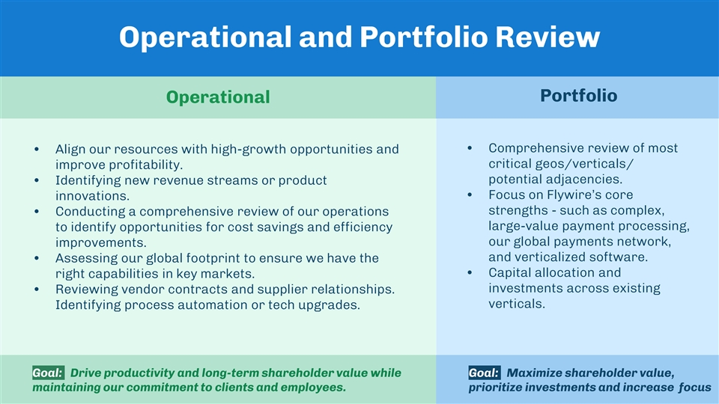
Operational and Portfolio Review Portfolio Operational • Comprehensive review of most • Align our resources with high-growth opportunities and critical geos/verticals/ improve profitability. potential adjacencies. • Identifying new revenue streams or product • Focus on Flywire’s core innovations. strengths - such as complex, • Conducting a comprehensive review of our operations large-value payment processing, to identify opportunities for cost savings and efficiency our global payments network, improvements. and verticalized software. • Assessing our global footprint to ensure we have the • Capital allocation and right capabilities in key markets. investments across existing • Reviewing vendor contracts and supplier relationships. verticals. Identifying process automation or tech upgrades. Goal: Drive productivity and long-term shareholder value while Goal: Maximize shareholder value, maintaining our commitment to clients and employees. prioritize investments and increase focus


2025 Financial Outlook

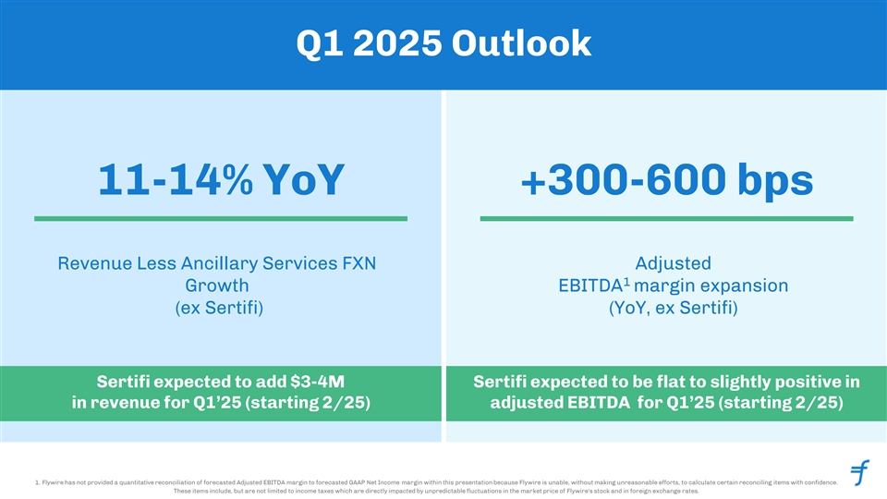
Q1 2025 Outlook 11-14% YoY +300-600 bps Revenue Less Ancillary Services FXN Adjusted 1 Growth EBITDA margin expansion (ex Sertifi) (YoY, ex Sertifi) Sertifi expected to add $3-4M Sertifi expected to be flat to slightly positive in in revenue for Q1’25 (starting 2/25) adjusted EBITDA for Q1’25 (starting 2/25) 1. Flywire has not provided a quantitative reconciliation of forecasted Adjusted EBITDA margin to forecasted GAAP Net Income margin within this presentation because Flywire is unable, without making unreasonable efforts, to calculate certain reconciling items with confidence. 28 These items include, but are not limited to income taxes which are directly impacted by unpredictable fluctuations in the market price of Flywire's stock and in foreign exchange rates.

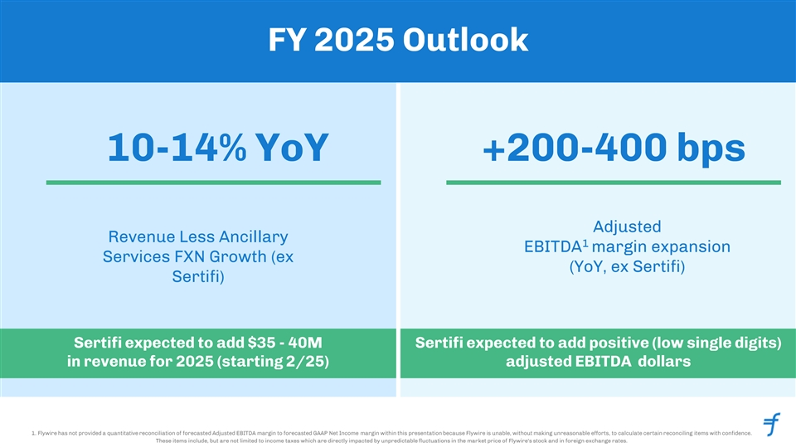
FY 2025 Outlook 10-14% YoY +200-400 bps Adjusted Revenue Less Ancillary 1 EBITDA margin expansion Services FXN Growth (ex (YoY, ex Sertifi) Sertifi) Sertifi expected to add $35 - 40M Sertifi expected to add positive (low single digits) in revenue for 2025 (starting 2/25) adjusted EBITDA dollars 1. Flywire has not provided a quantitative reconciliation of forecasted Adjusted EBITDA margin to forecasted GAAP Net Income margin within this presentation because Flywire is unable, without making unreasonable efforts, to calculate certain reconciling items with confidence. 29 These items include, but are not limited to income taxes which are directly impacted by unpredictable fluctuations in the market price of Flywire's stock and in foreign exchange rates.


Capital Allocation and Structure

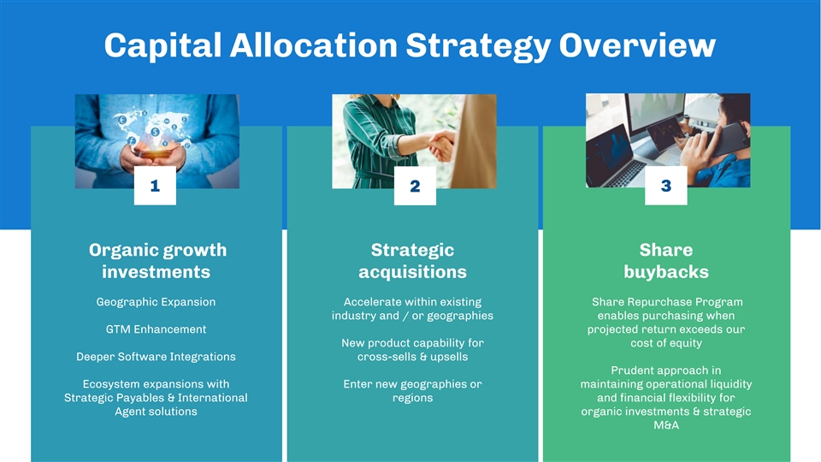
Capital Allocation Strategy Overview 1 3 2 Organic growth Strategic Share investments acquisitions buybacks Geographic Expansion Accelerate within existing Share Repurchase Program industry and / or geographies enables purchasing when GTM Enhancement projected return exceeds our New product capability for cost of equity Deeper Software Integrations cross-sells & upsells Prudent approach in Ecosystem expansions with Enter new geographies or maintaining operational liquidity Strategic Payables & International regions and financial flexibility for Agent solutions organic investments & strategic M&A

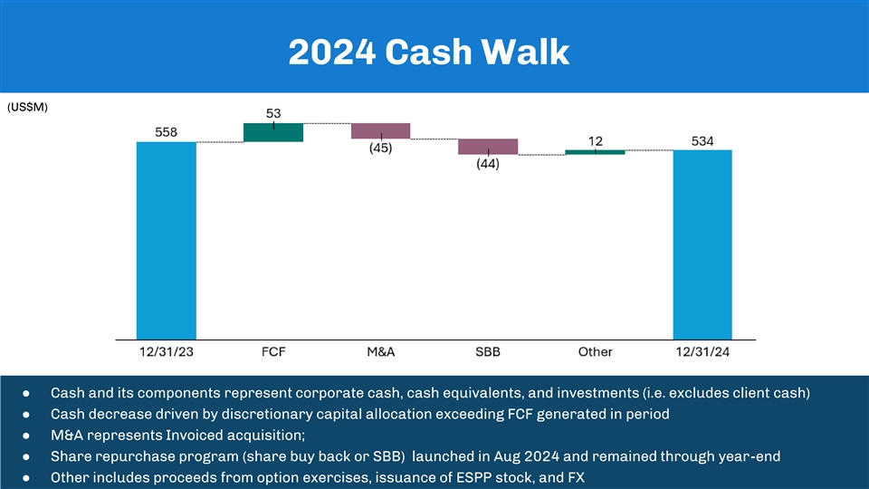
2024 Cash Walk (US$M) ● Cash and its components represent corporate cash, cash equivalents, and investments (i.e. excludes client cash) ● Cash decrease driven by discretionary capital allocation exceeding FCF generated in period ● M&A represents Invoiced acquisition; ● Share repurchase program (share buy back or SBB) launched in Aug 2024 and remained through year-end ● Other includes proceeds from option exercises, issuance of ESPP stock, and FX

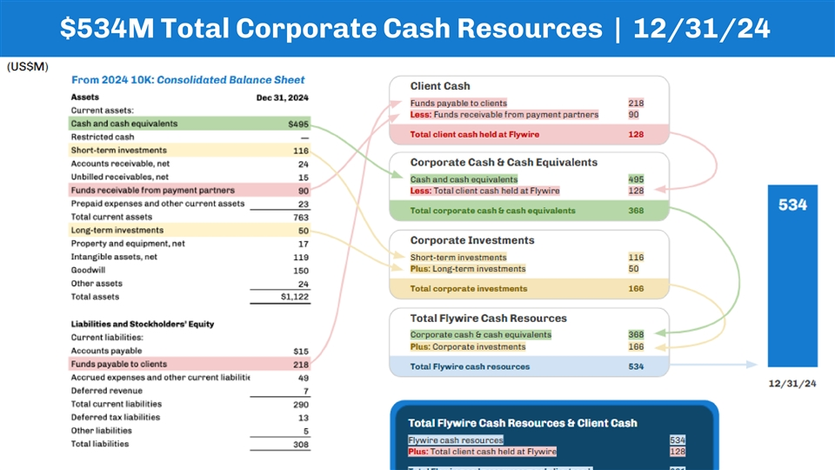
$534M Total Corporate Cash Resources | 12/31/24

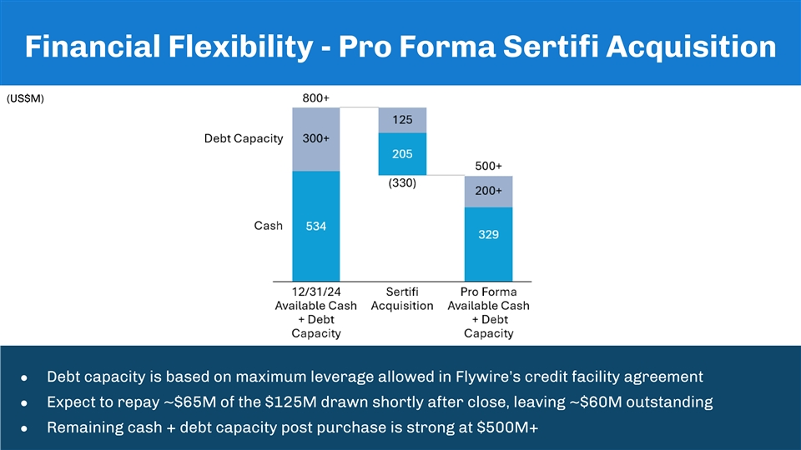
Financial Flexibility - Pro Forma Sertifi Acquisition (US$M) ● Debt capacity is based on maximum leverage allowed in Flywire’s credit facility agreement ● Expect to repay ~$65M of the $125M drawn shortly after close, leaving ~$60M outstanding ● Remaining cash + debt capacity post purchase is strong at $500M+

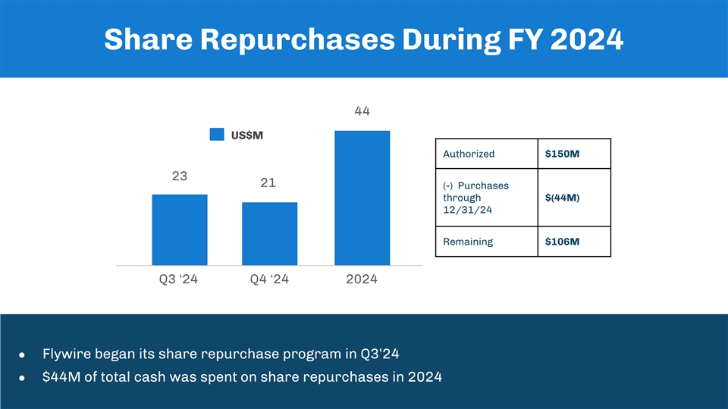
Share Repurchases During FY 2024 44 US$M Authorized $150M 23 21 (-) Purchases through $(44M) 12/31/24 Remaining $106M Q3 ‘24 Q4 ‘24 2024 ● Flywire began its share repurchase program in Q3’24 ● $44M of total cash was spent on share repurchases in 2024


Appendix

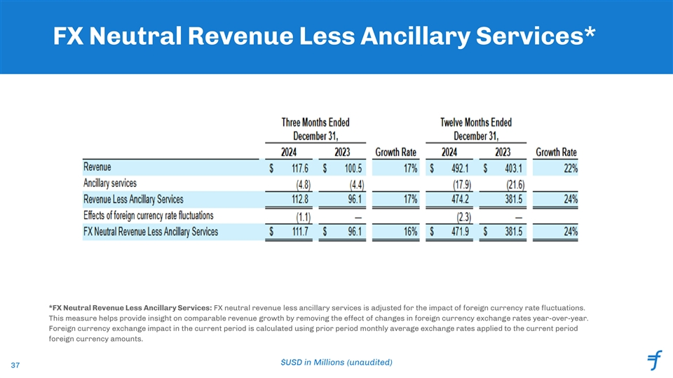
FX Neutral Revenue Less Ancillary Services* *FX Neutral Revenue Less Ancillary Services: FX neutral revenue less ancillary services is adjusted for the impact of foreign currency rate fluctuations. This measure helps provide insight on comparable revenue growth by removing the effect of changes in foreign currency exchange rates year-over-year. Foreign currency exchange impact in the current period is calculated using prior period monthly average exchange rates applied to the current period foreign currency amounts. $USD in Millions (unaudited) 37

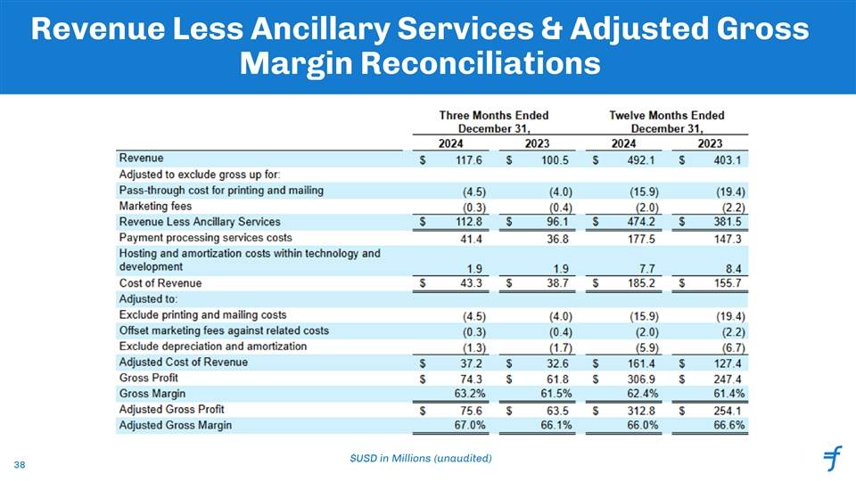
Revenue Less Ancillary Services & Adjusted Gross Margin Reconciliations $USD in Millions (unaudited) 38

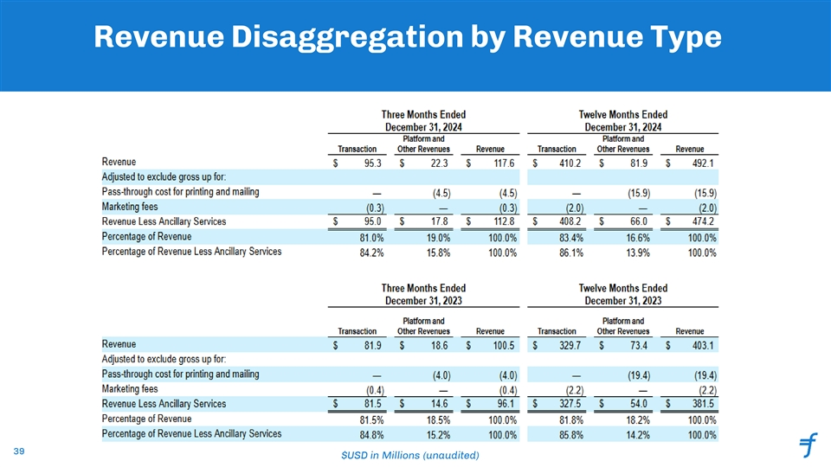
Revenue Disaggregation by Revenue Type 39 $USD in Millions (unaudited)

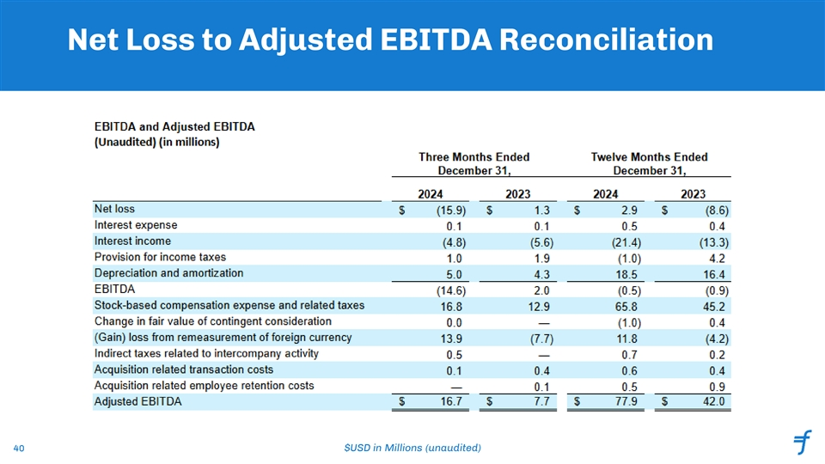
Net Loss to Adjusted EBITDA Reconciliation 40 $USD in Millions (unaudited)

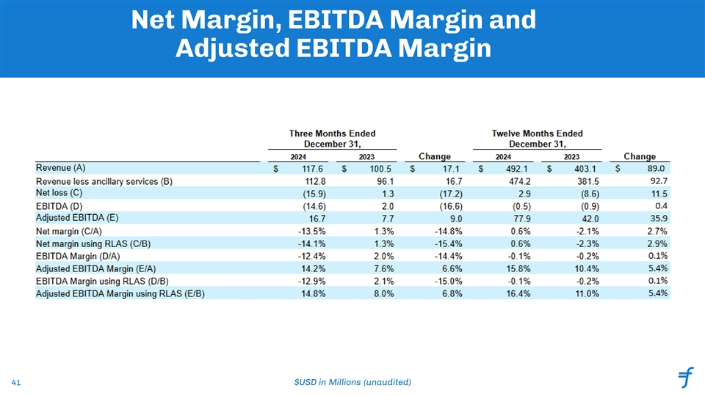
Net Margin, EBITDA Margin and Adjusted EBITDA Margin 41 $USD in Millions (unaudited)

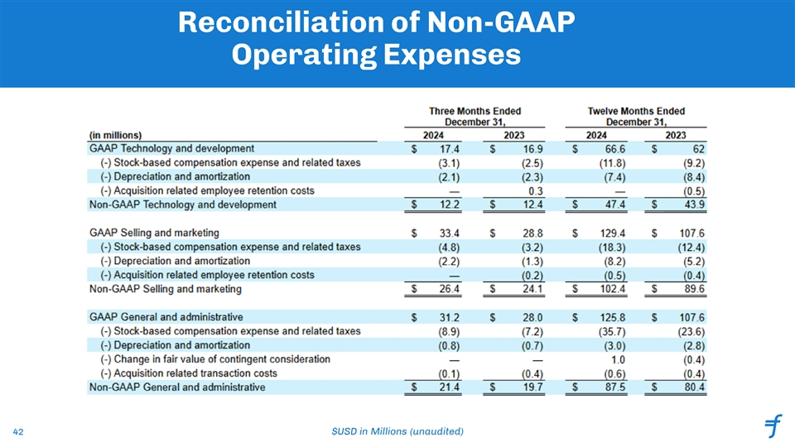
Reconciliation of Non-GAAP Operating Expenses 42 $USD in Millions (unaudited)

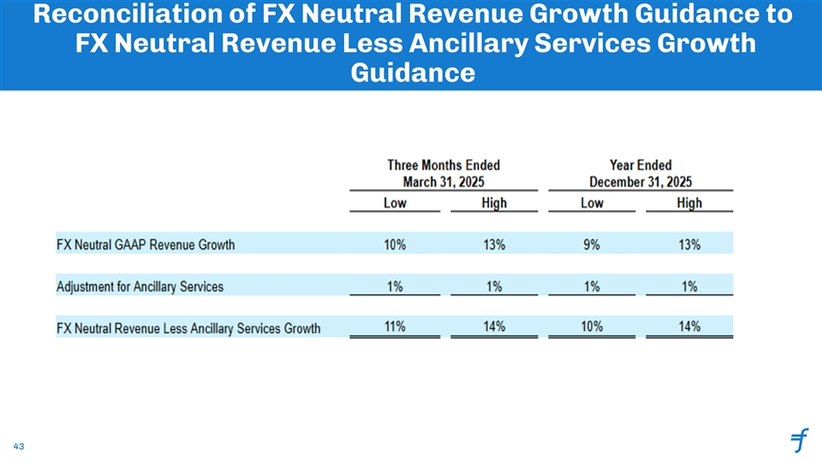
Reconciliation of FX Neutral Revenue Growth Guidance to FX Neutral Revenue Less Ancillary Services Growth Guidance 43

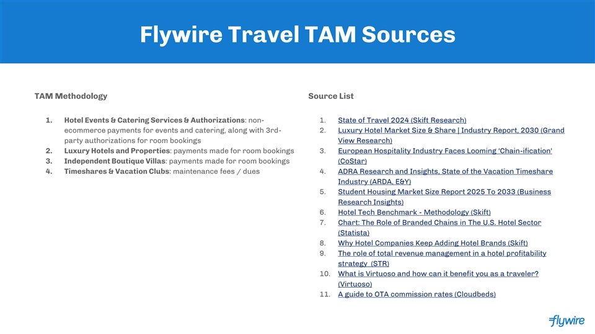
Flywire Travel TAM Sources TAM Methodology Source List 1. Hotel Events & Catering Services & Authorizations: non- 1. State of Travel 2024 (Skift Research) ecommerce payments for events and catering, along with 3rd- 2. Luxury Hotel Market Size & Share | Industry Report, 2030 (Grand party authorizations for room bookings View Research) 2. Luxury Hotels and Properties: payments made for room bookings 3. European Hospitality Industry Faces Looming 'Chain-ification' 3. Independent Boutique Villas: payments made for room bookings (CoStar) 4. Timeshares & Vacation Clubs: maintenance fees / dues 4. ADRA Research and Insights, State of the Vacation Timeshare Industry (ARDA, E&Y) 5. Student Housing Market Size Report 2025 To 2033 (Business Research Insights) 6. Hotel Tech Benchmark - Methodology (Skift) 7. Chart: The Role of Branded Chains in The U.S. Hotel Sector (Statista) 8. Why Hotel Companies Keep Adding Hotel Brands (Skift) 9. The role of total revenue management in a hotel profitability strategy (STR) 10. What is Virtuoso and how can it benefit you as a traveler? (Virtuoso) 11. A guide to OTA commission rates (Cloudbeds)

