UNITED STATES
SECURITIES AND EXCHANGE COMMISSION
Washington, D.C. 20549

FORM 8-K

CURRENT REPORT
Pursuant to Section 13 or 15(d)
of the Securities Exchange Act of 1934
Date of Report (Date of earliest event reported): May 7, 2024

FLYWIRE CORPORATION
(Exact name of Registrant as specified in its charter)

Delaware |  | 001-40430 |  | 27-0690799
(State or other jurisdiction  of incorporation) |  | (Commission  File No.) |  | (IRS Employer  Identification No.)

141 Tremont St #10
Boston, MA 02111
(Address of principal executive offices and zip code)
Registrant’s telephone number, including area code: (617) 329-4524
Not Applicable
(Former Name or Former Address, if Changed Since Last Report)

Check the appropriate box below if the Form 8-K filing is intended to simultaneously satisfy the filing obligation of the registrant under any of the following provisions:

☐ | Written communications pursuant to Rule 425 under the Securities Act (17 CFR 230.425)

☐ | Soliciting material pursuant to Rule 14a-12 under the Exchange Act (17 CFR 240.14a-12)

☐ | Pre-commencement communications pursuant to Rule 14d-2(b) under the Exchange Act (17 CFR 240.14d-2(b))

☐ | Pre-commencement communications pursuant to Rule 13e-4(c) under the Exchange Act (17 CFR 240.13e-4(c))
Securities registered pursuant to Section 12(b) of the Act:

Title of each class |  | Trading  Symbol(s) |  | Name of each exchange  on which registered
Voting Common Stock, $0.0001 par value per share |  | FLYW |  | The Nasdaq Stock Market LLC
 |  |  |  | (Nasdaq Global Select Market)
Indicate by check mark whether the registrant is an emerging growth company as defined in Rule 405 of the Securities Act of 1933 (§230.405 of this chapter) or Rule 12b-2 of the Securities Exchange Act of 1934 (§240.12b-2 of this chapter).
Emerging growth company ☐
If an emerging growth company, indicate by check mark if the registrant has elected not to use the extended transition period for complying with any new or revised financial accounting standards provided pursuant to Section 13(a) of the Exchange Act. ☐

Item 2.02. | Results of Operations and Financial Condition.
On May 7, 2024, Flywire Corporation (“Flywire” or the “Company”) issued a press release (the “Press Release”) and is holding a conference call regarding its preliminary and unaudited financial results for the quarter ended March 31, 2024. The Press Release is furnished as Exhibit 99.1 to this Current Report on Form 8-K and is incorporated by reference herein.
Various statements to be made during the conference call are “forward-looking statements” within the meaning of the Private Securities Litigation Reform Act of 1995, including, but not limited to, statements regarding Flywire’s future operating results and financial position, Flywire’s business strategy and plans, market growth, and Flywire’s objectives for future operations. Flywire intends such forward-looking statements to be covered by the safe harbor provisions for forward-looking statements contained in Section 21E of the Securities Exchange Act of 1934 and the Private Securities Litigation Reform Act of 1995. In some cases, you can identify forward-looking statements by terms such as, but not limited to, “believe,” “may,” “will,” “potentially,” “estimate,” “continue,” “anticipate,” “intend,” “could,” “would,” “project,” “target,” “plan,” “expect,” or the negative of these terms, and similar expressions intended to identify forward-looking statements. Such forward-looking statements are based upon current expectations that involve risks, changes in circumstances, assumptions, and uncertainties. Important factors that could cause actual results to differ materially from those reflected in Flywire’s forward-looking statements include, among others, Flywire’s future financial performance, including its expectations regarding Revenue, Revenue Less Ancillary Services, and Adjusted EBITDA and foreign exchange rates. Risks that may cause actual results to differ materially from these forward looking statements include, but are not limited to: Flywire’s ability to execute its business plan and effectively manage its growth; Flywire’s cross-border expansion plans and ability to expand internationally; anticipated trends, growth rates, and challenges in Flywire’s business and in the markets in which Flywire operates; the sufficiency of Flywire’s cash and cash equivalents to meet its liquidity needs; political, economic, foreign currency exchange rate, inflation, legal, social and health risks, that may affect Flywire’s business or the global economy; Flywire’s beliefs and objectives for future operations; Flywire’s ability to develop and protect its brand; Flywire’s ability to maintain and grow the payment volume that it processes; Flywire’s ability to further attract, retain, and expand its client base; Flywire’s ability to develop new solutions and services and bring them to market in a timely manner; Flywire’s expectations concerning relationships with third parties, including financial institutions and strategic partners; the effects of increased competition in Flywire’s markets and its ability to compete effectively; recent and future acquisitions or investments in complementary companies, products, services, or technologies; Flywire’s ability to enter new client verticals, including its relatively new business-to-business sector; Flywire’s expectations regarding anticipated technology needs and developments and its ability to address those needs and developments with its solutions; Flywire’s expectations regarding litigation and legal and regulatory matters; Flywire’s expectations regarding its ability to meet existing performance obligations and maintain the operability of its solutions; Flywire’s expectations regarding the effects of existing and developing laws and regulations, including with respect to payments and financial services, taxation, privacy and data protection; economic and industry trends, projected growth, or trend analysis; Flywire’s ability to adapt to changes in U.S. federal income or other tax laws or the interpretation of tax laws, including the Inflation Reduction Act of 2022; Flywire’s ability to attract and retain qualified employees; Flywire’s ability to maintain, protect, and enhance its intellectual property; Flywire’s ability to maintain the security and availability of its solutions; the increased expenses associated with being a public company; the future market price of Flywire’s common stock; and other factors that are described in the “Risk Factors” and “Management’s Discussion and Analysis of Financial Condition and Results of Operations” sections of Flywire’s Annual Report on Form 10-K for the year ended December 31, 2023. Additional factors may be described in those sections of Flywire’s Quarterly Report on Form 10-Q for the quarter ended March 31, 2024, expected to be filed with the SEC in the second quarter of 2024. The information conveyed on the conference call is provided only as of the date of the conference call, and Flywire undertakes no obligation to update any forward-looking statements presented during the conference call on account of new information, future events, or otherwise, except as required by law.

Item 7.01. | Regulation FD Disclosure.
On May 7, 2024, the Company provided an investor presentation that will be made available on the investor relations section of the Company’s website at https://ir.flywire.com/. The investor presentation is furnished as Exhibit 99.2 to this Current Report on Form 8-K and is incorporated by reference herein.
This information in this Item 7.01 of this Current Report on Form 8-K shall not be deemed “filed” for purposes of Section 18 of the Securities Exchange Act of 1934, as amended (the “Exchange Act”), or otherwise subject to the liabilities of that Section, or incorporated by reference in any filing under the Securities Act of 1933, as amended, or the Exchange Act, except as shall be expressly set forth by specific reference in any such filing.

Item 9.01. | Financial Statements and Exhibits.
(d) Exhibits

Exhibit  No. |  | Description
99.1 |  | Flywire Corporation Press Release dated May 7, 2024.
99.2 |  | Flywire Corporation Investor Presentation dated May 7, 2024.
104 |  | Cover Page Interactive Data File (embedded within the Inline XBRL document)

SIGNATURE
Pursuant to the requirements of the Securities Exchange Act of 1934, the registrant has duly caused this report to be signed on its behalf by the undersigned hereunto duly authorized.

FLYWIRE CORPORATION
By: |  | /s/ Cosmin Pitigoi
Name: |  | Cosmin Pitigoi
Title: |  | Chief Financial Officer
Dated May 7, 2024
Exhibit 99.1
Flywire Reports First Quarter 2024 Financial Results
First Quarter Revenue Increased 21% Year-over-Year
First Quarter Revenue Less Ancillary Services Increased 24% Year-over-Year
Company Provides Second Quarter and Fiscal-Year 2024 Outlook
Boston, MA  May 7, 2024: Flywire Corporation (Nasdaq: FLYW) (Flywire or the Company) a global payments enablement and software company, today reported financial results for its first quarter ended March 31, 2024.
We are pleased with our 2024 first quarter results, where we signed more than 200 new clients, the highest the company has signed in a quarter, said Mike Massaro, CEO of Flywire. This solid start to our year reflects the strength and resilience of our global and diversified business and underscores the penetration opportunity we have in the end markets we serve. Looking ahead, I remain confident that our focus on optimizing our Go-To-Market capabilities, expanding our Flywire Advantage and strengthening our FlyMate community will position us well for the future.
First Quarter 2024 Financial Highlights:
GAAP Results

 |  |  | Revenue increased 21% to $114.1 million in the first quarter of 2024, compared to $94.4 million in the first quarter of 2023.

 |  |  | Gross Profit increased to $70.4 million, resulting in Gross Margin of 61.7%, for the first quarter of 2024, compared to Gross Profit of $58.3 million and Gross Margin of 61.8% in the first quarter of 2023.

 |  |  | Net loss was $6.2 million in the first quarter of 2024, compared to net loss of $3.7 million in the first quarter of 2023.
Key Operating Metrics and Non-GAAP Results

 |  |  | Total Payment Volume increased 23% to $7.0 billion in the first quarter of 2024, compared to $5.7 billion in the first quarter of 2023.

 |  |  | Revenue Less Ancillary Services increased 24% to $110.2 million in the first quarter of 2024, compared to $89.1 million in the first quarter of 2023. Revenue Less Ancillary Services in the first quarter of 2024 was estimated to be unfavorably impacted by changes in foreign exchange rates between December 31, 2023 and March 31, 2024 by approximately $1.2 million.

 |  |  | Adjusted Gross Profit increased to $71.9 million, resulting in Adjusted Gross Margin of 65.2% in the first quarter of 2024, compared to Adjusted Gross Profit of $59.9 million and Adjusted Gross Margin of 67.2% in the first quarter of 2023.

 |  |  | Adjusted EBITDA increased to $13.2 million in the first quarter of 2024, compared to $7.0 million in the first quarter of 2023.
First Quarter 2024 Business Highlights:

 |  |  | Signed more than 200 new clients, the highest the company has signed in a quarter, and Flywire now supports more than 4,000 clients globally.

 |  |  | In the companys travel vertical, signed a historical high of projected ARR in a single quarter.

 |  |  | Strengthened management team with appointment of Cosmin Pitigoi as Chief Financial Officer.

 |  |  | Integrated with State Bank of India (SBI), Indias largest public sector bank, to digitize education payments from the region.

 |  |  | Signed partnership with VTEX, a digital commerce platform in Latin America, to deliver an integrated digital payment experience to higher education institutions across Latin America.
Second Quarter and Fiscal-Year 2024 Outlook:
I am excited by the culture and the long term growth opportunity at Flywire. Its clear that our four verticals are at a very early stage in truly automating their payments capabilities, and we are uniquely positioned to capture share with our software drives value in payments approach, said Cosmin Pitigoi, CFO of Flywire. For Fiscal-Year 2024 we are maintaining our top line growth expectations on a constant currency basis and our Adjusted EBITDA margin expansion expectations remain in line with prior guidance at approximately 320 basis points. Second quarter guidance is adjusted for foreign exchange impacts and a shift in expectations related to our Canadian education business.
Based on information available as of May 7, 2024, Flywire anticipates the following results for the second quarter and Fiscal-Year 2024.

 |  | Fiscal-Year 2024*
Revenue |  | $491 to $519 million
Revenue Less Ancillary Services |  | $478 to $498 million
Adjusted EBITDA** |  | $64 to $75 million

 |  | Second Quarter 2024*
Revenue |  | $99 to $108 million
Revenue Less Ancillary Services |  | $96 to $104 million
Adjusted EBITDA** |  | $1 to $4 million

* | The Company has assumed foreign exchange rates prevailing as of March 31, 2024.
** | Flywire has not provided a quantitative reconciliation of forecasted Adjusted EBITDA to forecasted GAAP net income (loss) or to forecasted GAAP income (loss) before income taxes within this earnings release because Flywire is unable, without making unreasonable efforts, to calculate certain reconciling items with confidence. These items include, but are not limited to income taxes which are directly impacted by unpredictable fluctuations in the market price of Flywires stock.
These statements are forward-looking and actual results may differ materially. Refer to the Safe Harbor Statement below for information on the factors that could cause Flywires actual results to differ materially from these forward-looking statements.
Conference Call
The Company will host a conference call to discuss first quarter 2024 financial results today at 5:00 pm ET. Hosting the call will be Mike Massaro, CEO, Rob Orgel, President and COO, and Cosmin Pitigoi, CFO. The conference call can be accessed live via webcast from the Companys investor relations website at https://ir.flywire.com/. A replay will be available on the investor relations website following the call.

Key Operating Metrics and Non-GAAP Financial Measures
Flywire uses non-GAAP financial measures to supplement financial information presented on a GAAP basis. The Company believes that excluding certain items from its GAAP results allows management to better understand its consolidated financial performance from period to period and better project its future consolidated financial performance as forecasts are developed at a level of detail different from that used to prepare GAAP-based financial measures. Moreover, Flywire believes these non-GAAP financial measures provide its stakeholders with useful information to help them evaluate the Companys operating results by facilitating an enhanced understanding of the Companys operating performance and enabling them to make more meaningful period to period comparisons. There are limitations to the use of the non-GAAP financial measures presented here. Flywires non-GAAP financial measures may not be comparable to similarly titled measures of other companies. Other companies, including companies in Flywires industry, may calculate non-GAAP financial measures differently, limiting the usefulness of those measures for comparative purposes.
Flywire uses supplemental measures of its performance which are derived from its consolidated financial information, but which are not presented in its consolidated financial statements prepared in accordance with GAAP. These non-GAAP financial measures include the following:

 |  |  | Revenue Less Ancillary Services. Revenue Less Ancillary Services represents the Companys consolidated revenue in accordance with GAAP after excluding (i) pass-through cost for printing and mailing services and (ii) marketing fees. The Company excludes these amounts to arrive at this supplemental non-GAAP financial measure as it views these services as ancillary to the primary services it provides to its clients.

 |  |  | Adjusted Gross Profit and Adjusted Gross Margin. Adjusted gross profit represents Revenue Less Ancillary Services less cost of revenue adjusted to (i) exclude pass-through cost for printing services, (ii) offset marketing fees against costs incurred and (iii) exclude depreciation and amortization, including accelerated amortization on the impairment of customer set-up costs tied to technology integration. Adjusted Gross Margin represents Adjusted Gross Profit divided by Revenue Less Ancillary Services. Management believes this presentation supplements the GAAP presentation of Gross Margin with a useful measure of the gross margin of the Companys payment-related services, which are the primary services it provides to its clients.

 |  |  | Adjusted EBITDA. Adjusted EBITDA represents EBITDA further adjusted by excluding (i) stock-based compensation expense and related payroll taxes, (ii) the impact from the change in fair value measurement for contingent consideration associated with acquisitions,(iii) gain (loss) from the remeasurement of foreign currency, (iv) indirect taxes related to intercompany activity, (v) acquisition related transaction costs, if applicable, and (vi) employee

retention costs, such as incentive compensation, associated with acquisition activities. Management believes that the exclusion of these amounts to calculate Adjusted EBITDA provides useful measures for period-to-period comparisons of the Companys business.

 |  |  | Revenue Less Ancillary Services at Constant Currency. Revenue Less Ancillary Services at Constant Currency represents Revenue Less Ancillary Services adjusted to show presentation on a constant currency basis. The constant currency information presented is calculated by translating current period results using prior period weighted average foreign currency exchange rates. Flywire analyzes Revenue Less Ancillary Services on a constant currency basis to provide a comparable framework for assessing how the business performed excluding the effect of foreign currency fluctuations.

 |  |  | Non-GAAP Operating Expenses - Non-GAAP Operating Expenses represents GAAP Operating Expenses adjusted by excluding (i) stock-based compensation expense and related payroll taxes, (ii) depreciation and amortization, (iii) acquisition related transaction costs, if applicable, (iv) employee retention costs, such as incentive compensation, associated with acquisition activities and (v) the impact from the change in fair value measurement for contingent consideration associated with acquisitions.
These non-GAAP financial measures are not meant to be considered as indicators of performance in isolation from or as a substitute for the Companys revenue, gross profit, gross margin, net income (loss) or operating expenses prepared in accordance with GAAP and should be read only in conjunction with financial information presented on a GAAP basis. Reconciliations of Revenue Less Ancillary Services, Revenue Less Ancillary Services at Constant Currency, Adjusted Gross Profit, Adjusted Gross Margin, Adjusted EBITDA and Non-GAAP Operating Expenses to the most directly comparable GAAP financial measure are presented below. Flywire encourages you to review these reconciliations in conjunction with the presentation of the non-GAAP financial measures for each of the periods presented. In future fiscal periods, Flywire may exclude such items and may incur income and expenses similar to these excluded items. Flywire has not provided a quantitative reconciliation of forecasted Adjusted EBITDA to forecasted GAAP net income (loss) or to forecasted GAAP income (loss) before income taxes within this earnings release because it is unable, without making unreasonable efforts, to calculate certain reconciling items with confidence. These items include but are not limited to income taxes which are directly impacted by unpredictable fluctuations in the market price of Flywires stock.
About Flywire
Flywire is a global payments enablement and software company. Flywire combines its proprietary global payments network, next-gen payments platform and vertical-specific software to deliver the most important and complex payments for its clients and their customers.

Flywire leverages its vertical-specific software and payments technology to deeply embed within the existing A/R workflows for its clients across the education, healthcare and travel vertical markets, as well as in key B2B industries. Flywire also integrates with leading ERP systems, so organizations can optimize the payment experience for their customers while eliminating operational challenges.
Flywire supports more than 4,000 clients with diverse payment methods in more than 140 currencies across 240 countries and territories around the world. Flywire is headquartered in Boston, MA, USA with additional offices around the globe. For more information, visit www.flywire.com. Follow Flywire on X (formerly known as Twitter), LinkedIn and Facebook.
Safe Harbor Statement
This release contains forward-looking statements within the meaning of the Private Securities Litigation Reform Act of 1995, including, but not limited to, statements regarding Flywires future operating results and financial position, Flywires business strategy and plans, market growth, and Flywires objectives for future operations. Flywire intends such forward-looking statements to be covered by the safe harbor provisions for forward-looking statements contained in Section 21E of the Securities Exchange Act of 1934 and the Private Securities Litigation Reform Act of 1995. In some cases, you can identify forward-looking statements by terms such as, but not limited to, believe, may, will, potentially, estimate, continue, anticipate, intend, could, would, project, target, plan, expect, or the negative of these terms, and similar expressions intended to identify forward-looking statements. Such forward-looking statements are based upon current expectations that involve risks, changes in circumstances, assumptions, and uncertainties. Important factors that could cause actual results to differ materially from those reflected in Flywires forward-looking statements include, among others, Flywires future financial performance, including its expectations regarding Revenue, Revenue Less Ancillary Services, and Adjusted EBITDA and foreign exchange rates. Risks that may cause actual results to differ materially from these forward looking statements include, but are not limited to: Flywires ability to execute its business plan and effectively manage its growth; Flywires cross-border expansion plans and ability to expand internationally; anticipated trends, growth rates, and challenges in Flywires business and in the markets in which Flywire operates; the sufficiency of Flywires cash and cash equivalents to meet its liquidity needs; political, economic, foreign currency exchange rate, inflation, legal,

social and health risks, that may affect Flywires business or the global economy; Flywires beliefs and objectives for future operations; Flywires ability to develop and protect its brand; Flywires ability to maintain and grow the payment volume that it processes; Flywires ability to further attract, retain, and expand its client base; Flywires ability to develop new solutions and services and bring them to market in a timely manner; Flywires expectations concerning relationships with third parties, including financial institutions and strategic partners; the effects of increased competition in Flywires markets and its ability to compete effectively; recent and future acquisitions or investments in complementary companies, products, services, or technologies; Flywires ability to enter new client verticals, including its relatively new business-to-business sector; Flywires expectations regarding anticipated technology needs and developments and its ability to address those needs and developments with its solutions; Flywires expectations regarding litigation and legal and regulatory matters; Flywires expectations regarding its ability to meet existing performance obligations and maintain the operability of its solutions; Flywires expectations regarding the effects of existing and developing laws and regulations, including with respect to payments and financial services, taxation, privacy and data protection; economic and industry trends, projected growth, or trend analysis; Flywires ability to adapt to changes in U.S. federal income or other tax laws or the interpretation of tax laws, including the Inflation Reduction Act of 2022; Flywires ability to attract and retain qualified employees; Flywires ability to maintain, protect, and enhance its intellectual property; Flywires ability to maintain the security and availability of its solutions; the increased expenses associated with being a public company; the future market price of Flywires common stock; and other factors that are described in the Risk Factors and Managements Discussion and Analysis of Financial Condition and Results of Operations sections of Flywires Annual Report on Form 10-K for the year ended December 31, 2023, which is on file with the Securities and Exchange Commission (SEC) and available on the SECs website at https://www.sec.gov/. Additional factors may be described in those sections of Flywires Quarterly Report on Form 10-Q for the quarter ended March 31, 2024, expected to be filed with the SEC in the second quarter of 2024. The information in this release is provided only as of the date of this release, and Flywire undertakes no obligation to update any forward-looking statements contained in this release on account of new information, future events, or otherwise, except as required by law.
Contacts
Investor Relations:
Akil Hollis
ir@Flywire.com
Media:
Sarah King
Sarah.King@Flywire.com

Prosek Partners
pro-flywire@prosek.com

Condensed Consolidated Statements of Operations and Comprehensive Income (Loss)
(Unaudited) (Amounts in thousands, except share and per share amounts)

 |  | Three Months Ended March 31,
 |  | 2024 |  |  |  | 2023
Revenue |  | $ | 114,103 |  |  | $ | 94,357
Costs and operating expenses:
Payment processing services costs |  |  | 41,650 |  |  |  | 33,855
Technology and development |  |  | 16,737 |  |  |  | 14,523
Selling and marketing |  |  | 30,083 |  |  |  | 24,434
General and administrative |  |  | 31,596 |  |  |  | 28,113
Total costs and operating expenses |  |  | 120,066 |  |  |  | 100,925
Loss from operations |  | $ | (5,963 | ) |  | $ | (6,568 | )
Other income (expense):
Interest expense |  |  | (142 | ) |  |  | (103 | )
Interest income |  |  | 5,879 |  |  |  | 1,935
Gain (loss) from remeasurement of foreign currency |  |  | (4,376 | ) |  |  | 1,470
Total other income (expense), net |  |  | 1,361 |  |  |  | 3,302
Loss before provision for income taxes |  |  | (4,602 | ) |  |  | (3,266 | )
Provision for income taxes |  |  | 1,615 |  |  |  | 417
Net Loss |  | $ | (6,217 | ) |  | $ | (3,683 | )
Foreign currency translation adjustment |  |  | (1,361 | ) |  |  | (367 | )
Comprehensive loss |  | $ | (7,578 | ) |  | $ | (4,050 | )
Net loss attributable to common stockholders - basic and diluted |  | $ | (6,217 | ) |  | $ | (3,683 | )
Net loss per share attributable to common stockholders - basic and diluted |  | $ | (0.05 | ) |  | $ | (0.03 | )
Weighted average common shares outstanding - basic and diluted |  |  | 123,143,343 |  |  |  | 109,787,528

Condensed Consolidated Balance Sheets
(Unaudited) (Amounts in thousands, except share amounts)

 |  | March 31,  2024 |  |  |  | December 31,  2023
Assets
Current assets:
Cash and cash equivalents |  | $ | 619,014 |  |  | $ | 654,608
Accounts receivable, net |  |  | 19,688 |  |  |  | 18,215
Unbilled receivables, net |  |  | 7,995 |  |  |  | 10,689
Funds receivable from payment partners |  |  | 76,231 |  |  |  | 113,945
Prepaid expenses and other current assets |  |  | 16,222 |  |  |  | 18,227
Total current assets |  |  | 739,150 |  |  |  | 815,684
Property and equipment, net |  |  | 15,588 |  |  |  | 15,134
Intangible assets, net |  |  | 103,421 |  |  |  | 108,178
Goodwill |  |  | 119,720 |  |  |  | 121,646
Other assets |  |  | 20,836 |  |  |  | 19,089
Total assets |  | $ | 998,715 |  |  | $ | 1,079,731
Liabilities and Stockholders Equity
Current liabilities:
Accounts payable |  | $ | 15,385 |  |  | $ | 12,587
Funds payable to clients |  |  | 124,111 |  |  |  | 210,922
Accrued expenses and other current liabilities |  |  | 37,385 |  |  |  | 43,315
Deferred revenue |  |  | 5,619 |  |  |  | 6,968
Total current liabilities |  |  | 182,500 |  |  |  | 273,792
Deferred tax liabilities |  |  | 14,587 |  |  |  | 15,391
Other liabilities |  |  | 4,643 |  |  |  | 4,431
Total liabilities |  |  | 201,730 |  |  |  | 293,614
Commitments and contingencies (Note 16)
Stockholders equity:
Preferred stock, $0.0001 par value; 10,000,000 shares authorized as of March 31, 2024 and December 31, 2023; and no shares issued and outstanding as or March 31, 2024 and December 31, 2023 |  |  |  |  |  |  | 
Voting common stock, $0.0001 par value; 2,000,000,000 shares authorized as of March 31, 2024 and December 31, 2023; 124,555,591 shares issued and 122,255,050 shares outstanding as of March 31, 2024; 123,010,207 shares issued and 120,695,162 shares outstanding as of December 31, 2023 |  |  | 11 |  |  |  | 11
Non-voting common stock, $0.0001 par value; 10,000,000 shares authorized as of March 31, 2024 and December 31, 2023; 1,873,320 shares issued and outstanding as of March 31, 2024 and December 31, 2023 |  |  | 1 |  |  |  | 1
Treasury voting common stock, 2,300,541 and 2,315,045 shares as of March 31, 2024 and December 31, 2023, respectively, held at cost |  |  | (742 | ) |  |  | (747 | )
Additional paid-in capital |  |  | 977,743 |  |  |  | 959,302
Accumulated other comprehensive income (loss) |  |  | (41 | ) |  |  | 1,320
Accumulated deficit |  |  | (179,987 | ) |  |  | (173,770 | )
Total stockholders equity |  |  | 796,985 |  |  |  | 786,117
Total liabilities and stockholders equity |  | $ | 998,715 |  |  | $ | 1,079,731

Condensed Consolidated Statement of Cash Flows
(Unaudited) (Amounts in thousands)

 |  | Three Months Ended March 31,
 |  | 2024 |  |  |  | 2023
Cash flows from operating activities:
Net loss |  | $ | (6,217 | ) |  | $ | (3,683 | )
Adjustments to reconcile net loss to net cash used in operating activities:
Depreciation and amortization |  |  | 4,259 |  |  |  | 3,731
Stock-based compensation expense |  |  | 14,842 |  |  |  | 8,603
Amortization of deferred contract costs |  |  | 242 |  |  |  | 109
Change in fair value of contingent consideration |  |  | (478 | ) |  |  | 410
Deferred tax provision (benefit) |  |  | (643 | ) |  |  | (620 | )
Provision for uncollectible accounts |  |  | (16 | ) |  |  | 83
Non-cash interest expense |  |  | 92 |  |  |  | 72
Changes in operating assets and liabilities, net of acquisitions:
Accounts receivable |  |  | (1,457 | ) |  |  | (4,324 | )
Unbilled receivables |  |  | 2,694 |  |  |  | 1,247
Funds receivable from payment partners |  |  | 37,714 |  |  |  | 34,323
Prepaid expenses, other current assets and other assets |  |  | 1,863 |  |  |  | (828 | )
Funds payable to clients |  |  | (86,810 | ) |  |  | (60,343 | )
Accounts payable, accrued expenses and other current liabilities |  |  | (2,489 | ) |  |  | 2,780
Contingent consideration |  |  |  |  |  |  | (467 | )
Other liabilities |  |  | (340 | ) |  |  | (413 | )
Deferred revenue |  |  | (1,349 | ) |  |  | (1,526 | )
Net cash provided by operating activities |  |  | (38,093 | ) |  |  | (20,846 | )
Cash flows from investing activities:
Capitalization of internally developed software |  |  | (1,259 | ) |  |  | (1,368 | )
Purchases of property and equipment |  |  | (255 | ) |  |  | (481 | )
Net cash used in investing activities |  |  | (1,514 | ) |  |  | (1,849 | )
Cash flows from financing activities:
Payment of debt issuance costs |  |  | (783 | ) |  |  | 
Contingent consideration paid for acquisitions |  |  |  |  |  |  | (1,207 | )
Proceeds from the issuance of stock under Employee Stock Purchase Plan |  |  | 1,415 |  |  |  | 864
Proceeds from exercise of stock options |  |  | 1,617 |  |  |  | 2,144
Net cash provided by (used in) financing activities |  |  | 2,249 |  |  |  | 1,801
Effect of exchange rates changes on cash and cash equivalents |  |  | 1,764 |  |  |  | (1,202 | )
Net increase (decrease) in cash, cash equivalents and restricted |  |  | (35,594 | ) |  |  | (22,096 | )
Cash, cash equivalents and restricted cash, beginning of year |  | $ | 654,608 |  |  | $ | 351,177
Cash, cash equivalents and restricted cash, end of year |  | $ | 619,014 |  |  | $ | 329,081

Reconciliation of Non-GAAP Financial measures
(Amounts in millions, except percentages)

Three Months Ended
March 31,
 |  | 2024 |  |  |  | 2023
Revenue |  | $ | 114.1 |  |  | $ | 94.4
Adjusted to exclude gross up for:
Pass-through cost for printing and mailing |  |  | (3.6 | ) |  |  | (4.9 | )
Marketing fees |  |  | (0.3 | ) |  |  | (0.4 | )
Revenue Less Ancillary Services |  | $ | 110.2 |  |  | $ | 89.1
Payment processing services costs |  |  | 41.7 |  |  |  | 33.9
Hosting and amortization costs within technology and development |  |  | 2.0 |  |  |  | 2.2
Cost of Revenue |  | $ | 43.7 |  |  | $ | 36.1
Adjusted to:
Exclude printing and mailing costs |  |  | (3.6 | ) |  |  | (4.9 | )
Offset marketing fees against related costs |  |  | (0.3 | ) |  |  | (0.4 | )
Exclude depreciation and amortization |  |  | (1.5 | ) |  |  | (1.6 | )
Adjusted Cost of Revenue |  | $ | 38.3 |  |  | $ | 29.2
Gross Profit |  | $ | 70.4 |  |  | $ | 58.3
Gross Margin |  |  | 61.7 | % |  |  | 61.8 | %
Adjusted Gross Profit |  | $ | 71.9 |  |  | $ | 59.9
Adjusted Gross Margin |  |  | 65.2 | % |  |  | 67.2 | %

Three Months Ended
March 31,
 |  | 2024 |  |  |  | 2023
Net income (loss) |  | $ | (6.2 | ) |  | $ | (3.7 | )
Interest expense |  |  | 0.1 |  |  |  | 0.1
Interest income |  |  | (5.9 | ) |  |  | (1.9 | )
Provision for income taxes |  |  | 1.6 |  |  |  | 0.4
Depreciation and amortization |  |  | 4.5 |  |  |  | 3.8
EBITDA |  |  | (5.9 | ) |  |  | (1.3 | )
Stock-based compensation expense and related taxes |  |  | 15.1 |  |  |  | 9.0
Change in fair value of contingent consideration |  |  | (0.5 | ) |  |  | 0.4
(Gain) loss from remeasurement of foreign currency |  |  | 4.4 |  |  |  | (1.5 | )
Indirect taxes related to intercompany activity |  |  | 0.1 |  |  |  | 0.1
Acquisition related employee retention costs |  |  | 0.0 |  |  |  | 0.3
Adjusted EBITDA |  | $ | 13.2 |  |  | $ | 7.0

Three Months Ended
March 31,
 |  | 2024 |  |  |  | 2023
Revenue |  | $ | 114.1 |  |  | $ | 94.4
Ancillary services |  |  | (3.9 | ) |  |  | (5.3 | )
Revenue Less Ancillary Services |  |  | 110.2 |  |  |  | 89.1
Effects of foreign currency rate fluctuations |  |  | (0.2 | ) |  |  | 
Revenue Less Ancillary Services at Constant Currency |  | $ | 110.0 |  |  | $ | 89.1

 |  | Three Months Ended March 31,
(in millions) |  | 2024 |  |  |  | 2023
GAAP Technology and development |  | $ | 16.7 |  |  | $ | 14.5
(-) Stock-based compensation expense and related taxes |  |  | (2.6 | ) |  |  | (1.6 | )
(-) Depreciation and amortization |  |  | (1.9 | ) |  |  | (1.7 | )
(-) Acquisition related employee retention costs |  |  |  |  |  |  | (0.1 | )
Non-GAAP Technology and development |  | $ | 12.2 |  |  | $ | 11.1
GAAP Selling and marketing |  | $ | 30.1 |  |  | $ | 24.4
(-) Stock-based compensation expense and related taxes |  |  | (4.1 | ) |  |  | (2.6 | )
(-) Depreciation and amortization |  |  | (1.9 | ) |  |  | (1.3 | )
(-) Acquisition related employee retention costs |  |  |  |  |  |  | (0.2 | )
Non-GAAP Selling and marketing |  | $ | 24.1 |  |  | $ | 20.3
GAAP General and administrative |  | $ | 31.6 |  |  | $ | 28.1
(-) Stock-based compensation expense and related taxes |  |  | (8.4 | ) |  |  | (4.8 | )
(-) Depreciation and amortization |  |  | (0.7 | ) |  |  | (0.7 | )
(-) Change in fair value of contingent consideration |  |  | 0.5 |  |  |  | (0.4 | )
Non-GAAP General and administrative |  | $ | 23.0 |  |  | $ | 22.2
Guidance

 |  | Three Months Ended  June 30, 2024 |  |  |  |  |  |  |  | Year Ended  December 31, 2024
 |  | Low |  |  |  | High |  |  |  | Low |  |  |  | High
Revenue |  | $ | 99.0 |  |  | $ | 108.0 |  |  | $ | 491.0 |  |  | $ | 519.0
Adjusted to exclude gross up for:
Pass through cost for printing and mailing |  |  | (2.9 | ) |  |  | (3.8 | ) |  |  | (10.8 | ) |  |  | (18.1 | )
Marketing fees |  |  | (0.1 | ) |  |  | (0.2 | ) |  |  | (2.2 | ) |  |  | (2.9 | )
Revenue Less Ancillary Services |  | $ | 96.0 |  |  | $ | 104.0 |  |  | $ | 478.0 |  |  | $ | 498.0
Adjusted EBITDA |  | $ | 1.0 |  |  | $ | 4.0 |  |  | $ | 64.0 |  |  | $ | 75.0
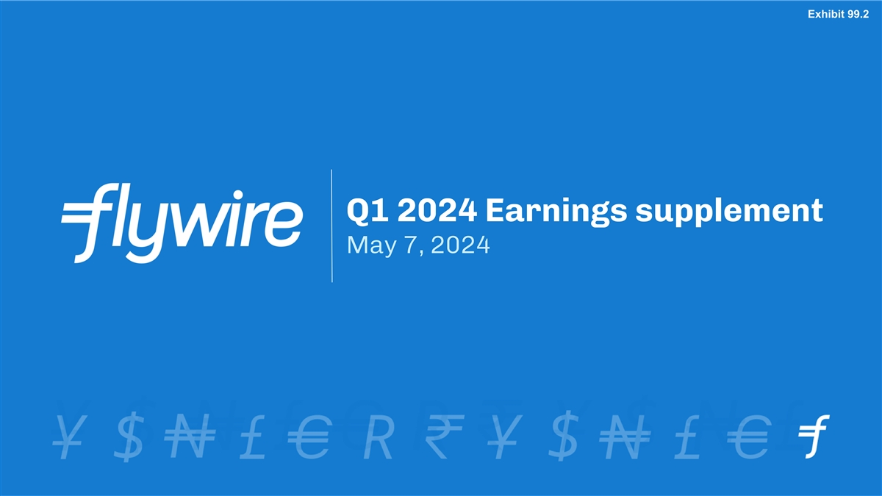
Exhibit 99.2 Q1 2024 Earnings supplement May 7, 2024

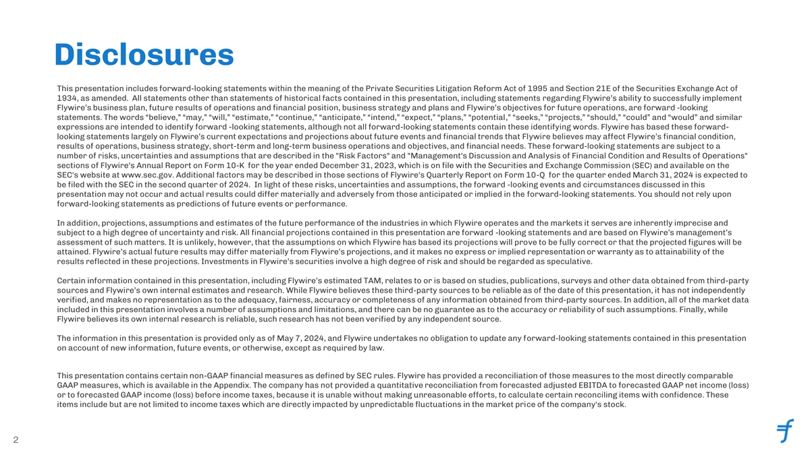
Disclosures This presentation includes forward-looking statements within the meaning of the Private Securities Litigation Reform Act of 1995 and Section 21E of the Securities Exchange Act of 1934, as amended. All statements other than statements of historical facts contained in this presentation, including statements regarding Flywire’s ability to successfully implement Flywire’s business plan, future results of operations and financial position, business strategy and plans and Flywire’s objectives for future operations, are forward -looking statements. The words “believe,” “may,” “will,” “estimate,” “continue,” “anticipate,” “intend,” “expect,” “plans,” “potential,” “seeks,” “projects,” “should,” “could” and “would” and similar expressions are intended to identify forward -looking statements, although not all forward-looking statements contain these identifying words. Flywire has based these forward- looking statements largely on Flywire’s current expectations and projections about future events and financial trends that Flywire believes may affect Flywire’s financial condition, results of operations, business strategy, short-term and long-term business operations and objectives, and financial needs. These forward-looking statements are subject to a number of risks, uncertainties and assumptions that are described in the Risk Factors and Management's Discussion and Analysis of Financial Condition and Results of Operations sections of Flywire's Annual Report on Form 10-K for the year ended December 31, 2023, which is on file with the Securities and Exchange Commission (SEC) and available on the SEC's website at www.sec.gov. Additional factors may be described in those sections of Flywire's Quarterly Report on Form 10-Q for the quarter ended March 31, 2024 is expected to be filed with the SEC in the second quarter of 2024. In light of these risks, uncertainties and assumptions, the forward -looking events and circumstances discussed in this presentation may not occur and actual results could differ materially and adversely from those anticipated or implied in the forward-looking statements. You should not rely upon forward-looking statements as predictions of future events or performance. In addition, projections, assumptions and estimates of the future performance of the industries in which Flywire operates and the markets it serves are inherently imprecise and subject to a high degree of uncertainty and risk. All financial projections contained in this presentation are forward -looking statements and are based on Flywire’s management’s assessment of such matters. It is unlikely, however, that the assumptions on which Flywire has based its projections will prove to be fully correct or that the projected figures will be attained. Flywire’s actual future results may differ materially from Flywire’s projections, and it makes no express or implied representation or warranty as to attainability of the results reflected in these projections. Investments in Flywire’s securities involve a high degree of risk and should be regarded as speculative. Certain information contained in this presentation, including Flywire’s estimated TAM, relates to or is based on studies, publications, surveys and other data obtained from third-party sources and Flywire’s own internal estimates and research. While Flywire believes these third-party sources to be reliable as of the date of this presentation, it has not independently verified, and makes no representation as to the adequacy, fairness, accuracy or completeness of any information obtained from third-party sources. In addition, all of the market data included in this presentation involves a number of assumptions and limitations, and there can be no guarantee as to the accuracy or reliability of such assumptions. Finally, while Flywire believes its own internal research is reliable, such research has not been verified by any independent source. The information in this presentation is provided only as of May 7, 2024, and Flywire undertakes no obligation to update any forward-looking statements contained in this presentation on account of new information, future events, or otherwise, except as required by law. This presentation contains certain non-GAAP financial measures as defined by SEC rules. Flywire has provided a reconciliation of those measures to the most directly comparable GAAP measures, which is available in the Appendix. The company has not provided a quantitative reconciliation from forecasted adjusted EBITDA to forecasted GAAP net income (loss) or to forecasted GAAP income (loss) before income taxes, because it is unable without making unreasonable efforts, to calculate certain reconciling items with confidence. These items include but are not limited to income taxes which are directly impacted by unpredictable fluctuations in the market price of the company's stock. 2


Execution Fulfillment Our mission is to deliver the most important and complex payments 3


Q1 2024 performance

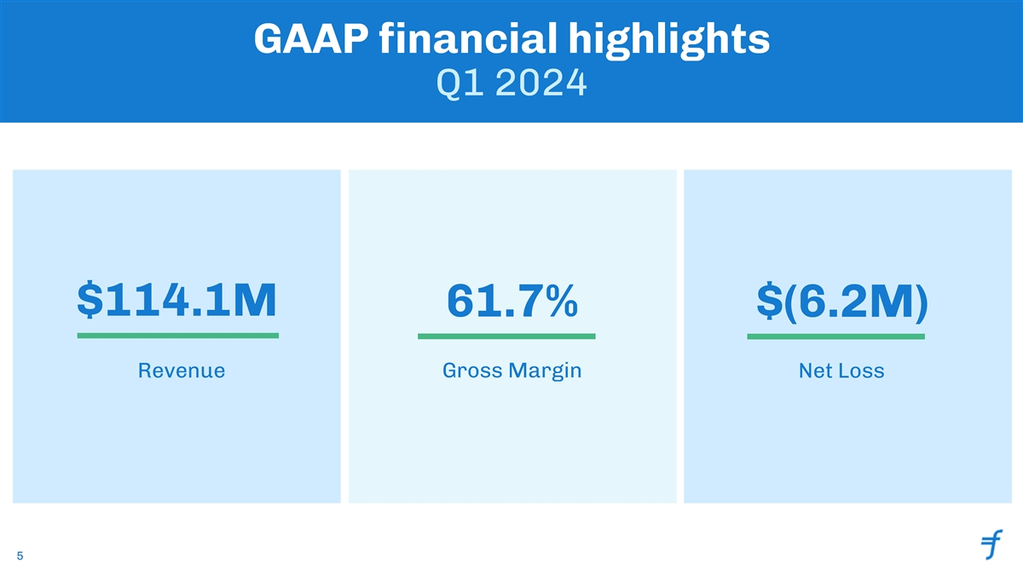
GAAP financial highlights Q1 2024 $114.1M 61.7% $(6.2M) Revenue Gross Margin Net Loss 5

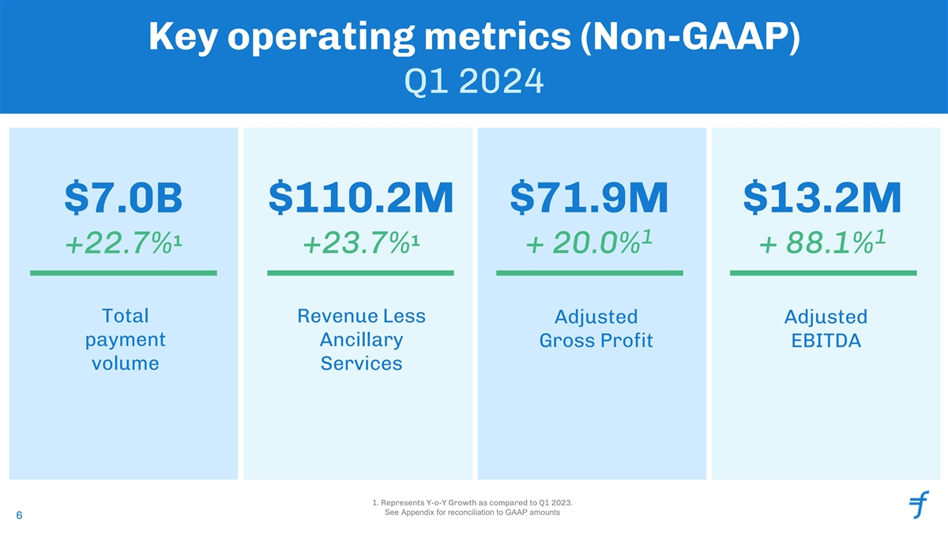
Key operating metrics (Non-GAAP) Q1 2024 $7.0B $110.2M $71.9M $13.2M 1 1 1 1 +22.7% +23.7% + 20.0% + 88.1% Total Revenue Less Adjusted Adjusted payment Ancillary Gross Profit EBITDA volume Services 1. Represents Y-o-Y Growth as compared to Q1 2023. See Appendix for reconciliation to GAAP amounts 6

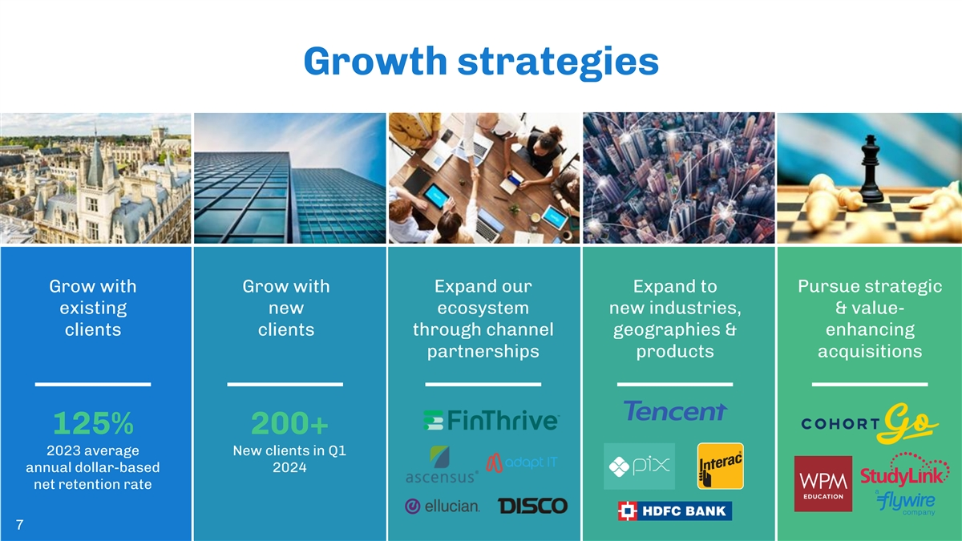
Growth strategies Grow with Grow with Expand our Expand to Pursue strategic existing new ecosystem new industries, & value- clients clients through channel geographies & enhancing partnerships products acquisitions 125% 200+ 2023 average New clients in Q1 annual dollar-based 2024 net retention rate 7


Healthcare spotlight

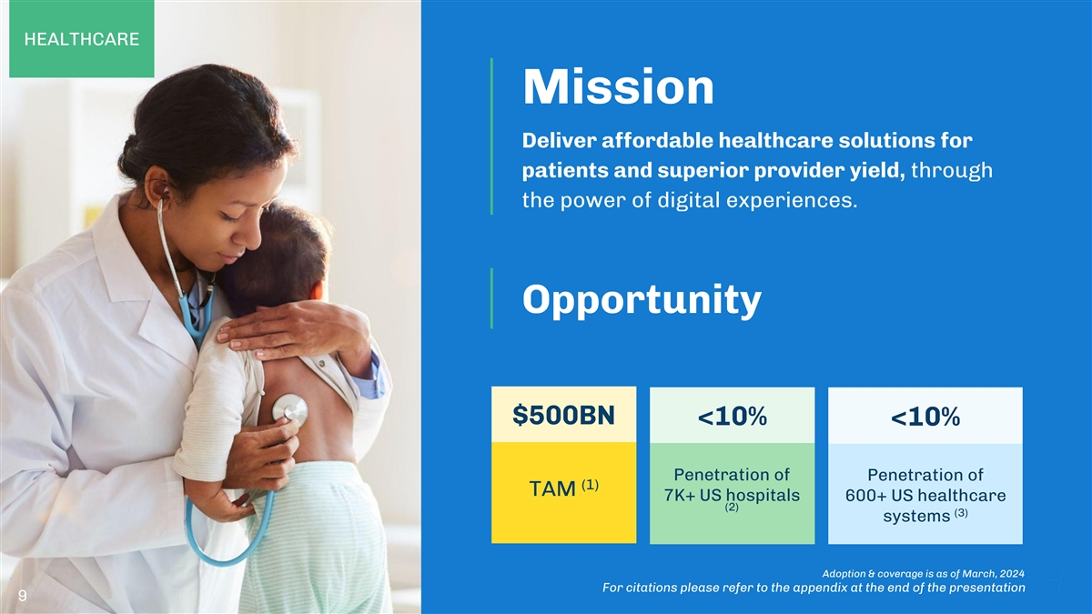
HEALTHCARE Mission Deliver affordable healthcare solutions for patients and superior provider yield, through the power of digital experiences. Opportunity $500BN <10% <10% Penetration of Penetration of (1) TAM 7K+ US hospitals 600+ US healthcare (2) (3) systems Adoption & coverage is as of March, 2024 For citations please refer to the appendix at the end of the presentation 9

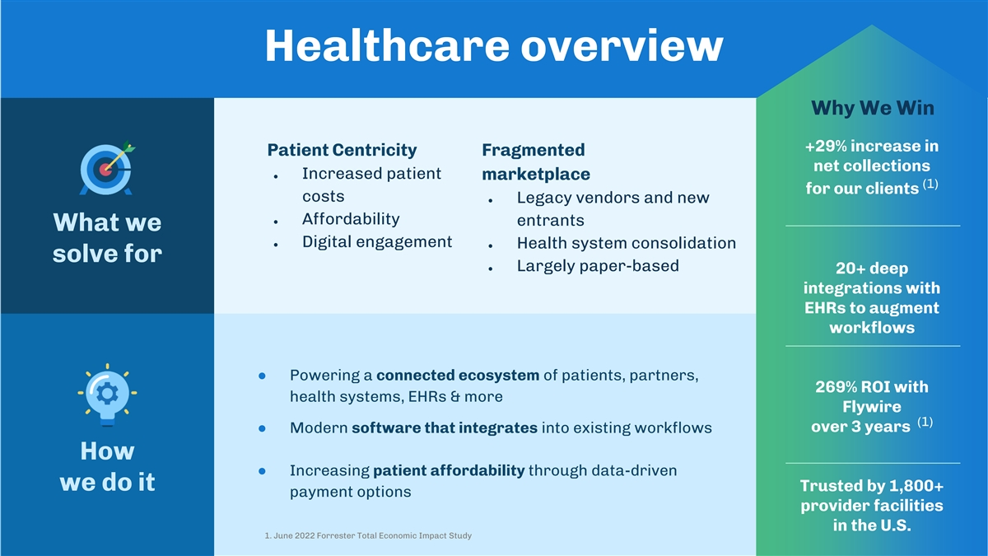
Healthcare overview What we solve Why We Win +29% increase in Patient Centricity Fragmented net collections ● Increased patient marketplace (1) for our clients costs ● Legacy vendors and new ● Affordability entrants What we ● Digital engagement ● Health system consolidation solve for ● Largely paper-based 20+ deep integrations with EHRs to augment workflows ● Powering a connected ecosystem of patients, partners, 269% ROI with health systems, EHRs & more Flywire (1) over 3 years ● Modern software that integrates into existing workflows How ● Increasing patient affordability through data-driven we do it Trusted by 1,800+ payment options provider facilities in the U.S. 1. June 2022 Forrester Total Economic Impact Study

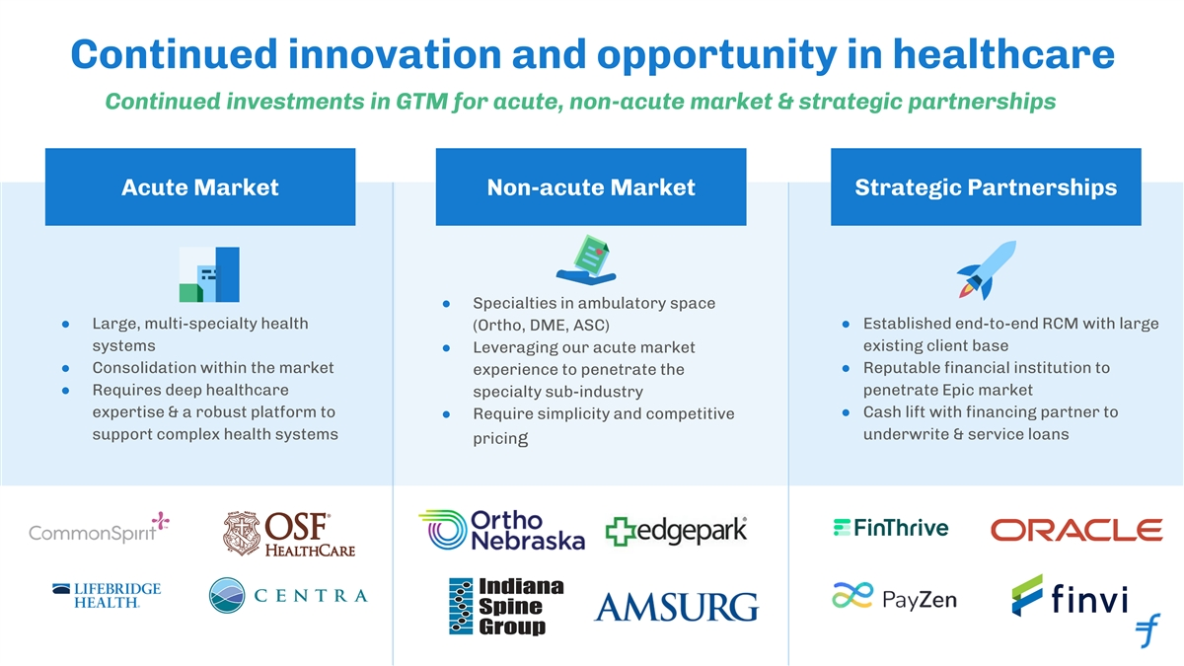
Continued innovation and opportunity in healthcare Continued investments in GTM for acute, non-acute market & strategic partnerships Acute Market Non-acute Market Strategic Partnerships ● Specialties in ambulatory space ● Large, multi-specialty health ● Established end-to-end RCM with large (Ortho, DME, ASC) systems existing client base ● Leveraging our acute market ● Consolidation within the market● Reputable financial institution to experience to penetrate the ● Requires deep healthcare penetrate Epic market specialty sub-industry expertise & a robust platform to ● Cash lift with financing partner to ● Require simplicity and competitive support complex health systems underwrite & service loans pricing

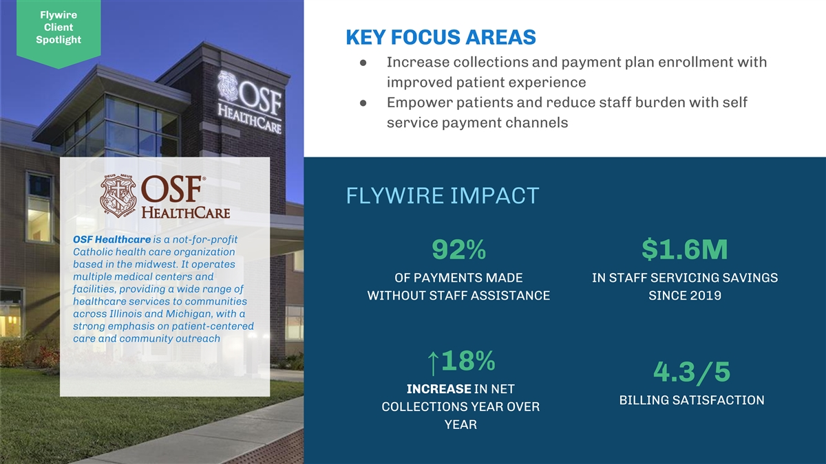
Flywire Client Spotlight KEY FOCUS AREAS ● Increase collections and payment plan enrollment with improved patient experience ● Empower patients and reduce staff burden with self service payment channels FLYWIRE IMPACT OSF Healthcare is a not-for-profit Catholic health care organization 92% $1.6M based in the midwest. It operates multiple medical centers and OF PAYMENTS MADE IN STAFF SERVICING SAVINGS facilities, providing a wide range of WITHOUT STAFF ASSISTANCE SINCE 2019 healthcare services to communities across Illinois and Michigan, with a strong emphasis on patient-centered care and community outreach ↑18% 4.3/5 INCREASE IN NET BILLING SATISFACTION COLLECTIONS YEAR OVER YEAR

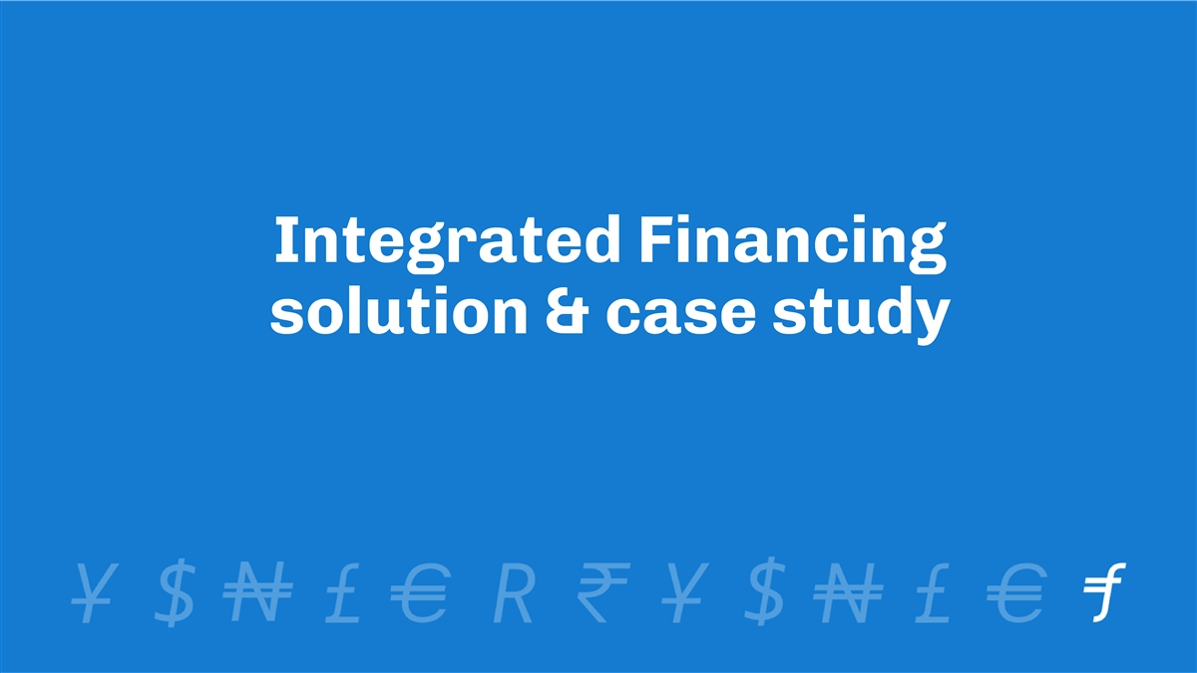
Integrated Financing solution & case study


Integrated Financing Flywire has partnered with a third party to extend affordability options through a non-recourse patient financing model ● Patient tailored payment options with zero interest and no surprise fees ● Analytics identifies options for how we can engage the patient ● Risk modelling analytics used to balance cost to hospital with increased collections ● Patient engagement and payment experience stays the same ● Servicing all financed accounts via integrated workflows through a third-party that is providing financing to these patients ● Reconciliation managed daily directly by Flywire

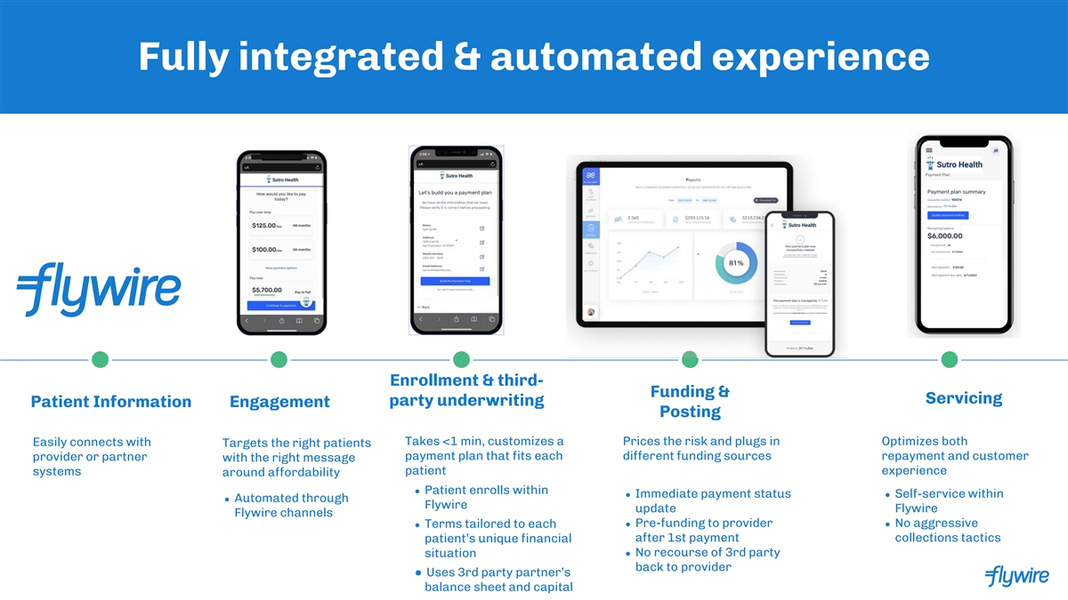
Fully integrated & automated experience Enrollment & third- Funding & Servicing party underwriting Patient Information Engagement Posting Takes <1 min, customizes a Prices the risk and plugs in Optimizes both Easily connects with Targets the right patients payment plan that fits each different funding sources repayment and customer provider or partner with the right message patient experience systems around affordability ● Patient enrolls within ● Immediate payment status ● Self-service within ● Automated through Flywire update Flywire Flywire channels ● Pre-funding to provider ● No aggressive ● Terms tailored to each patient’s unique financial after 1st payment collections tactics ● No recourse of 3rd party situation back to provider ● Uses 3rd party partner’s balance sheet and capital

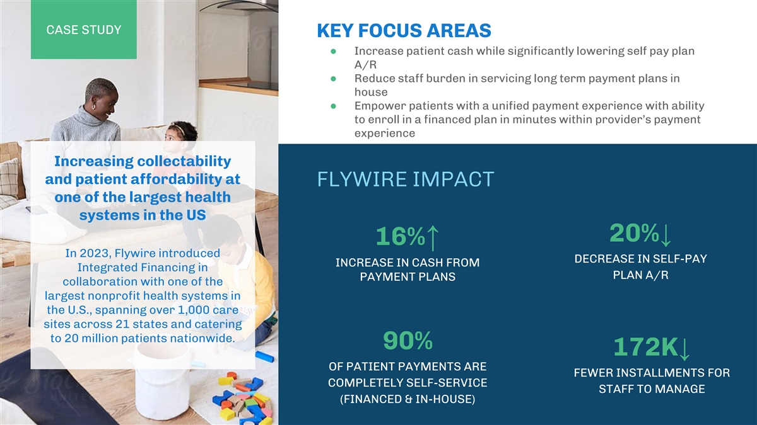
CASE STUDY KEY FOCUS AREAS ● Increase patient cash while significantly lowering self pay plan A/R ● Reduce staff burden in servicing long term payment plans in house ● Empower patients with a unified payment experience with ability to enroll in a financed plan in minutes within provider’s payment experience Increasing collectability and patient affordability at FLYWIRE IMPACT one of the largest health systems in the US 20%↓ 16%↑ In 2023, Flywire introduced DECREASE IN SELF-PAY INCREASE IN CASH FROM Integrated Financing in PLAN A/R PAYMENT PLANS collaboration with one of the largest nonprofit health systems in the U.S., spanning over 1,000 care sites across 21 states and catering to 20 million patients nationwide. 90% 172K↓ OF PATIENT PAYMENTS ARE FEWER INSTALLMENTS FOR COMPLETELY SELF-SERVICE STAFF TO MANAGE (FINANCED & IN-HOUSE)


Financial outlook

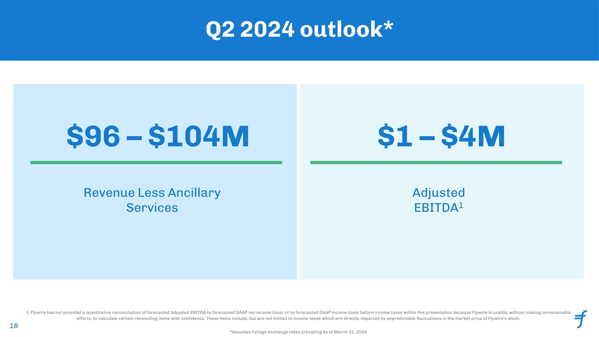
Q2 2024 outlook* $96 – $104M $1 – $4M Revenue Less Ancillary Adjusted 1 Services EBITDA 1. Flywire has not provided a quantitative reconciliation of forecasted Adjusted EBITDA to forecasted GAAP net income (loss) or to forecasted GAAP income (loss) before income taxes within this presentation because Flywire is unable, without making unreasonable efforts, to calculate certain reconciling items with confidence. These items include, but are not limited to income taxes which are directly impacted by unpredictable fluctuations in the market price of Flywire's stock. 18 18 *Assumes foreign exchange rates prevailing as of March 31, 2024

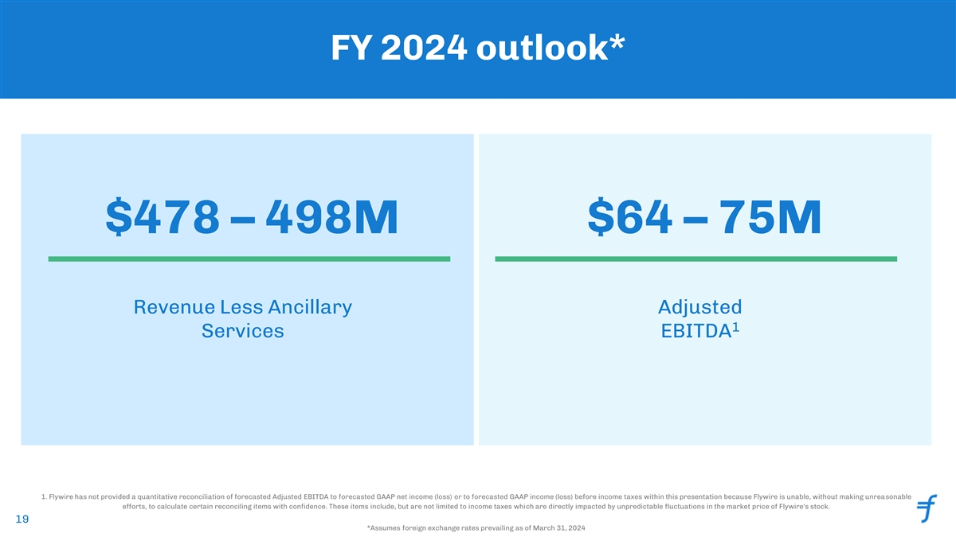
FY 2024 outlook* $478 – 498M $64 – 75M Revenue Less Ancillary Adjusted 1 Services EBITDA 1. Flywire has not provided a quantitative reconciliation of forecasted Adjusted EBITDA to forecasted GAAP net income (loss) or to forecasted GAAP income (loss) before income taxes within this presentation because Flywire is unable, without making unreasonable efforts, to calculate certain reconciling items with confidence. These items include, but are not limited to income taxes which are directly impacted by unpredictable fluctuations in the market price of Flywire's stock. 19 19 *Assumes foreign exchange rates prevailing as of March 31, 2024

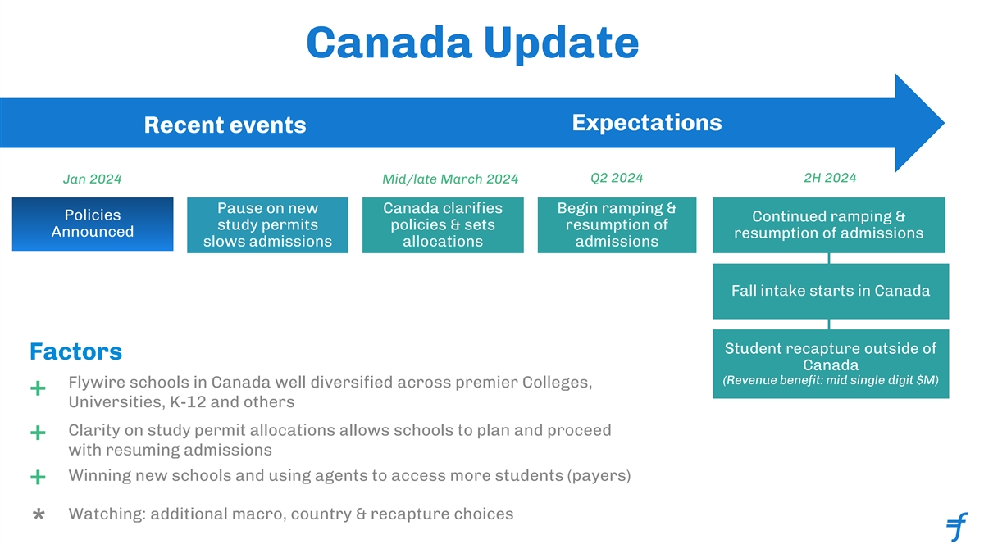
Canada Update Expectations Recent events Q2 2024 2H 2024 Jan 2024 Mid/late March 2024 Pause on new Canada clarifies Begin ramping & Policies Continued ramping & study permits policies & sets resumption of Announced resumption of admissions slows admissions allocations admissions Fall intake starts in Canada Inaugural ESG report Student recapture outside of Factors Canada (Revenue benefit: mid single digit $M) Flywire schools in Canada well diversified across premier Colleges, + Universities, K-12 and others Clarity on study permit allocations allows schools to plan and proceed + with resuming admissions Winning new schools and using agents to access more students (payers) + Watching: additional macro, country & recapture choices *


Appendix

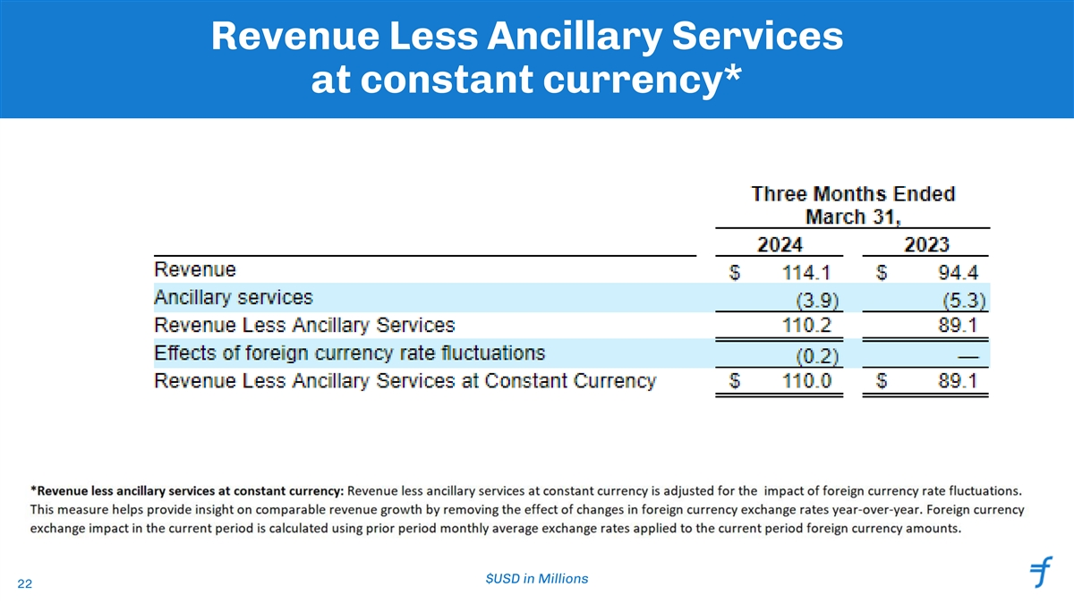
Revenue Less Ancillary Services at constant currency* $USD in Millions 22

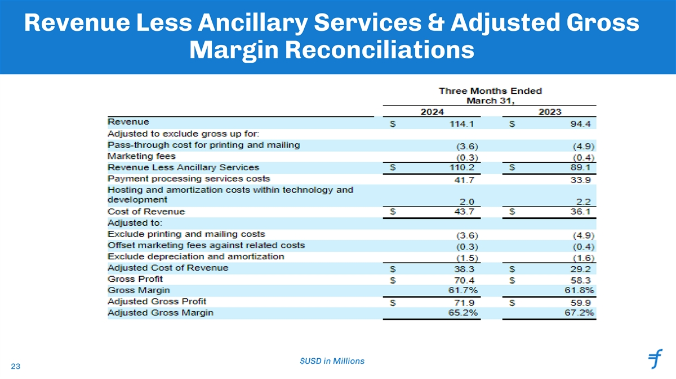
Revenue Less Ancillary Services & Adjusted Gross Margin Reconciliations $USD in Millions 23

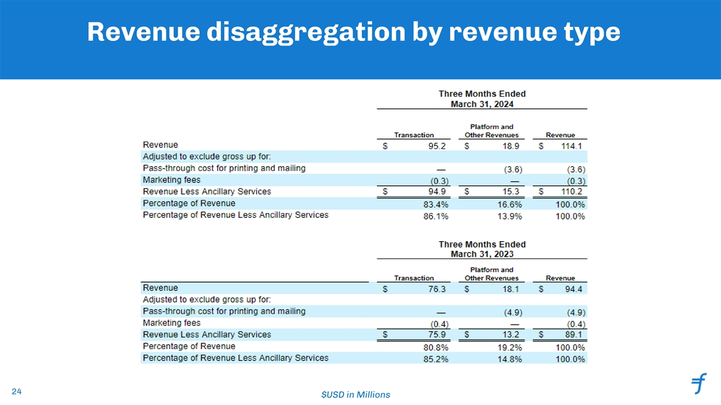
Revenue disaggregation by revenue type 24 $USD in Millions

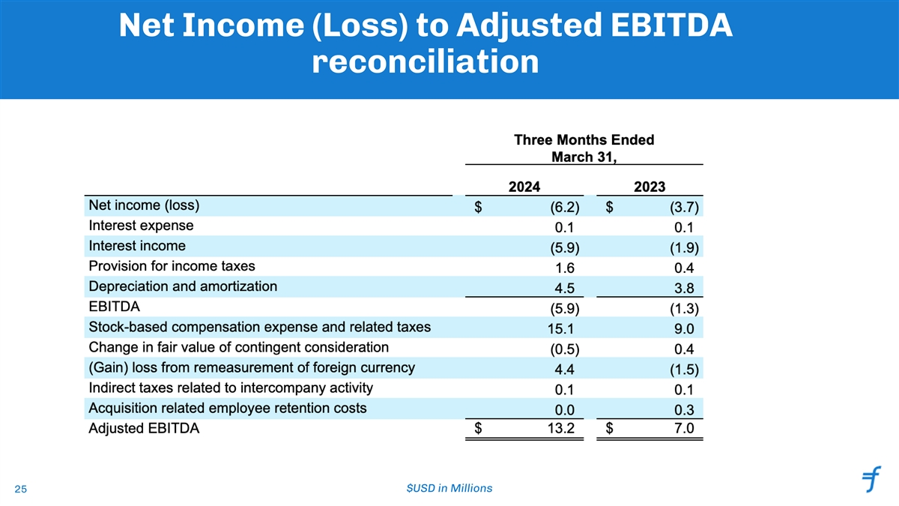
Net Income (Loss) to Adjusted EBITDA reconciliation $USD in Millions 25

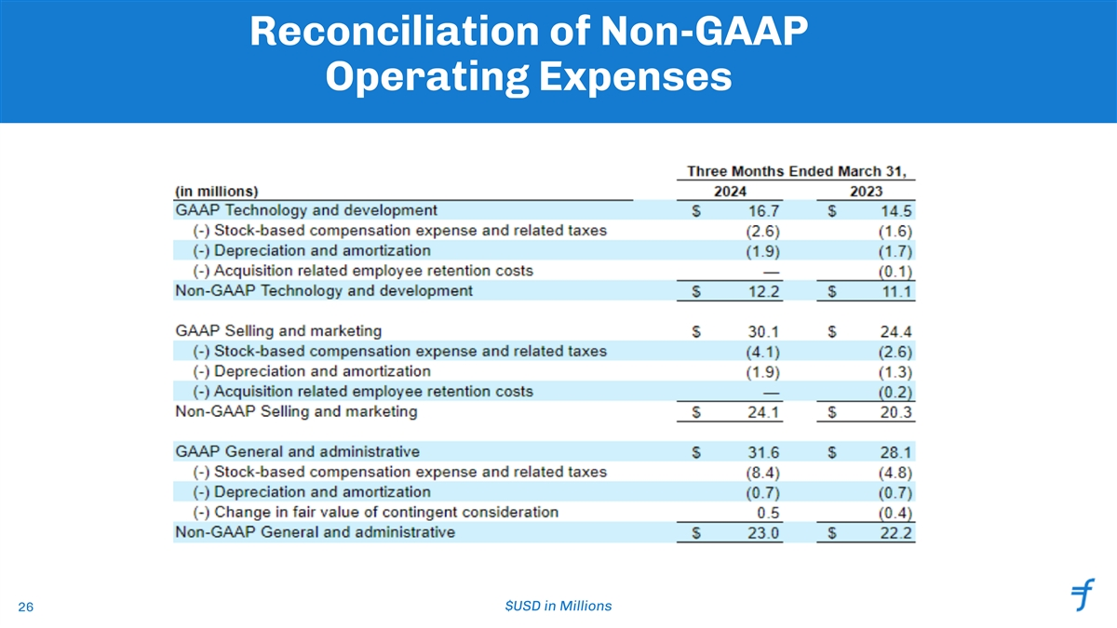
Reconciliation of Non-GAAP Operating Expenses $USD in Millions 26

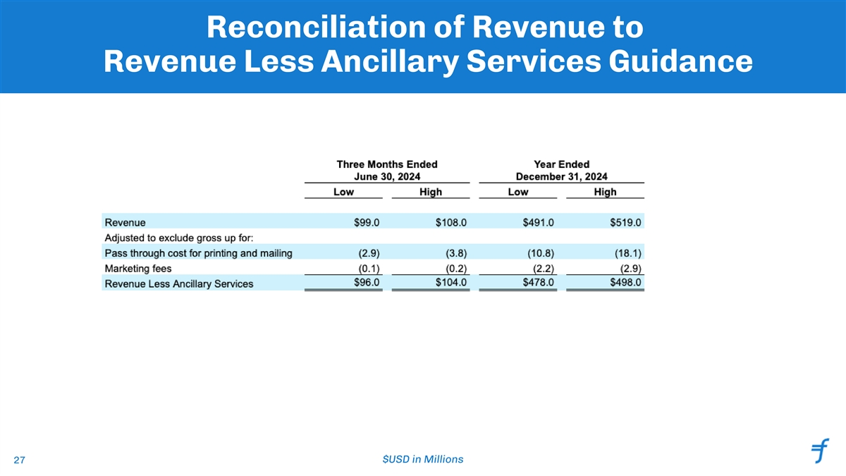
Reconciliation of Revenue to Revenue Less Ancillary Services Guidance $USD in Millions 27

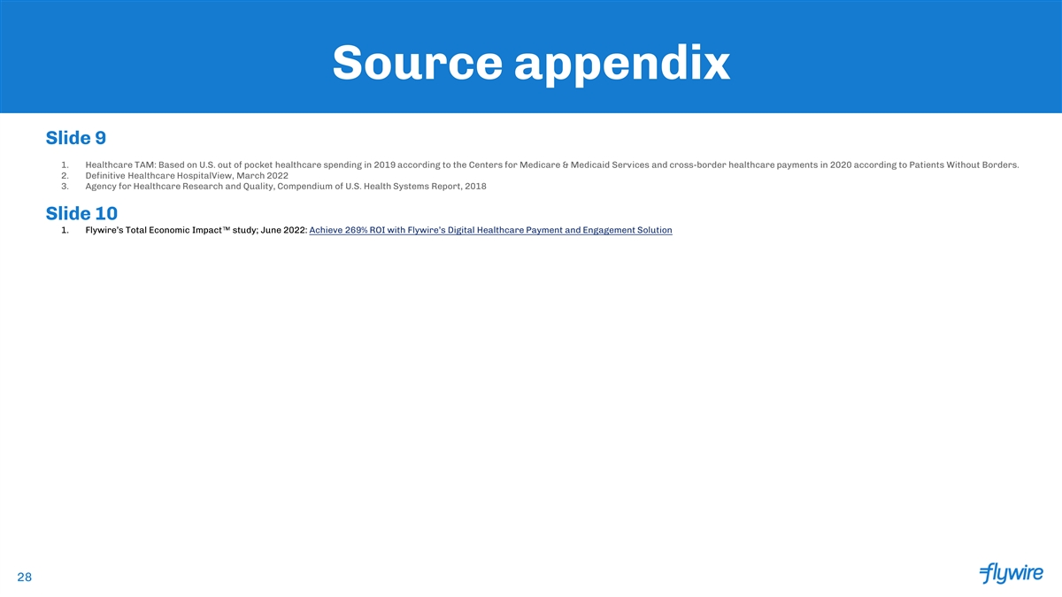
Source appendix Slide 9 1. Healthcare TAM: Based on U.S. out of pocket healthcare spending in 2019 according to the Centers for Medicare & Medicaid Services and cross-border healthcare payments in 2020 according to Patients Without Borders. 2. Definitive Healthcare HospitalView, March 2022 3. Agency for Healthcare Research and Quality, Compendium of U.S. Health Systems Report, 2018 Slide 10 1. Flywire’s Total Economic Impact study; June 2022: Achieve 269% ROI with Flywire’s Digital Healthcare Payment and Engagement Solution 28

