UNITED STATES
SECURITIES AND EXCHANGE COMMISSION
Washington, D.C. 20549

SCHEDULE 14A INFORMATION
Proxy Statement Pursuant to Section 14(a) of the
Securities Exchange Act of 1934
(Amendment No.)

Filed by the Registrant ☒
Filed by a party other than the Registrant ☐
Check the appropriate box:

☐ | Preliminary Proxy Statement

☐ | Confidential, for Use of the Commission Only (as permitted by Rule 14a-6(e)(2))

☐ | Definitive Proxy Statement

☒ | Definitive Additional Materials

☐ | Soliciting Material under Rule 14a-12
FLYWIRE CORPORATION
(Name of Registrant as Specified in its Charter)
(Name of Person(s) Filing Proxy Statement, if Other Than the Registrant)
Payment of Filing Fee (Check the appropriate box):

☒ | No fee required.

☐ | Fee paid previously with preliminary materials.

☐ | Fee computed on table in exhibit required by Item 25(b) per Exchange Act Rules 14a-6(i)(1) and 0-11.

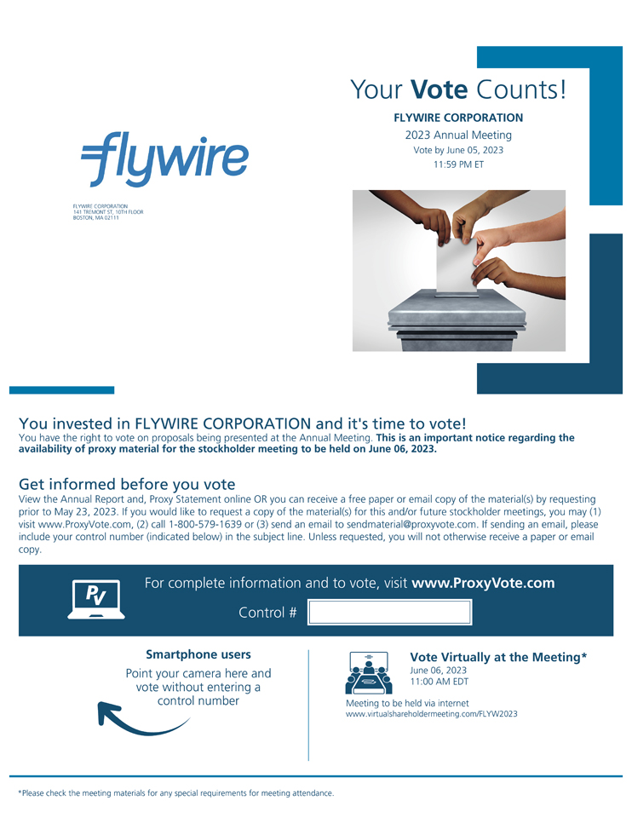
FLYWIRE CORPORATION 141 TREMONT ST, 10TH FLOOR BOSTON, MA 02111 Your Vote Counts! FLYWIRE CORPORATION 2023 Annual Meeting Vote by June 05, 2023 11 :59 PM ET You invested in FLYWIRE CORPORATION and its time to vote! You have the right to vote on proposals being presented at the Annual Meeting. This is an important notice regarding the availability of proxy material for the stockholder meeting to be held on June 06, 2023. Get informed before you vote View the Annual Report and, Proxy Statement online OR you can receive a free paper or email copy of the material(s) by requesting prior to May 23, 2023. If you would like to request a copy of the material(s) for this and/or future stockholder meetings, you may (1) visit www.ProxyVote.com, (2) call 1-800-579-1639 or (3) send an email to sendmaterial@proxyvote.com. If sending an email, please include your control number (indicated below) in the subject line. Unless requested, you will not otherwise receive a paper or email copy. Smartphone users Point your camera here and vote without entering a control number Vote Virtually at the Meeting* June 06, 2023 11:00 AM EDT Meeting to be held via internet www.virtualshareholdermeeting.com/FLYW2023 *Please check the meeting materials for any special requirements for meeting attendance.

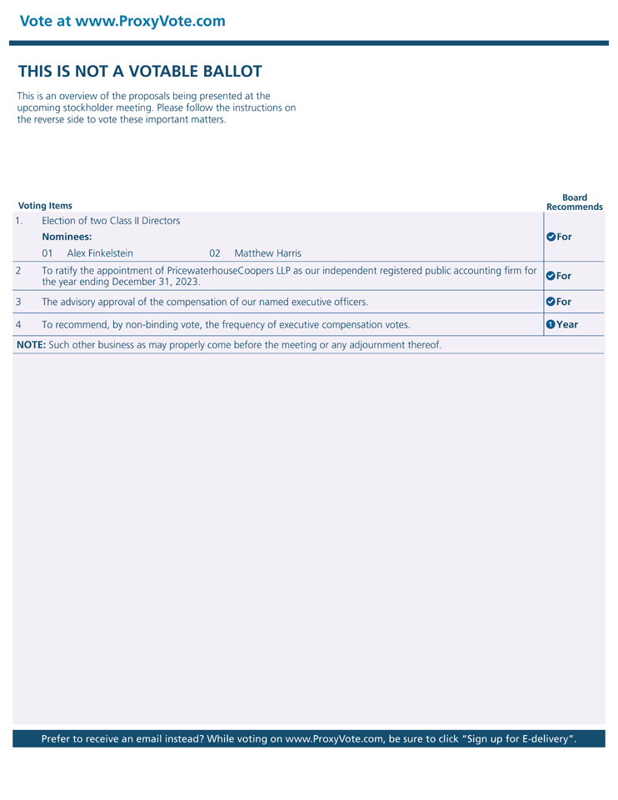
Vote at www.ProxyVote.com THIS IS NOT A VOTABLE BALLOT This is an overview of the proposals being presented at the upcoming stockholder meeting. Please follow the instructions on the reverse side to vote these important matters. Board Voting Items Recommends 1. Election of two Class II Directors Nominees: For 01 Alex Finkelstein 02 Matthew Harris 2 To ratify the appointment of PricewaterhouseCoopers LLP as our independent registered public accounting firm for the year ending December 31, 2023. 3 The advisory approval of the compensation of our named executive officers. For 4 To recommend, by non-binding vote, the frequency of executive compensation votes. Year NOTE: Such other business as may properly come before the meeting or any adjournment thereof. Prefer to receive an email instead? While voting on www.ProxyVote.com, be sure to click Sign up for E-delivery.

