UNITED STATES
SECURITIES AND EXCHANGE COMMISSION
Washington, D.C. 20549

FORM 8-K

CURRENT REPORT
Pursuant to Section 13 or 15(d)
of the Securities Exchange Act of 1934
Date of Report (Date of earliest event reported): November 7, 2023

FLYWIRE CORPORATION
(Exact name of Registrant as specified in its charter)

Delaware |  | 001-40430 |  | 27-0690799
(State or other jurisdiction  of incorporation) |  | (Commission  File No.) |  | (IRS Employer  Identification No.)

141 Tremont St #10
Boston, MA 02111
(Address of principal executive offices and zip code)
Registrant’s telephone number, including area code: (617) 329-4524
Not Applicable
(Former Name or Former Address, if Changed Since Last Report)

Check the appropriate box below if the Form 8-K filing is intended to simultaneously satisfy the filing obligation of the registrant under any of the following provisions:

☐ | Written communications pursuant to Rule 425 under the Securities Act (17 CFR 230.425)

☐ | Soliciting material pursuant to Rule 14a-12 under the Exchange Act (17 CFR 240.14a-12)

☐ | Pre-commencement communications pursuant to Rule 14d-2(b) under the Exchange Act (17 CFR 240.14d-2(b))

☐ | Pre-commencement communications pursuant to Rule 13e-4(c) under the Exchange Act (17 CFR 240.13e-4(c))
Securities registered pursuant to Section 12(b) of the Act:

Title of each class |  | Trading  Symbol(s) |  | Name of each exchange  on which registered
Voting Common Stock, $0.0001 par value per share |  | FLYW |  | The Nasdaq Stock Market LLC  (Nasdaq Global Select Market)
Indicate by check mark whether the registrant is an emerging growth company as defined in Rule 405 of the Securities Act of 1933 (§230.405 of this chapter) or Rule 12b-2 of the Securities Exchange Act of 1934 (§240.12b-2 of this chapter).
Emerging growth company ☐
If an emerging growth company, indicate by check mark if the registrant has elected not to use the extended transition period for complying with any new or revised financial accounting standards provided pursuant to Section 13(a) of the Exchange Act. ☐

Item 2.02. | Results of Operations and Financial Condition.
On November 7, 2023, Flywire Corporation (“Flywire” or the “Company”) issued a press release (the “Press Release”) and is holding a conference call regarding its preliminary and unaudited financial results for the quarter ended September 30, 2023. The Press Release is furnished as Exhibit 99.1 to this Current Report on Form 8-K and is incorporated by reference herein.
Various statements to be made during the conference call are “forward-looking statements” within the meaning of the Private Securities Litigation Reform Act of 1995, including, but not limited to, statements regarding Flywire’s future operating results and financial position, Flywire’s business strategy and plans, market growth, and Flywire’s objectives for future operations. Flywire intends such forward-looking statements to be covered by the safe harbor provisions for forward-looking statements contained in Section 21E of the Securities Exchange Act of 1934 and the Private Securities Litigation Reform Act of 1995. In some cases, you can identify forward-looking statements by terms such as, but not limited to, “believe,” “may,” “will,” “potentially,” “estimate,” “continue,” “anticipate,” “intend,” “could,” “would,” “project,” “target,” “plan,” “expect,” or the negative of these terms, and similar expressions intended to identify forward-looking statements. Such forward-looking statements are based upon current expectations that involve risks, changes in circumstances, assumptions, and uncertainties. Important factors that could cause actual results to differ materially from those reflected in Flywire’s forward-looking statements include, among others, Flywire’s future financial performance, including its expectations regarding Revenue, Revenue Less Ancillary Services and Adjusted EBITDA and foreign exchange rates. Risks that may cause actual results to differ materially from these forward looking statements include, but are not limited to: Flywire’s ability to execute its business plan and effectively manage its growth; Flywire’s cross-border expansion plans and ability to expand internationally; anticipated trends, growth rates, and challenges in Flywire’s business and in the markets in which Flywire operates; the sufficiency of Flywire’s cash and cash equivalents to meet its liquidity needs; political, economic, foreign currency exchange rate, inflation, legal, social and health risks, that may affect Flywire’s business or the global economy; Flywire’s beliefs and objectives for future operations; Flywire’s ability to develop and protect its brand; Flywire’s ability to maintain and grow the payment volume that it processes; Flywire’s ability to further attract, retain, and expand its client base; Flywire’s ability to develop new solutions and services and bring them to market in a timely manner; Flywire’s expectations concerning relationships with third parties, including financial institutions and strategic partners; the effects of increased competition in Flywire’s markets and its ability to compete effectively; future acquisitions or investments in complementary companies, products, services, or technologies; Flywire’s ability to enter new client verticals, including its relatively new business-to-business sector; Flywire’s expectations regarding anticipated technology needs and developments and its ability to address those needs and developments with its solutions; Flywire’s expectations regarding litigation and legal and regulatory matters; Flywire’s expectations regarding its ability to meet existing performance obligations and maintain the operability of its solutions; Flywire’s expectations regarding the effects of existing and developing laws and regulations, including with respect to payments and financial services, taxation, privacy and data protection; economic and industry trends, projected growth, or trend analysis; Flywire’s ability to adapt to changes in U.S. federal income or other tax laws or the interpretation of tax laws, including the recently enacted Inflation Reduction Act of 2022; Flywire’s ability to attract and retain qualified employees; Flywire’s ability to maintain, protect, and enhance its intellectual property; Flywire’s ability to maintain the security and availability of its solutions; the increased expenses associated with being a public company; the future market price of Flywire’s common stock; and other factors that are described in the “Risk Factors” and “Management’s Discussion and Analysis of Financial Condition and Results of Operations” sections of Flywire’s Annual Report on Form 10-K for the year ended December 31, 2022 and Quarterly Report on Form 10-Q for the quarter ended June 30, 2023, which are on file with the Securities and Exchange Commission (SEC) and available on the SEC’s website at https://www.sec.gov/. Additional factors may be described in those sections of Flywire’s Quarterly Report on Form 10-Q for the quarter ended September 30, 2023, expected to be filed with the SEC in the fourth quarter of 2023. The information conveyed on the conference call is provided only as of the date of the conference call, and Flywire undertakes no obligation to update any forward-looking statements presented on the conference call on account of new information, future events, or otherwise, except as required by law.

Item 7.01. | Regulation FD Disclosure.
On November 7, 2023, the Company provided an investor presentation that will be made available on the investor relations section of the Company’s website at https://ir.flywire.com/. The investor presentation is furnished as Exhibit 99.2 to this Current Report on Form 8-K and is incorporated by reference herein.
The information in this Item 7.01 of this Current Report on Form 8-K shall not be deemed “filed” for purposes of Section 18 of the Securities Exchange Act of 1934, as amended (the “Exchange Act”), or otherwise subject to the liabilities of that Section, or incorporated by reference in any filing under the Securities Act of 1933, as amended, or the Exchange Act, except as shall be expressly set forth by specific reference in any such filing.

Item 9.01. | Financial Statements and Exhibits.
(d) Exhibits

Exhibit  No. |  | Description
99.1 |  | Flywire Corporation Press Release dated November 7, 2023.
99.2 |  | Flywire Corporation Investor Presentation dated November 7, 2023.
104 |  | Cover Page Interactive Data File (embedded within the Inline XBRL document)

SIGNATURE
Pursuant to the requirements of the Securities Exchange Act of 1934, the registrant has duly caused this report to be signed on its behalf by the undersigned hereunto duly authorized.

FLYWIRE CORPORATION
By: |  | /s/ Michael Ellis
Name: |  | Michael Ellis
Title: |  | Chief Financial Officer
Dated November 7, 2023
Exhibit 99.1
Flywire Reports Third Quarter 2023 Financial Results
Third Quarter Revenue Increased 29.5% Year-over-Year
Third Quarter Revenue Less Ancillary Services Increased 31.4% Year-over-Year
Company Raises Full Year Outlook Before FX Impacts
Boston, MA  November 7, 2023: Flywire Corporation (Nasdaq: FLYW) (Flywire or the Company) a global payments enablement and software company, today reported financial results for its third quarter ended September 30, 2023.
We are pleased with our third quarter results, where we generated our highest quarter of revenue and adjusted EBITDA, ever, said Mike Massaro, CEO of Flywire. Our third quarter results were driven in part due to the ongoing optimization of our go-to-market strategy globally, where our sales and marketing teams continued to deliver new client wins and client expansions across all verticals. Our results were within our prior guidance range despite significant foreign exchange headwinds relative to when we previously provided our outlook.
Third Quarter 2023 Financial Highlights:
GAAP Results

 |  |  | Revenue increased 29.5% to $123.3 million in the third quarter of 2023, compared to $95.2 million in the third quarter of 2022.

 |  |  | Gross Profit increased to $78.4 million, resulting in Gross Margin of 63.6%, for the third quarter of 2023, compared to Gross Profit of $61.3 million and Gross Margin of 64.4% in the third quarter of 2022.

 |  |  | Net income was $10.6 million in the third quarter of 2023, compared to net (loss) of $(4.3) million in the third quarter of 2022.
Key Operating Metrics and Non-GAAP Results

 |  |  | Total Payment Volume increased 26% to $8.9 billion in the third quarter of 2023, compared to $7.0 billion in the third quarter of 2022.

 |  |  | Revenue Less Ancillary Services increased 31.4% to $116.8 million in the third quarter of 2023, compared to $88.9 million in the third quarter of 2022. Revenue Less Ancillary Services in the third quarter of 2023 was estimated to be unfavorably impacted by changes in foreign exchange rates between June 30, 2023 and September 30, 2023 by approximately $1.4 million.

 |  |  | Adjusted Gross Profit increased to $80.1 million, resulting in Adjusted Gross Margin of 68.6% in the third quarter of 2023, compared to Adjusted Gross Profit of $62.6 million and Adjusted Gross Margin of 70.4% in the third quarter of 2022. Third quarter 2022 Adjusted Gross Profit and Adjusted Gross Margin have been recast to align with the updated methodology as described in the Key Operating Metrics and Non-GAAP Financial Measures section below.

 |  |  | Adjusted EBITDA increased to $27.5 million in the third quarter of 2023, compared to $18.2 million in the third quarter of 2022.
Recent Business Highlights:

 |  |  | Acquired StudyLink to accelerate expansion in the Australian higher education market

 |  |  | Signed more than 185 new clients in the third quarter of 2023

 |  |  | Signed the highest number of net new clients in the travel vertical in the third quarter

 |  |  | Third quarter 2023 was the highest quarter of revenue and adjusted gross profit ever for the Company

 |  |  | Completed a follow-on offering of 8,500,000 shares of voting common stock. The Company raised $260.1 million after underwriter discounts and commissions and issuance costs

 |  |  | Appointed Gretchen Howard, a former Fidelity, Google and Robinhood executive who brings deep operating experience, to its Board of Directors
Fourth Quarter and Fiscal-Year 2023 Outlook:
We were very pleased with how we performed during the third quarter and believe that the 43% year-to-date growth rate in revenue less ancillary services reflects the strength of our business. As a result of this success, we are raising our Fiscal-Year outlook before FX impacts, said Mike Ellis, CFO of Flywire. Specifically, our updated outlook reflects the addition of $1.0 million attributable to the StudyLink acquisition and an additional $1.6 million in the fourth quarter related to underlying organic strength in our business. These factors are offset by an estimated $3.8 million in foreign exchange headwinds based on September 30, 2023 exchange compared to our prior guidance, of which $2.5 million was attributable to the fourth quarter of 2023.
Based on information available as of November 7, 2023, Flywire anticipates the following for the fourth quarter and fiscal-year 2023:

 |  | Fourth Quarter 2023*
Revenue |  | $91.5 to $96.5 million
Revenue Less Ancillary Services |  | $86.5 to $90.5 million
Adjusted EBITDA** |  | $1.0 to $4.0 million

 |  | Fiscal-Year 2023*
Revenue |  | $394.1 to $399.3 million
Revenue Less Ancillary Services |  | $372.0 to $376.0 million
Adjusted EBITDA** |  | $35.0 to $39.0 million

* | The Company has assumed foreign exchange rates prevailing as of September 30, 2023. For supplemental information regarding the estimated effects of changes in foreign exchange rates between June 30, 2023 and September 30, 2023 on the Companys updated outlook compared to prior outlook, see the section below entitled Supplemental Outlook Details.
** | Flywire has not provided a quantitative reconciliation of forecasted Adjusted EBITDA to forecasted GAAP net income (loss) or to forecasted GAAP income (loss) before income taxes within this earnings release because Flywire is unable, without making unreasonable efforts, to calculate certain reconciling items with confidence. These items include, but are not limited to income taxes which are directly impacted by unpredictable fluctuations in the market price of Flywires stock.
These statements are forward-looking and actual results may differ materially. Refer to the Safe Harbor Statement below for information on the factors that could cause Flywires actual results to differ materially from these forward-looking statements.
Conference Call
The Company will host a conference call to discuss third quarter 2023 financial results today at 5:00 pm ET. Hosting the call will be Mike Massaro, CEO, Rob Orgel, President and COO, and Mike Ellis, CFO. The conference call can be accessed live via webcast from the Companys investor relations website at https://ir.flywire.com/. A replay will be available on the investor relations website following the call.

Key Operating Metrics and Non-GAAP Financial Measures
Flywire uses non-GAAP financial measures to supplement financial information presented on a GAAP basis. The Company believes that excluding certain items from its GAAP results allows management to better understand its consolidated financial performance from period to period and better project its future consolidated financial performance as forecasts are developed at a level of detail different from that used to prepare GAAP-based financial measures. Moreover, Flywire believes these non-GAAP financial measures provide its stakeholders with useful information to help them evaluate the Companys operating results by facilitating an enhanced understanding of the Companys operating performance and enabling them to make more meaningful period to period comparisons. There are limitations to the use of the non-GAAP financial measures presented here. Flywires non-GAAP financial measures may not be comparable to similarly titled measures of other companies. Other companies, including companies in Flywires industry, may calculate non-GAAP financial measures differently, limiting the usefulness of those measures for comparative purposes.
Flywire uses supplemental measures of its performance which are derived from its consolidated financial information, but which are not presented in its consolidated financial statements prepared in accordance with GAAP. These non-GAAP financial measures include the following:

 |  |  | Revenue Less Ancillary Services. Revenue Less Ancillary Services represents the Companys consolidated revenue in accordance with GAAP after excluding (i) pass-through cost for printing and mailing services and (ii) marketing fees. The Company excludes these amounts to arrive at this supplemental non-GAAP financial measure as it views these services as ancillary to the primary services it provides to its clients.

 |  |  | Adjusted Gross Profit and Adjusted Gross Margin. Adjusted gross profit represents Revenue Less Ancillary Services less cost of revenue adjusted to (i) exclude pass-through cost for printing services, (ii) offset marketing fees against costs incurred and (iii) exclude depreciation and amortization, including accelerated amortization on the impairment of customer set-up costs tied to technology integration. Adjusted Gross Margin represents Adjusted Gross Profit divided by Revenue Less Ancillary Services. Management believes this presentation supplements the GAAP presentation of Gross Margin with a useful measure of the gross margin of the Companys payment-related services, which are the primary services it provides to its clients. Beginning with the quarter ended December 31, 2022, Flywire has excluded depreciation and amortization from the calculation of its adjusted Gross Profit, which it believes enhances the

understanding of the Companys operating performance and enables more meaningful period to period comparisons. The Companys previously reported Adjusted Gross Profit and Adjusted Gross Margin for the three months ended September 30, 2022 were recast to conform to the updated methodology and are reflected herein for comparison purposes.

 |  |  | Adjusted EBITDA. Adjusted EBITDA represents EBITDA further adjusted by excluding (i) stock-based compensation expense and related payroll taxes, (ii) the impact from the change in fair value measurement for contingent consideration associated with acquisitions,(iii) interest income, (iv) gain (loss) from the remeasurement of foreign currency, (v) indirect taxes related to intercompany activity, (vi) acquisition related transaction costs, if applicable, and (vii) employee retention costs, such as incentive compensation, associated with acquisition activities. Management believes that the exclusion of these amounts to calculate Adjusted EBITDA provides useful measures for period-to-period comparisons of the Companys business.

 |  |  | Revenue Less Ancillary Services at Constant Currency. Revenue Less Ancillary Services at Constant Currency represents Revenue Less Ancillary Services adjusted to show presentation on a constant currency basis. The constant currency information presented is calculated by translating current period results using prior period weighted average foreign currency exchange rates. Flywire analyzes Revenue Less Ancillary Services on a constant currency basis to provide a comparable framework for assessing how the business performed excluding the effect of foreign currency fluctuations.
These non-GAAP financial measures are not meant to be considered as indicators of performance in isolation from or as a substitute the Companys revenue, gross profit, gross margin or net income (loss) prepared in accordance with GAAP and should be read only in conjunction with financial information presented on a GAAP basis. Reconciliations of Revenue Less Ancillary Services, Revenue Less Ancillary Services at Constant Currency, Adjusted Gross Profit, Adjusted Gross Margin and Adjusted EBITDA to the most directly comparable GAAP financial measure are presented below. Flywire encourages you to review these reconciliations in conjunction with the presentation of the non-GAAP financial measures for each of the periods presented. In future fiscal periods, Flywire may exclude such items and may incur income and expenses similar to these excluded items. Flywire has not provided a quantitative reconciliation of forecasted Adjusted EBITDA to forecasted GAAP net income (loss) or to forecasted GAAP income (loss) before income taxes within this earnings release because it is unable, without making unreasonable efforts, to calculate certain reconciling items with confidence. These items include but are not limited to income taxes which are directly impacted by unpredictable fluctuations in the market price of Flywires stock.

About Flywire
Flywire is a global payments enablement and software company. Flywire combines its proprietary global payments network, next-gen payments platform and vertical-specific software to deliver the most important and complex payments for its clients and their customers.
Flywire leverages its vertical-specific software and payments technology to deeply embed within the existing A/R workflows for its clients across the education, healthcare and travel vertical markets, as well as in key B2B industries. Flywire also integrates with leading ERP systems, so organizations can optimize the payment experience for their customers while eliminating operational challenges.
Flywire supports more than 3,700 clients with diverse payment methods in more than 140 currencies across 240 countries and territories around the world. Flywire is headquartered in Boston, MA, USA with additional offices around the globe. For more information, visit www.flywire.com. Follow Flywire on Twitter, LinkedIn and Facebook.
Safe Harbor Statement
This release contains forward-looking statements within the meaning of the Private Securities Litigation Reform Act of 1995, including, but not limited to, statements regarding Flywires future operating results and financial position, Flywires business strategy and plans, market growth, and Flywires objectives for future operations. Flywire intends such forward-looking statements to be covered by the safe harbor provisions for forward-looking statements contained in Section 21E of the Securities Exchange Act of 1934 and the Private Securities Litigation Reform Act of 1995. In some cases, you can identify forward-looking statements by terms such as, but not limited to, believe, may, will, potentially, estimate, continue, anticipate, intend, could, would, project, target, plan, expect, or the negative of these terms, and similar expressions intended to identify forward-looking statements. Such forward-looking statements are based upon current expectations that involve risks, changes in circumstances, assumptions, and uncertainties. Important factors that could cause actual results to differ materially from those reflected in Flywires forward-looking statements include, among others, Flywires future financial performance, including its expectations regarding Revenue, Revenue Less Ancillary Services, and Adjusted EBITDA and foreign exchange rates. Risks that may cause actual results to differ materially from these forward looking statements include, but are not limited to: Flywires ability to execute its business plan and effectively manage its growth;

Flywires cross-border expansion plans and ability to expand internationally; anticipated trends, growth rates, and challenges in Flywires business and in the markets in which Flywire operates; the sufficiency of Flywires cash and cash equivalents to meet its liquidity needs; political, economic, foreign currency exchange rate, inflation, legal, social and health risks, that may affect Flywires business or the global economy; Flywires beliefs and objectives for future operations; Flywires ability to develop and protect its brand; Flywires ability to maintain and grow the payment volume that it processes; Flywires ability to further attract, retain, and expand its client base; Flywires ability to develop new solutions and services and bring them to market in a timely manner; Flywires expectations concerning relationships with third parties, including financial institutions and strategic partners; the effects of increased competition in Flywires markets and its ability to compete effectively; recent and future acquisitions or investments in complementary companies, products, services, or technologies; Flywires ability to enter new client verticals, including its relatively new business-to-business sector; Flywires expectations regarding anticipated technology needs and developments and its ability to address those needs and developments with its solutions; Flywires expectations regarding litigation and legal and regulatory matters; Flywires expectations regarding its ability to meet existing performance obligations and maintain the operability of its solutions; Flywires expectations regarding the effects of existing and developing laws and regulations, including with respect to payments and financial services, taxation, privacy and data protection; economic and industry trends, projected growth, or trend analysis; Flywires ability to adapt to changes in U.S. federal income or other tax laws or the interpretation of tax laws, including the recently enacted Inflation Reduction Act of 2022; Flywires ability to attract and retain qualified employees; Flywires ability to maintain, protect, and enhance its intellectual property; Flywires ability to maintain the security and availability of its solutions; the increased expenses associated with being a public company; the future market price of Flywires common stock; and other factors that are described in the Risk Factors and Managements Discussion and Analysis of Financial Condition and Results of Operations sections of Flywires Annual Report on Form 10-K for the year ended December 31, 2022 and Quarterly Report on Form 10-Q for the quarter ended June 30, 2023, which are on file with the Securities and Exchange Commission (SEC) and available on the SECs website at https://www.sec.gov/. Additional factors may be described in those sections of Flywires Quarterly Report on Form 10-Q for the quarter ended September 30, 2023, expected to be filed with the SEC in the fourth quarter of 2023. The information in this release is provided only as of the date of this release, and Flywire undertakes no obligation to update any forward-looking statements contained in this release on account of new information, future events, or otherwise, except as required by law.

Contacts
Investor Relations:
Akil Hollis
ir@Flywire.com
Media:
Sarah King
Sarah.King@Flywire.com
Prosek Partners
pro-flywire@prosek.com

Condensed Consolidated Statements of Operations and Comprehensive Income (Loss)
(Unaudited) (Amounts in thousands, except share and per share amounts)

 |  | Three Months Ended September 30, |  |  |  |  |  |  |  | Nine Months Ended September 30,
 |  | 2023 |  |  |  | 2022 |  |  |  | 2023 |  |  |  | 2022
Revenue |  | $ | 123,323 |  |  | $ | 95,232 |  |  | $ | 302,549 |  |  | $ | 216,322
Costs and operating expenses:
Payment processing services costs |  |  | 42,900 |  |  |  | 32,275 |  |  |  | 110,559 |  |  |  | 78,348
Technology and development |  |  | 14,591 |  |  |  | 13,385 |  |  |  | 45,130 |  |  |  | 37,565
Selling and marketing |  |  | 27,084 |  |  |  | 21,674 |  |  |  | 78,791 |  |  |  | 58,169
General and administrative |  |  | 26,862 |  |  |  | 24,246 |  |  |  | 79,559 |  |  |  | 63,089
Total costs and operating expenses |  |  | 111,437 |  |  |  | 91,580 |  |  |  | 314,039 |  |  |  | 237,171
Income (loss) from operations |  | $ | 11,886 |  |  | $ | 3,652 |  |  | $ | (11,490 | ) |  | $ | (20,849 | )
Other income (expense):
Interest expense |  |  | (99 | ) |  |  | (400 | ) |  |  | (280 | ) |  |  | (884 | )
Interest income |  |  | 3,841 |  |  |  | 1,273 |  |  |  | 7,711 |  |  |  | 1,457
Loss from remeasurement of foreign currency |  |  | (4,233 | ) |  |  | (7,520 | ) |  |  | (3,518 | ) |  |  | (15,087 | )
Total other income (expense), net |  |  | (491 | ) |  |  | (6,647 | ) |  |  | 3,913 |  |  |  | (14,514 | )
Income (loss) before provision for income taxes |  |  | 11,395 |  |  |  | (2,995 | ) |  |  | (7,577 | ) |  |  | (35,363 | )
Provision for income taxes |  |  | 752 |  |  |  | 1,277 |  |  |  | 2,276 |  |  |  | 2,855
Net income (loss) |  | $ | 10,643 |  |  | $ | (4,272 | ) |  | $ | (9,853 | ) |  | $ | (38,218 | )
Foreign currency translation adjustment |  |  | (2,581 | ) |  |  | (273 | ) |  |  | (499 | ) |  |  | (408 | )
Comprehensive income (loss) |  | $ | 8,062 |  |  | $ | (4,545 | ) |  | $ | (10,352 | ) |  | $ | (38,626 | )
Net income (loss) attributable to common stockholders - basic and diluted |  | $ | 10,643 |  |  | $ | (4,272 | ) |  | $ | (9,853 | ) |  | $ | (38,218 | )
Net income (loss) per share attributable to common stockholders - basic |  | $ | 0.09 |  |  | $ | (0.04 | ) |  | $ | (0.09 | ) |  | $ | (0.36 | )
Net income (loss) per share attributable to common stockholders - diluted |  | $ | 0.08 |  |  | $ | (0.04 | ) |  | $ | (0.09 | ) |  | $ | (0.36 | )
Weighted average common shares outstanding - basic |  |  | 116,492,191 |  |  |  | 107,925,637 |  |  |  | 112,495,539 |  |  |  | 107,562,799
Weighted average common shares outstanding - diluted |  |  | 125,480,393 |  |  |  | 107,925,637 |  |  |  | 112,495,539 |  |  |  | 107,562,799

Condensed Consolidated Balance Sheets
(Unaudited) (Amounts in thousands, except share amounts)

 |  | September 30, |  |  |  | December 31,
 |  | 2023 |  |  |  | 2022
Assets
Current assets:
Cash and cash equivalents |  | $ | 638,205 |  |  | $ | 349,177
Restricted cash |  |  |  |  |  |  | 2,000
Accounts receivable, net |  |  | 18,151 |  |  |  | 13,697
Unbilled receivables, net |  |  | 6,779 |  |  |  | 5,268
Funds receivable from payment partners |  |  | 80,499 |  |  |  | 62,970
Prepaid expenses and other current assets |  |  | 18,793 |  |  |  | 17,531
Total current assets |  |  | 762,427 |  |  |  | 450,643
Property and equipment, net |  |  | 15,241 |  |  |  | 13,317
Intangible assets, net |  |  | 88,287 |  |  |  | 97,616
Goodwill |  |  | 97,173 |  |  |  | 97,766
Other assets |  |  | 19,288 |  |  |  | 14,945
Total assets |  | $ | 982,416 |  |  | $ | 674,287
Liabilities and Stockholders Equity
Current liabilities:
Accounts payable |  | $ | 17,574 |  |  | $ | 13,325
Funds payable to clients |  |  | 132,467 |  |  |  | 124,305
Accrued expenses and other current liabilities |  |  | 38,255 |  |  |  | 34,423
Deferred revenue |  |  | 3,812 |  |  |  | 5,223
Total current liabilities |  |  | 192,108 |  |  |  | 177,276
Deferred tax liabilities |  |  | 11,271 |  |  |  | 12,149
Other liabilities |  |  | 3,719 |  |  |  | 2,959
Total liabilities |  |  | 207,098 |  |  |  | 192,384
Commitments and contingencies (Note 16)
Stockholders equity:
Preferred stock, $0.0001 par value; 10,000,000 shares authorized as of September 30, 2023 and December 31, 2022; and no shares issued and outstanding as of June 30, 2023 and December 31, 2022 |  |  |  |  |  |  | 
Voting common stock, $0.0001 par value; 2,000,000,000 shares authorized as of September 30, 2023 and December 31, 2022; 121,700,424 shares issued and 119,382,702 shares outstanding as of September 30, 2023; 109,790,702 shares issued and 107,472,980 shares outstanding as of December 31, 2022 |  |  | 11 |  |  |  | 10
Non-voting common stock, $0.0001 par value; 10,000,000 shares authorized as of September 30, 2023 and December 31, 2022; 1,873,320 shares issued and outstanding as of September 30, 2023 and December 31, 2022 |  |  | 1 |  |  |  | 1
Treasury voting common stock, 2,317,722 shares as of September 30, 2023 and December 31, 2022, held at cost |  |  | (748 | ) |  |  | (748 | )
Additional paid-in capital |  |  | 953,522 |  |  |  | 649,756
Accumulated other comprehensive loss |  |  | (2,411 | ) |  |  | (1,912 | )
Accumulated deficit |  |  | (175,057 | ) |  |  | (165,204 | )
Total stockholders equity |  |  | 775,318 |  |  |  | 481,903
Total liabilities and stockholders equity |  | $ | 982,416 |  |  | $ | 674,287

Condensed Consolidated Statement of Cash Flows
(Unaudited) (Amounts in thousands)

 |  | Nine Months Ended September 30,
 |  | 2023 |  |  |  | 2022
Cash flows from operating activities:
Net loss |  | $ | (9,853 | ) |  | $ | (38,218 | )
Adjustments to reconcile net loss to net cash used in operating activities:
Depreciation and amortization |  |  | 11,774 |  |  |  | 9,186
Stock-based compensation expense |  |  | 31,299 |  |  |  | 22,461
Amortization of deferred contract costs |  |  | 367 |  |  |  | 243
Change in fair value of contingent consideration |  |  | 380 |  |  |  | 297
Deferred tax benefit |  |  | (896 | ) |  |  | (527 | )
Provision for uncollectible accounts |  |  | 525 |  |  |  | 86
Non-cash interest expense |  |  | 242 |  |  |  | 268
Changes in operating assets and liabilities, net of acquisitions:
Accounts receivable |  |  | (4,979 | ) |  |  | (4,316 | )
Unbilled receivables |  |  | (1,511 | ) |  |  | (2,305 | )
Funds receivable from payment partners |  |  | (17,529 | ) |  |  | (2,090 | )
Prepaid expenses, other current assets and other assets |  |  | (4,536 | ) |  |  | (7,674 | )
Funds payable to clients |  |  | 8,163 |  |  |  | (3,798 | )
Accounts payable, accrued expenses and other current liabilities |  |  | 10,148 |  |  |  | 4,359
Contingent consideration |  |  | (467 | ) |  |  | (4,524 | )
Other liabilities |  |  | (882 | ) |  |  | (446 | )
Deferred revenue |  |  | (1,368 | ) |  |  | (730 | )
Net cash used in operating activities |  |  | 20,877 |  |  |  | (27,728 | )
Cash flows from investing activities:
Capitalization of internally developed software |  |  | (4,148 | ) |  |  | (4,129 | )
Purchases of property and equipment |  |  | (943 | ) |  |  | (1,059 | )
Business acquisition, net of cash acquired |  |  |  |  |  |  | (16,923 | )
Contingent consideration paid for acquisitions |  |  |  |  |  |  | (453 | )
Net cash used in investing activities |  |  | (5,091 | ) |  |  | (22,564 | )
Cash flows from financing activities:
Proceeds from issuance of common stock under public offering, net of underwriter discounts and commissions |  |  | 261,119 |  |  |  | 
Payments of costs related to public offering |  |  | (447 | ) |  |  | 
Contingent consideration paid for acquisitions |  |  | (1,207 | ) |  |  | (3,320 | )
Payments of tax withholdings for net settled option exercises |  |  |  |  |  |  | (2,564 | )
Proceeds from the issuance of stock under Employee Stock Purchase Plan |  |  | 2,691 |  |  |  | 1,271
Proceeds from exercise of stock options |  |  | 8,519 |  |  |  | 5,222
Net cash provided by (used in) financing activities |  |  | 270,675 |  |  |  | 609
Effect of exchange rates changes on cash and cash equivalents |  |  | 567 |  |  |  | 11,553
Net increase (decrease) in cash, cash equivalents and restricted cash |  |  | 287,028 |  |  |  | (38,130 | )
Cash, cash equivalents and restricted cash, beginning of year |  | $ | 351,177 |  |  | $ | 389,360
Cash, cash equivalents and restricted cash, end of year |  | $ | 638,205 |  |  | $ | 351,230

Reconciliation of Non-GAAP Financial Measures
(Amounts in millions, except percentages)
Modified Methodology

 |  | Three Months Ended  September 30, |  |  |  |  |  |  |  | Nine Months Ended  September 30,
 |  | 2023 |  |  |  | 2022 |  |  |  | 2023 |  |  |  | 2022
Revenue |  | $ | 123.3 |  |  | $ | 95.2 |  |  | $ | 302.5 |  |  | $ | 216.3
Adjusted to exclude gross up for:
Pass-through cost for printing and mailing |  |  | (5.2 | ) |  |  | (5.4 | ) |  |  | (15.4 | ) |  |  | (15.1 | )
Marketing fees |  |  | (1.3 | ) |  |  | (0.9 | ) |  |  | (1.8 | ) |  |  | (1.5 | )
Revenue Less Ancillary Services |  | $ | 116.8 |  |  | $ | 88.9 |  |  | $ | 285.3 |  |  | $ | 199.7
Payment processing services costs |  |  | 42.9 |  |  |  | 32.3 |  |  |  | 110.6 |  |  |  | 78.3
Hosting and amortization costs within technology and development expenses |  |  | 2.0 |  |  |  | 1.6 |  |  |  | 6.5 |  |  |  | 4.6
Cost of Revenue |  | $ | 44.9 |  |  | $ | 33.9 |  |  | $ | 117.1 |  |  | $ | 82.9
Adjusted to:
Exclude printing and mailing costs |  |  | (5.2 | ) |  |  | (5.4 | ) |  |  | (15.4 | ) |  |  | (15.1 | )
Offset marketing fees against related costs |  |  | (1.3 | ) |  |  | (0.9 | ) |  |  | (1.8 | ) |  |  | (1.5 | )
Exclude depreciation and amortization |  |  | (1.7 | ) |  |  | (1.3 | ) |  |  | (5.0 | ) |  |  | (3.7 | )
Adjusted Cost of Revenue |  | $ | 36.7 |  |  | $ | 26.3 |  |  | $ | 94.9 |  |  | $ | 62.6
Gross Profit |  | $ | 78.4 |  |  | $ | 61.3 |  |  | $ | 185.4 |  |  | $ | 133.4
Gross Margin |  |  | 63.6 | % |  |  | 64.4 | % |  |  | 61.3 | % |  |  | 61.7 | %
Adjusted Gross Profit |  | $ | 80.1 |  |  | $ | 62.6 |  |  | $ | 190.4 |  |  | $ | 137.1
Adjusted Gross Margin |  |  | 68.6 | % |  |  | 70.4 | % |  |  | 66.7 | % |  |  | 68.7 | %
Previous Methodology
 |  | Three Months Ended  September 30, |  |  |  |  |  |  |  | Nine Months Ended  September 30,
 |  | 2023 |  |  |  | 2022 |  |  |  | 2023 |  |  |  | 2022
Revenue |  | $ | 123.3 |  |  | $ | 95.2 |  |  | $ | 302.5 |  |  | $ | 216.3
Adjusted to exclude gross up for:
Pass-through cost for printing and mailing |  |  | (5.2 | ) |  |  | (5.4 | ) |  |  | (15.4 | ) |  |  | (15.1 | )
Marketing fees |  |  | (1.3 | ) |  |  | (0.9 | ) |  |  | (1.8 | ) |  |  | (1.5 | )
Revenue Less Ancillary Services |  | $ | 116.8 |  |  | $ | 88.9 |  |  | $ | 285.3 |  |  | $ | 199.7
Payment processing services costs |  |  | 42.9 |  |  |  | 32.3 |  |  |  | 110.6 |  |  |  | 78.3
Hosting and amortization costs within technology and development expenses |  |  | 2.0 |  |  |  | 1.6 |  |  |  | 6.5 |  |  |  | 4.6
Cost of Revenue |  | $ | 44.9 |  |  | $ | 33.9 |  |  | $ | 117.1 |  |  | $ | 82.9
Adjusted to:
Exclude printing and mailing costs |  |  | (5.2 | ) |  |  | (5.4 | ) |  |  | (15.4 | ) |  |  | (15.1 | )
Offset marketing fees against related costs |  |  | (1.3 | ) |  |  | (0.9 | ) |  |  | (1.8 | ) |  |  | (1.5 | )
Adjusted Cost of Revenue |  | $ | 38.4 |  |  | $ | 27.6 |  |  | $ | 99.9 |  |  | $ | 66.3
Gross Profit |  | $ | 78.4 |  |  | $ | 61.3 |  |  | $ | 185.4 |  |  | $ | 133.4
Gross Margin |  |  | 63.6 | % |  |  | 64.4 | % |  |  | 61.3 | % |  |  | 61.7 | %
Adjusted Gross Profit |  | $ | 78.4 |  |  | $ | 61.3 |  |  | $ | 185.4 |  |  | $ | 133.4
Adjusted Gross Margin |  |  | 67.1 | % |  |  | 69.0 | % |  |  | 65.0 | % |  |  | 66.8 | %

EBITDA and Adjusted EBITDA

 |  | Three Months Ended  September 30, |  |  |  |  |  |  |  | Nine Months Ended  September 30,
 |  | 2023 |  |  |  | 2022 |  |  |  | 2023 |  |  |  | 2022
Net income (loss) |  | $ | 10.6 |  |  | $ | (4.3 | ) |  | $ | (9.9 | ) |  | $ | (38.2 | )
Interest expense |  |  | 0.1 |  |  |  | 0.4 |  |  |  | 0.3 |  |  |  | 0.9
Provision for income taxes |  |  | 0.8 |  |  |  | 1.3 |  |  |  | 2.3 |  |  |  | 2.9
Depreciation and amortization |  |  | 4.0 |  |  |  | 3.4 |  |  |  | 12.1 |  |  |  | 9.2
EBITDA |  |  | 15.5 |  |  |  | 0.8 |  |  |  | 4.8 |  |  |  | (25.2 | )
Stock-based compensation expense and related taxes |  |  | 11.6 |  |  |  | 9.3 |  |  |  | 32.3 |  |  |  | 23.3
Change in fair value of contingent consideration |  |  | 0.0 |  |  |  | 1.3 |  |  |  | 0.4 |  |  |  | 0.3
Interest income |  |  | (3.8 | ) |  |  | (1.3 | ) |  |  | (7.7 | ) |  |  | (1.5 | )
(Gain) loss from remeasurement of foreign currency |  |  | 4.2 |  |  |  | 7.5 |  |  |  | 3.5 |  |  |  | 15.1
Indirect taxes related to intercompany activity |  |  | 0.1 |  |  |  | 0.1 |  |  |  | 0.2 |  |  |  | 0.3
Acquisition related transaction costs |  |  | 0.0 |  |  |  | 0.2 |  |  |  | 0.0 |  |  |  | 0.4
Acquisition related employee retention costs |  |  | (0.1 | ) |  |  | 0.3 |  |  |  | 0.8 |  |  |  | 1.2
Adjusted EBITDA |  | $ | 27.5 |  |  | $ | 18.2 |  |  | $ | 34.3 |  |  | $ | 13.9

 |  | Three Months  Ended September 30,  2023 |  |  |  |  |  |  |  |  |  |  |  | Nine Months  Ended September 30,  2023
 |  | Transaction |  |  |  | Platform and  Usage-Based  Fee |  |  |  | Revenue |  |  |  | Transaction |  |  |  | Platform and  Usage-Based  Fee |  |  |  | Revenue
Revenue |  | $ | 104.6 |  |  | $ | 18.7 |  |  | $ | 123.3 |  |  | $ | 247.7 |  |  | $ | 54.8 |  |  | $ | 302.5
Adjusted to exclude gross up for:
Pass-through cost for printing and mailing |  |  |  |  |  |  | (5.2 | ) |  |  | (5.2 | ) |  |  |  |  |  |  | (15.4 | ) |  |  | (15.4 | )
Marketing fees |  |  | (1.3 | ) |  |  |  |  |  |  | (1.3 | ) |  |  | (1.8 | ) |  |  |  |  |  |  | (1.8 | )
Revenue Less Ancillary Services |  | $ | 103.3 |  |  | $ | 13.5 |  |  | $ | 116.8 |  |  | $ | 245.9 |  |  | $ | 39.4 |  |  | $ | 285.3
Percentage of Revenue |  |  | 84.8 | % |  |  | 15.2 | % |  |  | 100.0 | % |  |  | 81.9 | % |  |  | 18.1 | % |  |  | 100.0 | %
Percentage of Revenue Less Ancillary Services |  |  | 88.4 | % |  |  | 11.6 | % |  |  | 100.0 | % |  |  | 86.2 | % |  |  | 13.8 | % |  |  | 100.0 | %
 |  | Three Months  Ended September 30,  2022 |  |  |  |  |  |  |  |  |  |  |  | Nine Months  Ended September 30,  2022
 |  | Transaction |  |  |  | Platform and  Usage-Based  Fee |  |  |  | Revenue |  |  |  | Transaction |  |  |  | Platform and  Usage-Based  Fee |  |  |  | Revenue
Revenue |  | $ | 77.1 |  |  | $ | 18.1 |  |  | $ | 95.2 |  |  | $ | 167.5 |  |  | $ | 48.8 |  |  | $ | 216.3
Adjusted to exclude gross up for:
Pass-through cost for printing and mailing |  |  |  |  |  |  | (5.4 | ) |  |  | (5.4 | ) |  |  |  |  |  |  | (15.1 | ) |  |  | (15.1 | )
Marketing fees |  |  | (0.9 | ) |  |  |  |  |  |  | (0.9 | ) |  |  | (1.5 | ) |  |  |  |  |  |  | (1.5 | )
Revenue Less Ancillary Services |  | $ | 76.2 |  |  | $ | 12.7 |  |  | $ | 88.9 |  |  | $ | 166.0 |  |  | $ | 33.7 |  |  | $ | 199.7
Percentage of Revenue |  |  | 81.0 | % |  |  | 19.0 | % |  |  | 100.0 | % |  |  | 77.4 | % |  |  | 22.6 | % |  |  | 100.0 | %
Percentage of Revenue Less Ancillary Services |  |  | 85.7 | % |  |  | 14.3 | % |  |  | 100.0 | % |  |  | 83.1 | % |  |  | 16.9 | % |  |  | 100.0 | %

Revenue Less Ancillary Services at Constant Currency

 |  | Three Months Ended  September 30, |  |  |  |  |  |  |  | Growth  Rates |  |  |  | Nine Months Ended  September 30, |  |  |  |  |  |  |  | Growth  Rates
 |  | 2023 |  |  |  | 2022 |  |  |  |  |  |  |  | 2023 |  |  |  | 2022
GAAP revenue |  | $ | 123.3 |  |  | $ | 95.2 |  |  |  | 29.5 | % |  | $ | 302.5 |  |  | $ | 216.3 |  |  |  | 39.9 | %
Ancillary services |  | $ | 6.5 |  |  | $ | 6.3 |  |  |  |  |  |  | $ | 17.2 |  |  | $ | 16.6
Revenue less ancillary services |  | $ | 116.8 |  |  | $ | 88.9 |  |  |  | 31.4 | % |  | $ | 285.3 |  |  | $ | 199.7 |  |  |  | 42.9 | %
Effects of foreign currency rate fluctuations |  | $ | (2.30 | ) |  |  |  |  |  |  |  |  |  | $ | 2.80
Revenue less ancillary services at constant currency |  | $ | 114.5 |  |  | $ | 88.9 |  |  |  | 28.8 | % |  | $ | 288.1 |  |  | $ | 199.7 |  |  |  | 44.3 | %

Supplemental Outlook Details
The following table provides a reconciliation of Fiscal Year 2023 outlook to the prior outlook provided in August:

 |  | (Unaudited)
 |  | Fiscal Year 2023
(in millions) |  | Midpoint of  Outlook in  August |  |  |  | Increase  (1) |  |  |  | Currency Fluctuations  from Prior Outlook (2) |  |  |  | Midpoint of Outlook in  November
Revenue |  | $ | 400 |  |  | $ | 0.5 |  |  | $ | (3.8 | ) |  | $ | 396.7
Revenue Less Ancillary Services |  | $ | 376 |  |  | $ | 1.8 |  |  | $ | (3.8 | ) |  | $ | 374.0

 |  | Fourth Quarter 2023
(in millions) |  | Midpoint of  Outlook in  August |  |  |  | Increase  (1) |  |  |  | Currency Fluctuations  from Prior Outlook (2) |  |  |  | Midpoint of Outlook in  November
Revenue |  | $ | 96.2 |  |  | $ | 0.3 |  |  | $ | (2.5 | ) |  | $ | 94.0
Revenue Less Ancillary Services |  | $ | 88.4 |  |  | $ | 2.6 |  |  | $ | (2.5 | ) |  | $ | 88.5

(1) | Reflects the assumed impact of the StudyLink acquisition and underlying organic strength in our business.
(2) | Flywires updated outlook reflects foreign exchange rates prevailing as of September 30, 2023 and its prior outlook, which reflected exchange rates prevailing as of June 30, 2023. The impacts to fiscal year of 2023 are considered forward-looking outlook.

Guidance

 |  | Three Months Ended December 31, 2023 |  |  |  |  |  |  |  | Year Ended December 31, 2023
 |  | Low |  |  |  | High |  |  |  | Low |  |  |  | High
Revenue |  | $ | 91.5 |  |  | $ | 96.5 |  |  | $ | 394.1 |  |  | $ | 399.3
Adjusted to exclude gross up for:
Pass through cost for printing and mailing |  |  | (4.9 | ) |  |  | (5.7 | ) |  |  | (20.3 | ) |  |  | (21.1 | )
Marketing fees |  |  | (0.1 | ) |  |  | (0.3 | ) |  |  | (1.8 | ) |  |  | (2.2 | )
Revenue Less Ancillary Services |  | $ | 86.5 |  |  | $ | 90.5 |  |  | $ | 372.0 |  |  | $ | 376.0
Adjusted EBITDA |  | $ | 1.0 |  |  | $ | 4.0 |  |  | $ | 35.0 |  |  | $ | 39.0

Exhibit 99.2 Q3 2023 Earnings Supplement November 7, 2023

Disclosures This presentation includes forward-looking statements within the meaning of the Private Securities Litigation Reform Act of 1995 and Section 21E of the Securities Exchange Act of 1934, as amended. All statements other than statements of historical facts contained in this presentation, including statements regarding Flywire’s ability to successfully implement Flywire’s business plan, future results of operations and financial position, business strategy and plans and Flywire’s objectives for future operations, are forward -looking statements. The words “believe,” “may,” “will,” “estimate,” “continue,” “anticipate,” “intend,” “expect,” “plans,” “potential,” “seeks,” “projects,” “should,” “could” and “would” and similar expressions are intended to identify forward -looking statements, although not all forward-looking statements contain these identifying words. Flywire has based these forward-looking statements largely on Flywire’s current expectations and projections about future events and financial trends that Flywire believes may affect Flywire’s financial condition, results of operations, business strategy, short-term and long-term business operations and objectives, and financial needs. These forward-looking statements are subject to a number of risks, uncertainties and assumptions that are described in the Risk Factors and Management's Discussion and Analysis of Financial Condition and Results of Operations sections of Flywire's Annual Report on Form 10-K for the year ended December 31, 2022 and Quarterly Report on Form 10-Q for the quarter ended June 30, 2023, which are on file with the Securities and Exchange Commission (SEC) and available on the SEC's website at www.sec.gov. Additional factors may be described in those sections of Flywire’s Quarterly Report on Form 10-Q for the quarter ended September 30, 2023, expected to be filed with the SEC in the fourth quarter of 2023. In light of these risks, uncertainties and assumptions, the forward -looking events and circumstances discussed in this presentation may not occur and actual results could differ materially and adversely from those anticipated or implied in the forward-looking statements. You should not rely upon forward-looking statements as predictions of future events or performance. In addition, projections, assumptions and estimates of the future performance of the industries in which Flywire operates and the markets it serves are inherently imprecise and subject to a high degree of uncertainty and risk. All financial projections contained in this presentation are forward -looking statements and are based on Flywire’s management’s assessment of such matters. It is unlikely, however, that the assumptions on which Flywire has based its projections will prove to be fully correct or that the projected figures will be attained. Flywire’s actual future results may differ materially from Flywire’s projections, and it makes no express or implied representation or warranty as to attainability of the results reflected in these projections. Investments in Flywire’s securities involve a high degree of risk and should be regarded as speculative. Certain information contained in this presentation relates to or is based on studies, publications, surveys and other data obtained from third-party sources and Flywire’s own internal estimates and research. While Flywire believes these third-party sources to be reliable as of the date of this presentation, it has not independently verified, and makes no representation as to the adequacy, fairness, accuracy or completeness of any information obtained from third-party sources. In addition, all of the market data included in this presentation involves a number of assumptions and limitations, and there can be no guarantee as to the accuracy or reliability of such assumptions. Finally, while Flywire believes its own internal research is reliable, such research has not been verified by any independent source. The information in this presentation is provided only as of November 7, 2023, and Flywire undertakes no obligation to update any forward-looking statements contained in this presentation on account of new information, future events, or otherwise, except as required by law. This presentation contains certain non-GAAP financial measures as defined by SEC rules. Flywire has provided a reconciliation of those measures to the most directly comparable GAAP measures, which is available in the Appendix. The company has not provided a quantitative reconciliation from forecasted adjusted EBITDA to forecasted GAAP net income (loss) or to forecasted GAAP income (loss) before income taxes, because it is unable without making unreasonable efforts, to calculate certain reconciling items with confidence. These items include but are not limited to income taxes which are directly impacted by unpredictable fluctuations in the market price of the company's stock. 2


Execution Fulfillment Our mission is to deliver the most important and complex payments 3


Q3 2023 Performance 4

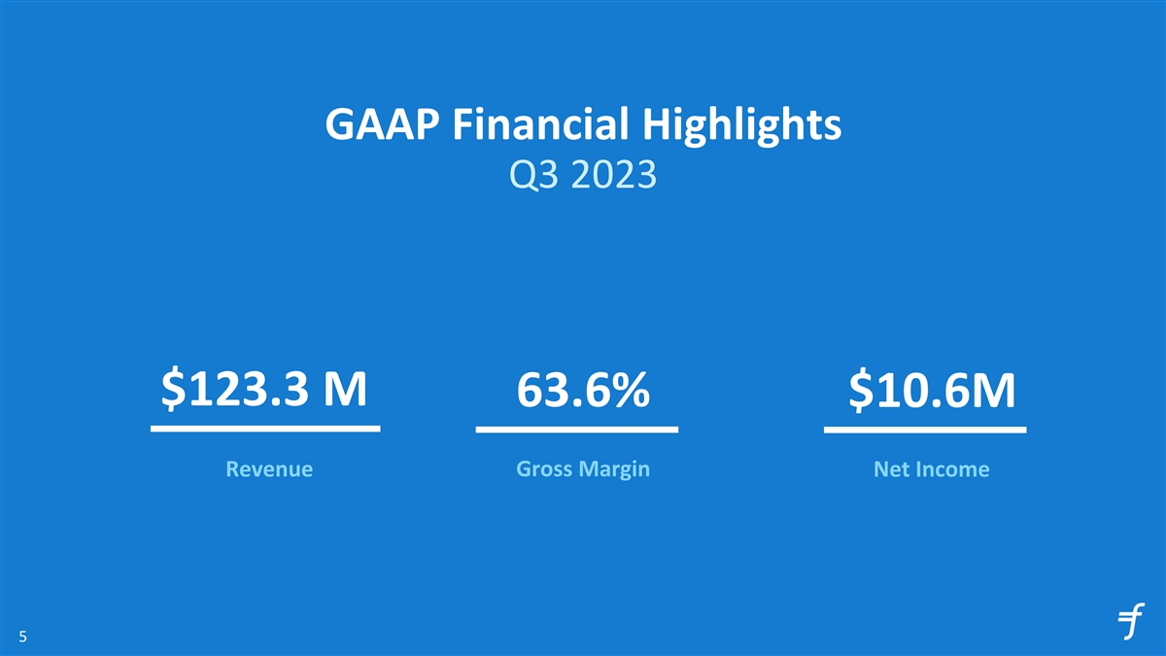
GAAP Financial Highlights Q3 2023 $123.3 M 63.6% $10.6M Revenue Gross Margin Net Income 5

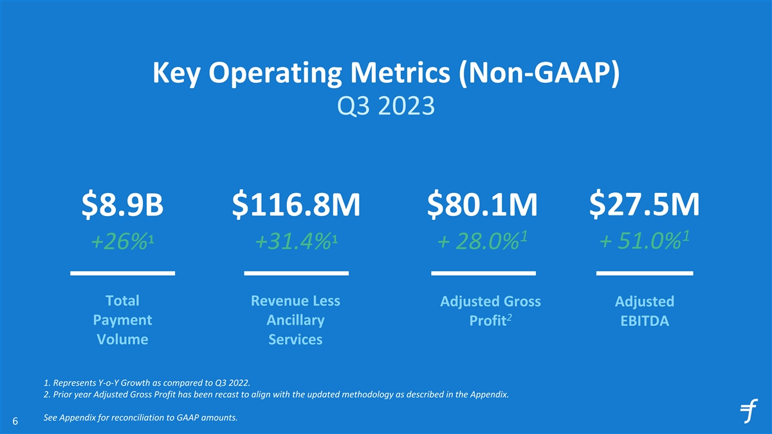
Key Operating Metrics (Non-GAAP) Q3 2023 $116.8M $80.1M $27.5M $8.9B 1 1 1 1 +26% +31.4% + 28.0% + 51.0% Total Revenue Less Adjusted Gross Adjusted 2 Payment Ancillary Profit EBITDA Volume Services 1. Represents Y-o-Y Growth as compared to Q3 2022. 2. Prior year Adjusted Gross Profit has been recast to align with the updated methodology as described in the Appendix. See Appendix for reconciliation to GAAP amounts. 6

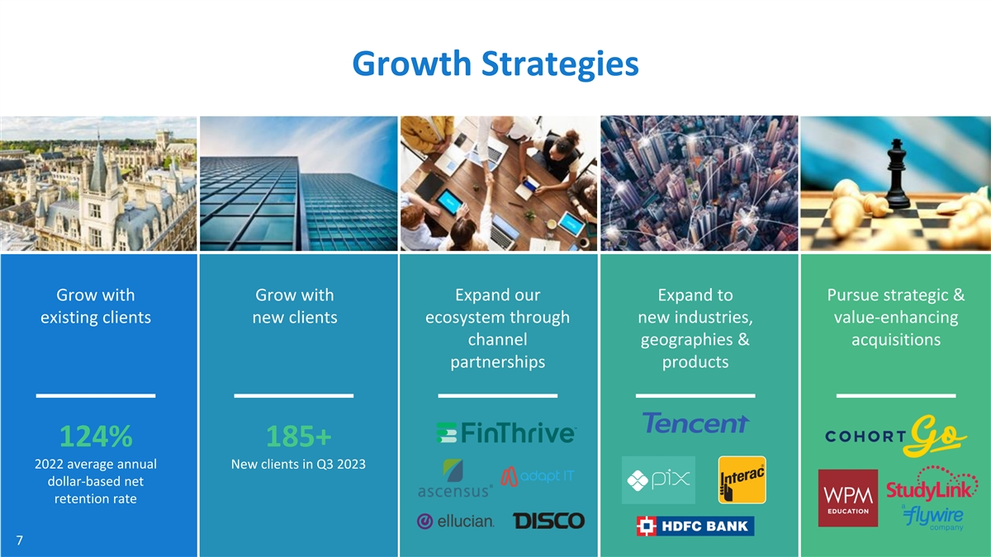
Growth Strategies Grow with Grow with Expand our Expand to Pursue strategic & existing clients new clients ecosystem through new industries, value-enhancing channel geographies & acquisitions partnerships products 124% 185+ 2022 average annual New clients in Q3 2023 dollar-based net retention rate 7


Pursue Strategic & Value-Enhancing Acquisitions

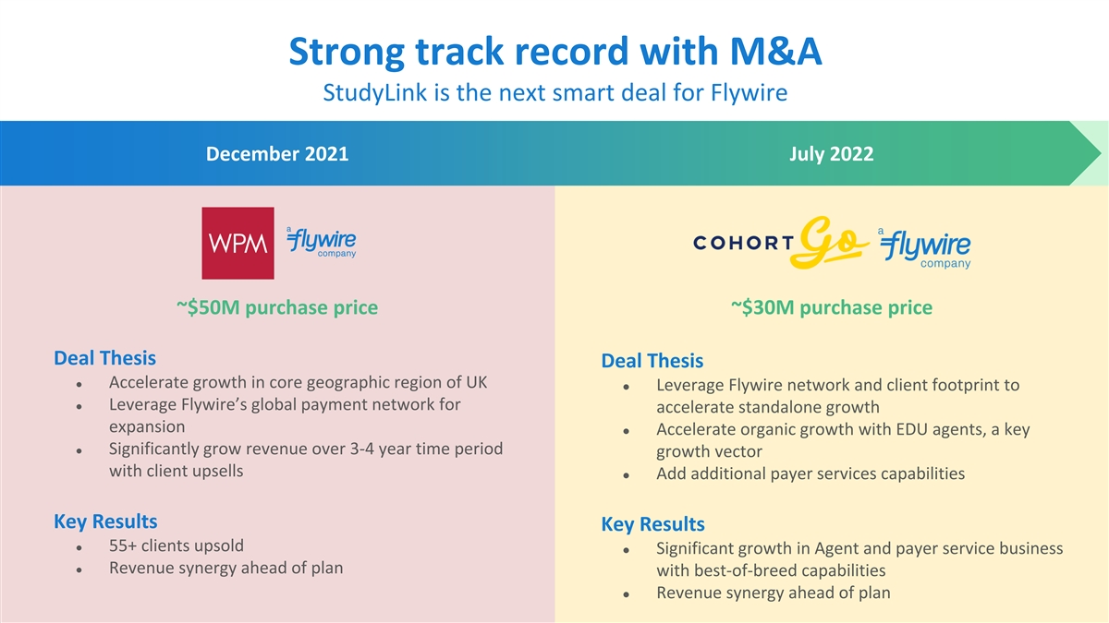
Strong track record with M&A StudyLink is the next smart deal for Flywire December 2021 July 2022 ~$50M purchase price ~$30M purchase price Deal Thesis Deal Thesis ● Accelerate growth in core geographic region of UK ● Leverage Flywire network and client footprint to ● Leverage Flywire’s global payment network for accelerate standalone growth expansion ● Accelerate organic growth with EDU agents, a key ● Significantly grow revenue over 3-4 year time period growth vector with client upsells ● Add additional payer services capabilities Key Results Key Results ● 55+ clients upsold ● Significant growth in Agent and payer service business ● Revenue synergy ahead of plan with best-of-breed capabilities ● Revenue synergy ahead of plan

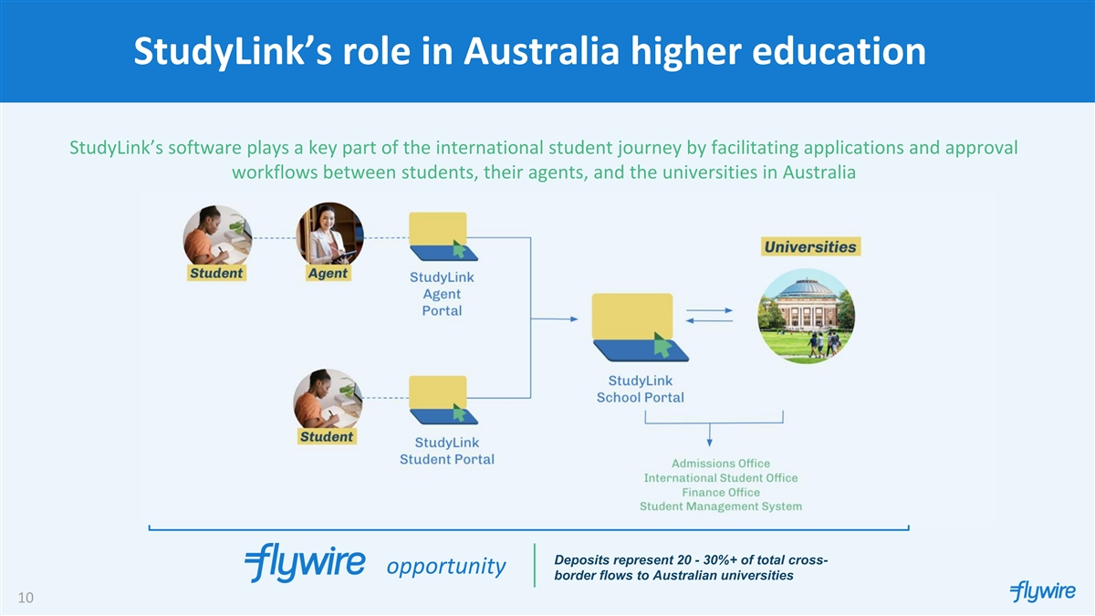
StudyLink’s role in Australia higher education StudyLink’s software plays a key part of the international student journey by facilitating applications and approval workflows between students, their agents, and the universities in Australia Deposits represent 20 - 30%+ of total cross- opportunity border flows to Australian universities 10

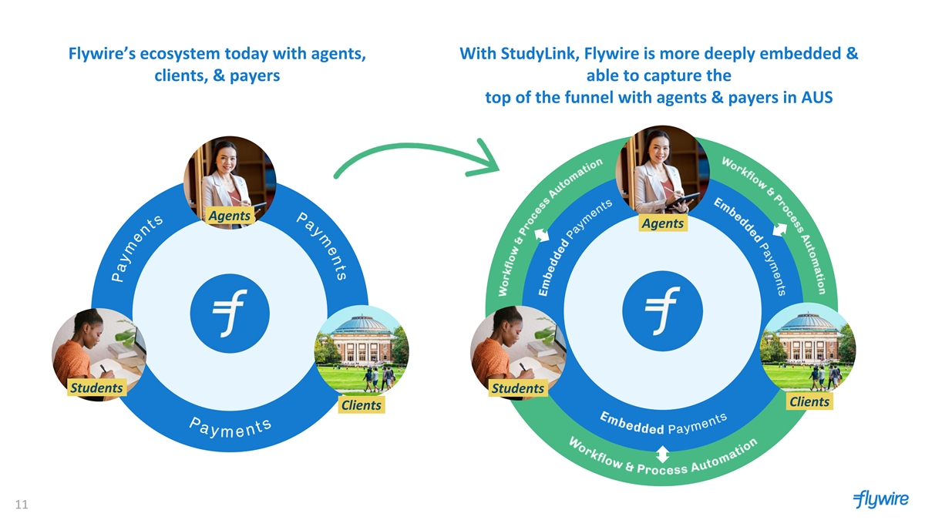
Flywire’s ecosystem today with agents, With StudyLink, Flywire is more deeply embedded & clients, & payers able to capture the top of the funnel with agents & payers in AUS Agents. Agents. Students. Students. Clients. Clients. 11

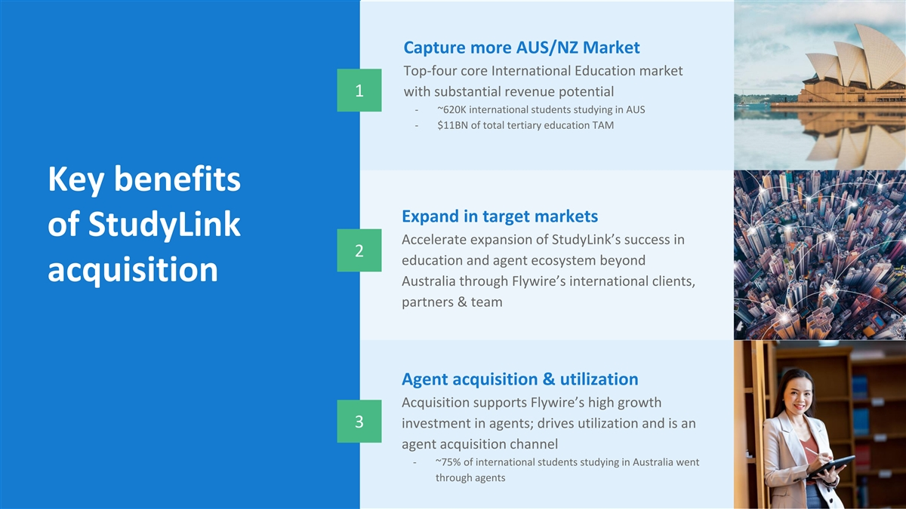
Capture more AUS/NZ Market Top-four core International Education market with substantial revenue potential 1 - ~620K international students studying in AUS - $11BN of total tertiary education TAM Key benefits Expand in target markets of StudyLink Accelerate expansion of StudyLink’s success in 2 education and agent ecosystem beyond acquisition Australia through Flywire’s international clients, partners & team Agent acquisition & utilization Acquisition supports Flywire’s high growth 3 investment in agents; drives utilization and is an agent acquisition channel - ~75% of international students studying in Australia went through agents


Travel spotlight

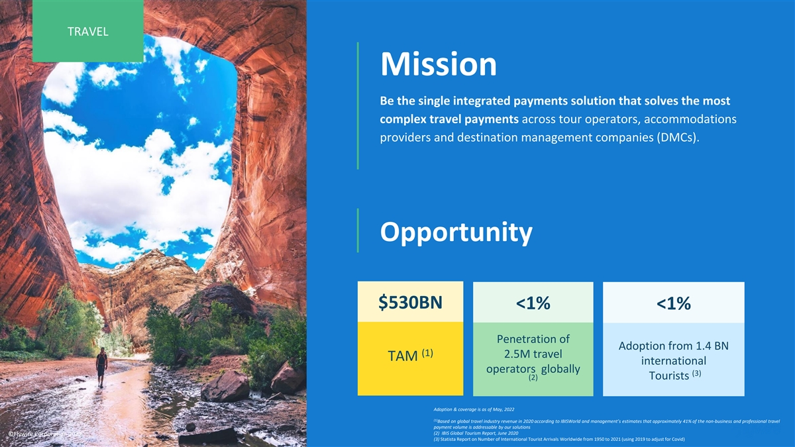
TRAVEL Mission Be the single integrated payments solution that solves the most complex travel payments across tour operators, accommodations providers and destination management companies (DMCs). Opportunity $530BN <1% <1% Penetration of Adoption from 1.4 BN (1) 2.5M travel TAM international operators globally (3) (2) Tourists Adoption & coverage is as of May, 2022 (1) Based on global travel industry revenue in 2020 according to IBISWorld and management’s estimates that approximately 41% of the non-business and professional travel payment volume is addressable by our solutions (2) IBIS Global Tourism Report, June 2020 ©Flywire Corporation 2022 (3) Statista Report on Number of International Tourist Arrivals Worldwide from 1950 to 2021 (using 2019 to adjust for Covid)

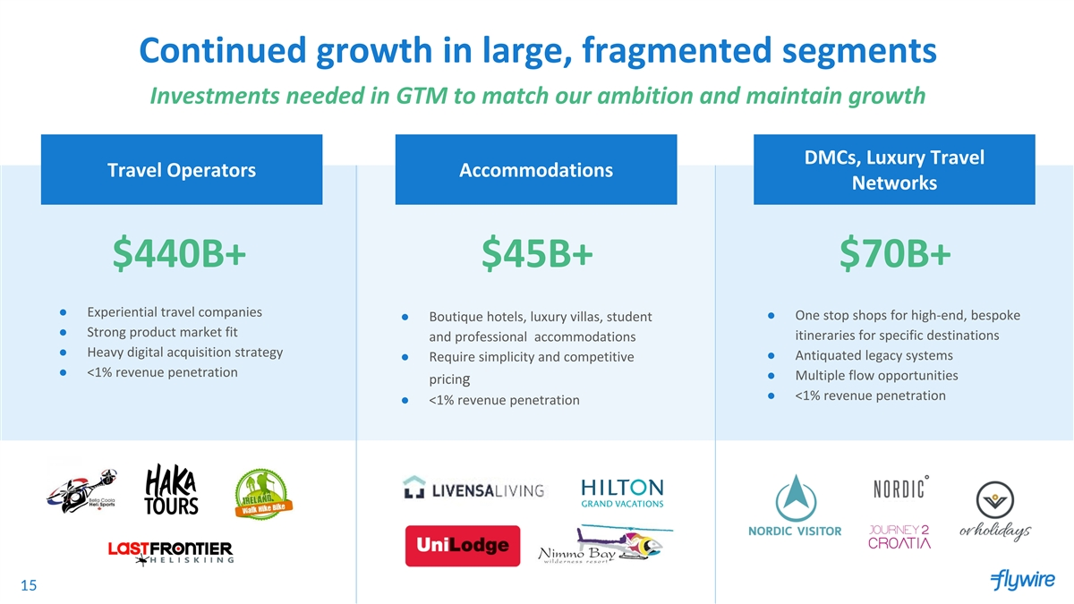
Continued growth in large, fragmented segments Investments needed in GTM to match our ambition and maintain growth DMCs, Luxury Travel Travel Operators Accommodations Networks $440B+ $45B+ $70B+ ● Experiential travel companies ● One stop shops for high-end, bespoke ● Boutique hotels, luxury villas, student ● Strong product market fit itineraries for specific destinations and professional accommodations ● Heavy digital acquisition strategy ● Antiquated legacy systems ● Require simplicity and competitive ● <1% revenue penetration ● Multiple flow opportunities pricing ● <1% revenue penetration ● <1% revenue penetration 15

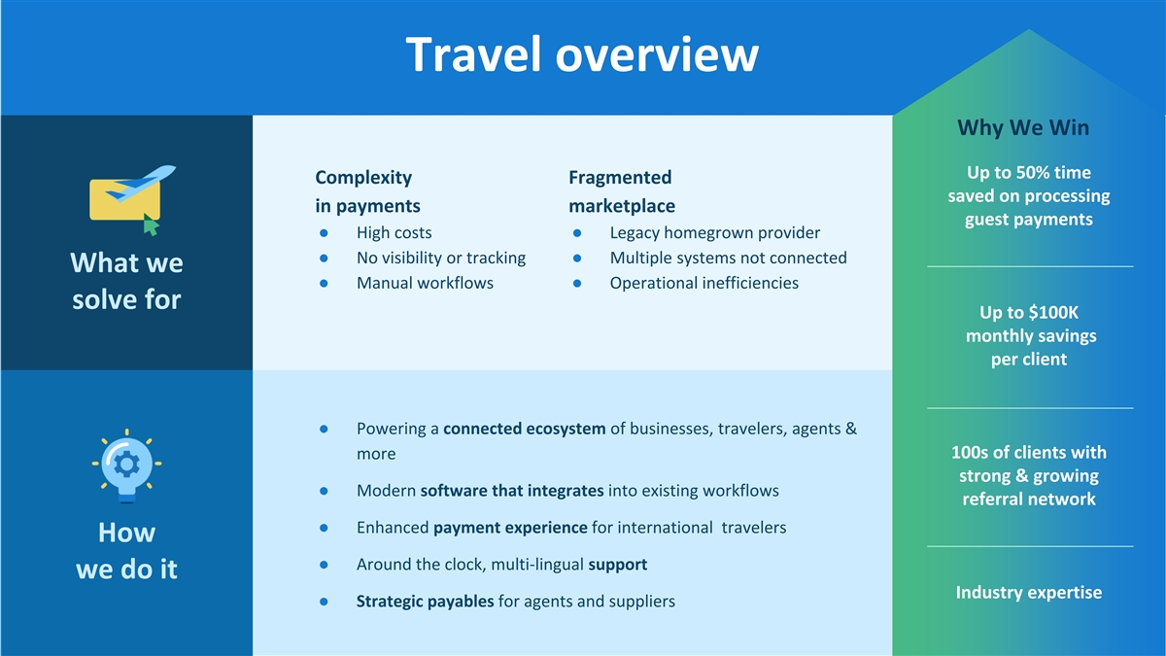
Travel overview What we solve Why We Win Up to 50% time Complexity Fragmented saved on processing in payments marketplace guest payments ● High costs ● Legacy homegrown provider ● No visibility or tracking ● Multiple systems not connected What we ● Manual workflows ● Operational inefficiencies solve for Up to $100K monthly savings per client ● Powering a connected ecosystem of businesses, travelers, agents & 100s of clients with more strong & growing ● Modern software that integrates into existing workflows referral network ● Enhanced payment experience for international travelers How ● Around the clock, multi-lingual support we do it Industry expertise ● Strategic payables for agents and suppliers


CASE CASE STUSTU DY DY Client Challenge ● Needed to automate currency conversion to provide customers choice and pay suppliers ● Security provisions impeded user experience ● Lacked support for customers and staff Why they chose Flywire South Africa us solution ● Ability to receive funds in the ● Reduced processing costs local desired currency (USD and ● Increased support for ZAR) customers and staff ● Preferred payment and currency ● High levels of security without options for customers unnecessary friction ● Dedicated support 17

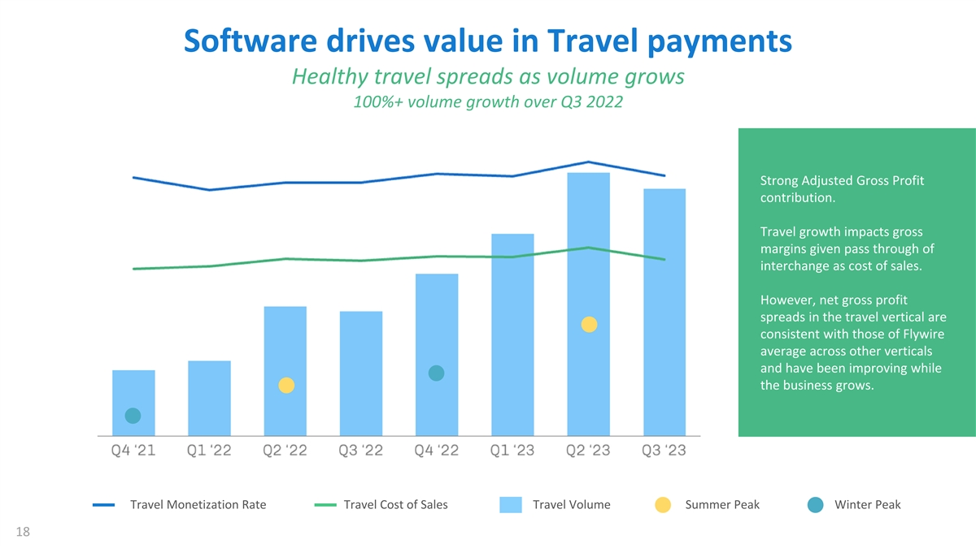
Software drives value in Travel payments Healthy travel spreads as volume grows 100%+ volume growth over Q3 2022 Strong Adjusted Gross Profit contribution. Travel growth impacts gross margins given pass through of interchange as cost of sales. However, net gross profit spreads in the travel vertical are consistent with those of Flywire average across other verticals and have been improving while the business grows. Travel Monetization Rate Travel Cost of Sales Travel Volume Summer Peak Winter Peak 18


Financial Outlook 19

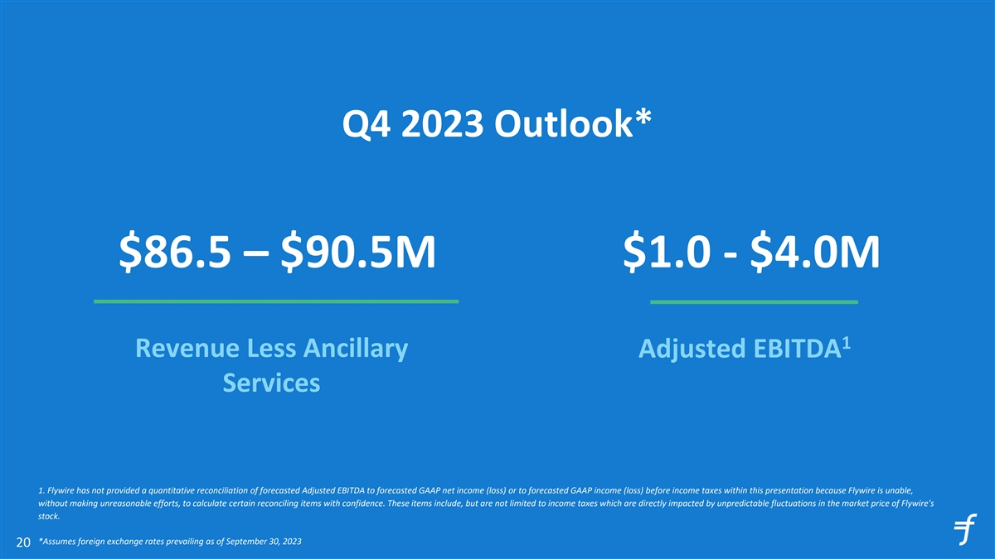
Q4 2023 Outlook* $86.5 – $90.5M $1.0 - $4.0M 1 Revenue Less Ancillary Adjusted EBITDA Services 1. Flywire has not provided a quantitative reconciliation of forecasted Adjusted EBITDA to forecasted GAAP net income (loss) or to forecasted GAAP income (loss) before income taxes within this presentation because Flywire is unable, without making unreasonable efforts, to calculate certain reconciling items with confidence. These items include, but are not limited to income taxes which are directly impacted by unpredictable fluctuations in the market price of Flywire's stock. *Assumes foreign exchange rates prevailing as of September 30, 2023 20

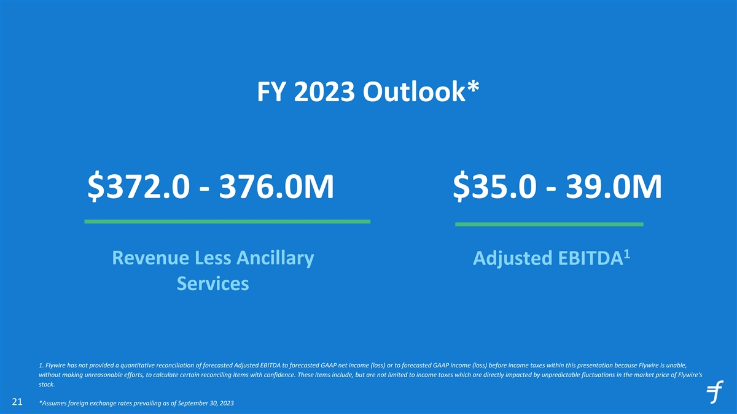
FY 2023 Outlook* $372.0 - 376.0M $35.0 - 39.0M 1 Revenue Less Ancillary Adjusted EBITDA Services 1. Flywire has not provided a quantitative reconciliation of forecasted Adjusted EBITDA to forecasted GAAP net income (loss) or to forecasted GAAP income (loss) before income taxes within this presentation because Flywire is unable, without making unreasonable efforts, to calculate certain reconciling items with confidence. These items include, but are not limited to income taxes which are directly impacted by unpredictable fluctuations in the market price of Flywire's stock. 21 *Assumes foreign exchange rates prevailing as of September 30, 2023


Appendix 22

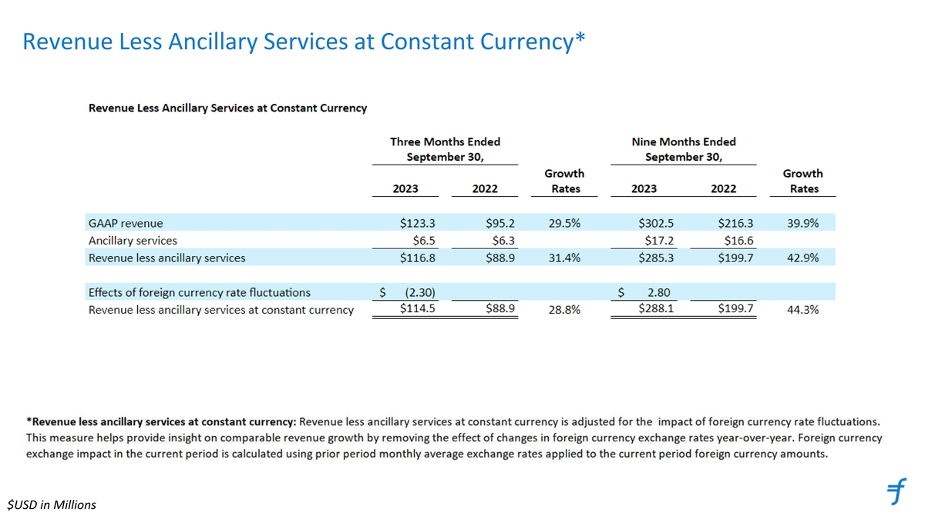
Revenue Less Ancillary Services at Constant Currency* $USD in Millions

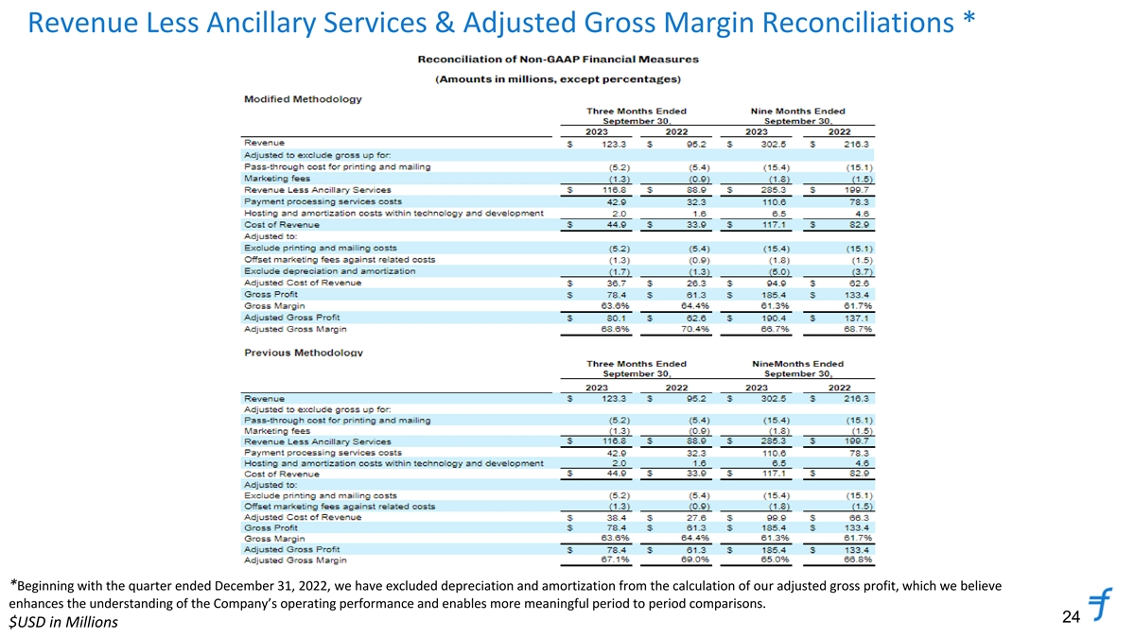
Revenue Less Ancillary Services & Adjusted Gross Margin Reconciliations * *Beginning with the quarter ended December 31, 2022, we have excluded depreciation and amortization from the calculation of our adjusted gross profit, which we believe enhances the understanding of the Company’s operating performance and enables more meaningful period to period comparisons. 24 $USD in Millions

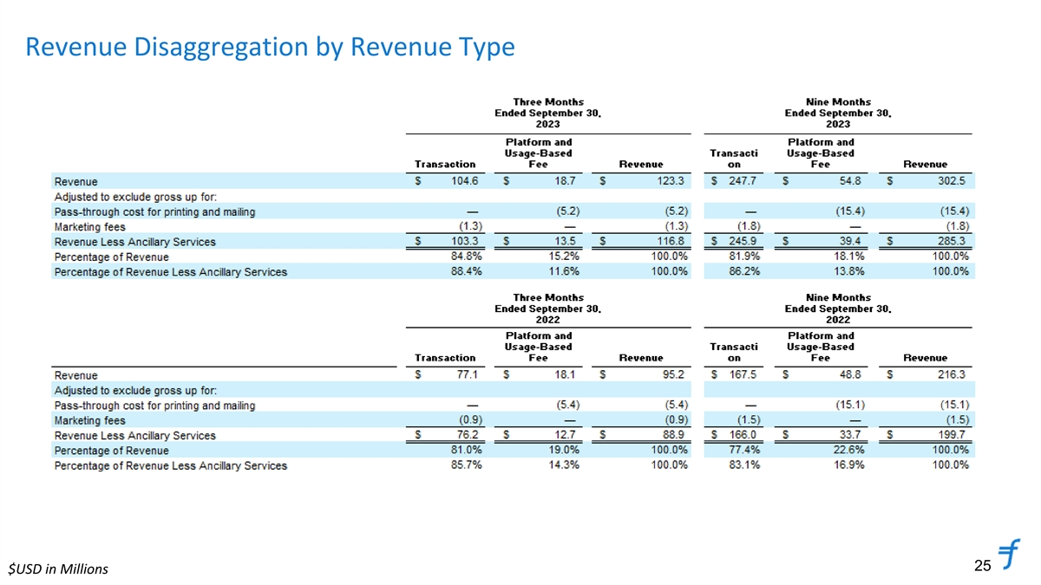
Revenue Disaggregation by Revenue Type 25 $USD in Millions

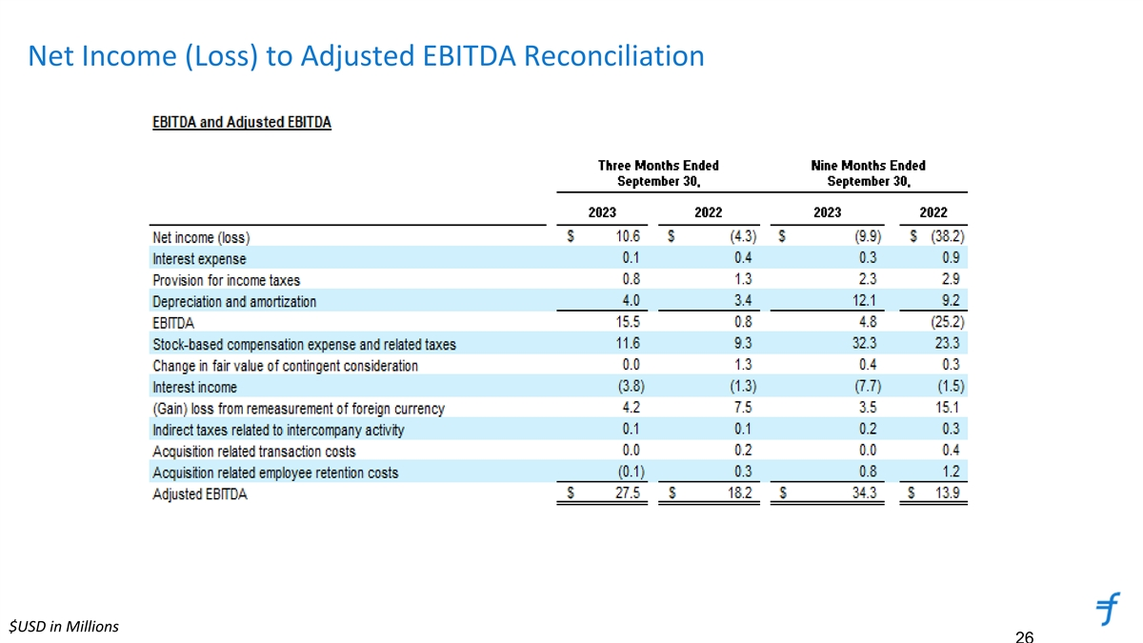
Net Income (Loss) to Adjusted EBITDA Reconciliation $USD in Millions 26

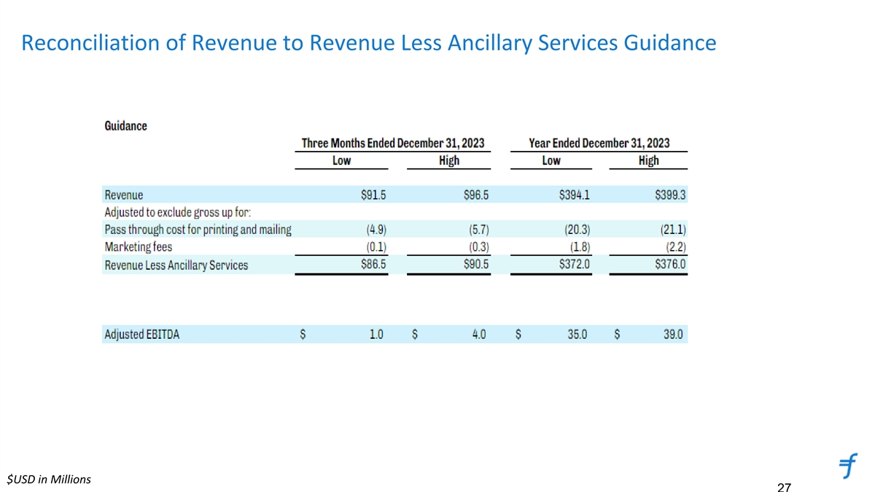
Reconciliation of Revenue to Revenue Less Ancillary Services Guidance $USD in Millions 27

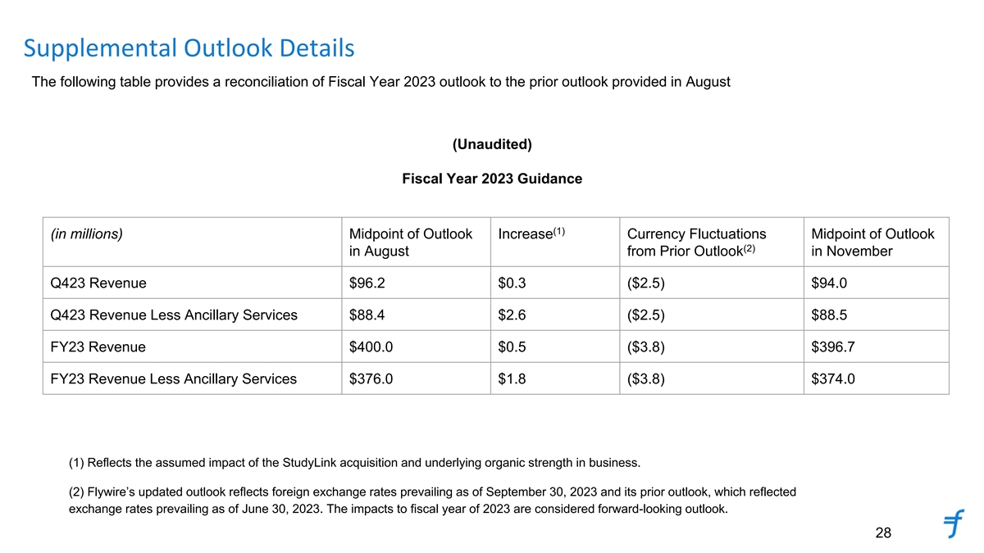
Supplemental Outlook Details The following table provides a reconciliation of Fiscal Year 2023 outlook to the prior outlook provided in August (Unaudited) Fiscal Year 2023 Guidance (1) (in millions) Midpoint of Outlook Increase Currency Fluctuations Midpoint of Outlook (2) in August from Prior Outlook in November Q423 Revenue $96.2 $0.3 ($2.5) $94.0 Q423 Revenue Less Ancillary Services $88.4 $2.6 ($2.5) $88.5 FY23 Revenue $400.0 $0.5 ($3.8) $396.7 FY23 Revenue Less Ancillary Services $376.0 $1.8 ($3.8) $374.0 (1) Reflects the assumed impact of the StudyLink acquisition and underlying organic strength in business. (2) Flywire’s updated outlook reflects foreign exchange rates prevailing as of September 30, 2023 and its prior outlook, which reflected exchange rates prevailing as of June 30, 2023. The impacts to fiscal year of 2023 are considered forward-looking outlook. 28

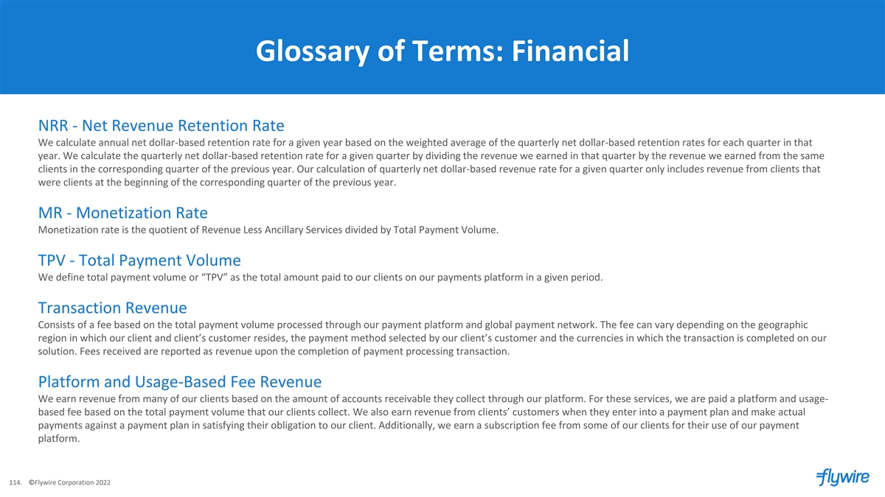
Glossary of Terms: Financial NRR - Net Revenue Retention Rate We calculate annual net dollar-based retention rate for a given year based on the weighted average of the quarterly net dollar-based retention rates for each quarter in that year. We calculate the quarterly net dollar-based retention rate for a given quarter by dividing the revenue we earned in that quarter by the revenue we earned from the same clients in the corresponding quarter of the previous year. Our calculation of quarterly net dollar-based revenue rate for a given quarter only includes revenue from clients that were clients at the beginning of the corresponding quarter of the previous year. MR - Monetization Rate Monetization rate is the quotient of Revenue Less Ancillary Services divided by Total Payment Volume. TPV - Total Payment Volume We define total payment volume or “TPV” as the total amount paid to our clients on our payments platform in a given period. Transaction Revenue Consists of a fee based on the total payment volume processed through our payment platform and global payment network. The fee can vary depending on the geographic region in which our client and client’s customer resides, the payment method selected by our client’s customer and the currencies in which the transaction is completed on our solution. Fees received are reported as revenue upon the completion of payment processing transaction. Platform and Usage-Based Fee Revenue We earn revenue from many of our clients based on the amount of accounts receivable they collect through our platform. For these services, we are paid a platform and usage- based fee based on the total payment volume that our clients collect. We also earn revenue from clients’ customers when they enter into a payment plan and make actual payments against a payment plan in satisfying their obligation to our client. Additionally, we earn a subscription fee from some of our clients for their use of our payment platform. 114. ©Flywire Corporation 2022

