UNITED STATES
SECURITIES AND EXCHANGE COMMISSION
Washington, D.C. 20549

FORM 8-K

CURRENT REPORT
Pursuant to Section 13 or 15(d)
of the Securities Exchange Act of 1934
Date of Report (Date of earliest event reported): February 27, 2024

FLYWIRE CORPORATION
(Exact name of Registrant as specified in its charter)

Delaware |  | 001-40430 |  | 27-0690799
(State or other jurisdiction  of incorporation) |  | (Commission  File No.) |  | (IRS Employer  Identification No.)
141 Tremont St #10
Boston, MA 02111
(Address of principal executive offices and zip code)
Registrant’s telephone number, including area code: (617) 329-4524
Not Applicable
(Former Name or Former Address, if Changed Since Last Report)

Check the appropriate box below if the Form 8-K filing is intended to simultaneously satisfy the filing obligation of the registrant under any of the following provisions:

☐ | Written communications pursuant to Rule 425 under the Securities Act (17 CFR 230.425)

☐ | Soliciting material pursuant to Rule 14a-12 under the Exchange Act (17 CFR 240.14a-12)

☐ | Pre-commencement communications pursuant to Rule 14d-2(b) under the Exchange Act (17 CFR 240.14d-2(b))

☐ | Pre-commencement communications pursuant to Rule 13e-4(c) under the Exchange Act (17 CFR 240.13e-4(c))
Securities registered pursuant to Section 12(b) of the Act:

Title of each class |  | Trading  Symbol(s) |  | Name of each exchange  on which registered
Voting Common Stock, $0.0001 par value per share |  | FLYW |  | The Nasdaq Stock Market LLC  (Nasdaq Global Select Market)
Indicate by check mark whether the registrant is an emerging growth company as defined in Rule 405 of the Securities Act of 1933 (§230.405 of this chapter) or Rule 12b-2 of the Securities Exchange Act of 1934 (§240.12b-2 of this chapter).
Emerging growth company ☐
If an emerging growth company, indicate by check mark if the registrant has elected not to use the extended transition period for complying with any new or revised financial accounting standards provided pursuant to Section 13(a) of the Exchange Act. ☐

Item 2.02. | Results of Operations and Financial Condition.
On February 27, 2024, Flywire Corporation (“Flywire” or the “Company”) issued a press release (the “Press Release”) and is holding a conference call regarding its preliminary and unaudited financial results for the quarter and year ended December 31, 2023. The Press Release is furnished as Exhibit 99.1 to this Current Report on Form 8-K and is incorporated by reference herein.
Various statements to be made during the conference call are “forward-looking statements” within the meaning of the Private Securities Litigation Reform Act of 1995, including, but not limited to, statements regarding Flywire’s future operating results and financial position, Flywire’s business strategy and plans, market growth, and Flywire’s objectives for future operations. Flywire intends such forward-looking statements to be covered by the safe harbor provisions for forward-looking statements contained in Section 21E of the Securities Exchange Act of 1934 and the Private Securities Litigation Reform Act of 1995. In some cases, you can identify forward-looking statements by terms such as, but not limited to, “believe,” “may,” “will,” “potentially,” “estimate,” “continue,” “anticipate,” “intend,” “could,” “would,” “project,” “target,” “plan,” “expect,” or the negative of these terms, and similar expressions intended to identify forward-looking statements. Such forward-looking statements are based upon current expectations that involve risks, changes in circumstances, assumptions, and uncertainties. Important factors that could cause actual results to differ materially from those reflected in Flywire’s forward-looking statements include, among others, Flywire’s future financial performance, including its expectations regarding Revenue, Revenue Less Ancillary Services, and Adjusted EBITDA and foreign exchange rates. Risks that may cause actual results to differ materially from these forward looking statements include, but are not limited to: Flywire’s ability to execute its business plan and effectively manage its growth; Flywire’s cross-border expansion plans and ability to expand internationally; anticipated trends, growth rates, and challenges in Flywire’s business and in the markets in which Flywire operates; the sufficiency of Flywire’s cash and cash equivalents to meet its liquidity needs; political, economic, foreign currency exchange rate, inflation, legal, social and health risks, that may affect Flywire’s business or the global economy; Flywire’s beliefs and objectives for future operations; Flywire’s ability to develop and protect its brand; Flywire’s ability to maintain and grow the payment volume that it processes; Flywire’s ability to further attract, retain, and expand its client base; Flywire’s ability to develop new solutions and services and bring them to market in a timely manner; Flywire’s expectations concerning relationships with third parties, including financial institutions and strategic partners; the effects of increased competition in Flywire’s markets and its ability to compete effectively; recent and future acquisitions or investments in complementary companies, products, services, or technologies; Flywire’s ability to enter new client verticals, including its relatively new business-to-business sector; Flywire’s expectations regarding anticipated technology needs and developments and its ability to address those needs and developments with its solutions; Flywire’s expectations regarding litigation and legal and regulatory matters; Flywire’s expectations regarding its ability to meet existing performance obligations and maintain the operability of its solutions; Flywire’s expectations regarding the effects of existing and developing laws and regulations, including with respect to payments and financial services, taxation, privacy and data protection; economic and industry trends, projected growth, or trend analysis; Flywire’s ability to adapt to changes in U.S. federal income or other tax laws or the interpretation of tax laws, including the Inflation Reduction Act of 2022; Flywire’s ability to attract and retain qualified employees; Flywire’s ability to maintain, protect, and enhance its intellectual property; Flywire’s ability to maintain the security and availability of its solutions; the increased expenses associated with being a public company; the future market price of Flywire’s common stock; and other factors that are described in the “Risk Factors” and “Management’s Discussion and Analysis of Financial Condition and Results of Operations” sections of Flywire’s Annual Report on Form 10-K for the year ended December 31, 2022 and Quarterly Report on Form 10-Q for the quarter ended September 30, 2023, which are on file with the Securities and Exchange Commission (SEC) and available on the SEC’s website at https://www.sec.gov/. Additional factors may be described in those sections of Flywire’s Annual Report on Form 10-K for the year ended December 31, 2023, expected to be filed with the SEC in the first quarter of 2024. The information conveyed on the conference call is provided only as of the date of the conference call, and Flywire undertakes no obligation to update any forward-looking statements presented during the conference call on account of new information, future events, or otherwise, except as required by law.

Item 7.01. | Regulation FD Disclosure.
On February 27, 2024, the Company provided an investor presentation that will be made available on the investor relations section of the Company’s website at https://ir.flywire.com/. The investor presentation is furnished as Exhibit 99.2 to this Current Report on Form 8-K and is incorporated by reference herein.
This information in this Item 7.01 of this Current Report on Form 8-K shall not be deemed “filed” for purposes of Section 18 of the Securities Exchange Act of 1934, as amended (the “Exchange Act”), or otherwise subject to the liabilities of that Section, or incorporated by reference in any filing under the Securities Act of 1933, as amended, or the Exchange Act, except as shall be expressly set forth by specific reference in any such filing.

Item 9.01. | Financial Statements and Exhibits.
(d) Exhibits

Exhibit  No. |  | Description
99.1 |  | Flywire Corporation Press Release dated February 27, 2024.
99.2 |  | Flywire Corporation Investor Presentation dated February 27, 2024.
104 |  | Cover Page Interactive Data File (embedded within the Inline XBRL document)

SIGNATURE
Pursuant to the requirements of the Securities Exchange Act of 1934, the registrant has duly caused this report to be signed on its behalf by the undersigned hereunto duly authorized.

FLYWIRE CORPORATION
By: |  | /s/ Michael Ellis
Name: |  | Michael Ellis
Title: |  | Chief Financial Officer
Dated February 27, 2024
Exhibit 99.1
Flywire Reports Fourth Quarter and Fiscal-Year 2023 Financial Results
Fourth Quarter Revenue Increased 37.5% Year-over-Year
Fourth Quarter Revenue Less Ancillary Services Increased 42.6% Year-over-Year
Company Provides First Quarter and Fiscal-Year 2024 Outlook
Boston, MA  February 27, 2024: Flywire Corporation (Nasdaq: FLYW) (Flywire or the Company) a global payments enablement and software company, today reported financial results for its fourth quarter and fiscal-year ended December 31, 2023.
Our strong fourth quarter results, which included 37.5% year over year growth in revenue and 42.6% year over year growth in revenue less ancillary services, capped off an exceptional year for Flywire as we continue to show strong performance across the business, said Mike Massaro, CEO of Flywire. We are proud of all that we have accomplished in 2023, and excited for what is ahead for Flywire, with a plan that puts up strong growth numbers in a complex macro environment and further expands Adjusted EBITDA in alignment with our multi-year targets.
Fourth Quarter 2023 Financial Highlights:
GAAP Results

 |  |  | Revenue increased 37.5% to $100.5 million in the fourth quarter of 2023, compared to $73.1 million in the fourth quarter of 2022.

 |  |  | Gross Profit increased to $61.8 million, resulting in Gross Margin of 61.5%, for the fourth quarter of 2023, compared to Gross Profit of $41.5 million and Gross Margin of 56.8% in the fourth quarter of 2022.

 |  |  | Net income was $1.3 million in the fourth quarter of 2023, compared to net loss of $1.1 million in the fourth quarter of 2022.
Key Operating Metrics and Non-GAAP Results

 |  |  | Total Payment Volume increased 33.2% to $5.4 billion in the fourth quarter of 2023, compared to $4.1 billion in the fourth quarter of 2022.

 |  |  | Revenue Less Ancillary Services increased 42.6% to $96.1 million in the fourth quarter of 2023, compared to $67.4 million in the fourth quarter of 2022. Revenue Less Ancillary Services in the fourth quarter of 2023 was estimated to be favorably impacted by changes in foreign exchange rates between September 30, 2023 and December 31, 2023 by approximately $0.7 million.

 |  |  | Adjusted Gross Profit increased to $63.5 million, resulting in Adjusted Gross Margin of 66.1% in the fourth quarter of 2023, compared to Adjusted Gross Profit of $44.5 million and Adjusted Gross Margin of 66.0% in the fourth quarter of 2022. Prior year Adjusted Gross Profit and Adjusted Gross Margin have been recast to align with the updated methodology as described in the Key Operating Metrics and Non-GAAP Financial Measures section below.

 |  |  | Adjusted EBITDA increased to $7.7 million in the fourth quarter of 2023, compared to $1.0 million in the fourth quarter of 2022.
Fiscal-Year 2023 Financial Highlights:
GAAP Results

 |  |  | Revenue increased 39.3% to $403.1 million in fiscal-year 2023, compared to $289.4 million in fiscal-year 2022.

 |  |  | Gross Profit increased to $247.4 million, resulting in Gross Margin of 61.4%, for fiscal-year 2023, compared to Gross Profit of $174.9 million and Gross Margin of 60.4% in fiscal-year 2022.

 |  |  | Net loss was $8.6 million in fiscal-year 2023, compared to net loss of $39.3 million in fiscal-year 2022.
Key Operating Metrics and Non-GAAP Results

 |  |  | Total Payment Volume increased 32.9% to $24.0 billion in fiscal-year 2023, compared to $18.1 billion in fiscal-year 2022.

 |  |  | Revenue Less Ancillary Services increased 42.8% to $381.5 million in fiscal-year 2023, compared to $267.1 million in fiscal-year 2022.

 |  |  | Adjusted Gross Profit increased to $254.1 million, resulting in Adjusted Gross Margin of 66.6% in fiscal-year 2023, compared to Adjusted Gross Profit of $181.9 million and Adjusted Gross Margin of 68.1% in fiscal-year 2022. Fiscal-year 2022 Adjusted Gross Profit and Adjusted Gross Margin have been recast to align with the updated methodology as described in the Key Operating Metrics and Non-GAAP Financial Measures section below.

 |  |  | Adjusted EBITDA increased to $42.0 million in fiscal-year 2023, compared to $14.9 million in fiscal-year 2022, a 546 basis point expansion of our Adjusted EBITDA as a percentage of revenue less ancillary services
Fiscal-Year 2023 Business Highlights:

 |  |  | In education, the Company continued to expand its higher education footprint globally including notable growth in the United Kingdom and throughout Asia-Pacific

 |  |  | The Company also continued to see success in its land and expand strategy in the U.S,. increasing the footprint of its full-suite solution, and landing many blue-chip clients

 |  |  | In travel, the Company experienced a significant increase in terms of clients signed and revenue realization from existing clients

 |  |  | In B2B, the Company continued to sign larger enterprise deals and drive utilization among existing clients

 |  |  | In healthcare, the Company accelerated our partnership strategy, solidifying relationships with Cerner and FinThrive

 |  |  | The Company bolstered its global payment network with a focus on supporting its strategic payer markets like India and China, enhancing its relationships with WeChat Pay as well as three of the largest banks in India

 |  |  | The Company continued its strong track record of strategic M&A with the acquisition of StudyLink
First Quarter and Fiscal-Year 2024 Outlook:
For Fiscal-Year 2024 we expect revenue less ancillary services to grow 30% at the midpoint of our guidance. We also expect to generate an approximately 320 basis point improvement in adjusted EBITDA as a percentage of revenue less ancillary services at the midpoint of our guidance, said Mike Ellis, CFO of Flywire. Our seasonality across the fiscal year, and our results for first quarter , are expected to be impacted by Canadian regulatory changes, which we expect will reduce the number of international study permit applications and delay some Canadian applications until later in the year. The changes may also lead some students to study in other countries.
Based on information available as of February 27, 2024, Flywire anticipates the following results for the first quarter and fiscal-year 2024.

 |  | Fiscal-Year 2024*
Revenue |  | $501 to $535 million
Revenue Less Ancillary Services |  | $483 to $509 million
Adjusted EBITDA** |  | $65 to $76 million

 |  | First Quarter 2024*
Revenue |  | $110 to $117 million
Revenue Less Ancillary Services |  | $106 to $111 million
Adjusted EBITDA** |  | $9 to $11 million

* | The Company has assumed foreign exchange rates prevailing as of December 31, 2023.
** | Flywire has not provided a quantitative reconciliation of forecasted Adjusted EBITDA to forecasted GAAP net income (loss) or to forecasted GAAP income (loss) before income taxes within this earnings release because Flywire is unable, without making unreasonable efforts, to calculate certain reconciling items with confidence. These items include, but are not limited to income taxes which are directly impacted by unpredictable fluctuations in the market price of Flywires stock.
These statements are forward-looking and actual results may differ materially. Refer to the Safe Harbor Statement below for information on the factors that could cause Flywires actual results to differ materially from these forward-looking statements.
Conference Call
The Company will host a conference call to discuss fourth quarter and fiscal-year 2023 financial results today at 5:00 pm ET. Hosting the call will be Mike Massaro, CEO, Rob Orgel, President and COO, and Mike Ellis, CFO. The conference call can be accessed live via webcast from the Companys investor relations website at https://ir.flywire.com/. A replay will be available on the investor relations website following the call.
Key Operating Metrics and Non-GAAP Financial Measures
Flywire uses non-GAAP financial measures to supplement financial information presented on a GAAP basis. The Company believes that excluding certain items from its GAAP results allows management to better understand its consolidated financial performance from period to period and better project its future consolidated financial performance as forecasts are developed at a level of detail different from that used to prepare GAAP-based financial measures. Moreover, Flywire believes these non-GAAP financial measures provide its stakeholders with useful information to help them evaluate the Companys operating results by facilitating an enhanced understanding of

the Companys operating performance and enabling them to make more meaningful period to period comparisons. There are limitations to the use of the non-GAAP financial measures presented here. Flywires non-GAAP financial measures may not be comparable to similarly titled measures of other companies. Other companies, including companies in Flywires industry, may calculate non-GAAP financial measures differently, limiting the usefulness of those measures for comparative purposes.
Flywire uses supplemental measures of its performance which are derived from its consolidated financial information, but which are not presented in its consolidated financial statements prepared in accordance with GAAP. These non-GAAP financial measures include the following:

 |  |  | Revenue Less Ancillary Services. Revenue Less Ancillary Services represents the Companys consolidated revenue in accordance with GAAP after excluding (i) pass-through cost for printing and mailing services and (ii) marketing fees. The Company excludes these amounts to arrive at this supplemental non-GAAP financial measure as it views these services as ancillary to the primary services it provides to its clients.

 |  |  | Adjusted Gross Profit and Adjusted Gross Margin. Adjusted gross profit represents Revenue Less Ancillary Services less cost of revenue adjusted to (i) exclude pass-through cost for printing services, (ii) offset marketing fees against costs incurred and (iii) exclude depreciation and amortization, including accelerated amortization on the impairment of customer set-up costs tied to technology integration. Adjusted Gross Margin represents Adjusted Gross Profit divided by Revenue Less Ancillary Services. Management believes this presentation supplements the GAAP presentation of Gross Margin with a useful measure of the gross margin of the Companys payment-related services, which are the primary services it provides to its clients. Beginning with the quarter ended December 31, 2022, Flywire has excluded depreciation and amortization from the calculation of its adjusted Gross Profit, which it believes enhances the understanding of the Companys operating performance and enables more meaningful period to period comparisons. The Companys previously reported Adjusted Gross Profit and Adjusted Gross Margin for the three months and twelve months ended December 31, 2022 were recast to conform to the updated methodology and are reflected herein for comparison purposes.

 |  |  | Adjusted EBITDA. Adjusted EBITDA represents EBITDA further adjusted by excluding (i) stock-based compensation expense and related payroll taxes, (ii) the impact from the change in fair value measurement for contingent consideration associated with acquisitions, (iii) gain (loss) from the remeasurement of foreign currency, (iv) indirect taxes related to intercompany activity, (v) acquisition related transaction costs, if applicable, and (vi) employee retention costs, such as incentive compensation, associated with acquisition activities. Management believes that the exclusion of these amounts to calculate Adjusted EBITDA provides useful measures for period-to-period comparisons of the Companys business.

 |  |  | Revenue Less Ancillary Services at Constant Currency. Revenue Less Ancillary Services at Constant Currency represents Revenue Less Ancillary Services adjusted to show presentation on a constant currency basis. The constant currency information presented is calculated by translating current period results using prior period weighted average foreign currency exchange rates. Flywire analyzes Revenue Less Ancillary Services on a constant currency basis to provide a comparable framework for assessing how the business performed excluding the effect of foreign currency fluctuations.
These non-GAAP financial measures are not meant to be considered as indicators of performance in isolation from or as a substitute for the Companys revenue, gross profit, gross margin or net income (loss) prepared in accordance with GAAP and should be read only in conjunction with financial information presented on a GAAP basis. Reconciliations of Revenue Less Ancillary Services, Revenue Less Ancillary Services at Constant Currency, Adjusted Gross Profit, Adjusted Gross Margin and Adjusted EBITDA to the most directly comparable GAAP financial measure are presented below. Flywire encourages you to review these reconciliations in conjunction with the presentation of the non-GAAP financial measures for each of the periods presented. In future fiscal periods, Flywire may exclude such items and may incur income and expenses similar to these excluded items. Flywire has not provided a quantitative reconciliation of forecasted Adjusted EBITDA to forecasted GAAP net income (loss) or to forecasted GAAP income (loss) before income taxes within this earnings release because it is unable, without making unreasonable efforts, to calculate certain reconciling items with confidence. These items include but are not limited to income taxes which are directly impacted by unpredictable fluctuations in the market price of Flywires stock.
About Flywire
Flywire is a global payments enablement and software company. Flywire combines its proprietary global payments network, next-gen payments platform and vertical-specific software to deliver the most important and complex payments for its clients and their customers.
Flywire leverages its vertical-specific software and payments technology to deeply embed within the existing A/R workflows for its clients across the education, healthcare and travel vertical markets, as well as in key B2B industries. Flywire also integrates with leading ERP systems, so organizations can optimize the payment experience for their customers while eliminating operational challenges.

Flywire supports more than 3,800 clients with diverse payment methods in more than 140 currencies across 240 countries and territories around the world. Flywire is headquartered in Boston, MA, USA with additional offices around the globe. For more information, visit www.flywire.com. Follow Flywire on X (formerly known as Twitter), LinkedIn and Facebook.
Safe Harbor Statement
This release contains forward-looking statements within the meaning of the Private Securities Litigation Reform Act of 1995, including, but not limited to, statements regarding Flywires future operating results and financial position, Flywires business strategy and plans, market growth, and Flywires objectives for future operations. Flywire intends such forward-looking statements to be covered by the safe harbor provisions for forward-looking statements contained in Section 21E of the Securities Exchange Act of 1934 and the Private Securities Litigation Reform Act of 1995. In some cases, you can identify forward-looking statements by terms such as, but not limited to, believe, may, will, potentially, estimate, continue, anticipate, intend, could, would, project, target, plan, expect, or the negative of these terms, and similar expressions intended to identify forward-looking statements. Such forward-looking statements are based upon current expectations that involve risks, changes in circumstances, assumptions, and uncertainties. Important factors that could cause actual results to differ materially from those reflected in Flywires forward-looking statements include, among others, Flywires future financial performance, including its expectations regarding Revenue, Revenue Less Ancillary Services, and Adjusted EBITDA and foreign exchange rates. Risks that may cause actual results to differ materially from these forward looking statements include, but are not limited to: Flywires ability to execute its business plan and effectively manage its growth; Flywires cross-border expansion plans and ability to expand internationally; anticipated trends, growth rates, and challenges in Flywires business and in the markets in which Flywire operates; the sufficiency of Flywires cash and cash equivalents to meet its liquidity needs; political, economic, foreign currency exchange rate, inflation, legal, social and health risks, that may affect Flywires business or the global economy; Flywires beliefs and objectives for future operations; Flywires ability to develop and protect its brand; Flywires ability to maintain and grow the payment volume that it processes; Flywires ability to further attract, retain, and expand its client base; Flywires ability to develop new solutions and services and bring them to market in a timely manner; Flywires expectations concerning relationships with third parties, including financial institutions and strategic partners; the effects of increased competition in Flywires markets and its ability to compete effectively; recent and future acquisitions or

investments in complementary companies, products, services, or technologies; Flywires ability to enter new client verticals, including its relatively new business-to-business sector; Flywires expectations regarding anticipated technology needs and developments and its ability to address those needs and developments with its solutions; Flywires expectations regarding litigation and legal and regulatory matters; Flywires expectations regarding its ability to meet existing performance obligations and maintain the operability of its solutions; Flywires expectations regarding the effects of existing and developing laws and regulations, including with respect to payments and financial services, taxation, privacy and data protection; economic and industry trends, projected growth, or trend analysis; Flywires ability to adapt to changes in U.S. federal income or other tax laws or the interpretation of tax laws, including the Inflation Reduction Act of 2022; Flywires ability to attract and retain qualified employees; Flywires ability to maintain, protect, and enhance its intellectual property; Flywires ability to maintain the security and availability of its solutions; the increased expenses associated with being a public company; the future market price of Flywires common stock; and other factors that are described in the Risk Factors and Managements Discussion and Analysis of Financial Condition and Results of Operations sections of Flywires Annual Report on Form 10-K for the year ended December 31, 2022 and Quarterly Report on Form 10-Q for the quarter ended September 30, 2023, which are on file with the Securities and Exchange Commission (SEC) and available on the SECs website at https://www.sec.gov/. Additional factors may be described in those sections of Flywires Annual Report on Form 10-K for the year ended December 31, 2023, expected to be filed with the SEC in the first quarter of 2024. The information in this release is provided only as of the date of this release, and Flywire undertakes no obligation to update any forward-looking statements contained in this release on account of new information, future events, or otherwise, except as required by law.
Contacts
Investor Relations:
Akil Hollis
ir@Flywire.com
Media:
Sarah King
Sarah.King@Flywire.com
Walker Sands
flywirepr@walkersands.com

Condensed Consolidated Statements of Operations and Comprehensive Income (Loss)
(Unaudited) (Amounts in thousands, except share and per share amounts)

 |  | Three Months Ended December 31, |  |  |  |  |  |  |  | Year Ended December 31,
 |  | 2023 |  |  |  | 2022 |  |  |  | 2023 |  |  |  | 2022
Revenue |  | $ | 100,545 |  |  | $ | 73,053 |  |  | $ | 403,094 |  |  | $ | 289,375
Costs and operating expenses:
Payment processing services costs |  |  | 36,780 |  |  |  | 29,585 |  |  |  | 147,339 |  |  |  | 107,933
Technology and development |  |  | 16,898 |  |  |  | 12,692 |  |  |  | 62,028 |  |  |  | 50,257
Selling and marketing |  |  | 28,830 |  |  |  | 20,287 |  |  |  | 107,621 |  |  |  | 78,456
General and administrative |  |  | 28,065 |  |  |  | 19,860 |  |  |  | 107,624 |  |  |  | 82,949
Total costs and operating expenses |  |  | 110,573 |  |  |  | 82,424 |  |  |  | 424,612 |  |  |  | 319,595
Loss from operations |  | $ | (10,028 | ) |  | $ | (9,371 | ) |  | $ | (21,518 | ) |  | $ | (30,220 | )
Other income (expense):
Interest expense |  |  | (92 | ) |  |  | (327 | ) |  |  | (372 | ) |  |  | (1,211 | )
Interest income |  |  | 5,638 |  |  |  | 1,787 |  |  |  | 13,349 |  |  |  | 3,244
Gain (loss) from remeasurement of foreign currency |  |  | 7,707 |  |  |  | 5,915 |  |  |  | 4,189 |  |  |  | (9,172 | )
Total other income (expense), net |  |  | 13,253 |  |  |  | 7,375 |  |  |  | 17,166 |  |  |  | (7,139 | )
Income (loss) before provision for income taxes |  |  | 3,225 |  |  |  | (1,996 | ) |  |  | (4,352 | ) |  |  | (37,359 | )
Provision for (benefit from) income taxes |  |  | 1,938 |  |  |  | (867 | ) |  |  | 4,214 |  |  |  | 1,988
Net income (loss) |  | $ | 1,287 |  |  | $ | (1,129 | ) |  | $ | (8,566 | ) |  | $ | (39,347 | )
Foreign currency translation adjustment |  |  | 3,731 |  |  |  | (1,105 | ) |  |  | 3,232 |  |  |  | (1,513 | )
Comprehensive income (loss) |  | $ | 5,018 |  |  | $ | (2,234 | ) |  | $ | (5,334 | ) |  | $ | (40,860 | )
Net income (loss) attributable to common stockholders - basic and diluted |  | $ | 1,287 |  |  | $ | (1,129 | ) |  | $ | (8,566 | ) |  | $ | (39,347 | )
Net income (loss) per share attributable to common stockholders - basic |  | $ | 0.01 |  |  | $ | (0.01 | ) |  | $ | (0.07 | ) |  | $ | (0.36 | )
Net income (loss) per share attributable to common stockholders - diluted |  | $ | 0.01 |  |  | $ | (0.01 | ) |  | $ | (0.07 | ) |  | $ | (0.36 | )
Weighted average common shares outstanding - basic |  |  | 121,690,938 |  |  |  | 107,925,637 |  |  |  | 114,828,494 |  |  |  | 107,935,514
Weighted average common shares outstanding - diluted |  |  | 128,877,877 |  |  |  | 107,925,637 |  |  |  | 114,828,494 |  |  |  | 107,935,514

Condensed Consolidated Balance Sheets
(Unaudited) (Amounts in thousands, except share amounts)

 |  | December 31, |  |  |  | December 31,
 |  | 2023 |  |  |  | 2022
Assets
Current assets:
Cash and cash equivalents |  | $ | 654,608 |  |  | $ | 349,177
Restricted cash |  |  |  |  |  |  | 2,000
Accounts receivable, net |  |  | 18,215 |  |  |  | 13,697
Unbilled receivables, net |  |  | 10,689 |  |  |  | 5,268
Funds receivable from payment partners |  |  | 113,945 |  |  |  | 62,970
Prepaid expenses and other current assets |  |  | 18,227 |  |  |  | 17,531
Total current assets |  |  | 815,684 |  |  |  | 450,643
Property and equipment, net |  |  | 15,134 |  |  |  | 13,317
Intangible assets, net |  |  | 108,178 |  |  |  | 97,616
Goodwill |  |  | 121,646 |  |  |  | 97,766
Other assets |  |  | 19,089 |  |  |  | 14,945
Total assets |  | $ | 1,079,731 |  |  | $ | 674,287
Liabilities and Stockholders Equity
Current liabilities:
Accounts payable |  | $ | 12,587 |  |  | $ | 13,325
Funds payable to clients |  |  | 210,922 |  |  |  | 124,305
Accrued expenses and other current liabilities |  |  | 43,315 |  |  |  | 34,423
Deferred revenue |  |  | 6,968 |  |  |  | 5,223
Total current liabilities |  |  | 273,792 |  |  |  | 177,276
Deferred tax liabilities |  |  | 15,391 |  |  |  | 12,149
Other liabilities |  |  | 4,431 |  |  |  | 2,959
Total liabilities |  |  | 293,614 |  |  |  | 192,384
Commitments and contingencies (Note 16)
Stockholders equity:
Preferred stock, $0.0001 par value; 10,000,000 shares authorized as of December 31, 2023 and 2022; and no shares issued and outstanding as of December 31, 2023 and 2022 |  |  |  |  |  |  | 
Voting common stock, $0.0001 par value; 2,000,000,000 shares authorized as of December 31, 2023 and 2022; 123,010,207 shares issued and 120,695,162 shares outstanding as of December 31, 2023; 109,790,702 shares issued and 107,472,980 shares outstanding as of December 31, 2022 |  |  | 11 |  |  |  | 10
Non-voting common stock, $0.0001 par value; 10,000,000 shares authorized as of December 31, 2023 and 2022; 1,873,320 shares issued and outstanding as of December 31, 2023 and 2022 |  |  | 1 |  |  |  | 1
Treasury voting common stock, 2,315,045 and 2,317,722 shares as of December 31, 2023 and 2022, respectively, held at cost |  |  | (747 | ) |  |  | (748 | )
Additional paid-in capital |  |  | 959,302 |  |  |  | 649,756
Accumulated other comprehensive income (loss) |  |  | 1,320 |  |  |  | (1,912 | )
Accumulated deficit |  |  | (173,770 | ) |  |  | (165,204 | )
Total stockholders equity |  |  | 786,117 |  |  |  | 481,903
Total liabilities and stockholders equity |  | $ | 1,079,731 |  |  | $ | 674,287

Condensed Consolidated Statement of Cash Flows
(Unaudited) (Amounts in thousands)

 |  | Year Ended December 31,
 |  | 2023 |  |  |  | 2022
Cash flows from operating activities:
Net loss |  | $ | (8,566 | ) |  | $ | (39,347 | )
Adjustments to reconcile net loss to net cash used in operating activities:
Depreciation and amortization |  |  | 15,764 |  |  |  | 12,304
Stock-based compensation expense |  |  | 43,726 |  |  |  | 30,259
Amortization of deferred contract costs |  |  | 1,789 |  |  |  | 1,799
Change in fair value of contingent consideration |  |  | 380 |  |  |  | (2,805 | )
Deferred tax provision (benefit) |  |  | 72 |  |  |  | (1,708 | )
Provision for uncollectible accounts |  |  | 326 |  |  |  | 152
Non-cash interest expense |  |  | 298 |  |  |  | 348
Changes in operating assets and liabilities, net of acquisitions:
Accounts receivable |  |  | (2,082 | ) |  |  | (323 | )
Unbilled receivables |  |  | (5,394 | ) |  |  | (1,928 | )
Funds receivable from payment partners |  |  | (50,975 | ) |  |  | (30,917 | )
Prepaid expenses, other current assets and other assets |  |  | (4,279 | ) |  |  | (11,318 | )
Funds payable to clients |  |  | 86,616 |  |  |  | 48,932
Accounts payable, accrued expenses and other current liabilities |  |  | 5,548 |  |  |  | 6,761
Contingent consideration |  |  | (467 | ) |  |  | (4,510 | )
Other liabilities |  |  | (1,260 | ) |  |  | (1,872 | )
Deferred revenue |  |  | (871 | ) |  |  | (400 | )
Net cash provided by operating activities |  |  | 80,625 |  |  |  | 5,427
Cash flows from investing activities:
Capitalization of internally developed software |  |  | (5,004 | ) |  |  | (5,717 | )
Purchases of property and equipment |  |  | (1,009 | ) |  |  | (1,353 | )
Business acquisition, net of cash acquired |  |  | (32,764 | ) |  |  | (17,140 | )
Contingent consideration paid for acquisitions |  |  |  |  |  |  | (453 | )
Net cash used in investing activities |  |  | (38,777 | ) |  |  | (24,663 | )
Cash flows from financing activities:
Proceeds from issuance of common stock under public offering, net of underwriter discounts and commissions |  |  | 261,119 |  |  |  | 
Payments of costs related to public offering |  |  | (1,062 | ) |  |  | 
Payment of long-term debt |  |  |  |  |  |  | (25,939 | )
Contingent consideration paid for acquisitions |  |  | (1,207 | ) |  |  | (3,701 | )
Payments of tax withholdings for net settled option exercises |  |  | (8,483 | ) |  |  | (2,564 | )
Proceeds from the issuance of stock under Employee Stock Purchase Plan |  |  | 2,691 |  |  |  | 1,271
Proceeds from exercise of stock options |  |  | 10,360 |  |  |  | 6,963
Net cash provided by (used in) financing activities |  |  | 263,418 |  |  |  | (23,970 | )
Effect of exchange rates changes on cash and cash equivalents |  |  | (1,835 | ) |  |  | 5,023
Net increase (decrease) in cash, cash equivalents and restricted cash |  |  | 303,431 |  |  |  | (38,183 | )
Cash, cash equivalents and restricted cash, beginning of year |  | $ | 351,177 |  |  | $ | 389,360
Cash, cash equivalents and restricted cash, end of year |  | $ | 654,608 |  |  | $ | 351,177

Reconciliation of Non-GAAP Financial Measures
(Amounts in millions, except percentages)
Modified Methodology

 |  | Three Months Ended  December 31, |  |  |  |  |  |  |  | Year Ended  December 31,
 |  | 2023 |  |  |  | 2022 |  |  |  | 2023 |  |  |  | 2022
Revenue |  | $ | 100.5 |  |  | $ | 73.1 |  |  | $ | 403.1 |  |  | $ | 289.4
Adjusted to exclude gross up for:
Pass-through cost for printing and mailing |  |  | (4.0 | ) |  |  | (5.3 | ) |  |  | (19.4 | ) |  |  | (20.4 | )
Marketing fees |  |  | (0.4 | ) |  |  | (0.4 | ) |  |  | (2.2 | ) |  |  | (1.9 | )
Revenue Less Ancillary Services |  | $ | 96.1 |  |  | $ | 67.4 |  |  | $ | 381.5 |  |  | $ | 267.1
Payment processing services costs |  |  | 36.8 |  |  |  | 29.6 |  |  |  | 147.3 |  |  |  | 107.9
Hosting and amortization costs within technology and development |  |  | 1.9 |  |  |  | 2.0 |  |  |  | 8.4 |  |  |  | 6.6
Cost of Revenue |  | $ | 38.7 |  |  | $ | 31.6 |  |  | $ | 155.7 |  |  | $ | 114.5
Adjusted to:
Exclude printing and mailing costs |  |  | (4.0 | ) |  |  | (5.3 | ) |  |  | (19.4 | ) |  |  | (20.4 | )
Offset marketing fees against related costs |  |  | (0.4 | ) |  |  | (0.4 | ) |  |  | (2.2 | ) |  |  | (1.9 | )
Exclude depreciation and amortization |  |  | (1.7 | ) |  |  | (3.0 | ) |  |  | (6.7 | ) |  |  | (7.0 | )
Adjusted Cost of Revenue |  | $ | 32.6 |  |  | $ | 22.9 |  |  | $ | 127.4 |  |  | $ | 85.2
Gross Profit |  | $ | 61.8 |  |  | $ | 41.5 |  |  | $ | 247.4 |  |  | $ | 174.9
Gross Margin |  |  | 61.5 | % |  |  | 56.8 | % |  |  | 61.4 | % |  |  | 60.4 | %
Adjusted Gross Profit |  | $ | 63.5 |  |  | $ | 44.5 |  |  | $ | 254.1 |  |  | $ | 181.9
Adjusted Gross Margin |  |  | 66.1 | % |  |  | 66.0 | % |  |  | 66.6 | % |  |  | 68.1 | %
Previous Methodology

 |  | Three Months Ended  December 31, |  |  |  |  |  |  |  | Year Ended  December 31,
 |  | 2023 |  |  |  | 2022 |  |  |  | 2023 |  |  |  | 2022
Revenue |  | $ | 100.5 |  |  | $ | 73.1 |  |  | $ | 403.1 |  |  | $ | 289.4
Adjusted to exclude gross up for:
Pass-through cost for printing and mailing |  |  | (4.0 | ) |  |  | (5.3 | ) |  |  | (19.4 | ) |  |  | (20.4 | )
Marketing fees |  |  | (0.4 | ) |  |  | (0.4 | ) |  |  | (2.2 | ) |  |  | (1.9 | )
Revenue Less Ancillary Services |  | $ | 96.1 |  |  | $ | 67.4 |  |  | $ | 381.5 |  |  | $ | 267.1
Payment processing services costs |  |  | 36.8 |  |  |  | 29.6 |  |  |  | 147.3 |  |  |  | 107.9
Hosting and amortization costs within technology and development |  |  | 1.9 |  |  |  | 2.0 |  |  |  | 8.4 |  |  |  | 6.6
Cost of Revenue |  | $ | 38.7 |  |  | $ | 31.6 |  |  | $ | 155.7 |  |  | $ | 114.5
Adjusted to:
Exclude printing and mailing costs |  |  | (4.0 | ) |  |  | (5.3 | ) |  |  | (19.4 | ) |  |  | (20.4 | )
Offset marketing fees against related costs |  |  | (0.4 | ) |  |  | (0.4 | ) |  |  | (2.2 | ) |  |  | (1.9 | )
Adjusted Cost of Revenue |  | $ | 34.3 |  |  | $ | 25.9 |  |  | $ | 134.1 |  |  | $ | 92.2
Gross Profit |  | $ | 61.8 |  |  | $ | 41.5 |  |  | $ | 247.4 |  |  | $ | 174.9
Gross Margin |  |  | 61.5 | % |  |  | 56.8 | % |  |  | 61.4 | % |  |  | 60.4 | %
Adjusted Gross Profit |  | $ | 61.8 |  |  | $ | 41.5 |  |  | $ | 247.4 |  |  | $ | 174.9
Adjusted Gross Margin |  |  | 64.3 | % |  |  | 61.6 | % |  |  | 64.8 | % |  |  | 65.5 | %

EBITDA and Adjusted EBITDA

 |  | Three Months Ended  December 31, |  |  |  |  |  |  |  | Year Ended  December 31,
 |  | 2023 |  |  |  | 2022 |  |  |  | 2023 |  |  |  | 2022
Net income (loss) |  | $ | 1.3 |  |  | $ | (1.1 | ) |  | $ | (8.6 | ) |  | $ | (39.3 | )
Interest expense |  |  | 0.1 |  |  |  | 0.3 |  |  |  | 0.4 |  |  |  | 1.2
Interest income |  |  | (5.6 | ) |  |  | (1.7 | ) |  |  | (13.3 | ) |  |  | (3.2 | )
Provision for income taxes |  |  | 1.9 |  |  |  | (0.9 | ) |  |  | 4.2 |  |  |  | 2.0
Depreciation and amortization |  |  | 4.3 |  |  |  | 4.9 |  |  |  | 16.4 |  |  |  | 14.1
EBITDA |  |  | 2.0 |  |  |  | 1.5 |  |  |  | (0.9 | ) |  |  | (25.2 | )
Stock-based compensation expense and related taxes |  |  | 12.9 |  |  |  | 7.9 |  |  |  | 45.2 |  |  |  | 31.2
Change in fair value of contingent consideration |  |  | 0.0 |  |  |  | (3.1 | ) |  |  | 0.4 |  |  |  | (2.8 | )
(Gain) loss from remeasurement of foreign currency |  |  | (7.7 | ) |  |  | (6.0 | ) |  |  | (4.2 | ) |  |  | 9.1
Indirect taxes related to intercompany activity |  |  |  |  |  |  | 0.1 |  |  |  | 0.2 |  |  |  | 0.4
Acquisition related transaction costs |  |  | 0.4 |  |  |  | 0.4 |  |  |  | 0.4 |  |  |  | 0.8
Acquisition related employee retention costs |  |  | 0.1 |  |  |  | 0.2 |  |  |  | 0.9 |  |  |  | 1.4
Adjusted EBITDA |  | $ | 7.7 |  |  | $ | 1.0 |  |  | $ | 42.0 |  |  | $ | 14.9

 |  | Three Months Ended  December 31, 2023 |  |  |  |  |  |  |  |  |  |  |  | Year Ended  December 31, 2023
 |  | Transaction |  |  |  | Platform and  Usage-Based  Fee |  |  |  | Revenue |  |  |  | Transaction |  |  |  | Platform and  Usage-Based  Fee |  |  |  | Revenue
Revenue |  | $ | 81.9 |  |  | $ | 18.6 |  |  | $ | 100.5 |  |  | $ | 329.7 |  |  | $ | 73.4 |  |  | $ | 403.1
Adjusted to exclude gross up for:
Pass-through cost for printing and mailing |  |  |  |  |  |  | (4.0 | ) |  |  | (4.0 | ) |  |  |  |  |  |  | (19.4 | ) |  |  | (19.4 | )
Marketing fees |  |  | (0.4 | ) |  |  |  |  |  |  | (0.4 | ) |  |  | (2.2 | ) |  |  |  |  |  |  | (2.2 | )
Revenue Less Ancillary Services |  | $ | 81.5 |  |  | $ | 14.6 |  |  | $ | 96.1 |  |  | $ | 327.5 |  |  | $ | 54.0 |  |  | $ | 381.5
Percentage of Revenue |  |  | 81.5 | % |  |  | 18.5 | % |  |  | 100.0 | % |  |  | 81.8 | % |  |  | 18.2 | % |  |  | 100.0 | %
Percentage of Revenue Less Ancillary Services |  |  | 84.8 | % |  |  | 15.2 | % |  |  | 100.0 | % |  |  | 85.8 | % |  |  | 14.2 | % |  |  | 100.0 | %
 |  | Three Months Ended  December 31, 2022 |  |  |  |  |  |  |  |  |  |  |  | Year Ended  December 31, 2022
 |  | Transaction |  |  |  | Platform and  Usage-Based  Fee |  |  |  | Revenue |  |  |  | Transaction |  |  |  | Platform and  Usage-Based  Fee |  |  |  | Revenue
Revenue |  | $ | 56.7 |  |  | $ | 16.4 |  |  | $ | 73.1 |  |  | $ | 224.2 |  |  | $ | 65.2 |  |  | $ | 289.4
Adjusted to exclude gross up for:
Pass-through cost for printing and mailing |  |  |  |  |  |  | (5.3 | ) |  |  | (5.3 | ) |  |  |  |  |  |  | (20.4 | ) |  |  | (20.4 | )
Marketing fees |  |  | (0.4 | ) |  |  |  |  |  |  | (0.4 | ) |  |  | (1.9 | ) |  |  |  |  |  |  | (1.9 | )
Revenue Less Ancillary Services |  | $ | 56.3 |  |  | $ | 11.1 |  |  | $ | 67.4 |  |  | $ | 222.3 |  |  | $ | 44.8 |  |  | $ | 267.1
Percentage of Revenue |  |  | 77.6 | % |  |  | 22.4 | % |  |  | 100.0 | % |  |  | 77.5 | % |  |  | 22.5 | % |  |  | 100.0 | %
Percentage of Revenue Less Ancillary Services |  |  | 83.5 | % |  |  | 16.5 | % |  |  | 100.0 | % |  |  | 83.2 | % |  |  | 16.8 | % |  |  | 100.0 | %

Adjusted EBITDA Margin

 |  | Three Months Ended  December 31, |  |  |  |  |  |  |  | Year Ended  December 31,
 |  | 2023 |  |  |  | 2022 |  |  |  | 2023 |  |  |  | 2022
Revenue (A) |  | $ | 100.5 |  |  | $ | 73.1 |  |  | $ | 403.1 |  |  | $ | 289.4
Revenue less ancillary services (B) |  |  | 96.1 |  |  |  | 67.4 |  |  |  | 381.5 |  |  |  | 267.1
EBITDA (C) |  |  | 2.0 |  |  |  | 1.5 |  |  |  | (0.9 | ) |  |  | (25.2 | )
Adjusted EBITDA (D) |  |  | 7.7 |  |  |  | 1.0 |  |  |  | 42.0 |  |  |  | 14.9
EBITDA Margin (C/A) |  |  | 2.0 | % |  |  | 2.0 | % |  |  | -0.2 | % |  |  | -8.7 | %
Adjusted EBITDA Margin (D/A) |  |  | 7.6 | % |  |  | 1.3 | % |  |  | 10.4 | % |  |  | 5.1 | %
EBITDA Margin using RLAS (C/B) |  |  | 2.07 | % |  |  | 2.18 | % |  |  | -0.23 | % |  |  | -9.45 | %
Adjusted EBITDA Margin using RLAS (D/B) |  |  | 8.00 | % |  |  | 1.44 | % |  |  | 11.02 | % |  |  | 5.56 | %
Revenue Less Ancillary Services at Constant Currency:

 |  | Three Months Ended  December 31, |  |  |  |  |  |  |  |  |  |  |  | Year Ended  December 31,
 |  | 2023 |  |  |  | 2022 |  |  |  | Growth |  |  |  | 2023 |  |  |  | 2022 |  |  |  | Growth
Revenue |  | $ | 100.5 |  |  | $ | 73.1 |  |  |  | 37.5 | % |  | $ | 403.1 |  |  | $ | 289.4 |  |  |  | 39.3 | %
Ancillary services |  |  | (4.4 | ) |  |  | (5.7 | ) |  |  |  |  |  |  | (21.6 | ) |  |  | (22.3 | )
Revenue Less Ancillary Services |  |  | 96.1 |  |  |  | 67.4 |  |  |  | 42.6 | % |  |  | 381.5 |  |  |  | 267.1 |  |  |  | 42.8 | %
Effects of foreign currency rate fluctuations |  |  | (1.5 | ) |  |  |  |  |  |  |  |  |  |  | 1.4 |  |  |  | 
Revenue Less Ancillary Services at Constant Currency |  | $ | 94.6 |  |  | $ | 67.4 |  |  |  | 40.4 | % |  | $ | 382.9 |  |  | $ | 267.1 |  |  |  | 43.4 | %
Guidance

 |  | Three Months Ended March 31, 2024 |  |  |  |  |  |  |  | Year Ended December 31, 2024
 |  | Low |  |  |  | High |  |  |  | Low |  |  |  | High
Revenue |  | $ | 109.9 |  |  | $ | 117.1 |  |  | $ | 500.6 |  |  | $ | 534.6
Adjusted to exclude gross up for:
Pass through cost for printing and mailing |  |  | (3.6 | ) |  |  | (5.6 | ) |  |  | (16.4 | ) |  |  | (21.4 | )
Marketing fees |  |  | (0.3 | ) |  |  | (0.5 | ) |  |  | (1.2 | ) |  |  | (4.2 | )
Revenue Less Ancillary Services |  | $ | 106.0 |  |  | $ | 111.0 |  |  | $ | 483.0 |  |  | $ | 509.0
Adjusted EBITDA |  | $ | 9.0 |  |  | $ | 11.0 |  |  | $ | 65.0 |  |  | $ | 76.0
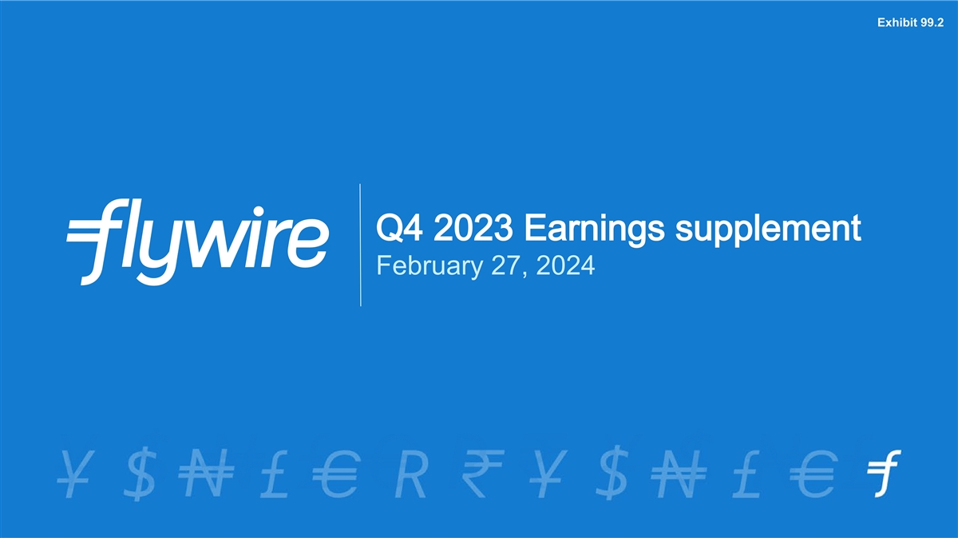
Exhibit 99.2 Q4 2023 Earnings supplement February 27, 2024

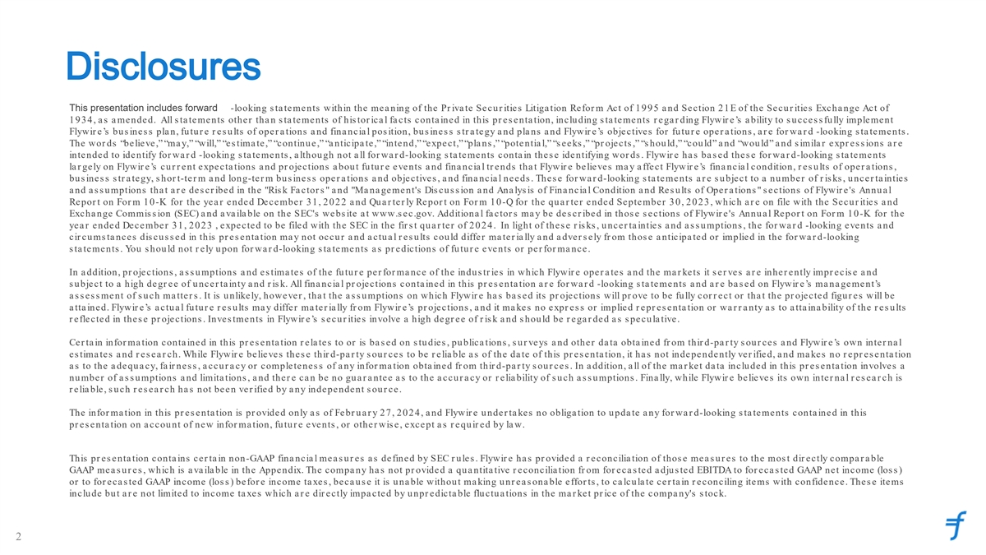
Disclosures This presentation includes forward -looking s ta tements within the mea ning of the Pr iva te Secur ities Litiga tion Refor m Act of 1995 a nd Section 21E of the Secur ities Excha nge Act of 1934, a s a mended. All s ta tements other tha n s ta tements of his tor ica l fa cts conta ined in this pr es enta tion, including s ta tements r ega r ding Flywir e’s a bility to s ucces s fully implement Flywir e’s bus ines s pla n, futur e r es ults of oper a tions a nd fina ncia l pos ition, bus ines s s tr a tegy a nd pla ns a nd Flywir e’s objectives for future opera tions , a re forwa rd -looking s tatements . The wor ds “believe,” “ma y,” “will,” “es tima te,” “continue,” “a nticipa te,” “intend,” “expect,” “pla ns ,” “potentia l,” “s eeks ,” “pr ojects ,” “s hould,” “could” a nd “would” a nd s imila r expr es s ions a r e intended to identify for wa r d -looking s ta tements , a lthough not a ll for wa r d-looking s ta tements conta in thes e identifying wor ds . Flywir e ha s ba s ed thes e for wa r d-looking s tatements la r gely on Flywir e’s cur r ent expecta tions a nd pr ojections a bout futur e events a nd fina ncia l tr ends tha t Flywir e believes ma y a ffect Flywir e’s fina ncia l condition, r es ults of oper a tions , business str a tegy, shor t-ter m a nd long-ter m bus ines s oper a tions a nd objectives , a nd fina ncia l needs . Thes e for wa r d-looking s tatements a r e s ubject to a number of r is ks , uncer ta inties a nd a s s umptions tha t a r e des cr ibed in the Ris k Fa ctor s a nd Ma na gement's Dis cus s ion a nd Ana lys is of Fina ncia l Condition a nd Res ults of Oper a tions s ections of Flywir e's Annua l Repor t on For m 10-K for the yea r ended December 31, 2022 a nd Qua r ter ly Repor t on For m 10-Q for the qua r ter ended September 30, 2023, which a r e on file with the Secur ities a nd Excha nge Commis s ion (SEC) a nd a va ila ble on the SEC's webs ite a t www.s ec.gov. Additiona l fa ctor s ma y be des cr ibed in thos e s ections of Flywir e's Annua l Repor t on For m 10-K for the yea r ended December 31, 2023 , expected to be filed with the SEC in the fir s t qua r ter of 2024. In light of thes e r is ks , uncer ta inties a nd a s s umptions , the for wa r d -looking events a nd cir cums ta nces dis cus s ed in this pr es enta tion ma y not occur a nd a ctua l r es ults could differ ma ter ia lly a nd a dver s ely fr om thos e a nticipa ted or implied in the for wa r d-looking s ta tements . You s hould not r ely upon for wa r d-looking s ta tements a s pr edictions of futur e events or per for ma nce. In a ddition, pr ojections , a s s umptions a nd es tima tes of the futur e per for ma nce of the indus tr ies in which Flywir e oper a tes a nd the ma r kets it s er ves a r e inher ently impr ecis e a nd s ubject to a high degr ee of uncer ta inty a nd r is k. All fina ncia l pr ojections conta ined in this pr es enta tion a r e for wa r d -looking s ta tements a nd a r e ba s ed on Flywir e’s ma na gement’s a s s es s ment of s uch ma tter s . It is unlikely, however , tha t the a s s umptions on which Flywir e ha s ba s ed its pr ojections will pr ove to be fully cor r ect or tha t the pr ojected figur es will be a tta ined. Flywir e’s a ctua l futur e r es ults ma y differ ma ter ia lly fr om Flywir e’s pr ojections , a nd it ma kes no expr es s or implied r epr es enta tion or wa r r a nty a s to a tta ina bility of the r es ults r eflected in thes e pr ojections . Inves tments in Flywir e’s s ecur ities involve a high degr ee of r is k a nd s hould be r ega r ded a s s pecula tive. Cer ta in infor ma tion conta ined in this pr es enta tion r ela tes to or is ba s ed on s tudies , publica tions , s ur veys a nd other da ta obta ined fr om thir d-pa r ty s our ces a nd Flywir e’s own inter na l es tima tes a nd r es ea r ch. While Flywir e believes thes e thir d-pa r ty s our ces to be r elia ble a s of the da te of this pr es enta tion, it ha s not independently ver ified, a nd ma kes no r epr es enta tion as to the adequacy, fair nes s , accur acy or completenes s of any infor mation obtained fr om thir d-pa r ty s our ces . In a ddition, a ll of the ma r ket da ta included in this pr es enta tion involves a number of a s s umptions a nd limita tions , a nd ther e ca n be no gua r a ntee a s to the a ccur a cy or r elia bility of s uch a s s umptions . Fina lly, while Flywir e believes its own inter na l r es ea r ch is r elia ble, s u ch r es ea r ch ha s not been ver ified by a ny independent s ou r ce. The infor ma tion in this pr es enta tion is pr ovided only a s of Febr ua r y 27, 2024, a nd Flywir e under ta kes no obliga tion to upda te any forwa rd-looking s tatements contained in this pr es enta tion on a ccount of new infor ma tion, futur e events , or other wis e, except a s r equir ed by la w. This pr es enta tion conta ins cer ta in non-GAAP fina ncia l mea s ur es a s defined by SEC r ules . Flywir e ha s pr ovided a r econcilia tion of thos e mea s ur es to the mos t dir ectly compa r a ble GAAP mea s ur es , which is a va ila ble in the Appendix. The compa ny ha s not pr ovided a qua ntita tive r econcilia tion fr om for eca s ted adjus ted EBITDA to for eca s ted GAAP net income (los s ) or to for eca s ted GAAP income (los s ) befor e income ta xes , beca us e it is una ble without ma king unr ea s ona ble effor ts , to ca lcula te cer ta in r econciling items with confidence. Thes e items include but a r e not limited to income ta xes which a r e dir ectly impa cted by unpr edicta ble fluctua tions in the ma r ket pr ice of the company's s tock. 2


Execution Fulfillment Our mission is to deliver the most important and complex payments 3

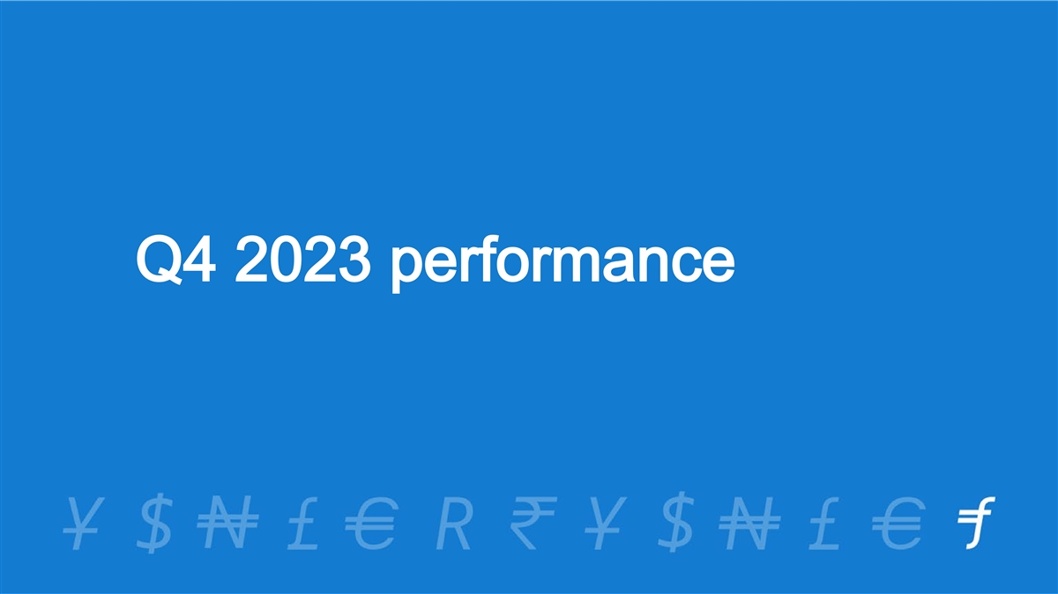
Q4 2023 performance

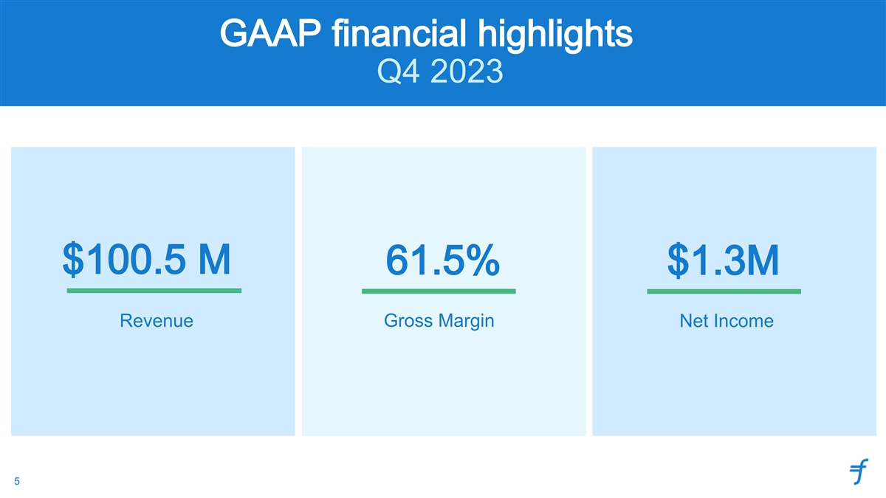
GAAP financial highlights Q4 2023 $100.5 M 61.5% $1.3M Revenue Gross Margin Net Income 5

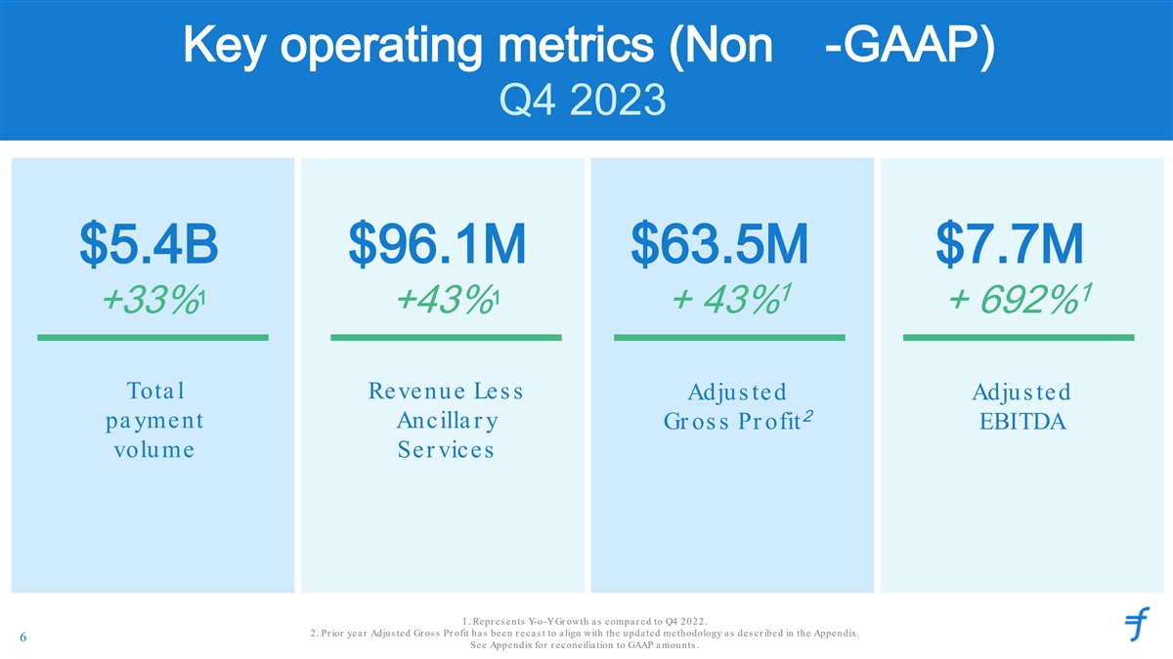
Key operating metrics (Non -GAAP) Q4 2023 $5.4B $96.1M $63.5M $7.7M 1 1 1 1 +33% +43% + 43% + 692% Tota l Revenue Les s Adjus ted Adjus ted 2 pa yment Ancilla r y Gr os s Pr ofit EBITDA volume Ser vices 1. Repr es ents Y-o-Y Gr owth a s compa r ed to Q4 2022. 2. Pr ior yea r Adjus ted Gr os s Pr ofit ha s been r eca s t to a lign with the upda ted methodology a s des cr ibed in the Appendix. 6 See Appendix for r econcilia tion to GAAP a mounts .


FY 2023 performance

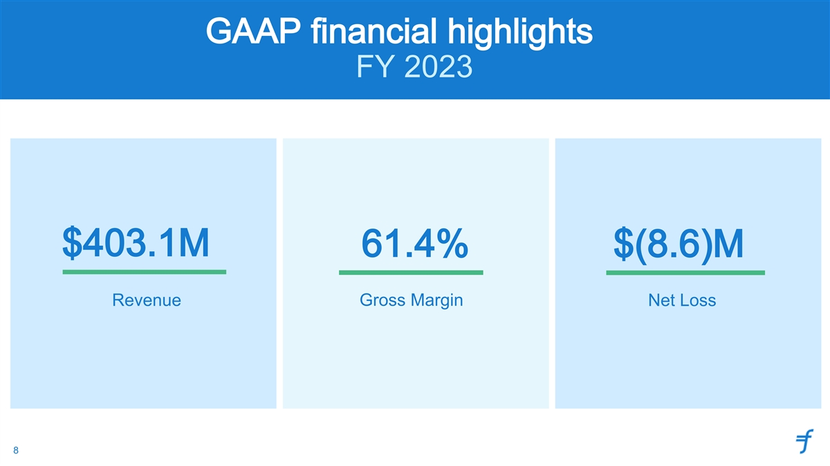
GAAP financial highlights FY 2023 $403.1M 61.4% $(8.6)M Revenue Gross Margin Net Loss 8

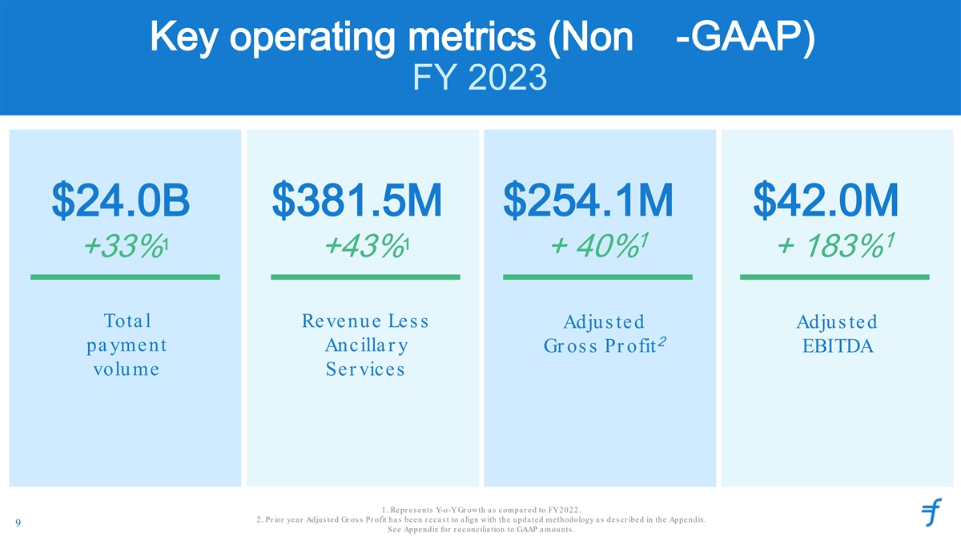
Key operating metrics (Non -GAAP) FY 2023 $24.0B $381.5M $254.1M $42.0M 1 1 1 1 +33% +43% + 40% + 183% Tota l Revenue Les s Adjus ted Adjus ted 2 pa yment Ancilla r y Gr os s Pr ofit EBITDA volume Ser vices 1. Repr es ents Y-o-Y Gr owth a s compa r ed to FY 2022. 2. Pr ior yea r Adjus ted Gr os s Pr ofit ha s been r eca s t to a lign with the upda ted methodology a s des cr ibed in the Appendix. 9 See Appendix for r econcilia tion to GAAP a mounts .


Business update

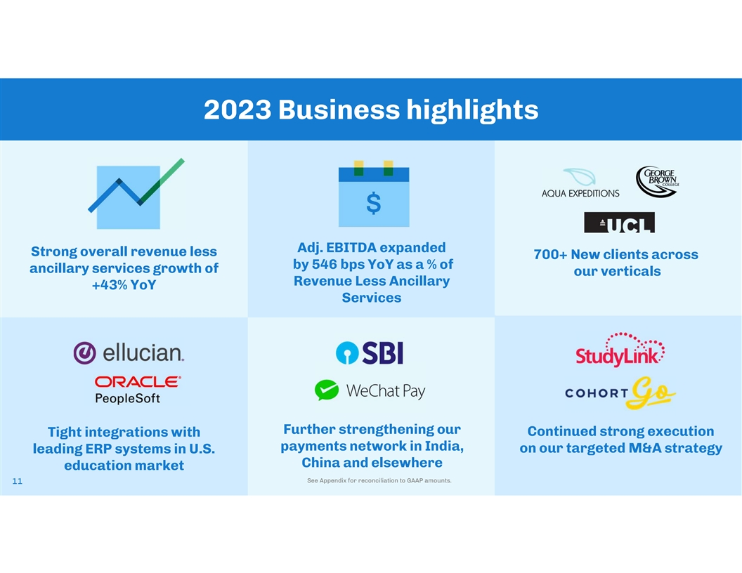
2023 Business highlights Adj. EBITDA expanded Strong overall revenue less 700+ New clients across by 546 bps YoY as a % of ancillary services growth of our verticals Revenue Less Ancillary +43% YoY Services [Add Image]S tudy Further strengthening our Continued strong execution Tight integrations with payments network in India, leading ERP systems in U.S. on our targeted M&A strategy China and elsewhere education market See Appendix for reconciliation to GAAP amounts. 11 1

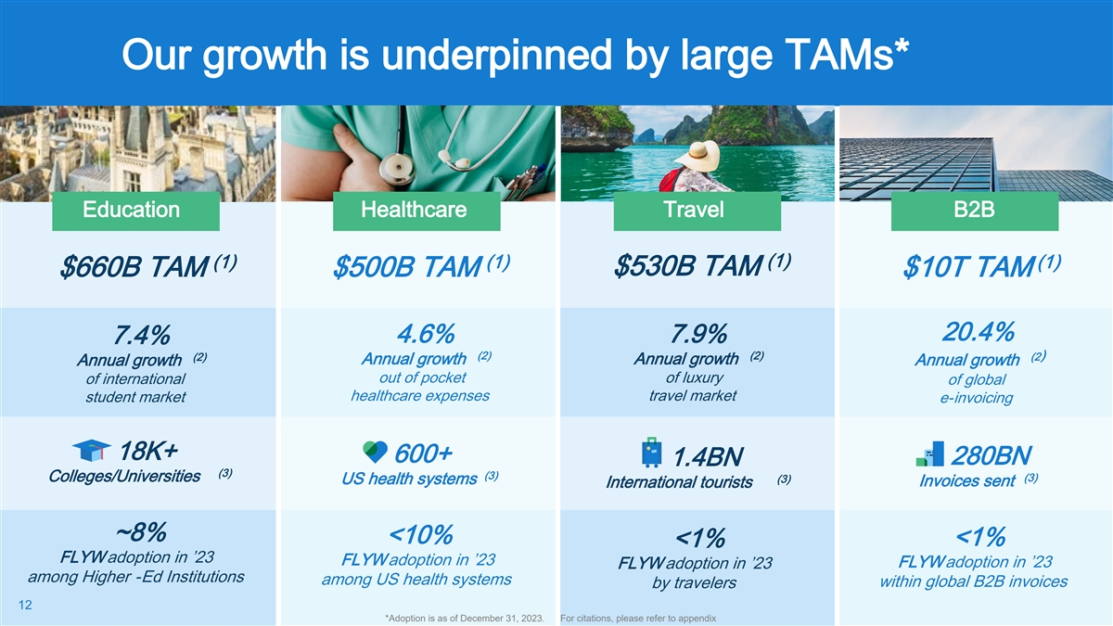
Our growth is underpinned by large TAMs* Education Healthcare Travel B2B (1) (1) (1) (1) $530B TAM $660B TAM $500B TAM $10T TAM 20.4% 4.6% 7.9% 7.4% (2) (2) ) (2) (2 Annual growth Annual growth Annual growth Annual growth out of pocket of luxury of international of global healthcare expenses travel market student market e-invoicing 18K+ 600+ 280BN 1.4BN (3) (3) (3) Colleges/Universities (3) US health systems Invoices sent International tourists ~8% <10% <1% <1% FLYW adoption in ’23 FLYW adoption in ’23 FLYW adoption in ’23 FLYW adoption in ’23 among Higher -Ed Institutions among US health systems within global B2B invoices by travelers 12 *Adoption is as of December 31, 2023. For citations, please refer to appendix

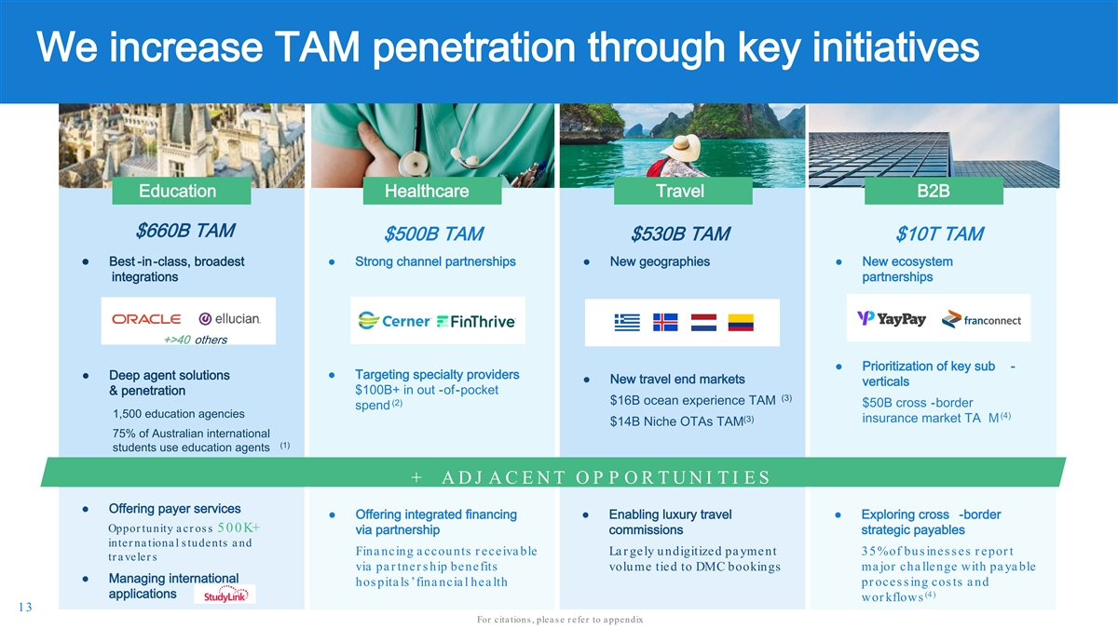
We increase TAM penetration through key initiatives Education Healthcare Travel B2B $660B TAM $500B TAM $530B TAM $10T TAM ● Best -in-class, broadest● Strong channel partnerships● New geographies● New ecosystem integrations partnerships +>40 others ● Prioritization of key sub - ● Deep agent solutions● Targeting specialty providers ● New travel end markets verticals $100B+ in out -of-pocket & penetration (3) $16B ocean experience TAM (2) $50B cross -border spend 1,500 education agencies (4) (3) insurance market TA M $14B Niche OTAs TAM 75% of Australian international (1) students use education agents + A D J A C E N T O P P O R T U N I T I E S ● Offering payer services ● Offering integrated financing ● Enabling luxury travel ● Exploring cross -border Oppor tunity a cr os s 500K+ via partnership commissions strategic payables inter na tiona l s tudents a nd Fina nc ing a c c ou nts r e c e iva ble La r ge ly u ndigitize d pa yme nt 3 5 % of bu s ine s s e s r e por t tr a veler s via pa r tne r s hip be ne fits volu me tied to DMC bookings major challe nge with payable ● Managing international hos pitals ’ financial he alth pr oce s s ing cos ts and applications (4) wor kflows 13 For cita tions , plea s e r efer to a ppendix

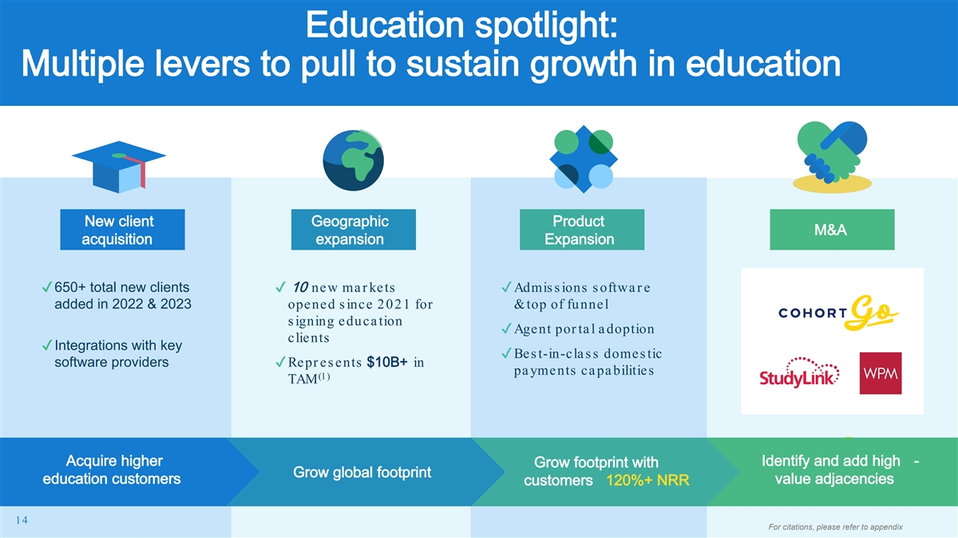
Education spotlight: Multiple levers to pull to sustain growth in education New client Geographic Product M&A acquisition expansion Expansion ✔650+ total new clients ✔ 10 new ma r kets ✔Admissions softwa r e added in 2022 & 2023 ope ne d s ince 2021 for & top of funnel s igning educa tion ✔Agent por ta l a doption clients ✔Integrations with key ✔Bes t-in-cla ss domestic software providers ✔Repr es ents $10B+ in pa yments ca pa bilities (1) TAM Acquire higher Identify and add high - Grow footprint with Grow global footprint education customers value adjacencies customers 120%+ NRR 14 For citations, please refer to appendix

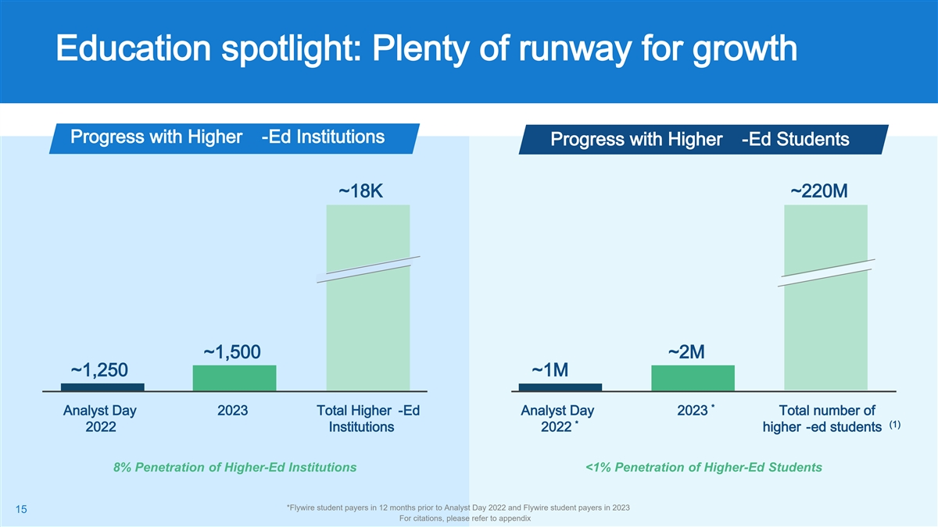
Education spotlight: Plenty of runway for growth Progress with Higher -Ed Institutions Progress with Higher -Ed Students ~18K ~220M ~1,500 ~2M ~1,250 ~1M * Analyst Day 2023 Total Higher -Ed Analyst Day 2023 Total number of * (1) 2022 Institutions 2022 higher -ed students 8% Penetration of Higher-Ed Institutions <1% Penetration of Higher-Ed Students *Flywire student payers in 12 months prior to Analyst Day 2022 and Flywire student payers in 2023 15 For citations, please refer to appendix

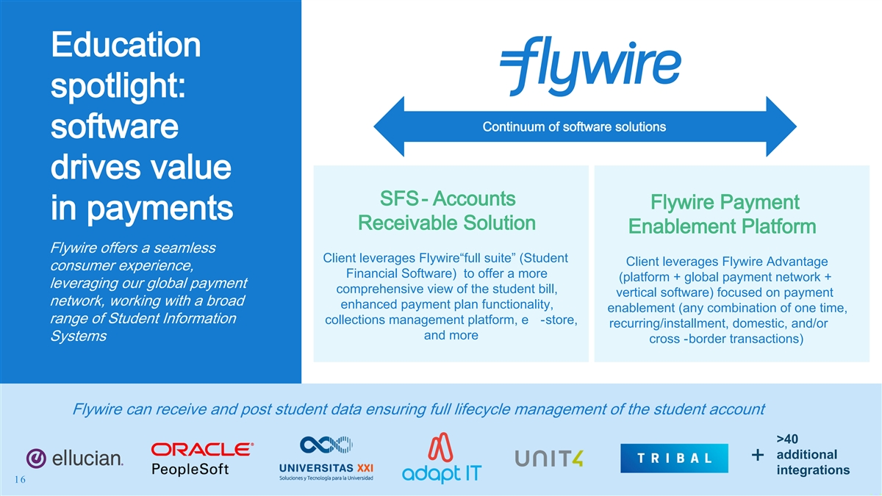
Education spotlight: Continuum of software solutions software drives value SFS - Accounts Flywire Payment in payments Receivable Solution Enablement Platform Flywire offers a seamless Client leverages Flywire“full suite” (Student Client leverages Flywire Advantage consumer experience, Financial Software) to offer a more (platform + global payment network + leveraging our global payment comprehensive view of the student bill, vertical software) focused on payment network, working with a broad enhanced payment plan functionality, enablement (any combination of one time, range of Student Information collections management platform, e -store, recurring/installment, domestic, and/or and more Systems cross -border transactions) Flywire can receive and post student data ensuring full lifecycle management of the student account >40 additional + Integrations with all major ERP/SIS providers to support both use cases integrations 16

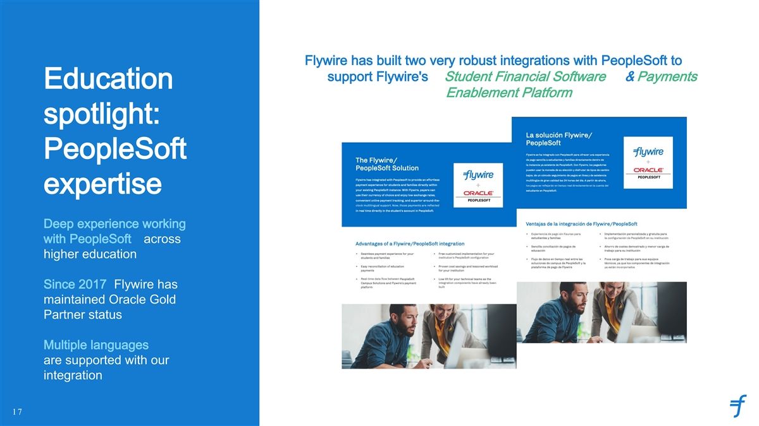
Flywire has built two very robust integrations with PeopleSoft to support Flywire's Student Financial Software & Payments Education Enablement Platform spotlight: PeopleSoft expertise Deep experience working with PeopleSoft across higher education Since 2017 Flywire has maintained Oracle Gold Partner status Multiple languages are supported with our integration 17

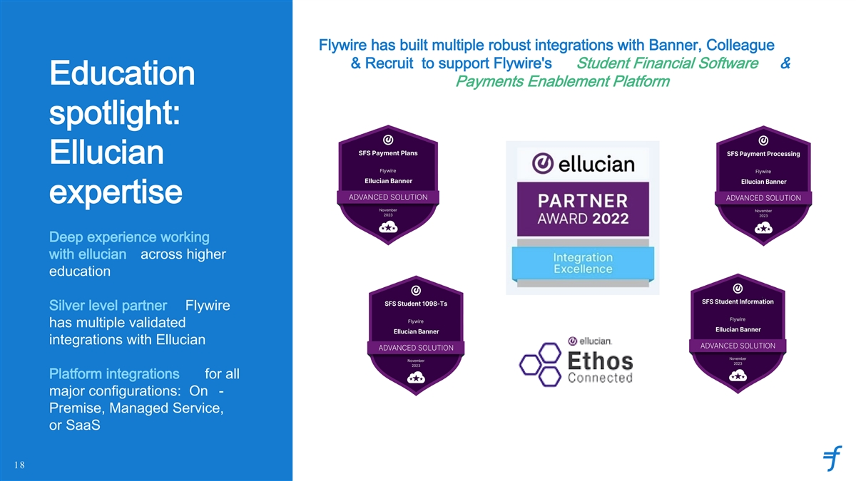
Flywire has built multiple robust integrations with Banner, Colleague & Recruit to support Flywire's Student Financial Software & Education Payments Enablement Platform spotlight: Ellucian expertise Deep experience working with ellucian across higher education Silver level partner Flywire has multiple validated integrations with Ellucian Platform integrations for all major configurations: On - Premise, Managed Service, or SaaS 18

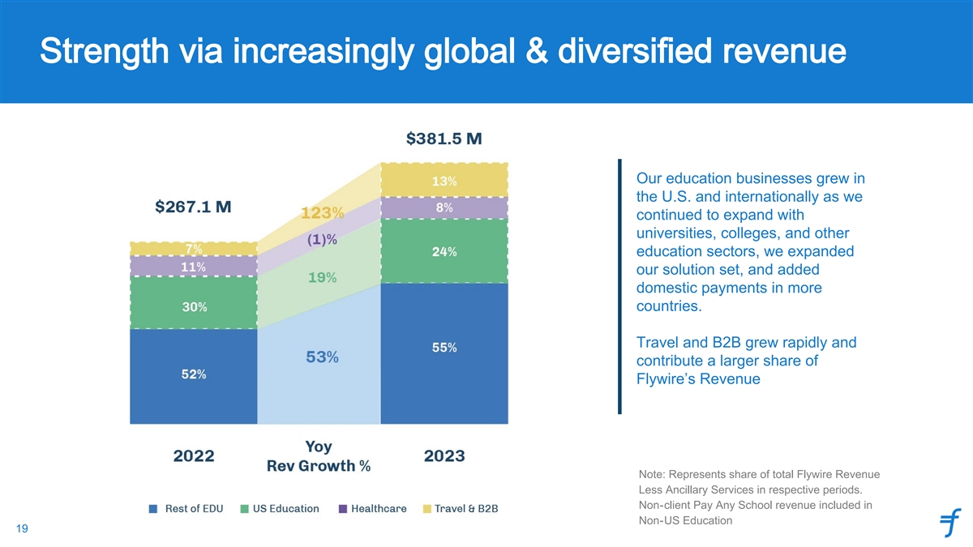
Strength via increasingly global & diversified revenue Our education businesses grew in the U.S. and internationally as we continued to expand with universities, colleges, and other education sectors, we expanded our solution set, and added domestic payments in more countries. Travel and B2B grew rapidly and contribute a larger share of Flywire’s Revenue Note: Represents share of total Flywire Revenue Less Ancillary Services in respective periods. Non-client Pay Any School revenue included in Non-US Education 19

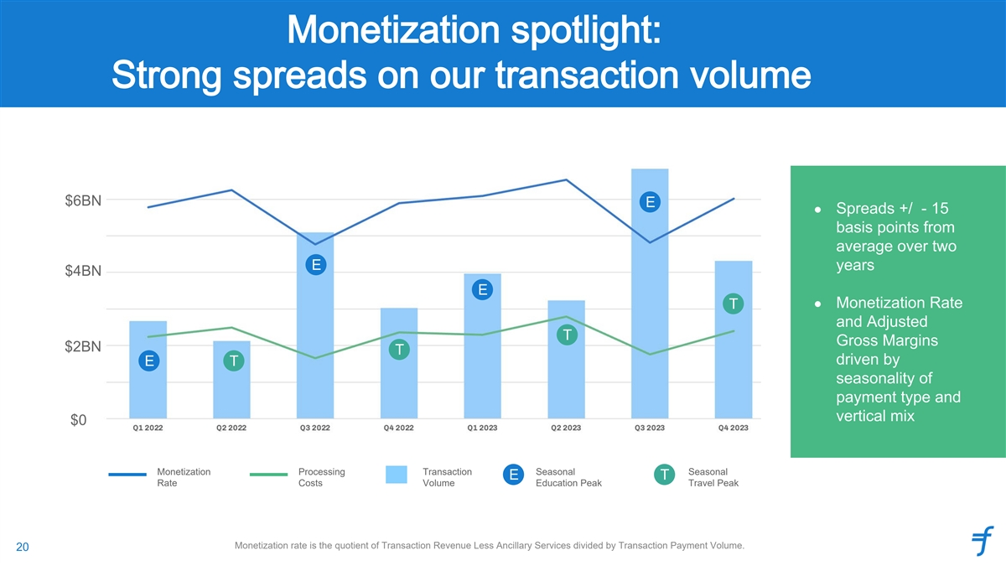
Monetization spotlight: Strong spreads on our transaction volume $6BN E ● Spreads +/ - 15 basis points from average over two E years $4BN E ● Monetization Rate T and Adjusted T Gross Margins $2BN T driven by E T seasonality of payment type and vertical mix $0 Monetization Processing Transaction Seasonal Seasonal E T Rate Costs Volume Education Peak Travel Peak Monetization rate is the quotient of Transaction Revenue Less Ancillary Services divided by Transaction Payment Volume. 20


Growth algorithm

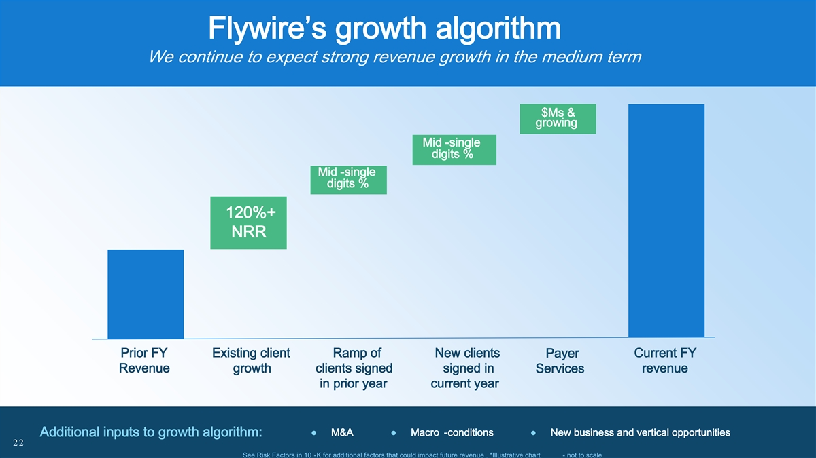
Flywire’s growth algorithm We continue to expect strong revenue growth in the medium term $Ms & growing Mid -single digits % Mid -single digits % 120%+ NRR Prior FY Existing client Ramp of New clients Current FY Payer Revenue growth clients signed signed in revenue Services in prior year current year ● M&A● Macro -conditions● New business and vertical opportunities Additional inputs to growth algorithm: 22 See Risk Factors in 10 -K for additional factors that could impact future revenue . *Illustrative chart - not to scale

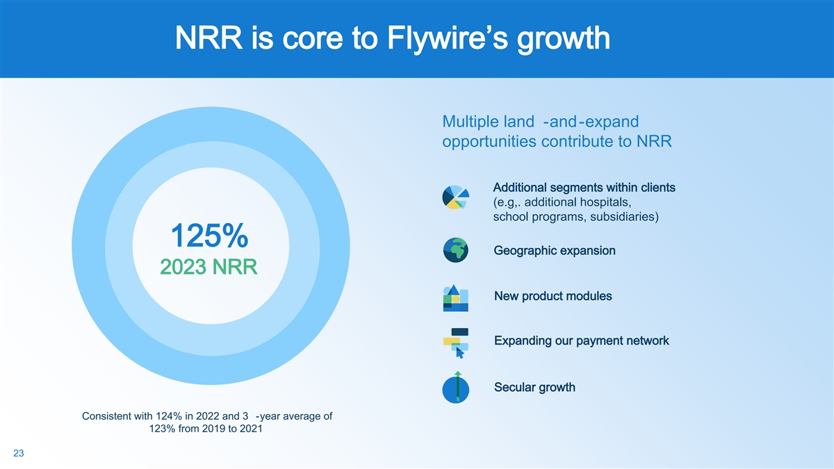
NRR is core to Flywire’s growth Multiple land -and-expand opportunities contribute to NRR Additional segments within clients (e.g,. additional hospitals, school programs, subsidiaries) 125% Geographic expansion 2023 NRR New product modules Expanding our payment network Secular growth Consistent with 124% in 2022 and 3 -year average of 123% from 2019 to 2021 23

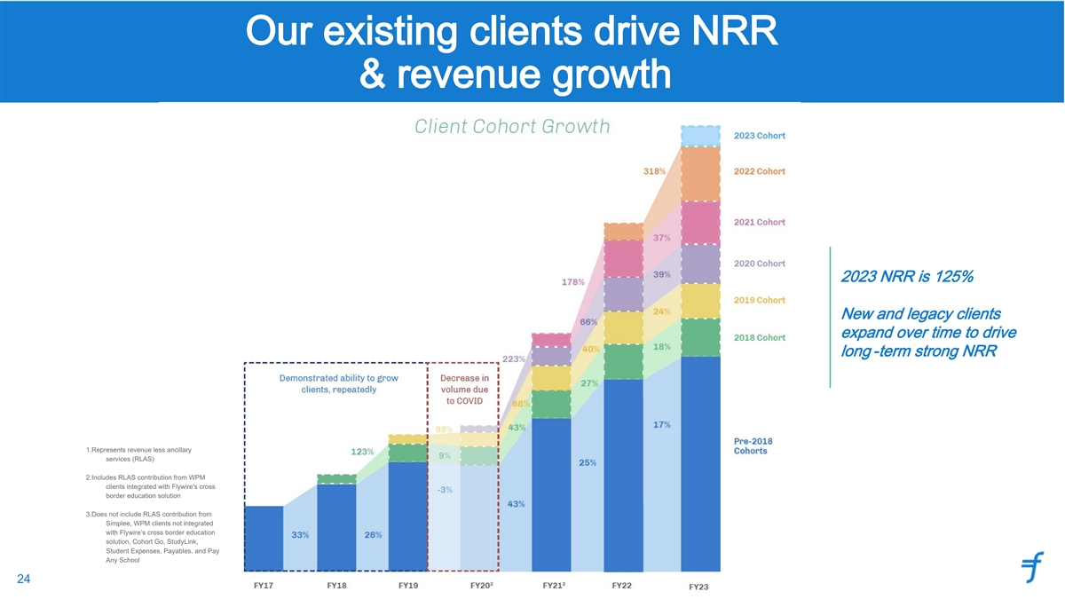
Our existing clients drive NRR & revenue growth 2023 NRR is 125% New and legacy clients expand over time to drive long -term strong NRR 1.Represents revenue less ancillary services (RLAS) 2.Includes RLAS contribution from WPM clients integrated with Flywire's cross border education solution 3.Does not include RLAS contribution from Simplee, WPM clients not integrated with Flywire’s cross border education solution, Cohort Go, StudyLink, Student Expenses, Payables, and Pay Any School 24

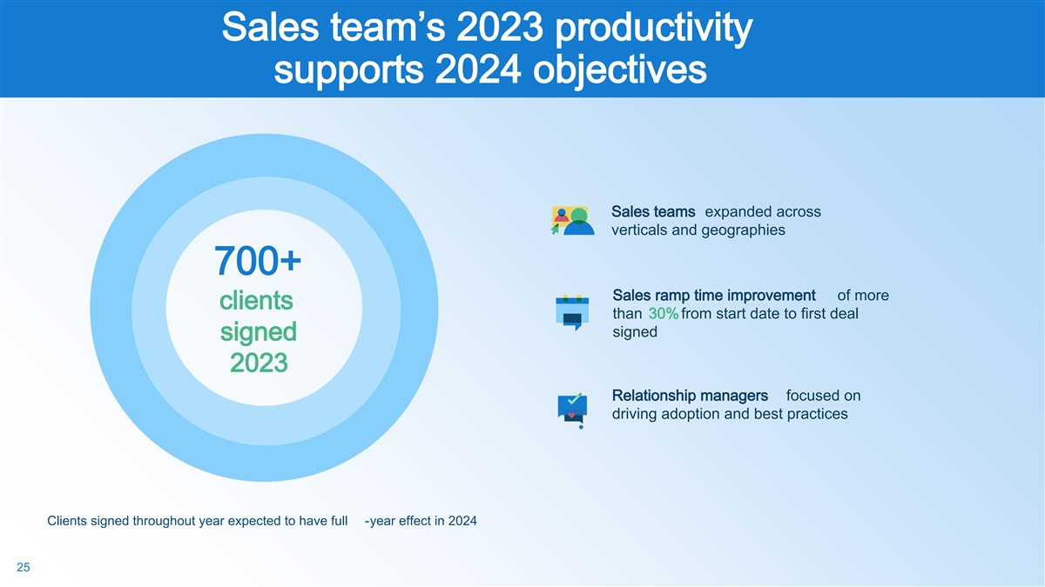
Sales team’s 2023 productivity supports 2024 objectives Sales teams expanded across verticals and geographies 700+ Sales ramp time improvement of more clients than 30% from start date to first deal signed signed 2023 Relationship managers focused on driving adoption and best practices Clients signed throughout year expected to have full -year effect in 2024 25

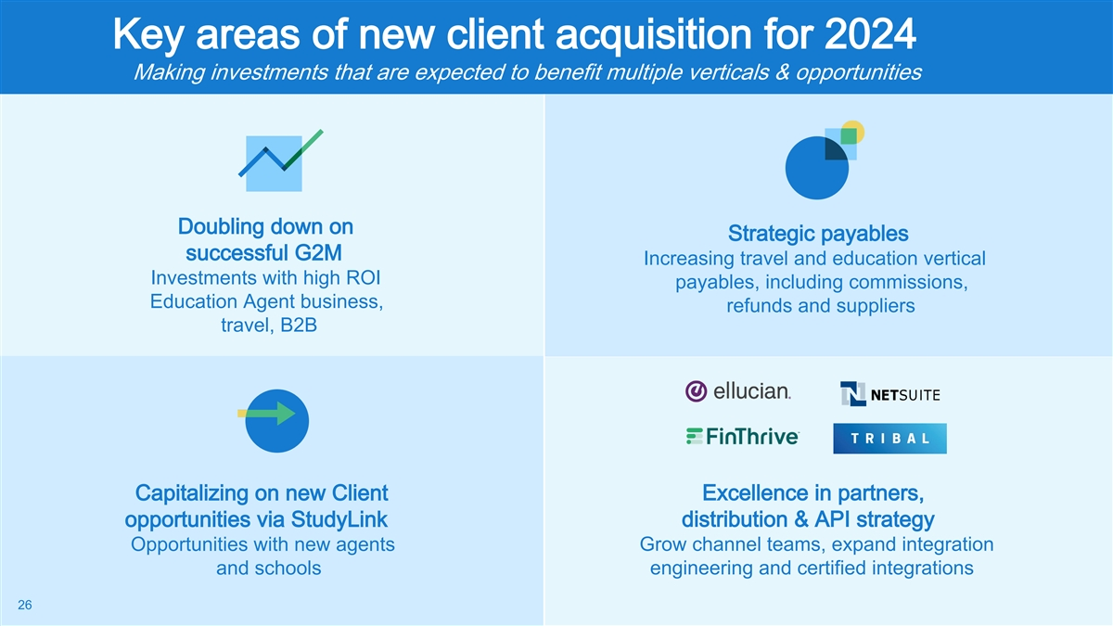
Key areas of new client acquisition for 2024 Making investments that are expected to benefit multiple verticals & opportunities Doubling down on Strategic payables successful G2M Increasing travel and education vertical Investments with high ROI payables, including commissions, Education Agent business, refunds and suppliers travel, B2B Capitalizing on new Client Excellence in partners, distribution & API strategy opportunities via StudyLink Opportunities with new agents Grow channel teams, expand integration and schools engineering and certified integrations 26

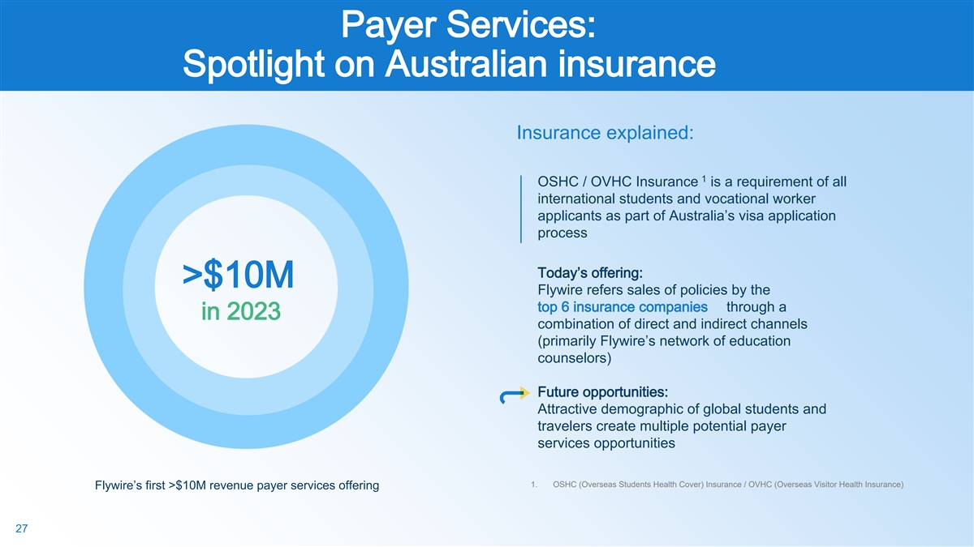
Payer Services: Spotlight on Australian insurance Insurance explained: 1 OSHC / OVHC Insurance is a requirement of all international students and vocational worker applicants as part of Australia’s visa application process Today’s offering: >$10M Flywire refers sales of policies by the top 6 insurance companies through a in 2023 combination of direct and indirect channels (primarily Flywire’s network of education counselors) Future opportunities: Attractive demographic of global students and travelers create multiple potential payer services opportunities 1. OSHC (Overseas Students Health Cover) Insurance / OVHC (Overseas Visitor Health Insurance) Flywire’s first >$10M revenue payer services offering 27


Financial outlook

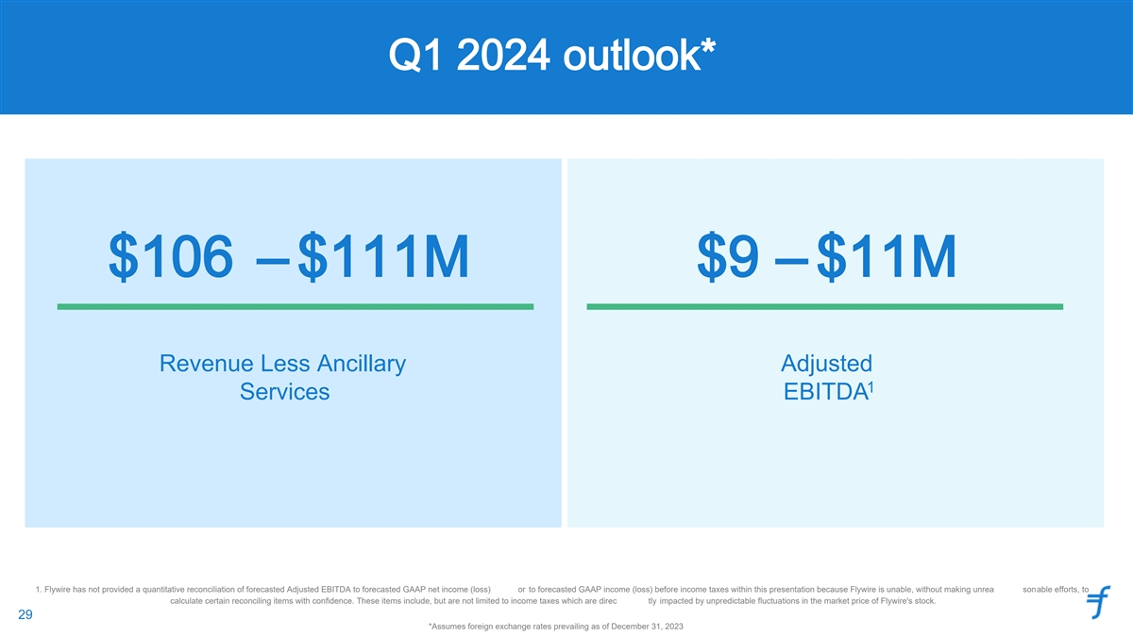
Q1 2024 outlook* $106 – $111M $9 – $11M Revenue Less Ancillary Adjusted 1 Services EBITDA 1. Flywire has not provided a quantitative reconciliation of forecasted Adjusted EBITDA to forecasted GAAP net income (loss) or to forecasted GAAP income (loss) before income taxes within this presentation because Flywire is unable, without making unrea sonable efforts, to calculate certain reconciling items with confidence. These items include, but are not limited to income taxes which are direc tly impacted by unpredictable fluctuations in the market price of Flywire's stock. 29 29 *Assumes foreign exchange rates prevailing as of December 31, 2023

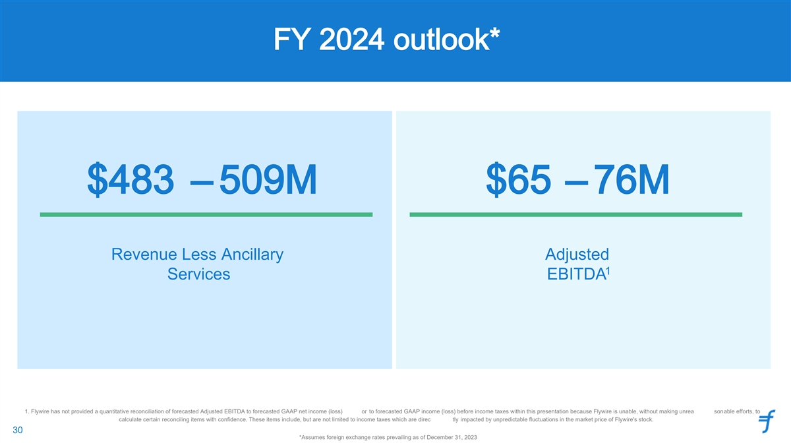
FY 2024 outlook* $483 – 509M $65 – 76M Revenue Less Ancillary Adjusted 1 Services EBITDA 1. Flywire has not provided a quantitative reconciliation of forecasted Adjusted EBITDA to forecasted GAAP net income (loss) or to forecasted GAAP income (loss) before income taxes within this presentation because Flywire is unable, without making unrea sonable efforts, to calculate certain reconciling items with confidence. These items include, but are not limited to income taxes which are direc tly impacted by unpredictable fluctuations in the market price of Flywire's stock. 30 30 *Assumes foreign exchange rates prevailing as of December 31, 2023


Appendix

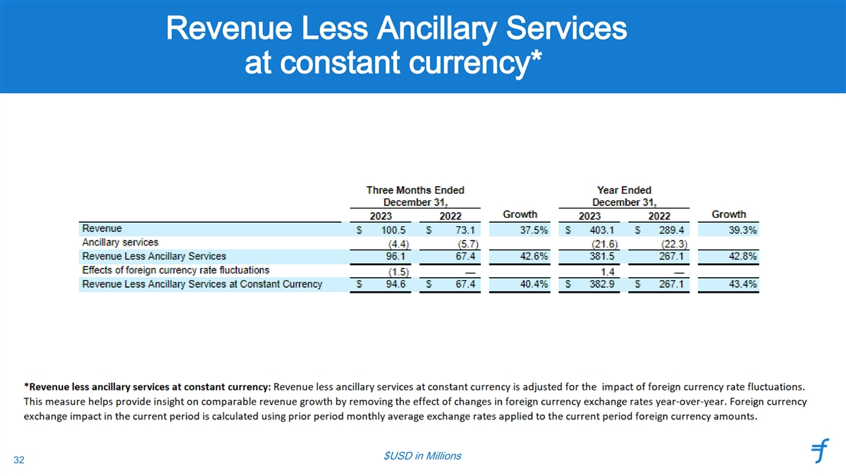
Revenue Less Ancillary Services at constant currency* $USD in Millions 32

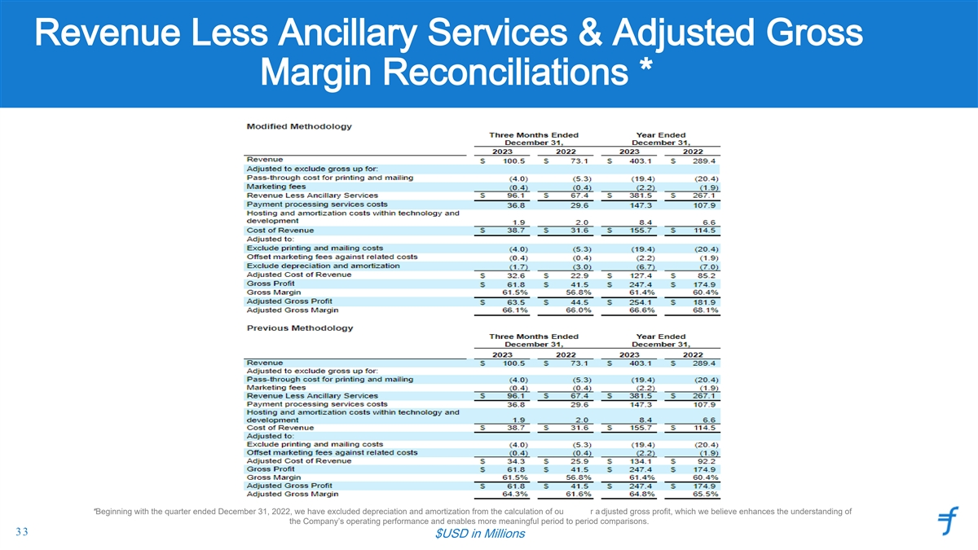
Revenue Less Ancillary Services & Adjusted Gross Margin Reconciliations * *Beginning with the quarter ended December 31, 2022, we have excluded depreciation and amortization from the calculation of ou r a djusted gross profit, which we believe enhances the understanding of the Company’s operating performance and enables more meaningful period to period comparisons. 33 $USD in Millions

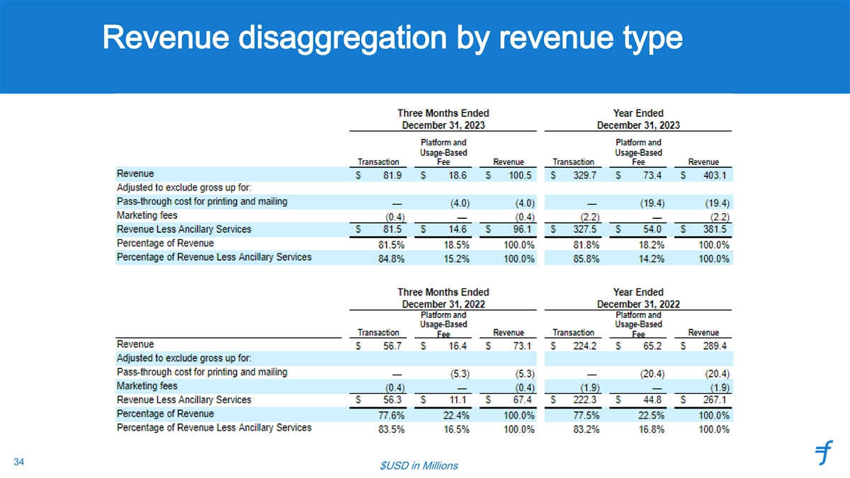
Revenue disaggregation by revenue type 34 $USD in Millions

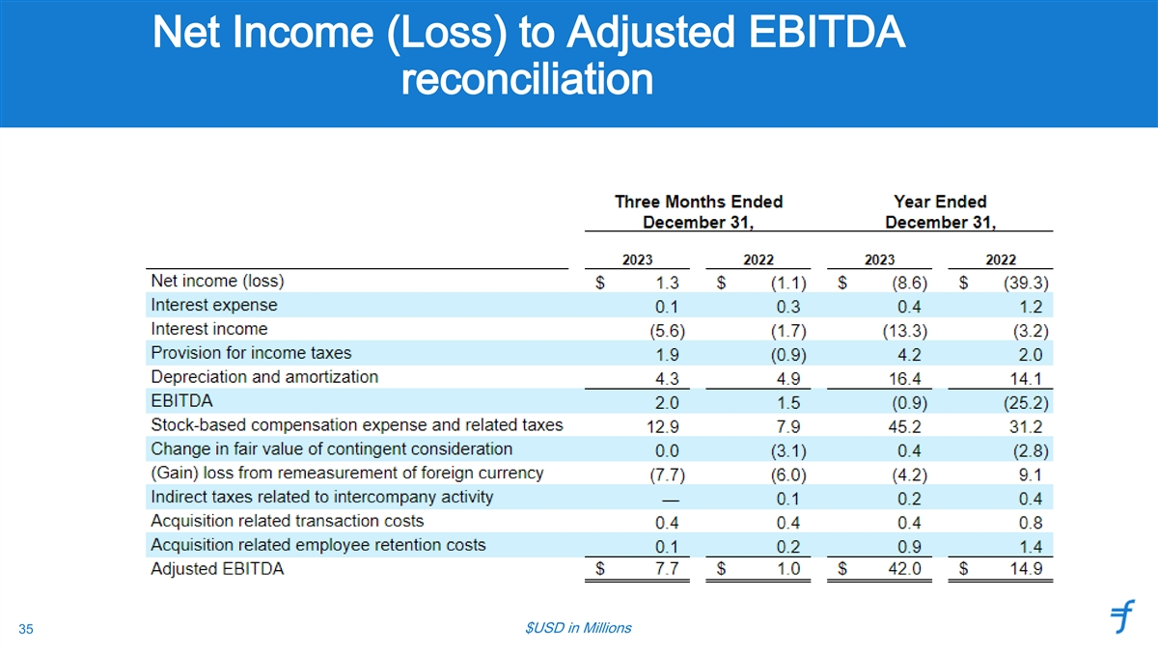
Net Income (Loss) to Adjusted EBITDA reconciliation $USD in Millions 35

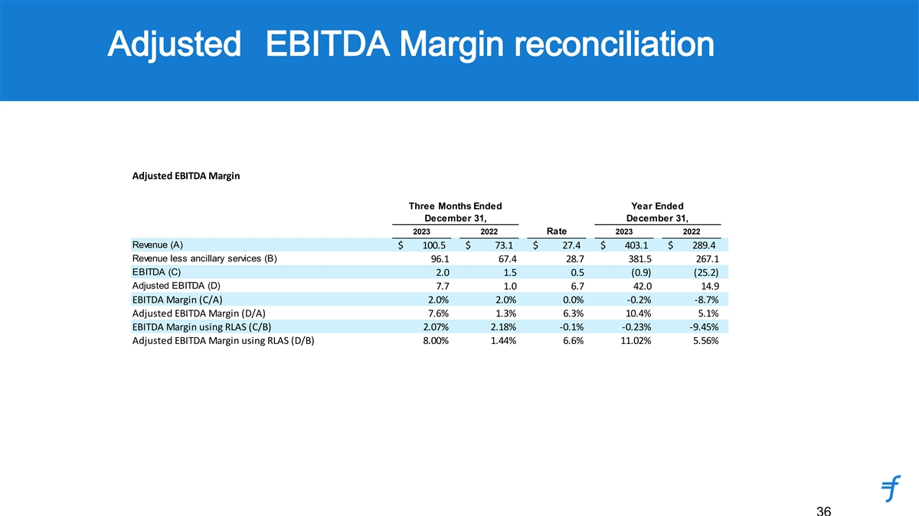
Adjusted EBITDA Margin reconciliation Adjusted EBITDA Margin Three Months Ended Year Ended December 31, December 31, 2023 2022 Rate 2023 2022 Revenue (A) $ 100.5 $ 73.1 $ 27.4 $ 403. 1 $ 289. 4 Revenue less ancillary services (B) 96.1 67.4 28.7 381.5 267.1 EBITDA (C) 2.0 1.5 0.5 (0.9) (25.2) Adjusted EBITDA (D) 7.7 1.0 6.7 42.0 14.9 EBITDA Margin (C/A) 2.0% 2.0% 0.0% -0.2% -8.7% Adjusted EBITDA Margin (D/A) 7.6% 1.3% 6.3% 10.4% 5.1% EBITDA Margin using RLAS (C/B) 2.07% 2.18% -0.1% -0.23% -9.45% Adjusted EBITDA Margin using RLAS (D/B) 8.00% 1.44% 6.6% 11.02% 5.56% 36

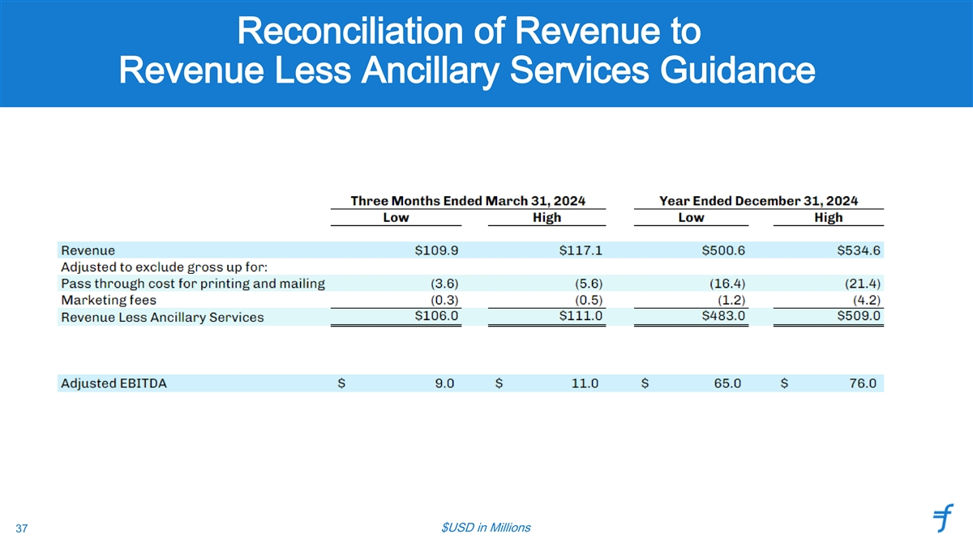
Reconciliation of Revenue to Revenue Less Ancillary Services Guidance $USD in Millions 37

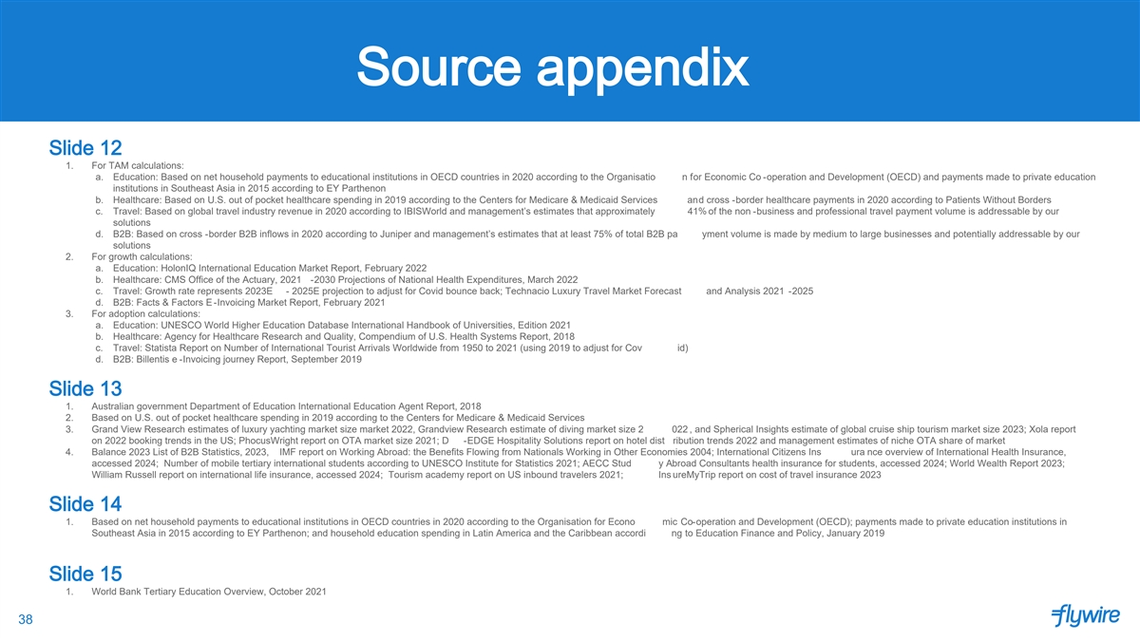
Source appendix Slide 12 1. For TAM calculations: a. Education: Based on net household payments to educational institutions in OECD countries in 2020 according to the Organisatio n for Economic Co -operation and Development (OECD) and payments made to private education institutions in Southeast Asia in 2015 according to EY Parthenon b. Healthcare: Based on U.S. out of pocket healthcare spending in 2019 according to the Centers for Medicare & Medicaid Services and cross -border healthcare payments in 2020 according to Patients Without Borders c. Travel: Based on global travel industry revenue in 2020 according to IBISWorld and management’s estimates that approximately 41% of the non -business and professional travel payment volume is addressable by our solutions d. B2B: Based on cross -border B2B inflows in 2020 according to Juniper and management’s estimates that at least 75% of total B2B pa yment volume is made by medium to large businesses and potentially addressable by our solutions 2. For growth calculations: a. Education: HolonIQ International Education Market Report, February 2022 b. Healthcare: CMS Office of the Actuary, 2021 -2030 Projections of National Health Expenditures, March 2022 c. Travel: Growth rate represents 2023E - 2025E projection to adjust for Covid bounce back; Technacio Luxury Travel Market Forecast and Analysis 2021 -2025 d. B2B: Facts & Factors E-Invoicing Market Report, February 2021 3. For adoption calculations: a. Education: UNESCO World Higher Education Database International Handbook of Universities, Edition 2021 b. Healthcare: Agency for Healthcare Research and Quality, Compendium of U.S. Health Systems Report, 2018 c. Travel: Statista Report on Number of International Tourist Arrivals Worldwide from 1950 to 2021 (using 2019 to adjust for Cov id) d. B2B: Billentis e -Invoicing journey Report, September 2019 Slide 13 1. Australian government Department of Education International Education Agent Report, 2018 2. Based on U.S. out of pocket healthcare spending in 2019 according to the Centers for Medicare & Medicaid Services 3. Grand View Research estimates of luxury yachting market size market 2022, Grandview Research estimate of diving market size 2 022 , and Spherical Insights estimate of global cruise ship tourism market size 2023; Xola report on 2022 booking trends in the US; PhocusWright report on OTA market size 2021; D -EDGE Hospitality Solutions report on hotel dist ribution trends 2022 and management estimates of niche OTA share of market 4. Balance 2023 List of B2B Statistics, 2023, IMF report on Working Abroad: the Benefits Flowing from Nationals Working in Other Economies 2004; International Citizens Ins ura nce overview of International Health Insurance, accessed 2024; Number of mobile tertiary international students according to UNESCO Institute for Statistics 2021; AECC Stud y Abroad Consultants health insurance for students, accessed 2024; World Wealth Report 2023; William Russell report on international life insurance, accessed 2024; Tourism academy report on US inbound travelers 2021; Ins ureMyTrip report on cost of travel insurance 2023 Slide 14 1. Based on net household payments to educational institutions in OECD countries in 2020 according to the Organisation for Econo mic Co-operation and Development (OECD); payments made to private education institutions in Southeast Asia in 2015 according to EY Parthenon; and household education spending in Latin America and the Caribbean accordi ng to Education Finance and Policy, January 2019 Slide 15 1. World Bank Tertiary Education Overview, October 2021 38

