UNITED STATES
SECURITIES AND EXCHANGE COMMISSION
Washington, D.C. 20549

FORM 8-K

CURRENT REPORT
Pursuant to Section 13 or 15(d)
of the Securities Exchange Act of 1934
Date of Report (Date of earliest event reported): August 8, 2023

FLYWIRE CORPORATION
(Exact name of Registrant as specified in its charter)

Delaware |  | 001-40430 |  | 27-0690799
(State or other jurisdiction  of incorporation) |  | (Commission  File No.) |  | (IRS Employer  Identification No.)

141 Tremont St #10
Boston, MA 02111
(Address of principal executive offices and zip code)
Registrant’s telephone number, including area code: (617) 329-4524
Not Applicable
(Former Name or Former Address, if Changed Since Last Report)

Check the appropriate box below if the Form 8-K filing is intended to simultaneously satisfy the filing obligation of the registrant under any of the following provisions:

☐ | Written communications pursuant to Rule 425 under the Securities Act (17 CFR 230.425)

☐ | Soliciting material pursuant to Rule 14a-12 under the Exchange Act (17 CFR 240.14a-12)

☐ | Pre-commencement communications pursuant to Rule 14d-2(b) under the Exchange Act (17 CFR 240.14d-2(b))

☐ | Pre-commencement communications pursuant to Rule 13e-4(c) under the Exchange Act (17 CFR 240.13e-4(c))
Securities registered pursuant to Section 12(b) of the Act:

Title of each class |  | Trading  Symbol(s) |  | Name of each exchange  on which registered
Voting Common Stock, $0.0001 par value per share |  | FLYW |  | The Nasdaq Stock Market LLC  (Nasdaq Global Select Market)
Indicate by check mark whether the registrant is an emerging growth company as defined in Rule 405 of the Securities Act of 1933 (§230.405 of this chapter) or Rule 12b-2 of the Securities Exchange Act of 1934 (§240.12b-2 of this chapter).
Emerging growth company ☐
If an emerging growth company, indicate by check mark if the registrant has elected not to use the extended transition period for complying with any new or revised financial accounting standards provided pursuant to Section 13(a) of the Exchange Act. ☐

Item 2.02. | Results of Operations and Financial Condition.
On August 8, 2023, Flywire Corporation (“Flywire” or the “Company”) issued a press release (the “Press Release”) and is holding a conference call regarding its preliminary and unaudited financial results for the quarter ended June 30, 2023. The Press Release is furnished as Exhibit 99.1 to this Current Report on Form 8-K and is incorporated by reference herein.
Various statements to be made during the conference call are “forward-looking statements” within the meaning of the Private Securities Litigation Reform Act of 1995, including, but not limited to, statements regarding Flywire’s future operating results and financial position, Flywire’s business strategy and plans, market growth, and Flywire’s objectives for future operations. Flywire intends such forward-looking statements to be covered by the safe harbor provisions for forward-looking statements contained in Section 21E of the Securities Exchange Act of 1934 and the Private Securities Litigation Reform Act of 1995. In some cases, you can identify forward-looking statements by terms such as, but not limited to, “believe,” “may,” “will,” “potentially,” “estimate,” “continue,” “anticipate,” “intend,” “could,” “would,” “project,” “target,” “plan,” “expect,” or the negative of these terms, and similar expressions intended to identify forward-looking statements. Such forward-looking statements are based upon current expectations that involve risks, changes in circumstances, assumptions, and uncertainties. Important factors that could cause actual results to differ materially from those reflected in Flywire’s forward-looking statements include, among others, Flywire’s future financial performance, including its expectations regarding revenue, revenue less ancillary services and adjusted EBITDA. Risks that may cause actual results to differ materially from these forward looking statements include, but are not limited to: Flywire’s ability to execute its business plan and effectively manage its growth; Flywire’s cross-border expansion plans and ability to expand internationally; anticipated trends, growth rates, and challenges in Flywire’s business and in the markets in which Flywire operates; the sufficiency of Flywire’s cash and cash equivalents to meet its liquidity needs; political, economic, foreign currency exchange rate, inflation, legal, social and health risks, including the ongoing effects of the COVID-19 pandemic and subsequent public health measures that may affect Flywire’s business or the global economy; beliefs and objectives for future operations; Flywire’s beliefs and objectives for future operations; Flywire’s ability to develop and protect its brand; Flywire’s ability to maintain and grow the payment volume that it processes; Flywire’s ability to further attract, retain, and expand its client base; Flywire’s ability to develop new solutions and services and bring them to market in a timely manner; Flywire’s expectations concerning relationships with third parties, including financial institutions and strategic partners; the effects of increased competition in Flywire’s markets and its ability to compete effectively; future acquisitions or investments in complementary companies, products, services, or technologies; Flywire’s ability to enter new client verticals, including its relatively new business-to-business sector; Flywire’s expectations regarding anticipated technology needs and developments and its ability to address those needs and developments with its solutions; Flywire’s expectations regarding litigation and legal and regulatory matters; Flywire’s expectations regarding its ability to meet existing performance obligations and maintain the operability of its solutions; Flywire’s expectations regarding the effects of existing and developing laws and regulations, including with respect to payments and financial services, taxation, privacy and data protection; economic and industry trends, projected growth, or trend analysis; Flywire’s ability to adapt to changes in U.S. federal income or other tax laws or the interpretation of tax laws, including the recently enacted Inflation Reduction Act of 2022; Flywire’s ability to attract and retain qualified employees; Flywire’s ability to maintain, protect, and enhance its intellectual property; Flywire’s ability to maintain the security and availability of its solutions; the increased expenses associated with being a public company; the future market price of Flywire’s common stock; and other factors that are described in the “Risk Factors” and “Management’s Discussion and Analysis of Financial Condition and Results of Operations” sections of Flywire’s Annual Report on Form 10-K for the year ended December 31, 2022 and Quarterly Report on Form 10-Q for the quarter ended March 31, 2023, which are on file with the Securities and Exchange Commission (SEC) and available on the SEC’s website at https://www.sec.gov/. Additional factors may be described in those sections of Flywire’s Quarterly Report on Form 10-Q for the quarter ended June 30, 2023, expected to be filed with the SEC in the third quarter of 2023. The information conveyed on the conference call is provided only as of the date of the conference call, and Flywire undertakes no obligation to update any forward-looking statements presented on the conference call on account of new information, future events, or otherwise, except as required by law.

Item 7.01. | Regulation FD Disclosure.
On August 8, 2023, the Company provided an investor presentation that will be made available on the investor relations section of the Company’s website at https://ir.flywire.com/. The investor presentation is furnished as Exhibit 99.2 to this Current Report on Form 8-K and is incorporated by reference herein.
The information in this Item 7.01 of this Current Report on Form 8-K shall not be deemed “filed” for purposes of Section 18 of the Securities Exchange Act of 1934, as amended (the “Exchange Act”), or otherwise subject to the liabilities of that Section, or incorporated by reference in any filing under the Securities Act of 1933, as amended, or the Exchange Act, except as shall be expressly set forth by specific reference in any such filing.

Item 9.01. | Financial Statements and Exhibits.
(d) Exhibits

Exhibit  No. |  | Description
99.1 |  | Flywire Corporation Press Release dated August 8, 2023.
99.2 |  | Flywire Corporation Investor Presentation dated August 8, 2023.
104 |  | Cover Page Interactive Data File (embedded within the Inline XBRL document)

SIGNATURE
Pursuant to the requirements of the Securities Exchange Act of 1934, the registrant has duly caused this report to be signed on its behalf by the undersigned hereunto duly authorized.

FLYWIRE CORPORATION
By: |  | /s/ Michael Ellis
Name: |  | Michael Ellis
Title: |  | Chief Financial Officer
Dated August 8, 2023
Exhibit 99.1

Flywire Reports Second Quarter 2023 Financial Results
Second Quarter Revenue Increased 50.3% Year-over-Year
Second Quarter Revenue Less Ancillary Services Increased 54.4% Year-over-Year or 56.7% on a Constant Currency Basis
Second Quarter Gross Profit Increased 47.0% and Adjusted Gross Profit Increased 46.8% Year-over-Year
Company Provides Third Quarter Outlook and Raises Fiscal-Year 2023 Outlook
Boston, MA  August 8, 2023: Flywire Corporation (Nasdaq: FLYW) (Flywire or the Company) a global payments enablement and software company, today reported financial results for its second quarter ended June 30, 2023.
I am extremely proud to report our excellent second quarter results, which capped off a strong first half of the year for us, said Mike Massaro, CEO of Flywire. Our performance and momentum across the business is a testament to the efforts of our global FlyMates who continue to execute against our growth strategies. Our ability to leverage high ROI initiatives to drive adjusted EBITDA gives us confidence for the second half of the year, leading us to increase our guidance for fiscal year 2023.
Second Quarter 2023 Financial Highlights:
GAAP Results

 |  |  | Revenue increased 50.3% to $84.9 million in the second quarter of 2023, compared to $56.5 million in the second quarter of 2022.

 |  |  | Gross Profit increased to $48.8 million, resulting in Gross Margin of 57.5%, for the second quarter of 2023, compared to Gross Profit of $33.2 million and Gross Margin of 58.8% in the second quarter of 2022.

 |  |  | Net loss was $(16.8) million in the second quarter of 2023, compared to net loss of $(23.8) million in the second quarter of 2022.
Key Operating Metrics and Non-GAAP Results

 |  |  | Total Payment Volume increased 43% to $4.1 billion in the second quarter of 2023, compared to $2.9 billion in the second quarter of 2022.

 |  |  | Revenue Less Ancillary Services increased 54.4% to $79.5 million in the second quarter of 2023, compared to $51.5 million in the second quarter of 2022.

 | ○ |  | Revenue Less Ancillary Services at Constant Currency increased 56.7% year-over-year

 |  |  | Adjusted Gross Profit increased to $50.5 million, resulting in Adjusted Gross Margin of 63.5% in the second quarter of 2023, compared to Adjusted Gross Profit of $34.4 million and Adjusted Gross Margin of 66.8% in the second quarter of 2022. Second quarter of 2023 Adjusted Gross Profit and Adjusted Gross margins were negatively impacted approximately 150 basis points by settlement losses relating to foreign exchange transactions that are partially offset by hedges within the Companys operating expenses. Second quarter 2022 Adjusted Gross Profit and Adjusted Gross Margin have been recast to align with the updated methodology as described in the Key Operating Metrics and Non-GAAP Financial Measures table below.

 |  |  | Adjusted EBITDA was $(0.1) million in the second quarter of 2023, compared to $(6.1) million in the second quarter of 2022.
Second Quarter 2023 Business Highlights:

 |  |  | Signed more than 165 new clients in the second quarter of 2023, one of the highest in company history

 |  |  | Strengthened its global education partner channel with DISCO, a market leader in international recruitment and career development, to optimize the cross-border tuition payments experience for students studying in Japan

 |  |  | Partnered with Tencent Financial Technology, to establish a direct connection to Weixin Pay (also known as WeChat Pay) as a payment option for Chinese students and families making tuition payments abroad enhancing our previous payer experience and easing reconciliation for institutions

 |  |  | Appointed to the 2023-2025 Payment Card Industry Security Standards Council (PCI SSC) Board of Advisors to help shape future PCI standards

 |  |  | Recognized for high employee satisfaction around the world and named a Most Loved Workplace®
Chief Financial Officer Transition
The Company is also announcing that Michael Ellis, the Chief Financial Officer, will be leaving Flywire in 2024 and the company is initiating a search for a successor.
I want to thank Mike Ellis for his many contributions to Flywire. It has been a pleasure building Flywire with him over the past several years and we thank him for all hes done to create our financial foundation to help us to where we are today, said Massaro. As we initiate the search for his successor, it will be business as usual for Flywire and Mike Ellis will be staying on in the interim to ensure a smooth transition in 2024.

Third Quarter and Fiscal-Year 2023 Outlook:
Based on information available as of August 8, 2023, Flywire anticipates the following for the third quarter and fiscal-year 2023:

 |  | Third Quarter 2023*
Revenue |  | $121 to $128 million
Revenue Less Ancillary Services |  | $116 to $122 million
Adjusted EBITDA** |  | $24 to $28 million
 |  | Fiscal-Year 2023*
Revenue |  | $392 to $408 million
Revenue Less Ancillary Services |  | $372 to $380 million
Adjusted EBITDA** |  | $33 to $39 million

* | The Company has assumed foreign exchange rates prevailing as of June 30, 2023.
** | Flywire has relied upon the exception in item 10(e)(1)(i)(B) of Regulation S-K and has not provided a quantitative reconciliation of forecasted Adjusted EBITDA to forecasted GAAP net income (loss) or to forecasted GAAP income (loss) before income taxes within this earnings release because Flywire is unable, without making unreasonable efforts, to calculate certain reconciling items with confidence. These items include, but are not limited to income taxes which are directly impacted by unpredictable fluctuations in the market price of Flywires stock.
These statements are forward-looking and actual results may differ materially. Refer to the Safe Harbor Statement below for information on the factors that could cause our actual results to differ materially from these forward-looking statements.

Conference Call
The Company will host a conference call to discuss second quarter 2023 financial results today at 5:30 pm ET. Hosting the call will be Mike Massaro, CEO, Rob Orgel, President and COO, and Mike Ellis, CFO. The conference call can be accessed live via webcast from the Companys investor relations website at https://ir.flywire.com/. A replay will be available on the investor relations website following the call.
Key Operating Metrics and Non-GAAP Financial Measures table
Flywire uses non-GAAP financial measures to supplement financial information presented on a GAAP basis. The Company believes that excluding certain items from its GAAP results allows management to better understand its consolidated financial performance from period to period and better project its future consolidated financial performance as forecasts are developed at a level of detail different from that used to prepare GAAP-based financial measures. Moreover, Flywire believes these non-GAAP financial measures provide its stakeholders with useful information to help them evaluate the Companys operating results by facilitating an enhanced understanding of the Companys operating performance and enabling them to make more meaningful period to period comparisons. There are limitations to the use of the non-GAAP financial measures presented here. Flywires non-GAAP financial measures may not be comparable to similarly titled measures of other companies. Other companies, including companies in Flywires industry, may calculate non-GAAP financial measures differently, limiting the usefulness of those measures for comparative purposes.
Flywire uses supplemental measures of its performance which are derived from its consolidated financial information, but which are not presented in its consolidated financial statements prepared in accordance with GAAP. These non-GAAP financial measures include the following:

 |  | Revenue Less Ancillary Services. Revenue Less Ancillary Services represents the Companys consolidated revenue in accordance with GAAP after excluding (i) pass-through cost for printing and mailing services and (ii) marketing fees. The Company excludes these amounts to arrive at this supplemental non-GAAP financial measure as it views these services as ancillary to the primary services it provides to its clients.

 |  | Adjusted Gross Profit and Adjusted Gross Margin. Adjusted gross profit represents Revenue Less Ancillary Services less cost of revenue adjusted to (i) exclude pass-through cost for printing services, (ii) offset marketing fees against costs incurred and (iii) exclude depreciation and amortization, including accelerated amortization on the impairment of customer set-up costs tied to technology integration. Adjusted Gross Margin represents Adjusted Gross Profit divided by Revenue Less Ancillary Services. Management believes

this presentation supplements the GAAP presentation of Gross Margin with a useful measure of the gross margin of the Companys payment-related services, which are the primary services it provides to its clients. Beginning with the quarter ended December 31, 2022, Flywire has excluded depreciation and amortization from the calculation of our adjusted Gross Profit, which it believes enhances the understanding of the Companys operating performance and enables more meaningful period to period comparisons. The Companys previously reported Adjusted Gross Profit and Adjusted Gross Margin for the three months ended June 30, 2022 were recast to conform to the updated methodology and are reflected herein for comparison purposes.

 |  | Adjusted EBITDA. Adjusted EBITDA represents EBITDA further adjusted by excluding (i) stock-based compensation expense and related payroll taxes, (ii) the impact from the change in fair value measurement for contingent consideration associated with acquisitions, (iii) interest income, (iv) gain (loss) from the remeasurement of foreign currency, (v) indirect taxes related to intercompany activity, (vi) acquisition related transaction costs, if applicable, and (vii) employee retention costs, such as incentive compensation, associated with acquisition activities. Management believes that the exclusion of these amounts to calculate Adjusted EBITDA provides useful measures for period-to-period comparisons of the Companys business.

 |  | Revenue Less Ancillary Services at Constant Currency. Revenue Less Ancillary Services at Constant Currency represents Revenue Less Ancillary Services adjusted to show presentation on a constant currency basis. The constant currency information presented is calculated by translating current period results using prior period weighted average foreign currency exchange rates. Flywire analyzes Revenue Less Ancillary Services on a constant currency basis to provide a comparable framework for assessing how the business performed excluding the effect of foreign currency fluctuations.
These non-GAAP financial measures are not meant to be considered as indicators of performance in isolation from or as a substitute the Companys revenue, gross profit, gross margin or net income (loss) prepared in accordance with GAAP and should be read only in conjunction with financial information presented on a GAAP basis. Reconciliations of Revenue Less Ancillary Services, Revenue Less Ancillary Services at Constant Currency, Adjusted Gross Profit, Adjusted Gross Margin and Adjusted EBITDA to the most directly comparable GAAP financial measure are presented below. Flywire encourages you to review these reconciliations in conjunction with the presentation of the non-GAAP financial measures for each of the periods presented. In future fiscal periods, Flywire may exclude such items and may incur income and expenses similar to these excluded items. Flywire has relied upon the exception in item 10(e)(1)(i)(B) of Regulation S-K and has not provided a quantitative reconciliation of forecasted Adjusted EBITDA to

forecasted GAAP net income (loss) or to forecasted GAAP income (loss) before income taxes within this earnings release because it is unable, without making unreasonable efforts, to calculate certain reconciling items with confidence. These items include but are not limited to income taxes which are directly impacted by unpredictable fluctuations in the market price of Flywires stock.
About Flywire
Flywire is a global payments enablement and software company. Flywire combines its proprietary global payments network, next-gen payments platform and vertical-specific software to deliver the most important and complex payments for its clients and their customers.
Flywire leverages its vertical-specific software and payments technology to deeply embed within the existing A/R workflows for its clients across the education, healthcare and travel vertical markets, as well as in key B2B industries. Flywire also integrates with leading ERP systems, so organizations can optimize the payment experience for their customers while eliminating operational challenges.
Flywire supports more than 3,500 clients with diverse payment methods in more than 140 currencies across 240 countries and territories around the world. Flywire is headquartered in Boston, MA, USA with additional offices around the globe. For more information, visit www.flywire.com. Follow Flywire on Twitter, LinkedIn and Facebook.
Safe Harbor Statement
This release contains forward-looking statements within the meaning of the Private Securities Litigation Reform Act of 1995, including, but not limited to, statements regarding Flywires future operating results and financial position, Flywires business strategy and plans, market growth, and Flywires objectives for future operations. Flywire intends such forward-looking statements to be covered by the safe harbor provisions for forward-looking statements contained in Section 21E of the Securities Exchange Act of 1934 and the Private Securities Litigation Reform Act of 1995. In some cases, you can identify forward-looking statements by terms such as, but not limited to, believe, may, will, potentially, estimate, continue, anticipate, intend, could, would, project, target, plan, expect, or the negative of these terms, and similar expressions intended to identify forward-looking statements. Such forward-looking statements are based upon current expectations that involve risks, changes in circumstances, assumptions, and uncertainties. Important factors that could cause actual results to differ materially from those reflected in Flywires forward-looking

statements include, among others, Flywires future financial performance, including its expectations regarding Revenue, Revenue Less Ancillary Services, and Adjusted EBITDA. Risks that may cause actual results to differ materially from these forward looking statements include, but are not limited to: Flywires ability to execute its business plan and effectively manage its growth; Flywires cross-border expansion plans and ability to expand internationally; anticipated trends, growth rates, and challenges in Flywires business and in the markets in which Flywire operates; the sufficiency of Flywires cash and cash equivalents to meet its liquidity needs; political, economic, foreign currency exchange rate, inflation, legal, social and health risks, including the ongoing effects of the COVID-19 pandemic and subsequent public health measures that may affect Flywires business or the global economy; Flywires beliefs and objectives for future operations; Flywires ability to develop and protect its brand; Flywires ability to maintain and grow the payment volume that it processes; Flywires ability to further attract, retain, and expand its client base; Flywires ability to develop new solutions and services and bring them to market in a timely manner; Flywires expectations concerning relationships with third parties, including financial institutions and strategic partners; the effects of increased competition in Flywires markets and its ability to compete effectively; future acquisitions or investments in complementary companies, products, services, or technologies; Flywires ability to enter new client verticals, including its relatively new business-to-business sector; Flywires expectations regarding anticipated technology needs and developments and its ability to address those needs and developments with its solutions; Flywires expectations regarding litigation and legal and regulatory matters; Flywires expectations regarding its ability to meet existing performance obligations and maintain the operability of its solutions; Flywires expectations regarding the effects of existing and developing laws and regulations, including with respect to payments and financial services, taxation, privacy and data protection; economic and industry trends, projected growth, or trend analysis; Flywires ability to adapt to changes in U.S. federal income or other tax laws or the interpretation of tax laws, including the recently enacted Inflation Reduction Act of 2022; Flywires ability to attract and retain qualified employees; Flywires ability to maintain, protect, and enhance its intellectual property; Flywires ability to maintain the security and availability of its solutions; the increased expenses associated with being a public company; the future market price of Flywires common stock; and other factors that are described in the Risk Factors and Managements Discussion and Analysis of Financial Condition and Results of Operations sections of Flywires Annual Report on Form 10-K for the year ended December 31, 2022 and Quarterly Report on Form 10-Q for the quarter ended March 31, 2023, which are on file with the Securities and Exchange Commission (SEC) and available on the SECs website at https://www.sec.gov/. Additional factors may be described in those sections of Flywires Quarterly Report on Form 10-Q for the quarter ended June 30, 2023, expected to be filed with the SEC in the third quarter of

2023. The information in this release is provided only as of the date of this release, and Flywire undertakes no obligation to update any forward-looking statements contained in this release on account of new information, future events, or otherwise, except as required by law.
Contacts
Investor Relations:
Akil Hollis
ir@Flywire.com
Media:
Sarah King
Sarah.King@Flywire.com
Prosek Partners
pro-flywire@prosek.com

Condensed Consolidated Statements of Operations and Comprehensive Income (Loss)
(Unaudited) (Amounts in thousands, except share and per share amounts)

 |  | Three Months Ended June 30, |  |  |  |  |  |  |  | Six Months Ended June 30,
 |  | 2023 |  |  |  | 2022 |  |  |  | 2023 |  |  |  | 2022
Revenue |  | $ | 84,869 |  |  | $ | 56,537 |  |  | $ | 179,226 |  |  | $ | 121,090
Costs and operating expenses:
Payment processing services costs |  |  | 33,804 |  |  |  | 21,820 |  |  |  | 67,659 |  |  |  | 46,073
Technology and development |  |  | 16,016 |  |  |  | 13,204 |  |  |  | 30,539 |  |  |  | 24,180
Selling and marketing |  |  | 27,273 |  |  |  | 18,887 |  |  |  | 51,707 |  |  |  | 36,495
General and administrative |  |  | 24,584 |  |  |  | 20,023 |  |  |  | 52,697 |  |  |  | 38,843
Total costs and operating expenses |  |  | 101,677 |  |  |  | 73,934 |  |  |  | 202,602 |  |  |  | 145,591
Loss from operations |  | $ | (16,808 | ) |  | $ | (17,397 | ) |  | $ | (23,376 | ) |  | $ | (24,501 | )
Other income (expense):
Interest expense |  |  | (78 | ) |  |  | (266 | ) |  |  | (181 | ) |  |  | (484 | )
Interest income |  |  | 1,935 |  |  |  | 184 |  |  |  | 3,870 |  |  |  | 184
Gain (loss) from remeasurement of foreign currency |  |  | (755 | ) |  |  | (5,240 | ) |  |  | 715 |  |  |  | (7,567 | )
Total other income (expense), net |  |  | 1,102 |  |  |  | (5,322 | ) |  |  | 4,404 |  |  |  | (7,867 | )
Loss before provision for income taxes |  |  | (15,706 | ) |  |  | (22,719 | ) |  |  | (18,972 | ) |  |  | (32,368 | )
Provision for income taxes |  |  | 1,107 |  |  |  | 1,078 |  |  |  | 1,524 |  |  |  | 1,578
Net loss |  | $ | (16,813 | ) |  | $ | (23,797 | ) |  | $ | (20,496 | ) |  | $ | (33,946 | )
Foreign currency translation adjustment |  |  | 2,449 |  |  |  | (45 | ) |  |  | 2,082 |  |  |  | (135 | )
Comprehensive loss |  | $ | (14,364 | ) |  | $ | (23,842 | ) |  | $ | (18,414 | ) |  | $ | (34,081 | )
Net loss attributable to common stockholders - basic and |  | $ | (16,813 | ) |  | $ | (23,797 | ) |  | $ | (20,496 | ) |  | $ | (33,946 | )
Net loss per share attributable to common stockholders - basic |  | $ | (0.15 | ) |  | $ | (0.22 | ) |  | $ | (0.19 | ) |  | $ | (0.32 | )
Weighted average common shares outstanding - basic and |  |  | 111,133,221 |  |  |  | 107,426,898 |  |  |  | 110,464,092 |  |  |  | 107,085,233

Condensed Consolidated Balance Sheets
(Unaudited) (Amounts in thousands, except share amounts)

 |  | June 30, |  |  |  | December 31,
 |  | 2023 |  |  |  | 2022
Assets
Current assets:
Cash and cash equivalents |  | $ | 328,063 |  |  | $ | 349,177
Restricted cash |  |  |  |  |  |  | 2,000
Accounts receivable, net |  |  | 19,284 |  |  |  | 13,697
Unbilled receivables, net |  |  | 6,779 |  |  |  | 5,268
Funds receivable from payment partners |  |  | 43,321 |  |  |  | 62,970
Prepaid expenses and other current assets |  |  | 16,272 |  |  |  | 17,531
Total current assets |  |  | 413,719 |  |  |  | 450,643
Property and equipment, net |  |  | 14,701 |  |  |  | 13,317
Intangible assets, net |  |  | 92,522 |  |  |  | 97,616
Goodwill |  |  | 98,967 |  |  |  | 97,766
Other assets |  |  | 18,664 |  |  |  | 14,945
Total assets |  | $ | 638,573 |  |  | $ | 674,287
Liabilities and Stockholders Equity
Current liabilities:
Accounts payable |  | $ | 11,658 |  |  | $ | 13,325
Funds payable to clients |  |  | 81,958 |  |  |  | 124,305
Accrued expenses and other current liabilities |  |  | 35,044 |  |  |  | 34,423
Deferred revenue |  |  | 2,845 |  |  |  | 5,223
Total current liabilities |  |  | 131,505 |  |  |  | 177,276
Deferred tax liabilities |  |  | 12,086 |  |  |  | 12,149
Other liabilities |  |  | 3,906 |  |  |  | 2,959
Total liabilities |  |  | 147,497 |  |  |  | 192,384
Commitments and contingencies (Note 16)
Stockholders equity:
Preferred stock, $0.0001 par value; 10,000,000 shares authorized as of June 30, 2023 and December 31, 2022; and no shares issued and outstanding as of June 30, 2023 and December 31, 2022 |  |  |  |  |  |  | 
Voting common stock, $0.0001 par value; 2,000,000,000 shares authorized as of June 30, 2023 and December 31, 2022; 112,229,190 shares issued and 109,911,468 shares outstanding as of June 30, 2023; 109,790,702 shares issued and 107,472,980 shares outstanding as of December 31, 2022 |  |  | 10 |  |  |  | 10
Non-voting common stock, $0.0001 par value; 10,000,000 shares authorized as of June 30, 2023 and December 31, 2022; 1,873,320 shares issued and outstanding as of June 30, 2023 and December 31, 2022 |  |  | 1 |  |  |  | 1
Treasury voting common stock, 2,317,722 shares as of June 30, 2023 and December 31, 2022, held at cost |  |  | (748 | ) |  |  | (748 | )
Additional paid-in capital |  |  | 677,343 |  |  |  | 649,756
Accumulated other comprehensive loss |  |  | 170 |  |  |  | (1,912 | )
Accumulated deficit |  |  | (185,700 | ) |  |  | (165,204 | )
Total stockholders equity |  |  | 491,076 |  |  |  | 481,903
Total liabilities and stockholders equity |  | $ | 638,573 |  |  | $ | 674,287

Condensed Consolidated Statement of Cash Flows
(Unaudited) (Amounts in thousands)

 |  | Six Months Ended June 30,
 |  | 2023 |  |  |  | 2022
Cash flows from operating activities:
Net loss |  | $ | (20,496 | ) |  | $ | (33,946 | )
Adjustments to reconcile net loss to net cash used in operating activities:
Depreciation and amortization |  |  | 7,876 |  |  |  | 5,784
Stock-based compensation expense |  |  | 19,979 |  |  |  | 13,932
Amortization of deferred contract costs |  |  | 228 |  |  |  | 161
Change in fair value of contingent consideration |  |  | 410 |  |  |  | (950 | )
Deferred tax benefit |  |  | (584 | ) |  |  | (101 | )
Provision for uncollectible accounts |  |  | 599 |  |  |  | 73
Non-cash interest expense |  |  | 144 |  |  |  | 158
Changes in operating assets and liabilities, net of acquisitions:
Accounts receivable |  |  | (6,186 | ) |  |  | (3,709 | )
Unbilled receivables |  |  | (1,511 | ) |  |  | (620 | )
Funds receivable from payment partners |  |  | 19,649 |  |  |  | 8,104
Prepaid expenses, other current assets and other assets |  |  | (1,030 | ) |  |  | (3,677 | )
Funds payable to clients |  |  | (42,347 | ) |  |  | (8,988 | )
Accounts payable, accrued expenses and other current liabilities |  |  | 1,121 |  |  |  | 1,333
Contingent consideration |  |  | (467 | ) |  |  | (4,524 | )
Other liabilities |  |  | (574 | ) |  |  | (764 | )
Deferred revenue |  |  | (2,463 | ) |  |  | 143
Net cash used in operating activities |  |  | (25,652 | ) |  |  | (27,591 | )
Cash flows from investing activities:
Capitalization of internally developed software |  |  | (2,812 | ) |  |  | (2,534 | )
Purchases of property and equipment |  |  | (671 | ) |  |  | (1,099 | )
Net cash used in investing activities |  |  | (3,483 | ) |  |  | (3,633 | )
Cash flows from financing activities:
Contingent consideration paid for acquisitions |  |  | (1,207 | ) |  |  | (3,320 | )
Payments of tax withholdings for net settled option exercises |  |  |  |  |  |  | (756 | )
Proceeds from the issuance of stock under Employee Stock |  |  | 864 |  |  |  | 
Proceeds from exercise of stock options |  |  | 6,044 |  |  |  | 2,293
Net cash provided by (used in) financing activities |  |  | 5,701 |  |  |  | (1,783 | )
Effect of exchange rates changes on cash and cash equivalents |  |  | 320 |  |  |  | 6,231
Net increase (decrease) in cash, cash equivalents and restricted |  |  | (23,114 | ) |  |  | (26,776 | )
Cash, cash equivalents and restricted cash, beginning of year |  | $ | 351,177 |  |  | $ | 389,360
Cash, cash equivalents and restricted cash, end of year |  | $ | 328,063 |  |  | $ | 362,584

Reconciliation of Non-GAAP Financial Measures
(Amounts in millions)
Modified Methodology

 |  | Three Months Ended  June 30, |  |  |  |  |  |  |  | Six Months Ended  June 30,
 |  | 2023 |  |  |  | 2022 |  |  |  | 2023 |  |  |  | 2022
Revenue |  | $ | 84.9 |  |  | $ | 56.5 |  |  | $ | 179.2 |  |  | $ | 121.1
Adjusted to exclude gross up for:
Pass-through cost for printing and mailing |  |  | (5.3 | ) |  |  | (4.8 | ) |  |  | (10.2 | ) |  |  | (9.8 | )
Marketing fees |  |  | (0.1 | ) |  |  | (0.2 | ) |  |  | (0.5 | ) |  |  | (0.6 | )
Revenue Less Ancillary Services |  | $ | 79.5 |  |  | $ | 51.5 |  |  | $ | 168.5 |  |  | $ | 110.7
Payment processing services costs |  |  | 33.8 |  |  |  | 21.8 |  |  |  | 67.7 |  |  |  | 46.1
Hosting and amortization costs within technology and development |  |  | 2.3 |  |  |  | 1.5 |  |  |  | 4.5 |  |  |  | 3.0
Cost of Revenue |  | $ | 36.1 |  |  | $ | 23.3 |  |  | $ | 72.2 |  |  | $ | 49.1
Adjusted to:
Exclude printing and mailing costs |  |  | (5.3 | ) |  |  | (4.8 | ) |  |  | (10.2 | ) |  |  | (9.8 | )
Offset marketing fees against related costs |  |  | (0.1 | ) |  |  | (0.2 | ) |  |  | (0.5 | ) |  |  | (0.6 | )
Exclude depreciation and amortization |  |  | (1.7 | ) |  |  | (1.2 | ) |  |  | (3.3 | ) |  |  | (2.4 | )
Adjusted Cost of Revenue |  | $ | 29.0 |  |  | $ | 17.1 |  |  | $ | 58.2 |  |  | $ | 36.3
Gross Profit |  | $ | 48.8 |  |  | $ | 33.2 |  |  | $ | 107.0 |  |  | $ | 72.0
Gross Margin |  |  | 57.5 | % |  |  | 58.8 | % |  |  | 59.7 | % |  |  | 59.5 | %
Adjusted Gross Profit |  | $ | 50.5 |  |  | $ | 34.4 |  |  | $ | 110.3 |  |  | $ | 74.4
Adjusted Gross Margin |  |  | 63.5 | % |  |  | 66.8 | % |  |  | 65.5 | % |  |  | 67.2 | %
Previous Methodology

 |  | Three Months Ended  June 30, |  |  |  |  |  |  |  | Six Months Ended  June 30,
 |  | 2023 |  |  |  | 2022 |  |  |  | 2023 |  |  |  | 2022
Revenue |  | $ | 84.9 |  |  | $ | 56.5 |  |  | $ | 179.2 |  |  | $ | 121.1
Adjusted to exclude gross up for:
Pass-through cost for printing and mailing |  |  | (5.3 | ) |  |  | (4.8 | ) |  |  | (10.2 | ) |  |  | (9.8 | )
Marketing fees |  |  | (0.1 | ) |  |  | (0.2 | ) |  |  | (0.5 | ) |  |  | (0.6 | )
Revenue Less Ancillary Services |  | $ | 79.5 |  |  | $ | 51.5 |  |  | $ | 168.5 |  |  | $ | 110.7
Payment processing services costs |  |  | 33.8 |  |  |  | 21.8 |  |  |  | 67.7 |  |  |  | 46.1
Hosting and amortization costs within technology and development |  |  | 2.3 |  |  |  | 1.5 |  |  |  | 4.5 |  |  |  | 3.0
Cost of Revenue |  | $ | 36.1 |  |  | $ | 23.3 |  |  | $ | 72.2 |  |  | $ | 49.1
Adjusted to:
Exclude printing and mailing costs |  |  | (5.3 | ) |  |  | (4.8 | ) |  |  | (10.2 | ) |  |  | (9.8 | )
Offset marketing fees against related costs |  |  | (0.1 | ) |  |  | (0.2 | ) |  |  | (0.5 | ) |  |  | (0.6 | )
Adjusted Cost of Revenue |  | $ | 30.7 |  |  | $ | 18.3 |  |  | $ | 61.5 |  |  | $ | 38.7
Gross Profit |  | $ | 48.8 |  |  | $ | 33.2 |  |  | $ | 107.0 |  |  | $ | 72.0
Gross Margin |  |  | 57.5 | % |  |  | 58.8 | % |  |  | 59.7 | % |  |  | 59.5 | %
Adjusted Gross Profit |  | $ | 48.8 |  |  | $ | 33.2 |  |  | $ | 107.0 |  |  | $ | 72.0
Adjusted Gross Margin |  |  | 61.4 | % |  |  | 64.5 | % |  |  | 63.5 | % |  |  | 65.0 | %

EBITDA and Adjusted EBITDA

 |  | Three Months Ended  June 30, |  |  |  |  |  |  |  | Six Months Ended  June 30,
 |  | 2023 |  |  |  | 2022 |  |  |  | 2023 |  |  |  | 2022
Net loss |  | $ | (16.8 | ) |  | $ | (23.8 | ) |  | $ | (20.5 | ) |  | $ | (33.9 | )
Interest expense |  |  | 0.1 |  |  |  | 0.3 |  |  |  | 0.2 |  |  |  | 0.5
Provision for income taxes |  |  | 1.1 |  |  |  | 1.1 |  |  |  | 1.5 |  |  |  | 1.6
Depreciation and amortization |  |  | 4.3 |  |  |  | 3.0 |  |  |  | 8.1 |  |  |  | 5.8
EBITDA |  |  | (11.3 | ) |  |  | (19.4 | ) |  |  | (10.7 | ) |  |  | (26.0 | )
Stock-based compensation expense and related taxes |  |  | 11.7 |  |  |  | 8.5 |  |  |  | 20.7 |  |  |  | 13.9
Change in fair value of contingent consideration |  |  | 0.0 |  |  |  | (0.9 | ) |  |  | 0.4 |  |  |  | (1.0 | )
Interest income |  |  | (1.9 | ) |  |  | (0.2 | ) |  |  | (3.9 | ) |  |  | (0.2 | )
(Gain) loss from remeasurement of foreign currency |  |  | 0.8 |  |  |  | 5.3 |  |  |  | (0.7 | ) |  |  | 7.6
Indirect taxes related to intercompany activity |  |  |  |  |  |  | 0.1 |  |  |  | 0.1 |  |  |  | 0.2
Acquisition related employee retention costs |  |  | 0.6 |  |  |  | 0.5 |  |  |  | 0.9 |  |  |  | 1.1
Adjusted EBITDA |  | $ | (0.1 | ) |  | $ | (6.1 | ) |  | $ | 6.8 |  |  | $ | (4.4 | )

 |  | Three Months Ended June 30, 2023 |  |  |  |  |  |  |  |  |  |  |  | Six Months Ended June 30, 2023
 |  | Transaction |  |  |  | Platform and  Usage-Based Fee |  |  |  | Revenue |  |  |  | Transaction |  |  |  | Platform and  Usage-Based Fee |  |  |  | Revenue
Revenue |  | $ | 66.9 |  |  | $ | 18.0 |  |  | $ | 84.9 |  |  | $ | 143.1 |  |  | $ | 36.1 |  |  | $ | 179.2
Adjusted to exclude gross up for:
Pass-through cost for printing and mailing |  |  |  |  |  |  | (5.3 | ) |  |  | (5.3 | ) |  |  |  |  |  |  | (10.2 | ) |  |  | (10.2 | )
Marketing fees |  |  | (0.1 | ) |  |  |  |  |  |  | (0.1 | ) |  |  | (0.5 | ) |  |  |  |  |  |  | (0.5 | )
Revenue Less Ancillary Services |  | $ | 66.8 |  |  | $ | 12.7 |  |  | $ | 79.5 |  |  | $ | 142.6 |  |  | $ | 25.9 |  |  | $ | 168.5
Percentage of Revenue |  |  | 78.8 | % |  |  | 21.2 | % |  |  | 100.0 | % |  |  | 79.9 | % |  |  | 20.1 | % |  |  | 100.0 | %
Percentage of Revenue Less Ancillary Services |  |  | 84.0 | % |  |  | 16.0 | % |  |  | 100.0 | % |  |  | 84.6 | % |  |  | 15.4 | % |  |  | 100.0 | %
 |  | Three Months Ended June 30, 2022 |  |  |  |  |  |  |  |  |  |  |  | Six Months Ended June 30, 2022
 |  | Transaction |  |  |  | Platform and  Usage-Based Fee |  |  |  | Revenue |  |  |  | Transaction |  |  |  | Platform and  Usage-Based Fee |  |  |  | Revenue
Revenue |  | $ | 41.7 |  |  | $ | 14.8 |  |  | $ | 56.5 |  |  | $ | 90.3 |  |  | $ | 30.8 |  |  | $ | 121.1
Adjusted to exclude gross up for:
Pass-through cost for printing and mailing |  |  |  |  |  |  | (4.8 | ) |  |  | (4.8 | ) |  |  |  |  |  |  | (9.8 | ) |  |  | (9.8 | )
Marketing fees |  |  | (0.2 | ) |  |  |  |  |  |  | (0.2 | ) |  |  | (0.6 | ) |  |  |  |  |  |  | (0.6 | )
Revenue Less Ancillary Services |  | $ | 41.5 |  |  | $ | 10.0 |  |  | $ | 51.5 |  |  | $ | 89.7 |  |  | $ | 21.0 |  |  | $ | 110.7
Percentage of Revenue |  |  | 73.8 | % |  |  | 26.2 | % |  |  | 100.0 | % |  |  | 74.6 | % |  |  | 25.4 | % |  |  | 100.0 | %
Percentage of Revenue Less Ancillary Services |  |  | 80.6 | % |  |  | 19.4 | % |  |  | 100.0 | % |  |  | 81.0 | % |  |  | 19.0 | % |  |  | 100.0 | %
Revenue Less Ancillary Services at Constant Currency:

 |  | Three Months Ended  June 30, |  |  |  |  |  |  |  |  |  |  |  | Six Months Ended  June 30,
 |  | 2023 |  |  |  | 2022 |  |  |  | Growth Rate |  |  |  | 2023 |  |  |  | 2022 |  |  |  | Growth Rate
Revenue |  | $ | 84.9 |  |  | $ | 56.5 |  |  |  | 50.3 | % |  | $ | 179.2 |  |  | $ | 121.1 |  |  |  | 48.0 | %
Ancillary services |  |  | (5.4 | ) |  |  | (5.0 | ) |  |  |  |  |  |  | (10.7 | ) |  |  | (10.4 | )
Revenue Less Ancillary Services |  |  | 79.5 |  |  |  | 51.5 |  |  |  | 54.4 | % |  |  | 168.5 |  |  |  | 110.7 |  |  |  | 52.2 | %
Effects of foreign currency rate fluctuations |  |  | 1.2 |  |  |  |  |  |  |  |  |  |  |  | 5.1 |  |  |  | 
Revenue Less Ancillary Services at Constant Currency |  | $ | 80.7 |  |  | $ | 51.5 |  |  |  | 56.7 | % |  | $ | 173.6 |  |  | $ | 110.7 |  |  |  | 56.8 | %

 |  | Guidance
 |  | Three Months Ended September 30, 2023 |  |  |  |  |  |  |  | Year Ended December 31, 2023
 |  | Low |  |  |  | High |  |  |  | Low |  |  |  | High
Revenue |  | $ | 121.0 |  |  | $ | 128.0 |  |  | $ | 392.0 |  |  | $ | 408.0
Adjusted to exclude gross up for:
Pass through cost for printing and mailing |  |  | (4.9 | ) |  |  | (5.7 | ) |  |  | (18.4 | ) |  |  | (25.7 | )
Marketing fees |  |  | (0.1 | ) |  |  | (0.3 | ) |  |  | (1.6 | ) |  |  | (2.3 | )
Revenue Less Ancillary Services |  | $ | 116.0 |  |  | $ | 122.0 |  |  | $ | 372.0 |  |  | $ | 380.0
Adjusted EBITDA |  | $ | 24.0 |  |  | $ | 28.0 |  |  | $ | 33.0 |  |  | $ | 39.0
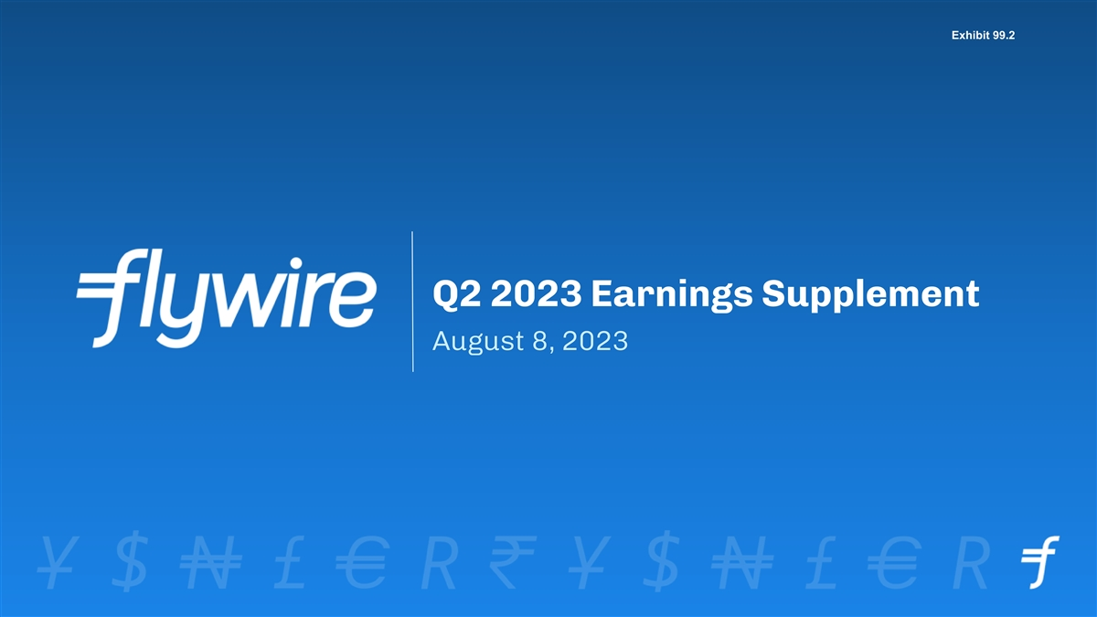
Exhibit 99.2 Q2 2023 Earnings Supplement August 8, 2023

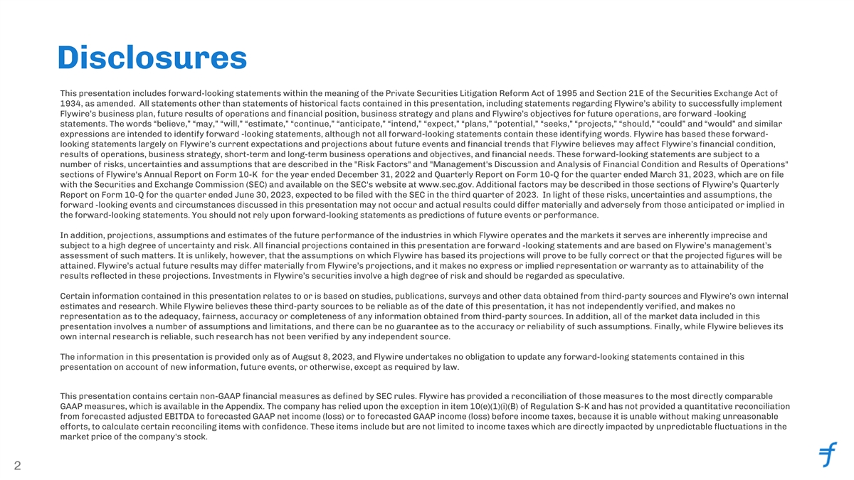
Disclosures This presentation includes forward-looking statements within the meaning of the Private Securities Litigation Reform Act of 1995 and Section 21E of the Securities Exchange Act of 1934, as amended. All statements other than statements of historical facts contained in this presentation, including statements regarding Flywire’s ability to successfully implement Flywire’s business plan, future results of operations and financial position, business strategy and plans and Flywire’s objectives for future operations, are forward -looking statements. The words “believe,” “may,” “will,” “estimate,” “continue,” “anticipate,” “intend,” “expect,” “plans,” “potential,” “seeks,” “projects,” “should,” “could” and “would” and similar expressions are intended to identify forward -looking statements, although not all forward-looking statements contain these identifying words. Flywire has based these forward- looking statements largely on Flywire’s current expectations and projections about future events and financial trends that Flywire believes may affect Flywire’s financial condition, results of operations, business strategy, short-term and long-term business operations and objectives, and financial needs. These forward-looking statements are subject to a number of risks, uncertainties and assumptions that are described in the Risk Factors and Management's Discussion and Analysis of Financial Condition and Results of Operations sections of Flywire's Annual Report on Form 10-K for the year ended December 31, 2022 and Quarterly Report on Form 10-Q for the quarter ended March 31, 2023, which are on file with the Securities and Exchange Commission (SEC) and available on the SEC's website at www.sec.gov. Additional factors may be described in those sections of Flywire’s Quarterly Report on Form 10-Q for the quarter ended June 30, 2023, expected to be filed with the SEC in the third quarter of 2023. In light of these risks, uncertainties and assumptions, the forward -looking events and circumstances discussed in this presentation may not occur and actual results could differ materially and adversely from those anticipated or implied in the forward-looking statements. You should not rely upon forward-looking statements as predictions of future events or performance. In addition, projections, assumptions and estimates of the future performance of the industries in which Flywire operates and the markets it serves are inherently imprecise and subject to a high degree of uncertainty and risk. All financial projections contained in this presentation are forward -looking statements and are based on Flywire’s management’s assessment of such matters. It is unlikely, however, that the assumptions on which Flywire has based its projections will prove to be fully correct or that the projected figures will be attained. Flywire’s actual future results may differ materially from Flywire’s projections, and it makes no express or implied representation or warranty as to attainability of the results reflected in these projections. Investments in Flywire’s securities involve a high degree of risk and should be regarded as speculative. Certain information contained in this presentation relates to or is based on studies, publications, surveys and other data obtained from third-party sources and Flywire’s own internal estimates and research. While Flywire believes these third-party sources to be reliable as of the date of this presentation, it has not independently verified, and makes no representation as to the adequacy, fairness, accuracy or completeness of any information obtained from third-party sources. In addition, all of the market data included in this presentation involves a number of assumptions and limitations, and there can be no guarantee as to the accuracy or reliability of such assumptions. Finally, while Flywire believes its own internal research is reliable, such research has not been verified by any independent source. The information in this presentation is provided only as of Augsut 8, 2023, and Flywire undertakes no obligation to update any forward-looking statements contained in this presentation on account of new information, future events, or otherwise, except as required by law. This presentation contains certain non-GAAP financial measures as defined by SEC rules. Flywire has provided a reconciliation of those measures to the most directly comparable GAAP measures, which is available in the Appendix. The company has relied upon the exception in item 10(e)(1)(i)(B) of Regulation S-K and has not provided a quantitative reconciliation from forecasted adjusted EBITDA to forecasted GAAP net income (loss) or to forecasted GAAP income (loss) before income taxes, because it is unable without making unreasonable efforts, to calculate certain reconciling items with confidence. These items include but are not limited to income taxes which are directly impacted by unpredictable fluctuations in the market price of the company's stock. 2


Execution Fulfillment Our mission is to deliver the most important and complex payments 3

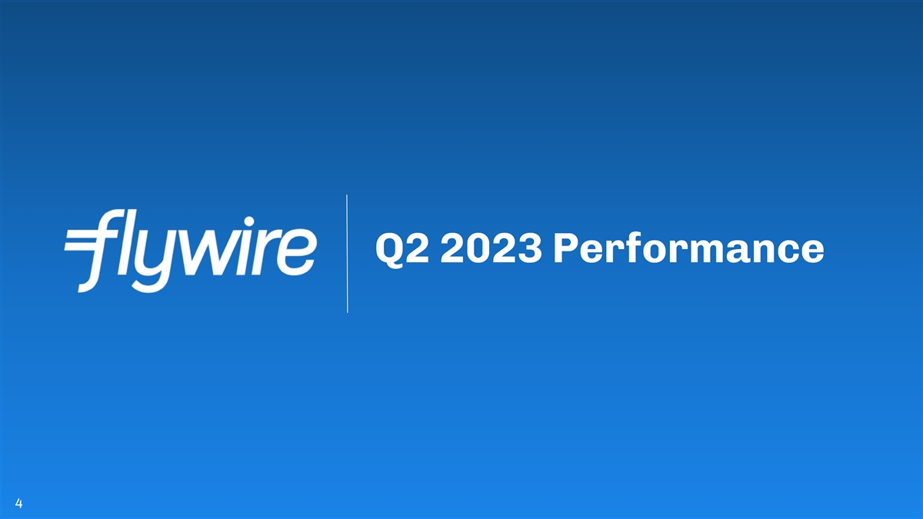
Q2 2023 Performance 4

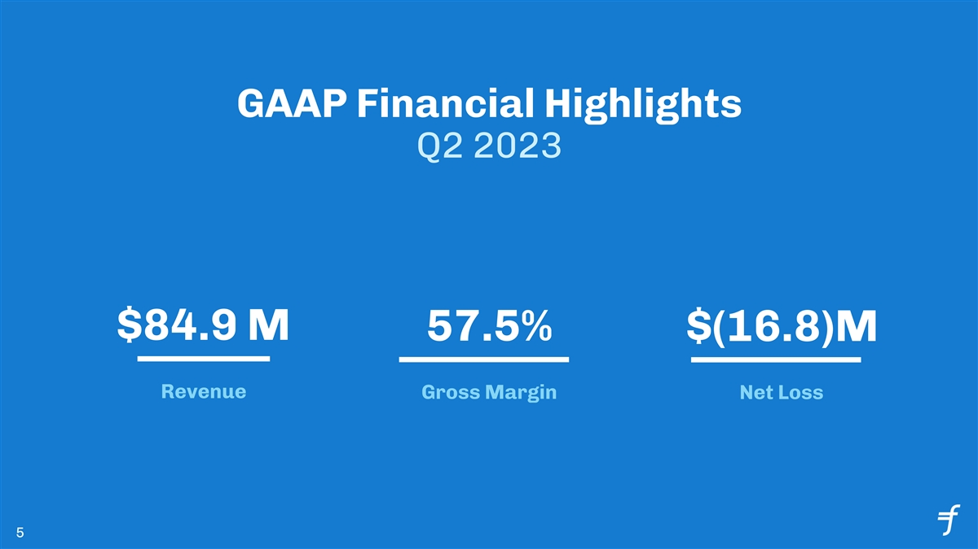
GAAP Financial Highlights Q2 2023 $84.9 M 57.5% $(16.8)M Revenue Gross Margin Net Loss 5

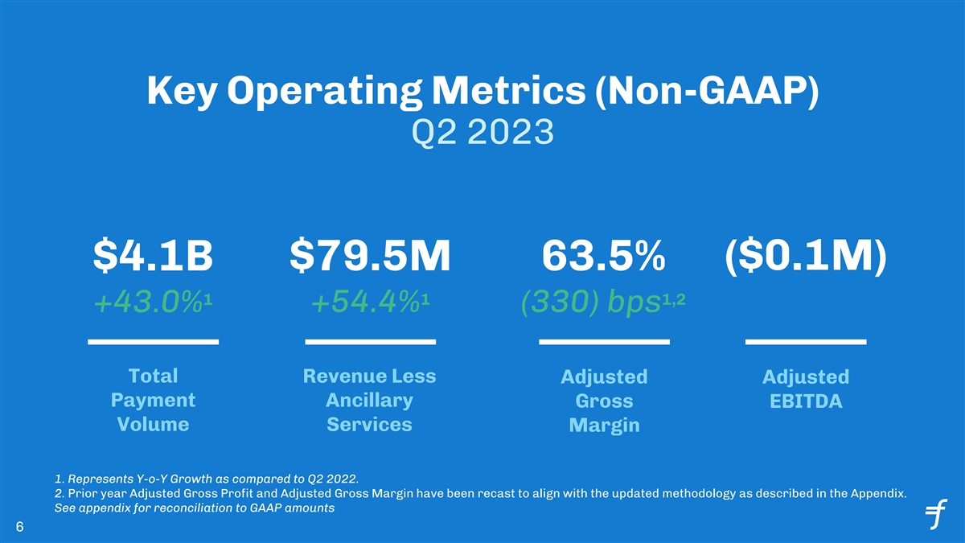
Key Operating Metrics (Non-GAAP) Q2 2023 ($0.1M) $4.1B $79.5M 63.5% 1 1 1,2 +54.4% (330) bps +43.0% Total Revenue Less Adjusted Adjusted Payment Ancillary Gross EBITDA Volume Services Margin 1. Represents Y-o-Y Growth as compared to Q2 2022. 2. Prior year Adjusted Gross Profit and Adjusted Gross Margin have been recast to align with the updated methodology as described in the Appendix. See appendix for reconciliation to GAAP amounts 6

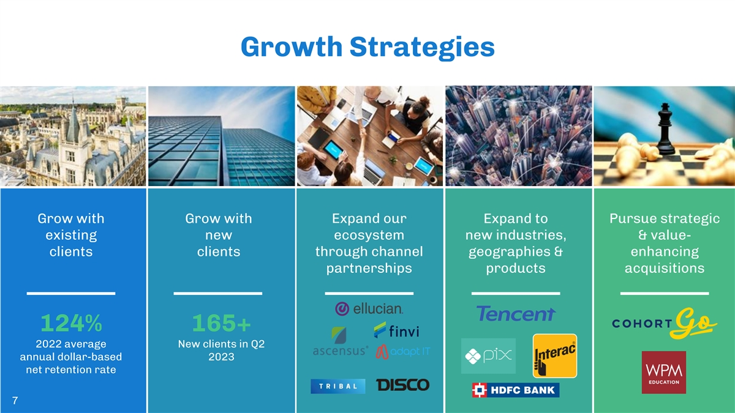
Growth Strategies Grow with Grow with Expand our Expand to Pursue strategic existing new ecosystem new industries, & value- clients clients through channel geographies & enhancing partnerships products acquisitions 124% 165+ 2022 average New clients in Q2 annual dollar-based 2023 net retention rate 7


GROWTH with NEW CLIENTS What I love about the Flywire platform is that it is very easy to use and comprehensive. You are able to see your Overview payments quickly, and there’s so much detail provided. That ● A global software leader in is a major gain when you are doing cash application and digital insights and research technology trying to get details on a client quickly. It’s very efficient. ● Founded in 1998 with 18 global And the customer service has been great, very responsive. offices ● Over 3,200 companies use Cint to gather consumer insights Chelsea Holmes Flywire Solution Treasury Department Implemented Flywire is contracted exclusively for all cross-border payments coming into Cint’s global business lines. Flywire’s solution is seamlessly integrated with NetSuite and Quadient AR by YayPay

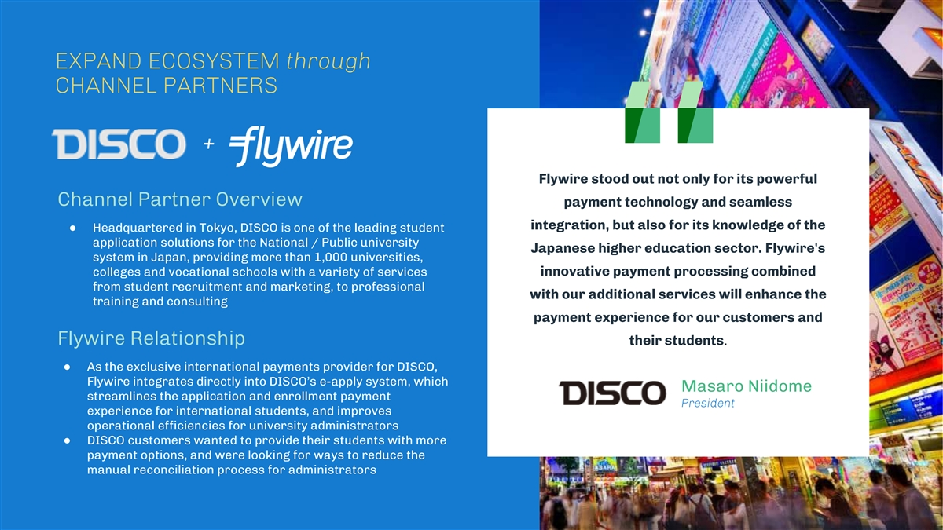
EXPAND ECOSYSTEM through CHANNEL PARTNERS + Flywire stood out not only for its powerful Channel Partner Overview payment technology and seamless integration, but also for its knowledge of the ● Headquartered in Tokyo, DISCO is one of the leading student application solutions for the National / Public university Japanese higher education sector. Flywire's system in Japan, providing more than 1,000 universities, colleges and vocational schools with a variety of services innovative payment processing combined from student recruitment and marketing, to professional with our additional services will enhance the training and consulting payment experience for our customers and Flywire Relationship their students. ● As the exclusive international payments provider for DISCO, Flywire integrates directly into DISCO’s e-apply system, which Masaro Niidome streamlines the application and enrollment payment President experience for international students, and improves operational efficiencies for university administrators ● DISCO customers wanted to provide their students with more payment options, and were looking for ways to reduce the manual reconciliation process for administrators


Financial Outlook 10

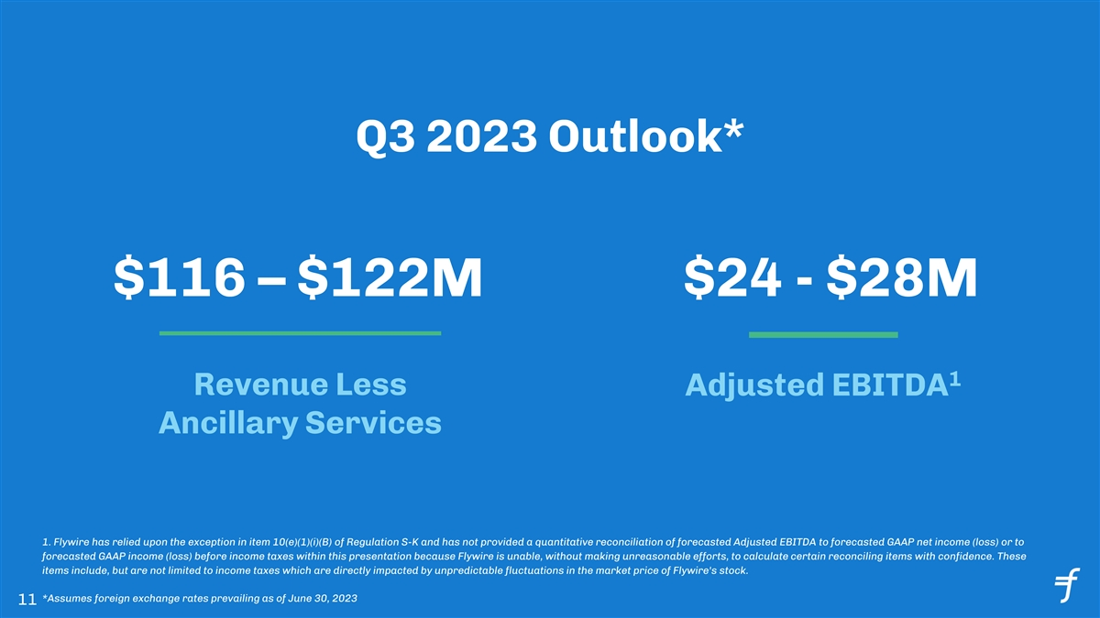
Q3 2023 Outlook* $116 – $122M $24 - $28M 1 Revenue Less Adjusted EBITDA Ancillary Services 1. Flywire has relied upon the exception in item 10(e)(1)(i)(B) of Regulation S-K and has not provided a quantitative reconciliation of forecasted Adjusted EBITDA to forecasted GAAP net income (loss) or to forecasted GAAP income (loss) before income taxes within this presentation because Flywire is unable, without making unreasonable efforts, to calculate certain reconciling items with confidence. These items include, but are not limited to income taxes which are directly impacted by unpredictable fluctuations in the market price of Flywire's stock. *Assumes foreign exchange rates prevailing as of June 30, 2023 11

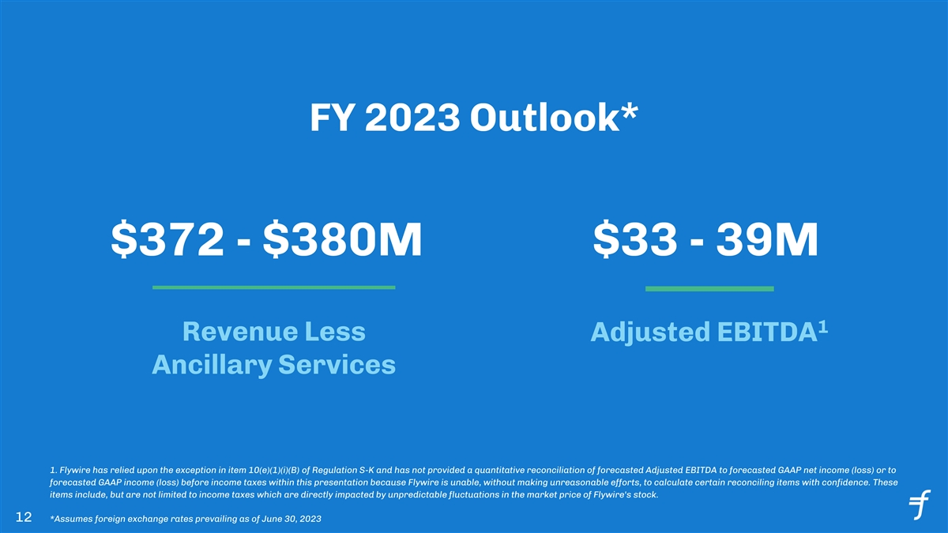
FY 2023 Outlook* $372 - $380M $33 - 39M 1 Revenue Less Adjusted EBITDA Ancillary Services 1. Flywire has relied upon the exception in item 10(e)(1)(i)(B) of Regulation S-K and has not provided a quantitative reconciliation of forecasted Adjusted EBITDA to forecasted GAAP net income (loss) or to forecasted GAAP income (loss) before income taxes within this presentation because Flywire is unable, without making unreasonable efforts, to calculate certain reconciling items with confidence. These items include, but are not limited to income taxes which are directly impacted by unpredictable fluctuations in the market price of Flywire's stock. 12 *Assumes foreign exchange rates prevailing as of June 30, 2023


Appendix 13

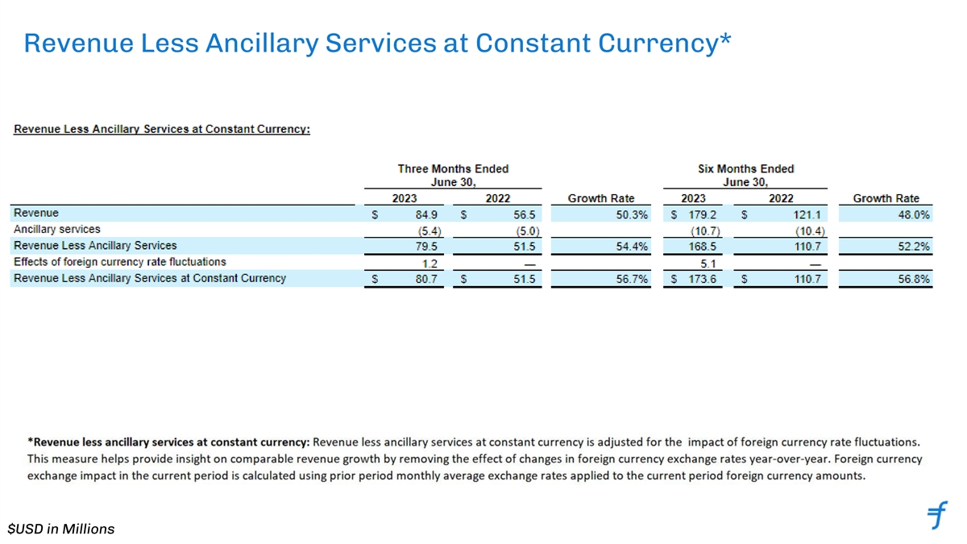
Revenue Less Ancillary Services at Constant Currency* $USD in Millions

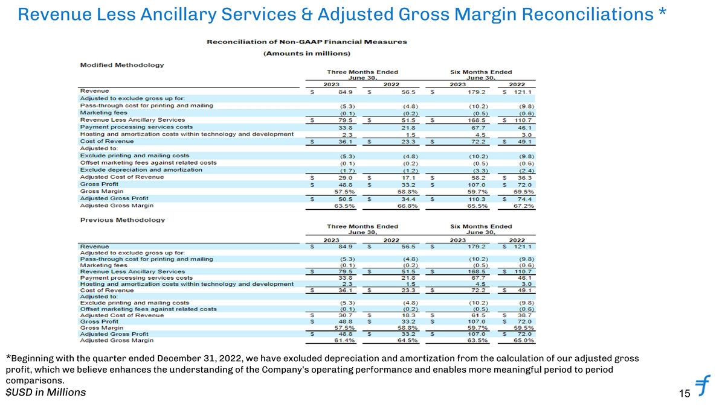
Revenue Less Ancillary Services & Adjusted Gross Margin Reconciliations * *Beginning with the quarter ended December 31, 2022, we have excluded depreciation and amortization from the calculation of our adjusted gross profit, which we believe enhances the understanding of the Company’s operating performance and enables more meaningful period to period comparisons. $USD in Millions 15

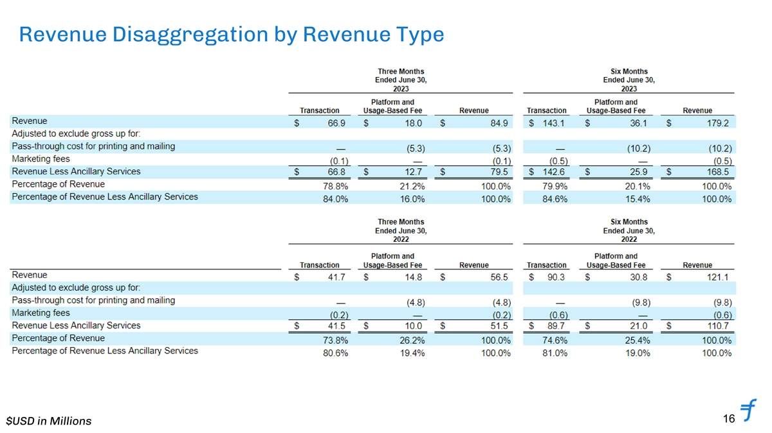
Revenue Disaggregation by Revenue Type 16 $USD in Millions

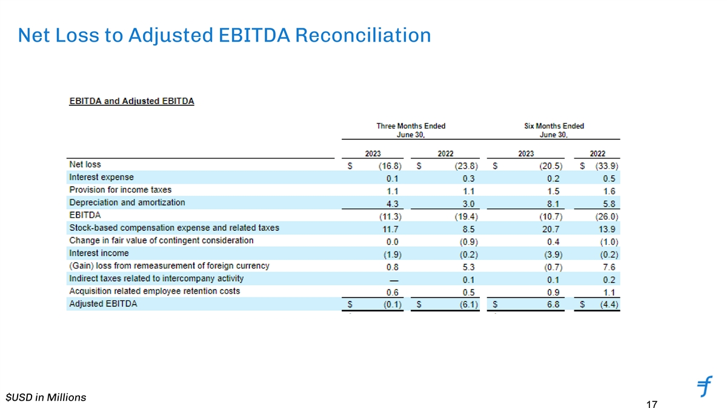
Net Loss to Adjusted EBITDA Reconciliation $USD in Millions 17

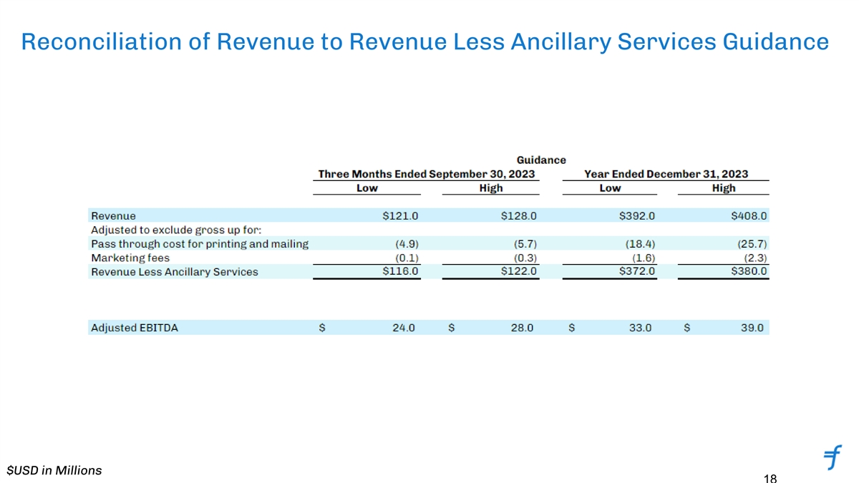
Reconciliation of Revenue to Revenue Less Ancillary Services Guidance $USD in Millions 18

