UNITED STATES
SECURITIES AND EXCHANGE COMMISSION
Washington, D.C. 20549

FORM 8-K

CURRENT REPORT
Pursuant to Section 13 or 15(d)
of the Securities Exchange Act of 1934
Date of Report (Date of earliest event reported): August 6, 2024

FLYWIRE CORPORATION
(Exact name of Registrant as specified in its charter)

Delaware |  | 001-40430 |  | 27-0690799
(State or other jurisdiction  of incorporation) |  | (Commission  File No.) |  | (IRS Employer  Identification No.)
141 Tremont St #10
Boston, MA 02111
(Address of principal executive offices and zip code)
Registrant’s telephone number, including area code: (617) 329-4524
Not Applicable
(Former Name or Former Address, if Changed Since Last Report)

Check the appropriate box below if the Form 8-K filing is intended to simultaneously satisfy the filing obligation of the registrant under any of the following provisions:

☐ | Written communications pursuant to Rule 425 under the Securities Act (17 CFR 230.425)

☐ | Soliciting material pursuant to Rule 14a-12 under the Exchange Act (17 CFR 240.14a-12)

☐ | Pre-commencement communications pursuant to Rule 14d-2(b) under the Exchange Act (17 CFR 240.14d-2(b))

☐ | Pre-commencement communications pursuant to Rule 13e-4(c) under the Exchange Act (17 CFR 240.13e-4(c))
Securities registered pursuant to Section 12(b) of the Act:

Title of each class |  | Trading  Symbol(s) |  | Name of each exchange  on which registered
Voting Common Stock, $0.0001 par value per share |  | FLYW |  | The Nasdaq Stock Market LLC
 |  |  |  | (Nasdaq Global Select Market)
Indicate by check mark whether the registrant is an emerging growth company as defined in Rule 405 of the Securities Act of 1933 (§230.405 of this chapter) or Rule 12b-2 of the Securities Exchange Act of 1934 (§240.12b-2 of this chapter).
Emerging growth company ☐
If an emerging growth company, indicate by check mark if the registrant has elected not to use the extended transition period for complying with any new or revised financial accounting standards provided pursuant to Section 13(a) of the Exchange Act. ☐

Item 2.02. | Results of Operations and Financial Condition.
On August 6, 2024, Flywire Corporation (“Flywire” or the “Company”) issued a press release (the “Press Release”) and is holding a conference call regarding its preliminary and unaudited financial results for the quarter ended June 30, 2024. The Press Release is furnished as Exhibit 99.1 to this Current Report on Form 8-K and is incorporated by reference herein.
Various statements to be made during the conference call are “forward-looking statements” within the meaning of the Private Securities Litigation Reform Act of 1995, including, but not limited to, statements regarding Flywire’s future operating results and financial position, Flywire’s business strategy and plans, market growth, and Flywire’s objectives for future operations. Flywire intends such forward-looking statements to be covered by the safe harbor provisions for forward-looking statements contained in Section 21E of the Securities Exchange Act of 1934 and the Private Securities Litigation Reform Act of 1995. In some cases, you can identify forward-looking statements by terms such as, but not limited to, “believe,” “may,” “will,” “potentially,” “estimate,” “continue,” “anticipate,” “intend,” “could,” “would,” “project,” “target,” “plan,” “expect,” or the negative of these terms, and similar expressions intended to identify forward-looking statements. Such forward-looking statements are based upon current expectations that involve risks, changes in circumstances, assumptions, and uncertainties. Important factors that could cause actual results to differ materially from those reflected in Flywire’s forward-looking statements include, among others, Flywire’s future financial performance, including its expectations regarding Revenue, Revenue Less Ancillary Services, and Adjusted EBITDA and foreign exchange rates. Risks that may cause actual results to differ materially from these forward looking statements include, but are not limited to: Flywire’s ability to execute its business plan and effectively manage its growth; Flywire’s cross-border expansion plans and ability to expand internationally; anticipated trends, growth rates, and challenges in Flywire’s business and in the markets in which Flywire operates; the sufficiency of Flywire’s cash and cash equivalents to meet its liquidity needs; political, economic, foreign currency exchange rate, inflation, legal, social and health risks, that may affect Flywire’s business or the global economy; Flywire’s beliefs and objectives for future operations; Flywire’s ability to develop and protect its brand; Flywire’s ability to maintain and grow the payment volume that it processes; Flywire’s ability to further attract, retain, and expand its client base; Flywire’s ability to develop new solutions and services and bring them to market in a timely manner; Flywire’s expectations concerning relationships with third parties, including financial institutions and strategic partners; the effects of increased competition in Flywire’s markets and its ability to compete effectively; recent and future acquisitions or investments in complementary companies, products, services, or technologies; Flywire’s ability to enter new client verticals, including its relatively new business-to-business sector; Flywire’s expectations regarding anticipated technology needs and developments and its ability to address those needs and developments with its solutions; Flywire’s expectations regarding litigation and legal and regulatory matters; Flywire’s expectations regarding its ability to meet existing performance obligations and maintain the operability of its solutions; Flywire’s expectations regarding the effects of existing and developing laws and regulations, including with respect to payments and financial services, taxation, privacy and data protection; economic and industry trends, projected growth, or trend analysis; the effects of global events and geopolitical conflicts, including without limitation the continuing hostilities in Ukraine and involving Israel; Flywire’s ability to adapt to changes in U.S. federal income or other tax laws or the interpretation of tax laws, including the Inflation Reduction Act of 2022; Flywire’s ability to attract and retain qualified employees; Flywire’s ability to maintain, protect, and enhance its intellectual property; Flywire’s ability to maintain the security and availability of its solutions; the increased expenses associated with being a public company; the future market price of Flywire’s common stock; and other factors that are described in the “Risk Factors” and “Management’s Discussion and Analysis of Financial Condition and Results of Operations” sections of Flywire’s Annual Report on Form 10-K for the year ended December 31, 2023. Additional factors may be described in those sections of Flywire’s Quarterly Report on Form 10-Q for the quarter ended June 30, 2024, expected to be filed with the SEC in the third quarter of 2024. The information conveyed on the conference call is provided only as of the date of the conference call, and Flywire undertakes no obligation to update any forward-looking statements presented during the conference call on account of new information, future events, or otherwise, except as required by law.

Item 7.01. | Regulation FD Disclosure.
On August 6, 2024, the Company provided an investor presentation that will be made available on the investor relations section of the Company’s website at https://ir.flywire.com/. The investor presentation is furnished as Exhibit 99.2 to this Current Report on Form 8-K and is incorporated by reference herein.
This information in this Item 7.01 of this Current Report on Form 8-K shall not be deemed “filed” for purposes of Section 18 of the Securities Exchange Act of 1934, as amended (the “Exchange Act”), or otherwise subject to the liabilities of that Section, or incorporated by reference in any filing under the Securities Act of 1933, as amended, or the Exchange Act, except as shall be expressly set forth by specific reference in any such filing.

Item 9.01. | Financial Statements and Exhibits.
(d) Exhibits

Exhibit  No. |  | Description
99.1 |  | Flywire Corporation Press Release dated August 6, 2024.
99.2 |  | Flywire Corporation Investor Presentation dated August 6, 2024.
104 |  | Cover Page Interactive Data File (embedded within the Inline XBRL document)

SIGNATURE
Pursuant to the requirements of the Securities Exchange Act of 1934, the registrant has duly caused this report to be signed on its behalf by the undersigned hereunto duly authorized.

FLYWIRE CORPORATION
By: |  | /s/ Cosmin Pitigoi
Name: |  | Cosmin Pitigoi
Title: |  | Chief Financial Officer
Dated August 6, 2024
Exhibit 99.1
Flywire Reports Second Quarter 2024 Financial Results
Second Quarter Revenue Increased 22% Year-over-Year
Second Quarter Revenue Less Ancillary Services Increased 26% Year-over-Year
Company Announces Acquisition of Invoiced, an Award-Winning Accounts Receivable SaaS Platform
Board of Directors Authorizes $150 Million Share Repurchase Program
Boston, MA  August 6, 2024: Flywire Corporation (Nasdaq: FLYW) (Flywire or the Company) a global payments enablement and software company, today reported financial results for its second quarter ended June 30, 2024.
Our second quarter results demonstrate resilient performance across the business where we signed more than 200 new clients and grew revenue by 22% and revenue less ancillary services by 26% year-over-year, despite revenue headwinds related to the ongoing Canadian government actions involving student study permits, said Mike Massaro, CEO of Flywire. These results reflect our ability to both grow within our existing accounts and drive revenue diversity, demonstrating continued progress against our strategy of optimizing our Go-To-Market capabilities, expanding our Flywire Advantage and strengthening our FlyMate community. I am also thrilled to be welcoming a talented group of new FlyMates to our global team with the acquisition of Invoiced, an award-winning Accounts Receivable SaaS platform. We expect Invoiced to help accelerate our organic progress to date in the fast growing B2B vertical.
Second Quarter 2024 Financial Highlights:
GAAP Results

 |  |  | Revenue increased 22% to $103.7 million in the second quarter of 2024, compared to $84.9 million in the second quarter of 2023.

 |  |  | Gross Profit increased to $61.9 million, resulting in Gross Margin of 59.7%, for the second quarter of 2024, compared to Gross Profit of $48.8 million and Gross Margin of 57.5% in the second quarter of 2023.

 |  |  | Net loss was $13.9 million in the second quarter of 2024, compared to net loss of $16.8 million in the second quarter of 2023.

Key Operating Metrics and Non-GAAP Results

 |  |  | Total Payment Volume increased 19% to $4.9 billion in the second quarter of 2024, compared to $4.1 billion in the second quarter of 2023.

 |  |  | Revenue Less Ancillary Services increased 26% to $99.9 million in the second quarter of 2024, compared to $79.5 million in the second quarter of 2023. Revenue Less Ancillary Services in the second quarter of 2024 was estimated to be unfavorably impacted by changes in foreign exchange rates between March 31, 2024 and June 30, 2024 by approximately $0.1 million.

 |  |  | Adjusted Gross Profit increased to $63.4 million, resulting in Adjusted Gross Margin of 63.5% in the second quarter of 2024, compared to Adjusted Gross Profit of $50.5 million and Adjusted Gross Margin of 63.5% in the second quarter of 2023.

 |  |  | Adjusted EBITDA increased to $5.8 million in the second quarter of 2024, compared to $(0.1) million in the second quarter of 2023, a 593 bps adjusted EBITDA margin expansion compared to the second quarter of 2023.
Second Quarter 2024 and Recent Business Highlights:

 |  |  | Signed more than 200 new clients across all verticals.

 |  |  | Expanded availability of third-party invoicing, streamlining the payment experience for third-party sponsors paying a students tuition and fees.

 |  |  | Announced Partnership with HDFC by Credila, the largest independent student loan provider in India, to enable Indian payers to seamlessly and digitally disburse their loan payments in their local currency (Indian Rupees) directly to higher education institutions all over the world.

 |  |  | Acquired Invoiced to bolster Flywires global B2B payment network with award-winning Accounts Receivable SaaS platform
Share Repurchase Program:
As part of Flywires capital allocation strategy to maximize shareholder value, the Companys Board of Directors authorized a share repurchase program, pursuant to which the Company may, from time to time, purchase shares of its common stock, up to an aggregate repurchase price of $150 million.
Third Quarter and Fiscal-Year 2024 Outlook:
We had a strong quarter across many of our key operating metrics and financial measures, said Cosmin Pitigoi, CFO of Flywire. Our first half results demonstrate the resilience of our team and our business model despite softer than expected performance in our Canadian education business. For Fiscal Year 2024, we are lowering our revenue outlook due to our current expectations regarding the external headwinds in Canada and raising our Full Year Adjusted EBITDA guidance which reflects 490 basis points of margin improvement at the midpoint, 170 basis points higher than our prior guidance. Lastly, our share repurchase program is a direct reflection of our confidence in the long term potential of the business and the strength of our balance sheet. We believe this program still allows us ample capacity to continue investing organically and to pursue strategic value-enhancing acquisitions.

Based on information available as of August 6, 2024, Flywire anticipates the following results for the third quarter and Fiscal-Year 2024.

 |  | Fiscal-Year 2024*
Revenue |  | $483 to $506 million
Revenue Less Ancillary Services |  | $469 to $485 million
Adjusted EBITDA** |  | $72 to $80 million

 |  | Third Quarter 2024*
Revenue |  | $146 to $157 million
Revenue Less Ancillary Services |  | $141 to $151 million
Adjusted EBITDA** |  | $37 to $43 million

* | The Company has assumed foreign exchange rates prevailing as of June 30, 2024.
** | Flywire has not provided a quantitative reconciliation of forecasted Adjusted EBITDA to forecasted GAAP net income (loss) or to forecasted GAAP income (loss) before income taxes within this earnings release because Flywire is unable, without making unreasonable efforts, to calculate certain reconciling items with confidence. These items include, but are not limited to income taxes which are directly impacted by unpredictable fluctuations in the market price of Flywires stock.

These statements are forward-looking and actual results may differ materially. Refer to the Safe Harbor Statement below for information on the factors that could cause Flywires actual results to differ materially from these forward-looking statements.
Conference Call
The Company will host a conference call to discuss second quarter 2024 financial results today at 5:00 pm ET. Hosting the call will be Mike Massaro, CEO, Rob Orgel, President and COO, and Cosmin Pitigoi, CFO. The conference call can be accessed live via webcast from the Companys investor relations website at https://ir.flywire.com/. A replay will be available on the investor relations website following the call.
Note Regarding Share Repurchase Program
Repurchases under the Companys share repurchase program (the Repurchase Program) may be made from time to time through open market purchases, in privately negotiated transactions or by other means, including through the use of trading plans intended to qualify under Rule 10b5-1 under the Securities Exchange Act of 1934, as amended, in accordance with applicable securities laws and other restrictions, including Rule 10b-18. The timing, value and number of shares repurchased will be determined by the Company in its discretion and will be based on various factors, including an evaluation of current and future capital needs, current and forecasted cash flows, the Companys capital structure, cost of capital and prevailing stock prices, general market and economic conditions, applicable legal requirements, and compliance with covenants in the Companys credit facility that may limit share repurchases based on defined leverage ratios. The Repurchase Program does not obligate the Company to purchase a specific number of, or any, shares. The Repurchase Program does not expire and may be modified, suspended or terminated at any time without notice at the Companys discretion.
Key Operating Metrics and Non-GAAP Financial Measures
Flywire uses non-GAAP financial measures to supplement financial information presented on a GAAP basis. The Company believes that excluding certain items from its GAAP results allows management to better understand its consolidated financial performance from period to period and better project its future consolidated financial performance as forecasts are developed at a level of detail different from that used to prepare GAAP-based financial measures. Moreover, Flywire believes these non-GAAP financial measures provide its stakeholders with useful information to help them evaluate the Companys operating results by facilitating an enhanced understanding of the Companys operating performance and enabling them to make more meaningful period to period comparisons. There are limitations to the use of the non-GAAP financial

measures presented here. Flywires non-GAAP financial measures may not be comparable to similarly titled measures of other companies. Other companies, including companies in Flywires industry, may calculate non-GAAP financial measures differently, limiting the usefulness of those measures for comparative purposes.
Flywire uses supplemental measures of its performance which are derived from its consolidated financial information, but which are not presented in its consolidated financial statements prepared in accordance with GAAP. These non-GAAP financial measures include the following:

 |  |  | Revenue Less Ancillary Services. Revenue Less Ancillary Services represents the Companys consolidated revenue in accordance with GAAP after excluding (i) pass-through cost for printing and mailing services and (ii) marketing fees. The Company excludes these amounts to arrive at this supplemental non-GAAP financial measure as it views these services as ancillary to the primary services it provides to its clients.

 |  |  | Adjusted Gross Profit and Adjusted Gross Margin. Adjusted gross profit represents Revenue Less Ancillary Services less cost of revenue adjusted to (i) exclude pass-through cost for printing services, (ii) offset marketing fees against costs incurred and (iii) exclude depreciation and amortization, including accelerated amortization on the impairment of customer set-up costs tied to technology integration. Adjusted Gross Margin represents Adjusted Gross Profit divided by Revenue Less Ancillary Services. Management believes this presentation supplements the GAAP presentation of Gross Margin with a useful measure of the gross margin of the Companys payment-related services, which are the primary services it provides to its clients.

 |  |  | Adjusted EBITDA. Adjusted EBITDA represents EBITDA further adjusted by excluding (i) stock-based compensation expense and related payroll taxes, (ii) the impact from the change in fair value measurement for contingent consideration associated with acquisitions,(iii) gain (loss) from the remeasurement of foreign currency, (iv) indirect taxes related to intercompany activity, (v) acquisition related transaction costs, if applicable, and (vi) employee retention costs, such as incentive compensation, associated with acquisition activities. Management believes that the exclusion of these amounts to calculate Adjusted EBITDA provides useful measures for period-to-period comparisons of the Companys business.

 |  |  | Revenue Less Ancillary Services at Constant Currency. Revenue Less Ancillary Services at Constant Currency represents Revenue Less Ancillary Services adjusted to show presentation on a constant currency basis. The constant currency information presented is calculated by translating current period results using prior period weighted average foreign currency exchange rates. Flywire analyzes Revenue Less Ancillary Services on a constant currency basis to provide a comparable framework for assessing how the business performed excluding the effect of foreign currency fluctuations.

 |  |  | Non-GAAP Operating Expenses - Non-GAAP Operating Expenses represents GAAP Operating Expenses adjusted by excluding (i) stock-based compensation expense and related payroll taxes, (ii) depreciation and amortization, (iii) acquisition related transaction costs, if applicable, (iv) employee retention costs, such as incentive compensation, associated with acquisition activities and (v) the impact from the change in fair value measurement for contingent consideration associated with acquisitions.
These non-GAAP financial measures are not meant to be considered as indicators of performance in isolation from or as a substitute for the Companys revenue, gross profit, gross margin or net income (loss), or operating expenses prepared in accordance with GAAP and should be read only in conjunction with financial information presented on a GAAP basis. Reconciliations of Revenue Less Ancillary Services, Revenue Less Ancillary Services at Constant Currency, Adjusted Gross Profit, Adjusted Gross Margin, Adjusted EBITDA and non-GAAP Operating Expenses to the most directly comparable GAAP financial measure are presented below. Flywire encourages you to review these reconciliations in conjunction with the presentation of the non-GAAP financial measures for each of the periods presented. In future fiscal periods, Flywire may exclude such items and may incur income and expenses similar to these excluded items. Flywire has not provided a quantitative reconciliation of forecasted Adjusted EBITDA to forecasted GAAP net income (loss) or to forecasted GAAP income (loss) before income taxes within this earnings release because it is unable, without making unreasonable efforts, to calculate certain reconciling items with confidence. These items include but are not limited to income taxes which are directly impacted by unpredictable fluctuations in the market price of Flywires stock.
About Flywire
Flywire is a global payments enablement and software company. Flywire combines its proprietary global payments network, next-gen payments platform and vertical-specific software to deliver the most important and complex payments for its clients and their customers.
Flywire leverages its vertical-specific software and payments technology to deeply embed within the existing A/R workflows for its clients across the education, healthcare and travel vertical markets, as well as in key B2B industries. Flywire also integrates with leading ERP systems, so organizations can optimize the payment experience for their customers while eliminating operational challenges.

Flywire supports more than 4,000 clients with diverse payment methods in more than 140 currencies across 240 countries and territories around the world. Flywire is headquartered in Boston, MA, USA with additional offices around the globe. For more information, visit www.flywire.com. Follow Flywire on X (formerly known as Twitter), LinkedIn and Facebook.
Safe Harbor Statement
This release contains forward-looking statements within the meaning of the Private Securities Litigation Reform Act of 1995, including, but not limited to, statements regarding Flywires future operating results and financial position, Flywires business strategy and plans, market growth, and Flywires objectives for future operations. Flywire intends such forward-looking statements to be covered by the safe harbor provisions for forward-looking statements contained in Section 21E of the Securities Exchange Act of 1934 and the Private Securities Litigation Reform Act of 1995. In some cases, you can identify forward-looking statements by terms such as, but not limited to, believe, may, will, potentially, estimate, continue, anticipate, intend, could, would, project, target, plan, expect, or the negative of these terms, and similar expressions intended to identify forward-looking statements. Such forward-looking statements are based upon current expectations that involve risks, changes in circumstances, assumptions, and uncertainties. Important factors that could cause actual results to differ materially from those reflected in Flywires forward-looking statements include, among others, Flywires future financial performance, including its expectations regarding Revenue, Revenue Less Ancillary Services, and Adjusted EBITDA and foreign exchange rates. Risks that may cause actual results to differ materially from these forward looking statements include, but are not limited to: Flywires ability to execute its business plan and effectively manage its growth; Flywires cross-border expansion plans and ability to expand internationally; anticipated trends, growth rates, and challenges in Flywires business and in the markets in which Flywire operates; the sufficiency of Flywires cash and cash equivalents to meet its liquidity needs; political, economic, foreign currency exchange rate, inflation, legal, social and health risks, that may affect Flywires business or the global economy; Flywires beliefs and objectives for future operations; Flywires ability to develop and protect its brand; Flywires ability to maintain and grow the payment volume that it processes; Flywires ability to further attract, retain, and expand its client base; Flywires ability to develop new solutions and services and bring them to market in a timely manner; Flywires expectations concerning relationships with third parties, including financial institutions and strategic partners; the effects of increased competition in Flywires markets and its ability to compete effectively; recent and future acquisitions or

investments in complementary companies, products, services, or technologies; Flywires ability to enter new client verticals, including its relatively new business-to-business sector; Flywires expectations regarding anticipated technology needs and developments and its ability to address those needs and developments with its solutions; Flywires expectations regarding litigation and legal and regulatory matters; Flywires expectations regarding its ability to meet existing performance obligations and maintain the operability of its solutions; Flywires expectations regarding the effects of existing and developing laws and regulations, including with respect to payments and financial services, taxation, privacy and data protection; economic and industry trends, projected growth, or trend analysis; Flywires ability to adapt to changes in U.S. federal income or other tax laws or the interpretation of tax laws, including the Inflation Reduction Act of 2022; Flywires ability to attract and retain qualified employees; Flywires ability to maintain, protect, and enhance its intellectual property; Flywires ability to maintain the security and availability of its solutions; the increased expenses associated with being a public company; the future market price of Flywires common stock; and other factors that are described in the Risk Factors and Managements Discussion and Analysis of Financial Condition and Results of Operations sections of Flywires Annual Report on Form 10-K for the year ended December 31, 2023, and Quarterly Report on Form 10-Q for the quarter ended March 31, 2024, which are on file with the Securities and Exchange Commission (SEC) and available on the SECs website at https://www.sec.gov/. Additional factors may be described in those sections of Flywires Quarterly Report on Form 10-Q for the quarter ended March 31, 2024, expected to be filed with the SEC in the third quarter of 2024. The information in this release is provided only as of the date of this release, and Flywire undertakes no obligation to update any forward-looking statements contained in this release on account of new information, future events, or otherwise, except as required by law.
Contacts
Investor Relations:
ir@Flywire.com
Media:
Sarah King
Media@Flywire.com

Condensed Consolidated Statements of Operations and Comprehensive Loss
(Unaudited) (Amounts in thousands, except share and per share amounts)

 |  | Three Months Ended June 30, |  |  |  |  |  |  |  | Six Months Ended June 30,
 |  | 2024 |  |  |  | 2023 |  |  |  | 2024 |  |  |  | 2023
Revenue |  | $ | 103,676 |  |  | $ | 84,869 |  |  | $ | 217,779 |  |  | $ | 179,226
Costs and operating expenses:
Payment processing services costs |  |  | 39,899 |  |  |  | 33,804 |  |  |  | 81,549 |  |  |  | 67,659
Technology and development |  |  | 15,834 |  |  |  | 16,016 |  |  |  | 32,571 |  |  |  | 30,539
Selling and marketing |  |  | 31,771 |  |  |  | 27,273 |  |  |  | 61,854 |  |  |  | 51,707
General and administrative |  |  | 31,959 |  |  |  | 24,584 |  |  |  | 63,555 |  |  |  | 52,697
Total costs and operating expenses |  |  | 119,463 |  |  |  | 101,677 |  |  |  | 239,529 |  |  |  | 202,602
Loss from operations |  | $ | (15,787 | ) |  | $ | (16,808 | ) |  | $ | (21,750 | ) |  | $ | (23,376 | )
Other income (expense):
Interest expense |  |  | (133 | ) |  |  | (78 | ) |  |  | (275 | ) |  |  | (181 | )
Interest income |  |  | 5,719 |  |  |  | 1,935 |  |  |  | 11,598 |  |  |  | 3,870
Gain (loss) from remeasurement of foreign currency |  |  | 998 |  |  |  | (755 | ) |  |  | (3,378 | ) |  |  | 715
Total other income (expense), net |  |  | 6,584 |  |  |  | 1,102 |  |  |  | 7,945 |  |  |  | 4,404
Loss before provision for income taxes |  |  | (9,203 | ) |  |  | (15,706 | ) |  |  | (13,805 | ) |  |  | (18,972 | )
Provision for income taxes |  |  | 4,677 |  |  |  | 1,107 |  |  |  | 6,292 |  |  |  | 1,524
Net Loss |  | $ | (13,880 | ) |  | $ | (16,813 | ) |  | $ | (20,097 | ) |  | $ | (20,496 | )
Foreign currency translation adjustment |  |  | 193 |  |  |  | 2,449 |  |  |  | (1,168 | ) |  |  | 2,082
Unrealized losses on available-for-sale debt securities, net |  | $ | (53 | ) |  | $ |  |  |  | $ | (53 | ) |  | $ | 
Total other comprehensive income (loss) |  | $ | 140 |  |  | $ | 2,449 |  |  | $ | (1,221 | ) |  | $ | 2,082
Comprehensive loss |  | $ | (13,740 | ) |  | $ | (14,364 | ) |  | $ | (21,318 | ) |  | $ | (18,414 | )
Net loss attributable to common stockholders - basic and diluted |  | $ | (13,880 | ) |  | $ | (16,813 | ) |  | $ | (20,097 | ) |  | $ | (20,496 | )
Net loss per share attributable to common stockholders - basic and diluted |  | $ | (0.11 | ) |  | $ | (0.15 | ) |  | $ | (0.16 | ) |  | $ | (0.19 | )
Weighted average common shares outstanding - basic and diluted |  |  | 124,562,015 |  |  |  | 111,133,221 |  |  |  | 123,859,762 |  |  |  | 110,464,092

Condensed Consolidated Balance Sheets
(Unaudited) (Amounts in thousands, except share amounts)

 |  | June 30, |  |  |  | December 31,
 |  | 2024 |  |  |  | 2023
Assets
Current assets:
Cash and cash equivalents |  | $ | 539,300 |  |  | $ | 654,608
Restricted cash |  |  |  |  |  |  | 
Short-term investments |  |  | 31,694 |  |  |  | 
Accounts receivable, net |  |  | 20,275 |  |  |  | 18,215
Unbilled receivables, net |  |  | 13,052 |  |  |  | 10,689
Funds receivable from payment partners |  |  | 84,974 |  |  |  | 113,945
Prepaid expenses and other current assets |  |  | 21,633 |  |  |  | 18,227
Total current assets |  |  | 710,928 |  |  |  | 815,684
Long-term investments |  |  | 26,721 |  |  |  | 
Property and equipment, net |  |  | 17,074 |  |  |  | 15,134
Intangible assets, net |  |  | 101,303 |  |  |  | 108,178
Goodwill |  |  | 120,657 |  |  |  | 121,646
Other assets |  |  | 22,029 |  |  |  | 19,089
Total assets |  | $ | 998,712 |  |  | $ | 1,079,731
Liabilities and Stockholders Equity
Current liabilities:
Accounts payable |  | $ | 13,509 |  |  | $ | 12,587
Funds payable to clients |  |  | 116,191 |  |  |  | 210,922
Accrued expenses and other current liabilities |  |  | 43,536 |  |  |  | 43,315
Deferred revenue |  |  | 4,183 |  |  |  | 6,968
Total current liabilities |  |  | 177,419 |  |  |  | 273,792
Deferred tax liabilities |  |  | 14,744 |  |  |  | 15,391
Other liabilities |  |  | 3,989 |  |  |  | 4,431
Total liabilities |  |  | 196,152 |  |  |  | 293,614
Commitments and contingencies (Note 16)
Stockholders equity:
Preferred stock, $0.0001 par value; 10,000,000 shares authorized as of June 30, 2024 and December 31, 2023; and no shares issued and outstanding as of June 30, 2024 and December 31, 2023 |  |  |  |  |  |  | 
Voting common stock, $0.0001 par value; 2,000,000,000 shares authorized as of June 30, 2024 and December 31, 2023; 125,528,991 shares issued and 123,233,953 shares outstanding as of June 30, 2024; 123,010,207 shares issued and 120,695,162 shares outstanding as of December 31, 2023 |  |  | 11 |  |  |  | 11
Non-voting common stock, $0.0001 par value; 10,000,000 shares authorized as of June 30, 2024 and December 31, 2023; 1,873,320 shares issued and outstanding as of June 30, 2024 and December 31, 2023 |  |  | 1 |  |  |  | 1
Treasury voting common stock, 2,295,038 and 2,315,045 shares as of June 30, 2024 and December 31, 2023, respectively, held at cost |  |  | (741 | ) |  |  | (747 | )
Additional paid-in capital |  |  | 997,057 |  |  |  | 959,302
Accumulated other comprehensive income |  |  | 99 |  |  |  | 1,320
Accumulated deficit |  |  | (193,867 | ) |  |  | (173,770 | )
Total stockholders equity |  |  | 802,560 |  |  |  | 786,117
Total liabilities and stockholders equity |  | $ | 998,712 |  |  | $ | 1,079,731

Condensed Consolidated Statement of Cash Flows
(Unaudited) (Amounts in thousands)

 |  | Six Months Ended June 30,
 |  | 2024 |  |  |  | 2023
Cash flows from operating activities:
Net loss |  | $ | (20,097 | ) |  | $ | (20,496 | )
Adjustments to reconcile net loss to net cash used in operating activities:
Depreciation and amortization |  |  | 8,463 |  |  |  | 7,876
Stock-based compensation expense |  |  | 31,903 |  |  |  | 19,979
Amortization of deferred contract costs |  |  | 517 |  |  |  | 228
Change in fair value of contingent consideration |  |  | (894 | ) |  |  | 410
Deferred tax provision (benefit) |  |  | (1,045 | ) |  |  | (584 | )
Provision for uncollectible accounts |  |  | (121 | ) |  |  | 599
Non-cash interest expense |  |  | 138 |  |  |  | 144
Accretion of discounts on investments, net of amortization of premiums |  |  | (143 | ) |  |  | 
Changes in operating assets and liabilities, net of acquisitions:
Accounts receivable |  |  | (1,939 | ) |  |  | (6,186 | )
Unbilled receivables |  |  | (2,363 | ) |  |  | (1,511 | )
Funds receivable from payment partners |  |  | 28,971 |  |  |  | 19,649
Prepaid expenses, other current assets and other assets |  |  | (4,421 | ) |  |  | (1,030 | )
Funds payable to clients |  |  | (94,730 | ) |  |  | (42,347 | )
Accounts payable, accrued expenses and other current liabilities |  |  | 1,807 |  |  |  | 1,121
Contingent consideration |  |  |  |  |  |  | (467 | )
Other liabilities |  |  | (675 | ) |  |  | (574 | )
Deferred revenue |  |  | (2,785 | ) |  |  | (2,463 | )
Net cash used in operating activities |  |  | (57,414 | ) |  |  | (25,652 | )
Cash flows from investing activities:
Purchase of debt securities |  |  | (58,491 | ) |  |  | 
Sale of debt securities |  |  | 165 |  |  |  | 
Capitalization of internally developed software |  |  | (3,304 | ) |  |  | (2,812 | )
Purchases of property and equipment |  |  | (604 | ) |  |  | (671 | )
Net cash used in investing activities |  |  | (62,234 | ) |  |  | (3,483 | )
Cash flows from financing activities:
Payment of debt issuance costs |  |  | (783 | ) |  |  | 
Contingent consideration paid for acquisitions |  |  |  |  |  |  | (1,207 | )
Proceeds from the issuance of stock under Employee Stock Purchase Plan |  |  | 1,415 |  |  |  | 864
Proceeds from exercise of stock options |  |  | 3,227 |  |  |  | 6,044
Net cash provided by (used in) financing activities |  |  | 3,859 |  |  |  | 5,701
Effect of exchange rates changes on cash and cash equivalents |  |  | 481 |  |  |  | 320
Net increase (decrease) in cash, cash equivalents and restricted  cash |  |  | (115,308 | ) |  |  | (23,114 | )
Cash, cash equivalents and restricted cash, beginning of year |  | $ | 654,608 |  |  | $ | 351,177
Cash, cash equivalents and restricted cash, end of year |  | $ | 539,300 |  |  | $ | 328,063

Reconciliation of Non-GAAP Financial Measures
(Unaudited) (Amounts in millions, except percentages)

 |  | Three Months Ended  June 30, |  |  |  |  |  |  |  | Six Months Ended  June 30,
 |  | 2024 |  |  |  | 2023 |  |  |  | 2024 |  |  |  | 2023
Revenue |  | $ | 103.7 |  |  | $ | 84.9 |  |  | $ | 217.8 |  |  | $ | 179.2
Adjusted to exclude gross up for:
Pass-through cost for printing and mailing |  |  | (3.6 | ) |  |  | (5.3 | ) |  |  | (7.2 | ) |  |  | (10.2 | )
Marketing fees |  |  | (0.2 | ) |  |  | (0.1 | ) |  |  | (0.5 | ) |  |  | (0.5 | )
Revenue Less Ancillary Services |  | $ | 99.9 |  |  | $ | 79.5 |  |  | $ | 210.1 |  |  | $ | 168.5
Payment processing services costs |  |  | 39.9 |  |  |  | 33.8 |  |  |  | 81.5 |  |  |  | 67.7
Hosting and amortization costs within technology and development expenses |  |  | 1.9 |  |  |  | 2.3 |  |  |  | 3.9 |  |  |  | 4.5
Cost of Revenue |  | $ | 41.8 |  |  | $ | 36.1 |  |  | $ | 85.4 |  |  | $ | 72.2
Adjusted to:
Exclude printing and mailing costs |  |  | (3.6 | ) |  |  | (5.3 | ) |  |  | (7.2 | ) |  |  | (10.2 | )
Offset marketing fees against related costs |  |  | (0.2 | ) |  |  | (0.1 | ) |  |  | (0.5 | ) |  |  | (0.5 | )
Exclude depreciation and amortization |  |  | (1.5 | ) |  |  | (1.7 | ) |  |  | (3.0 | ) |  |  | (3.3 | )
Adjusted Cost of Revenue |  | $ | 36.5 |  |  | $ | 29.0 |  |  | $ | 74.7 |  |  | $ | 58.2
Gross Profit |  | $ | 61.9 |  |  | $ | 48.8 |  |  | $ | 132.4 |  |  | $ | 107.0
Gross Margin |  |  | 59.7 | % |  |  | 57.5 | % |  |  | 60.8 | % |  |  | 59.7 | %
Adjusted Gross Profit |  | $ | 63.4 |  |  | $ | 50.5 |  |  | $ | 135.4 |  |  | $ | 110.3
Adjusted Gross Margin |  |  | 63.5 | % |  |  | 63.5 | % |  |  | 64.4 | % |  |  | 65.5 | %

 |  | Three Months Ended  June 30, 2024 |  |  |  |  |  |  |  |  |  |  |  | Six Months Ended  June 30, 2024
 |  | Transaction |  |  |  | Platform and  Other Revenues |  |  |  | Revenue |  |  |  | Transaction |  |  |  | Platform and  Other Revenues |  |  |  | Revenue
Revenue |  | $ | 85.3 |  |  | $ | 18.4 |  |  | $ | 103.7 |  |  | $ | 180.5 |  |  | $ | 37.3 |  |  | $ | 217.8
Adjusted to exclude gross up for:
Pass-through cost for printing and mailing |  |  |  |  |  |  | (3.6 | ) |  |  | (3.6 | ) |  |  |  |  |  |  | (7.2 | ) |  |  | (7.2 | )
Marketing fees |  |  | (0.2 | ) |  |  |  |  |  |  | (0.2 | ) |  |  | (0.5 | ) |  |  |  |  |  |  | (0.5 | )
Revenue Less Ancillary Services |  | $ | 85.1 |  |  | $ | 14.8 |  |  | $ | 99.9 |  |  | $ | 180.0 |  |  | $ | 30.1 |  |  | $ | 210.1
Percentage of Revenue |  |  | 82.3 | % |  |  | 17.7 | % |  |  | 100.0 | % |  |  | 82.9 | % |  |  | 17.1 | % |  |  | 100.0 | %
Percentage of Revenue Less Ancillary Services |  |  | 85.2 | % |  |  | 14.8 | % |  |  | 100.0 | % |  |  | 85.7 | % |  |  | 14.3 | % |  |  | 100.0 | %
 |  | Three Months Ended  June 30, 2023 |  |  |  |  |  |  |  |  |  |  |  | Six Months Ended  June 30, 2023
 |  | Transaction |  |  |  | Platform and  Other Revenues |  |  |  | Revenue |  |  |  | Transaction |  |  |  | Platform and  Other Revenues |  |  |  | Revenue
Revenue |  | $ | 66.8 |  |  | $ | 18.0 |  |  | $ | 84.9 |  |  | $ | 143.1 |  |  | $ | 36.1 |  |  | $ | 179.2
Adjusted to exclude gross up for:
Pass-through cost for printing and mailing |  |  |  |  |  |  | (5.3 | ) |  |  | (5.3 | ) |  |  |  |  |  |  | (10.2 | ) |  |  | (10.2 | )
Marketing fees |  |  | (0.1 | ) |  |  |  |  |  |  | (0.1 | ) |  |  | (0.5 | ) |  |  |  |  |  |  | (0.5 | )
Revenue Less Ancillary Services |  | $ | 66.7 |  |  | $ | 12.7 |  |  | $ | 79.5 |  |  | $ | 142.6 |  |  | $ | 25.9 |  |  | $ | 168.5
Percentage of Revenue |  |  | 78.8 | % |  |  | 21.2 | % |  |  | 100.0 | % |  |  | 79.9 | % |  |  | 20.1 | % |  |  | 100.0 | %
Percentage of Revenue Less Ancillary Services |  |  | 84.0 | % |  |  | 16.0 | % |  |  | 100.0 | % |  |  | 84.6 | % |  |  | 15.4 | % |  |  | 100.0 | %

Revenue Less Ancillary Services at Constant Currency:
(unaudited) (in millions)

 |  | Three Months Ended  June 30, |  |  |  |  |  |  |  |  |  |  |  | Six Months Ended  June 30,
 |  | 2024 |  |  |  | 2023 |  |  |  | Growth Rate |  |  |  | 2024 |  |  |  | 2023 |  |  |  | Growth Rate
Revenue |  | $ | 103.7 |  |  | $ | 84.9 |  |  |  | 22 | % |  | $ | 217.8 |  |  | $ | 179.2 |  |  |  | 22 | %
Ancillary services |  |  | (3.8 | ) |  |  | (5.4 | ) |  |  |  |  |  |  | (7.7 | ) |  |  | (10.7 | )
Revenue Less Ancillary Services |  |  | 99.9 |  |  |  | 79.5 |  |  |  | 26 | % |  |  | 210.1 |  |  |  | 168.5 |  |  |  | 25 | %
Effects of foreign currency rate fluctuations |  |  | 0.9 |  |  |  |  |  |  |  |  |  |  |  | 0.7 |  |  |  | 
Revenue Less Ancillary Services at Constant Currency |  | $ | 100.8 |  |  | $ | 79.5 |  |  |  | 27 | % |  | $ | 210.8 |  |  | $ | 168.5 |  |  |  | 25 | %
EBITDA and Adjusted EBITDA
(Unaudited) (in millions)

 |  | Three Months Ended  June 30, |  |  |  |  |  |  |  | Six Months Ended  June 30,
 |  | 2024 |  |  |  | 2023 |  |  |  | 2024 |  |  |  | 2023
Net loss |  | $ | (13.9 | ) |  | $ | (16.8 | ) |  | $ | (20.1 | ) |  | $ | (20.5 | )
Interest expense |  |  | 0.1 |  |  |  | 0.1 |  |  |  | 0.3 |  |  |  | 0.2
Interest income |  |  | (5.7 | ) |  |  | (1.9 | ) |  |  | (11.6 | ) |  |  | (3.9 | )
Provision for income taxes |  |  | 4.7 |  |  |  | 1.1 |  |  |  | 6.3 |  |  |  | 1.5
Depreciation and amortization |  |  | 4.5 |  |  |  | 4.3 |  |  |  | 9.0 |  |  |  | 8.1
EBITDA |  |  | (10.3 | ) |  |  | (13.2 | ) |  |  | (16.1 | ) |  |  | (14.6 | )
Stock-based compensation expense and related taxes |  |  | 17.5 |  |  |  | 11.7 |  |  |  | 32.6 |  |  |  | 20.7
Change in fair value of contingent consideration |  |  | (0.4 | ) |  |  | 0.0 |  |  |  | (0.9 | ) |  |  | 0.4
(Gain) loss from remeasurement of foreign currency |  |  | (1.0 | ) |  |  | 0.8 |  |  |  | 3.4 |  |  |  | (0.7 | )
Indirect taxes related to intercompany activity |  |  |  |  |  |  |  |  |  |  | 0.1 |  |  |  | 0.1
Acquisition related employee retention costs |  |  |  |  |  |  | 0.6 |  |  |  |  |  |  |  | 0.9
Adjusted EBITDA |  | $ | 5.8 |  |  | $ | (0.1 | ) |  | $ | 19.1 |  |  | $ | 6.8

Reconciliation of Non-GAAP Operating Expenses
(Unaudited) (in millions)

 |  | Three Months Ended June 30, |  |  |  |  |  |  |  | Six Months Ended June 30,
(in millions) |  | 2024 |  |  |  | 2023 |  |  |  | 2024 |  |  |  | 2023
GAAP Technology and development |  | $ | 15.8 |  |  | $ | 16 |  |  | $ | 32.6 |  |  | $ | 30.5
(-) Stock-based compensation expense and related taxes |  |  | (2.9 | ) |  |  | (2.7 | ) |  |  | (5.5 | ) |  |  | (4.3 | )
(-) Depreciation and amortization |  |  | (1.7 | ) |  |  | (2.3 | ) |  |  | (3.6 | ) |  |  | (4.0 | )
(-) Acquisition related employee retention costs |  |  |  |  |  |  | (0.6 | ) |  |  |  |  |  |  | (0.7 | )
Non-GAAP Technology and development |  | $ | 11.2 |  |  | $ | 10.4 |  |  | $ | 23.5 |  |  | $ | 21.5
GAAP Selling and marketing |  | $ | 31.8 |  |  | $ | 27.3 |  |  | $ | 61.9 |  |  | $ | 51.7
(-) Stock-based compensation expense and related taxes |  |  | (4.9 | ) |  |  | (3.5 | ) |  |  | (9.0 | ) |  |  | (6.1 | )
(-) Depreciation and amortization |  |  | (2.0 | ) |  |  | (1.3 | ) |  |  | (3.9 | ) |  |  | (2.6 | )
(-) Acquisition related employee retention costs |  |  |  |  |  |  |  |  |  |  |  |  |  |  | (0.2 | )
Non-GAAP Selling and marketing |  | $ | 24.9 |  |  | $ | 22.5 |  |  | $ | 49.0 |  |  | $ | 42.8
GAAP General and administrative |  | $ | 32.0 |  |  | $ | 24.6 |  |  | $ | 63.6 |  |  | $ | 52.7
(-) Stock-based compensation expense and related taxes |  |  | (9.7 | ) |  |  | (5.5 | ) |  |  | (18.1 | ) |  |  | (10.3 | )
(-) Depreciation and amortization |  |  | (0.8 | ) |  |  | (0.7 | ) |  |  | (1.5 | ) |  |  | (1.5 | )
(-) Change in fair value of contingent consideration |  |  | 0.4 |  |  |  |  |  |  |  | 0.9 |  |  |  | (0.4 | )
Non-GAAP General and administrative |  | $ | 21.9 |  |  | $ | 18.4 |  |  | $ | 44.9 |  |  | $ | 40.5

Net Margin, EBITDA Margin and Adjusted EBITDA Margin
(Unaudited) (Amounts in millions, except percentages)

 |  | Three Months Ended  June 30, |  |  |  |  |  |  |  |  |  |  |  | Six Months Ended  June 30,
 |  | 2024 |  |  |  | 2023 |  |  |  | Change |  |  |  | 2024 |  |  |  | 2023 |  |  |  | Change
Revenue (A) |  | $ | 103.7 |  |  | $ | 84.9 |  |  | $ | 18.8 |  |  | $ | 217.8 |  |  | $ | 179.2 |  |  | $ | 38.6
Revenue less ancillary services (B) |  |  | 99.9 |  |  |  | 79.5 |  |  |  | 20.4 |  |  |  | 210.1 |  |  |  | 168.5 |  |  |  | 41.6
Net loss (C) |  |  | (13.9 | ) |  |  | (16.8 | ) |  |  | 2.9 |  |  |  | (20.1 | ) |  |  | (20.5 | ) |  |  | 0.4
EBITDA (D) |  |  | (10.3 | ) |  |  | (13.2 | ) |  |  | 2.9 |  |  |  | (16.1 | ) |  |  | (14.6 | ) |  |  | (1.5 | )
Adjusted EBITDA (E) |  |  | 5.8 |  |  |  | (0.1 | ) |  |  | 5.9 |  |  |  | 19.1 |  |  |  | 6.8 |  |  |  | 12.3
Net margin (C/A) |  |  | -13.4 | % |  |  | -19.8 | % |  |  | 6.4 | % |  |  | -9.2 | % |  |  | -11.4 | % |  |  | 2.2 | %
Net margin using RLAS (C/B) |  |  | -13.9 | % |  |  | -21.1 | % |  |  | 7.3 | % |  |  | -9.6 | % |  |  | -12.2 | % |  |  | 2.6 | %
EBITDA Margin (D/A) |  |  | -9.9 | % |  |  | -15.6 | % |  |  | 5.6 | % |  |  | -7.4 | % |  |  | -8.1 | % |  |  | 0.8 | %
Adjusted EBITDA Margin (E/A) |  |  | 5.6 | % |  |  | -0.1 | % |  |  | 5.7 | % |  |  | 8.8 | % |  |  | 3.8 | % |  |  | 5.0 | %
EBITDA Margin using RLAS (D/B) |  |  | -10.3 | % |  |  | -16.6 | % |  |  | 6.3 | % |  |  | -7.7 | % |  |  | -8.7 | % |  |  | 1.0 | %
Adjusted EBITDA Margin using RLAS (E/B) |  |  | 5.8 | % |  |  | -0.1 | % |  |  | 6.0 | % |  |  | 9.1 | % |  |  | 4.0 | % |  |  | 5.1 | %
Guidance
(in millions)

 |  | Three Months Ended  September 30, 2024 |  |  |  |  |  |  |  | Year Ended  December 31, 2024
 |  | Low |  |  |  | High |  |  |  | Low |  |  |  | High
Revenue |  | $ | 146.0 |  |  | $ | 157.0 |  |  | $ | 483.0 |  |  | $ | 506.0
Adjusted to exclude gross up for:
Pass through cost for printing and mailing |  |  | (3.4 | ) |  |  | (4.2 | ) |  |  | (11.8 | ) |  |  | (18.0 | )
Marketing fees |  |  | (1.7 | ) |  |  | (1.9 | ) |  |  | (2.2 | ) |  |  | (3.0 | )
Revenue Less Ancillary Services |  | $ | 141.0 |  |  | $ | 151.0 |  |  | $ | 469.0 |  |  | $ | 485.0
Adjusted EBITDA |  | $ | 37.0 |  |  | $ | 43.0 |  |  | $ | 72.0 |  |  | $ | 80.0

Exhibit 99.2 Q2 2024 Earnings Supplement August 6, 2024

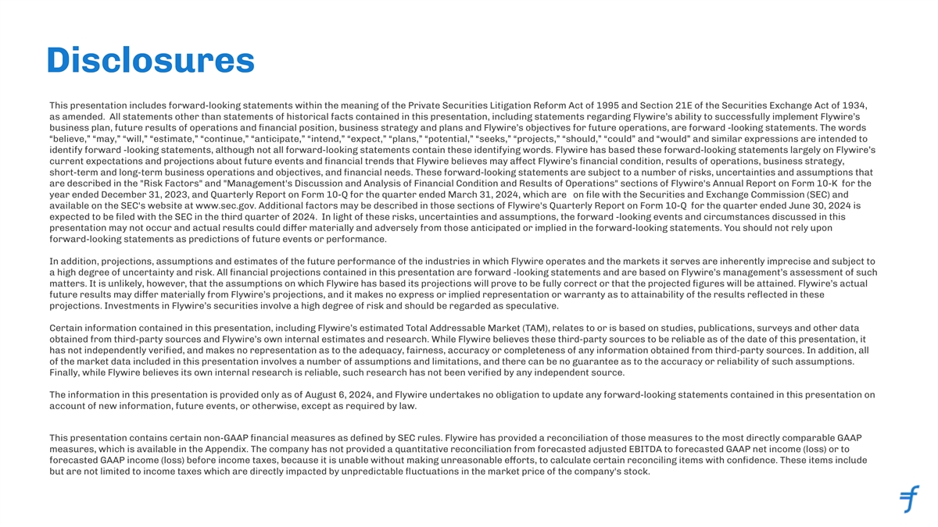
Disclosures This presentation includes forward-looking statements within the meaning of the Private Securities Litigation Reform Act of 1995 and Section 21E of the Securities Exchange Act of 1934, as amended. All statements other than statements of historical facts contained in this presentation, including statements regarding Flywire’s ability to successfully implement Flywire’s business plan, future results of operations and ﬁnancial position, business strategy and plans and Flywire’s objectives for future operations, are forward -looking statements. The words “believe,” “may,” “will,” “estimate,” “continue,” “anticipate,” “intend,” “expect,” “plans,” “potential,” “seeks,” “projects,” “should,” “could” and “would” and similar expressions are intended to identify forward -looking statements, although not all forward-looking statements contain these identifying words. Flywire has based these forward-looking statements largely on Flywire’s current expectations and projections about future events and ﬁnancial trends that Flywire believes may affect Flywire’s ﬁnancial condition, results of operations, business strategy, short-term and long-term business operations and objectives, and ﬁnancial needs. These forward-looking statements are subject to a number of risks, uncertainties and assumptions that are described in the Risk Factors and Management's Discussion and Analysis of Financial Condition and Results of Operations sections of Flywire's Annual Report on Form 10-K for the year ended December 31, 2023, and Quarterly Report on Form 10-Q for the quarter ended March 31, 2024, which are on ﬁle with the Securities and Exchange Commission (SEC) and available on the SEC's website at www.sec.gov. Additional factors may be described in those sections of Flywire's Quarterly Report on Form 10-Q for the quarter ended June 30, 2024 is expected to be ﬁled with the SEC in the third quarter of 2024. In light of these risks, uncertainties and assumptions, the forward -looking events and circumstances discussed in this presentation may not occur and actual results could dier ma ff terially and adversely from those anticipated or implied in the forward-looking statements. You should not rely upon forward-looking statements as predictions of future events or performance. In addition, projections, assumptions and estimates of the future performance of the industries in which Flywire operates and the markets it serves are inherently imprecise and subject to a high degree of uncertainty and risk. All ﬁnancial projections contained in this presentation are forward -looking statements and are based on Flywire’s management’s assessment of such matters. It is unlikely, however, that the assumptions on which Flywire has based its projections will prove to be fully correct or that the projected ﬁgures will be attained. Flywire’s actual future results may dier ma ff terially from Flywire’s projections, and it makes no express or implied representation or warranty as to attainability of the results reﬂected in these projections. Investments in Flywire’s securities involve a high degree of risk and should be regarded as speculative. Certain information contained in this presentation, including Flywire’s estimated Total Addressable Market (TAM), relates to or is based on studies, publications, surveys and other data obtained from third-party sources and Flywire’s own internal estimates and research. While Flywire believes these third-party sources to be reliable as of the date of this presentation, it has not independently veriﬁed, and makes no representation as to the adequacy, fairness, accuracy or completeness of any information obtained from third-party sources. In addition, all of the market data included in this presentation involves a number of assumptions and limitations, and there can be no guarantee as to the accuracy or reliability of such assumptions. Finally, while Flywire believes its own internal research is reliable, such research has not been veriﬁed by any independent source. The information in this presentation is provided only as of August 6, 2024, and Flywire undertakes no obligation to update any forward-looking statements contained in this presentation on account of new information, future events, or otherwise, except as required by law. This presentation contains certain non-GAAP ﬁnancial measures as deﬁned by SEC rules. Flywire has provided a reconciliation of those measures to the most directly comparable GAAP measures, which is available in the Appendix. The company has not provided a quantitative reconciliation from forecasted adjusted EBITDA to forecasted GAAP net income (loss) or to forecasted GAAP income (loss) before income taxes, because it is unable without making unreasonable eorts, to calcula ff te certain reconciling items with conﬁdence. These items include but are not limited to income taxes which are directly impacted by unpredictable ﬂuctuations in the market price of the company's stock.


Execution Fulﬁllment Our mission is to deliver the most important and complex payments

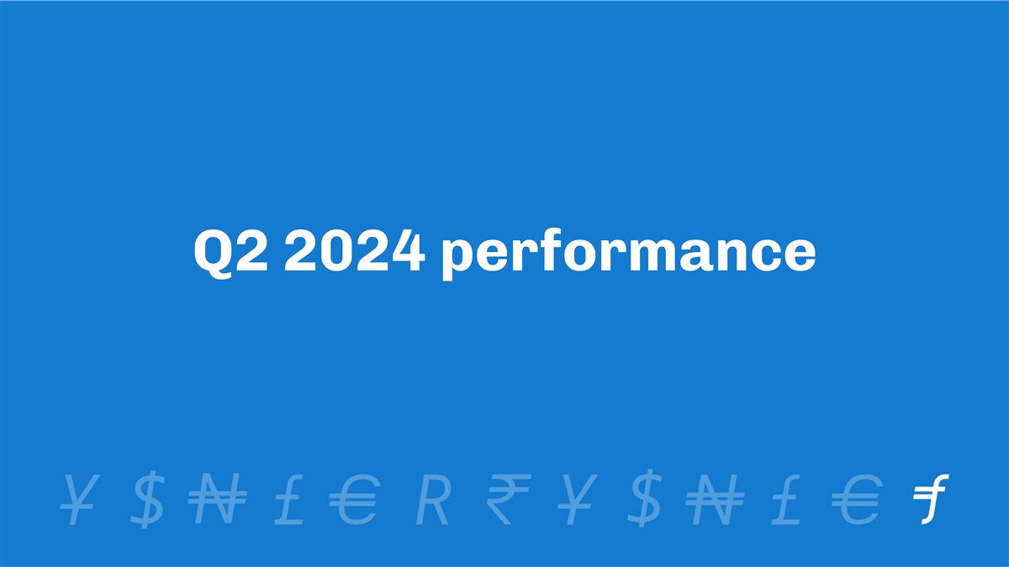
Q2 2024 performance

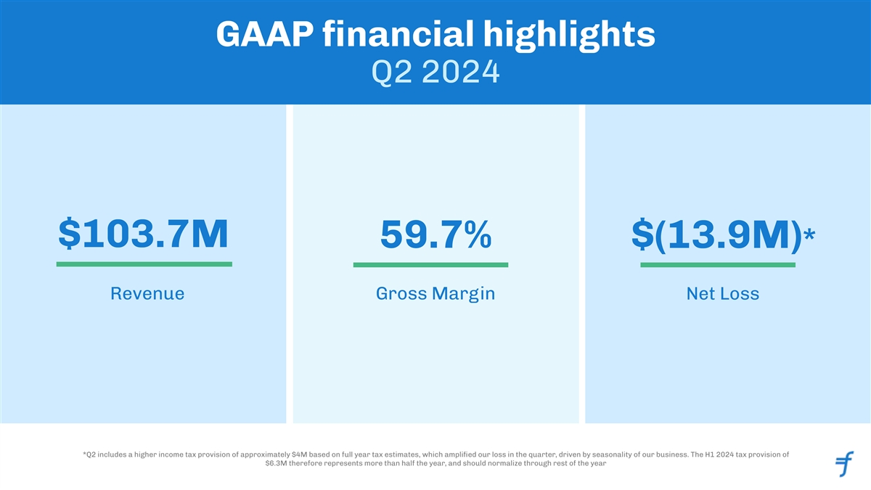
GAAP ﬁnancial highlights Q2 2024 $103.7M 59.7% $(13.9M)* Revenue Gross Margin Net Loss *Q2 includes a higher income tax provision of approximately $4M based on full year tax estimates, which ampliﬁed our loss in the quarter, driven by seasonality of our business. The H1 2024 tax provision of $6.3M therefore represents more than half the year, and should normalize through rest of the year

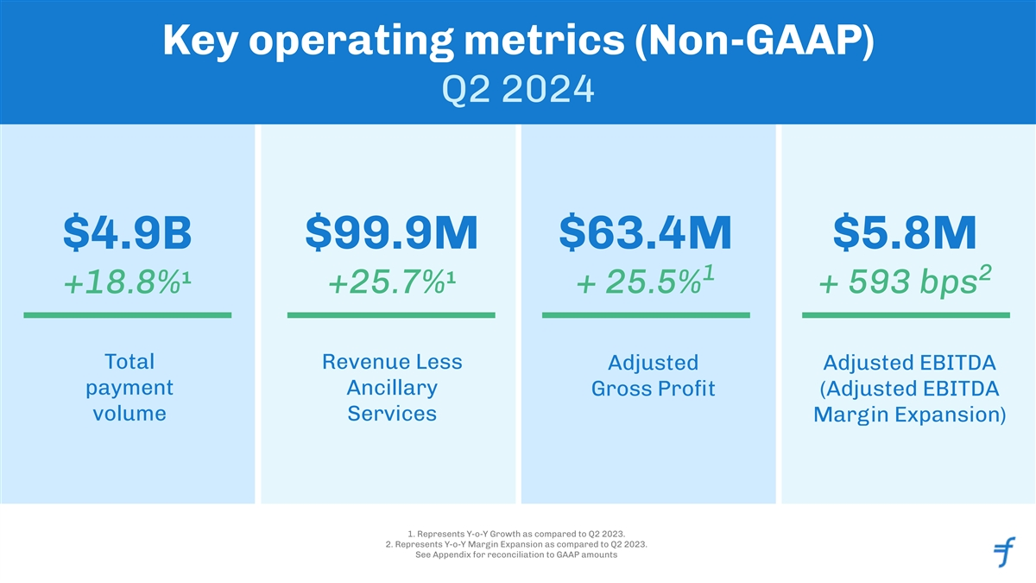
Key operating metrics (Non-GAAP) Q2 2024 $99.9M $63.4M $5.8M $4.9B 1 2 1 1 +18.8% +25.7% + 25.5% + 593 bps Total Revenue Less Adjusted Adjusted EBITDA payment Ancillary Gross Proﬁt (Adjusted EBITDA volume Services Margin Expansion) 1. Represents Y-o-Y Growth as compared to Q2 2023. 2. Represents Y-o-Y Margin Expansion as compared to Q2 2023. See Appendix for reconciliation to GAAP amounts

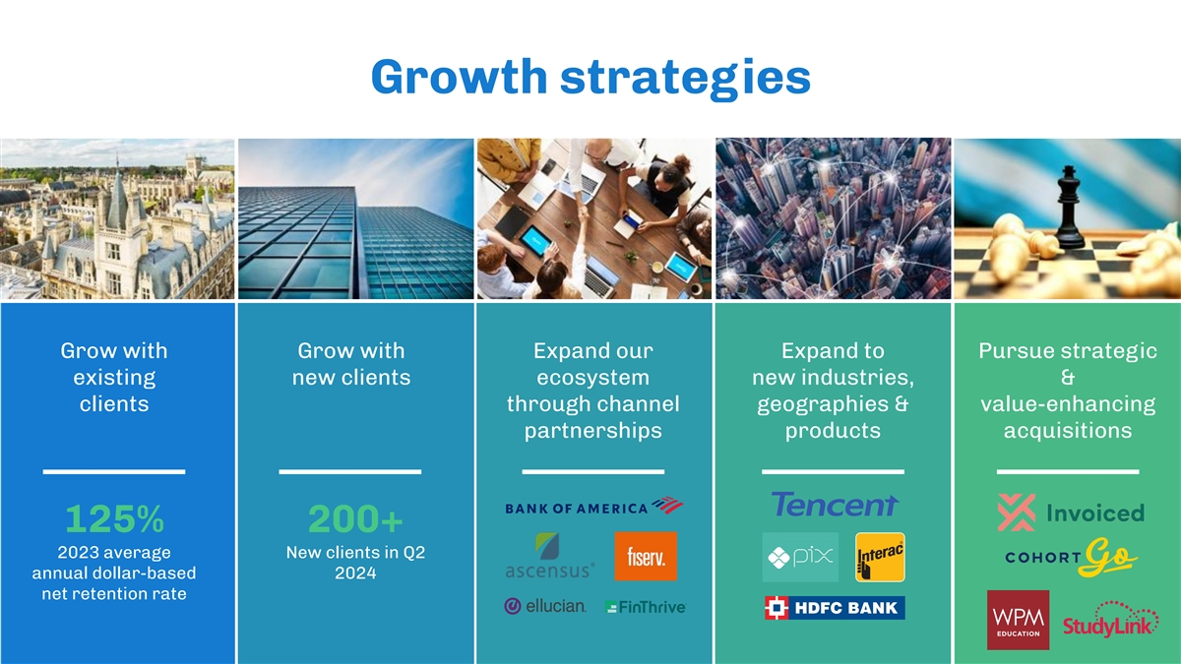
Growth strategies Grow with Grow with Expand our Expand to Pursue strategic existing new clients ecosystem new industries, & clients through channel geographies & value-enhancing partnerships products acquisitions 125% 200+ 2023 average New clients in Q2 annual dollar-based 2024 net retention rate

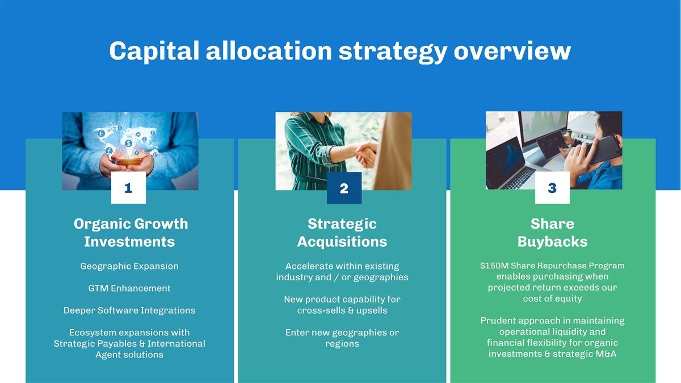
Capital allocation strategy overview 13 2 Organic Growth Strategic Share Investments Acquisitions Buybacks $150M Share Repurchase Program Geographic Expansion Accelerate within existing enables purchasing when industry and / or geographies projected return exceeds our GTM Enhancement cost of equity New product capability for Deeper Software Integrations cross-sells & upsells Prudent approach in maintaining operational liquidity and Ecosystem expansions with Enter new geographies or ﬁnancial ﬂexibility for organic Strategic Payables & International regions investments & strategic M&A Agent solutions

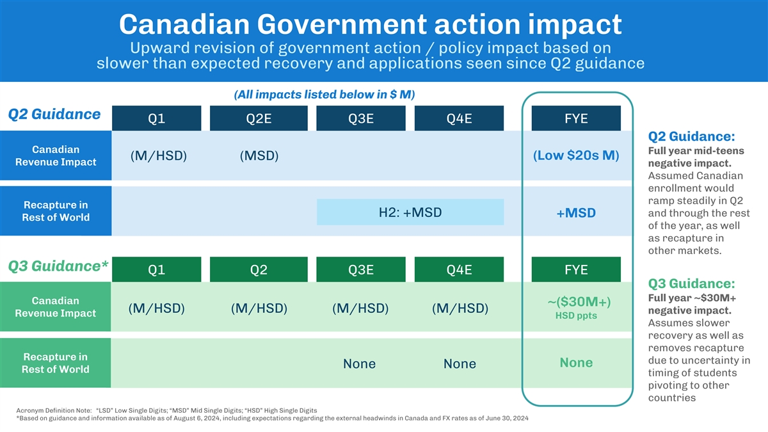
Canadian Government action impact Upward revision of government action / policy impact based on slower than expected recovery and applications seen since Q2 guidance (All impacts listed below in $ M) Q2 Guidance Q1 Q2E Q3E Q4E FYE Q2 Guidance: Canadian Full year mid-teens (M/HSD) (MSD) (Low $20s M) Revenue Impact negative impact. Assumed Canadian enrollment would ramp steadily in Q2 Recapture in H2: +MSD and through the rest +MSD Rest of World of the year, as well as recapture in other markets. Q3 Guidance* Q1 Q2 Q3E Q4E FYE Q3 Guidance: Full year ~$30M+ Canadian ~($30M+) (M/HSD) (M/HSD) (M/HSD) (M/HSD) negative impact. Revenue Impact HSD ppts Assumes slower recovery as well as removes recapture Recapture in due to uncertainty in None None None Rest of World timing of students pivoting to other countries Acronym Deﬁnition Note: “LSD” Low Single Digits; “MSD” Mid Single Digits; “HSD” High Single Digits *Based on guidance and information available as of August 6, 2024, including expectations regarding the external headwinds in Canada and FX rates as of June 30, 2024

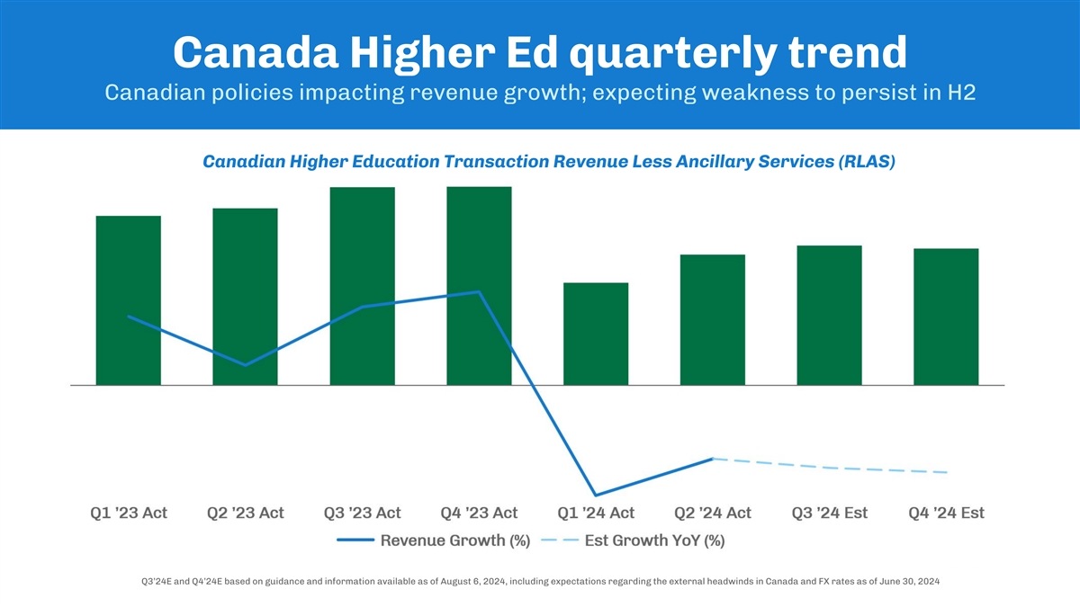
Canada Higher Ed quarterly trend Canadian policies impacting revenue growth; expecting weakness to persist in H2 Canadian Higher Education Transaction Revenue Less Ancillary Services (RLAS) Q3’24E and Q4’24E based on guidance and information available as of August 6, 2024, including expectations regarding the external headwinds in Canada and FX rates as of June 30, 2024


B2B spotlight


Why traditional payment solutions doesn’t meet B2B Businesses global collection needs ✘ High cost of getting paid ✘ Back-office inefficiencies ✘ Poor customer experience ✘ Inability to scale and operate globally

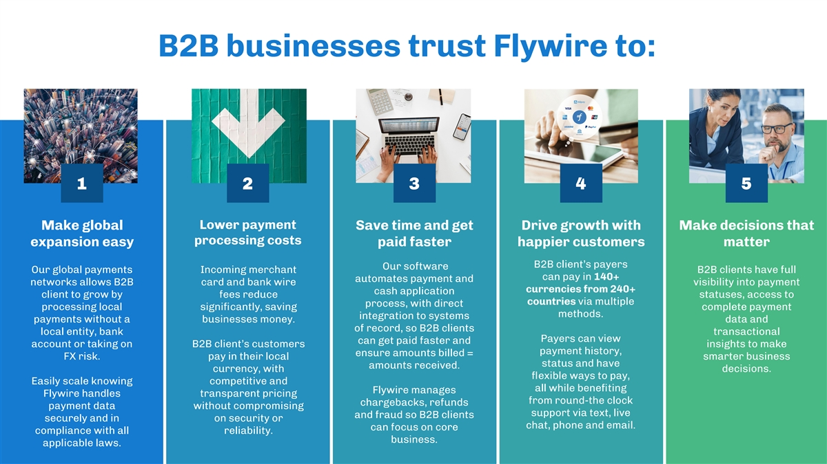
B2B businesses trust Flywire to: 12345 Lower payment Make global Save time and get Drive growth with Make decisions that processing costs expansion easy paid faster happier customers matter B2B client’s payers Our software Our global payments Incoming merchant B2B clients have full can pay in 140+ automates payment and networks allows B2B card and bank wire visibility into payment currencies from 240+ cash application client to grow by fees reduce statuses, access to countries via multiple process, with direct processing local signiﬁcantly, saving complete payment methods. integration to systems payments without a businesses money. data and of record, so B2B clients local entity, bank transactional Payers can view can get paid faster and account or taking on B2B client’s customers insights to make payment history, ensure amounts billed = FX risk. pay in their local smarter business status and have amounts received. currency, with decisions. ﬂexible ways to pay, Easily scale knowing competitive and all while beneﬁting Flywire manages Flywire handles transparent pricing from round-the clock chargebacks, refunds payment data without compromising support via text, live and fraud so B2B clients securely and in on security or chat, phone and email. can focus on core compliance with all reliability. business. applicable laws.

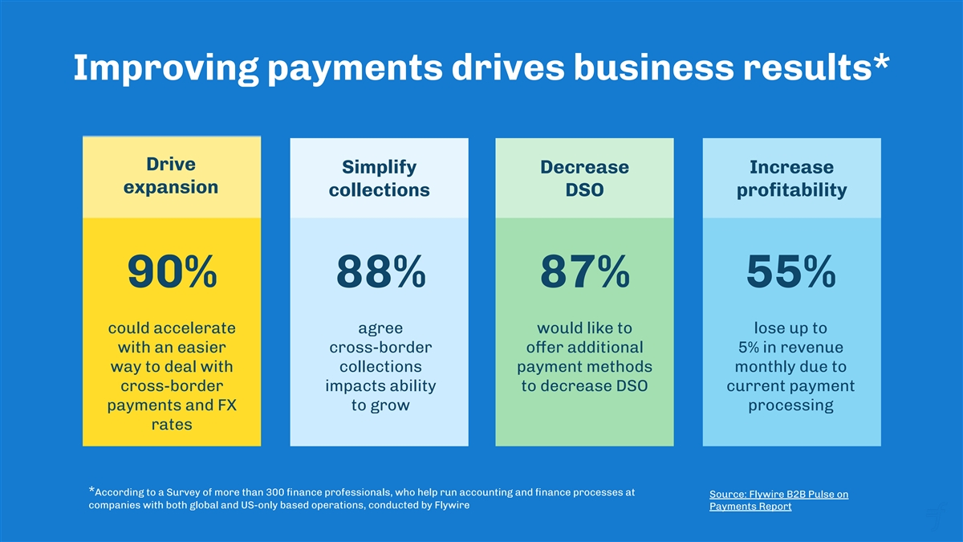
Improving payments drives business results* Drive Simplify Decrease Increase expansion collections DSO proﬁtability 90% 88% 87% 55% could accelerate agree would like to lose up to with an easier cross-border oer add ff itional 5% in revenue way to deal with collections payment methods monthly due to cross-border impacts ability to decrease DSO current payment payments and FX to grow processing rates *According to a Survey of more than 300 ﬁnance professionals, who help run accounting and ﬁnance processes at Source: Flywire B2B Pulse on companies with both global and US-only based operations, conducted by Flywire Payments Report

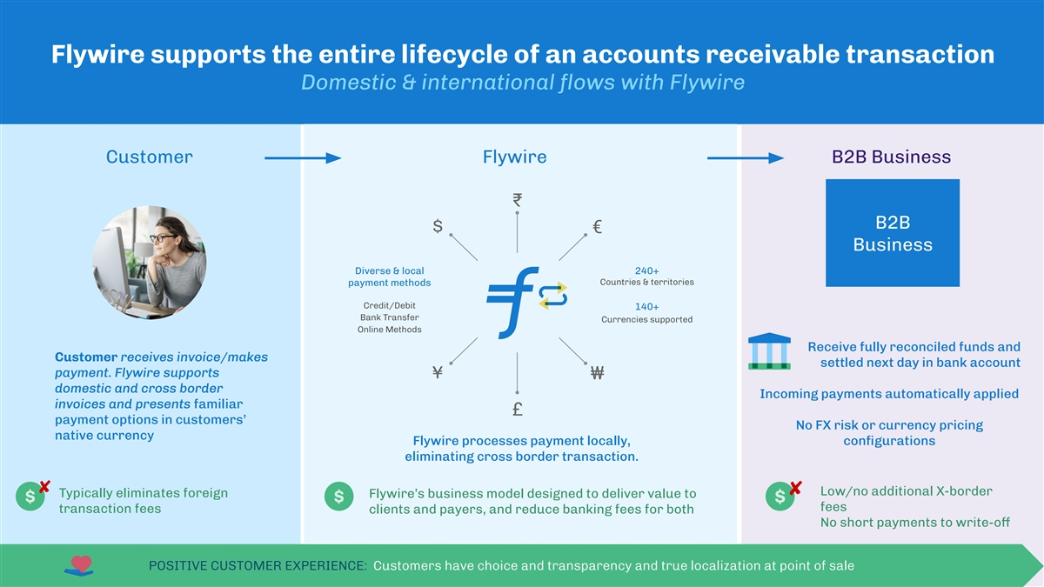
Flywire supports the entire lifecycle of an accounts receivable transaction Domestic & international ﬂows with Flywire Customer Flywire B2B Business ₹ B2B $ € Business Diverse & local 240+ Countries & territories payment methods Credit/Debit 140+ Bank Transfer Currencies supported Online Methods Receive fully reconciled funds and Customer receives invoice/makes settled next day in bank account payment. Flywire supports ¥ ₩ domestic and cross border Incoming payments automatically applied invoices and presents familiar £ payment options in customers’ No FX risk or currency pricing native currency Flywire processes payment locally, conﬁgurations eliminating cross border transaction. ✘ ✘ Low/no additional X-border Typically eliminates foreign Flywire’s business model designed to deliver value to $ $ $ fees transaction fees clients and payers, and reduce banking fees for both No short payments to write-off POSITIVE CUSTOMER EXPERIENCE: Customers have choice and transparency and true localization at point of sale


Invoiced acquisition

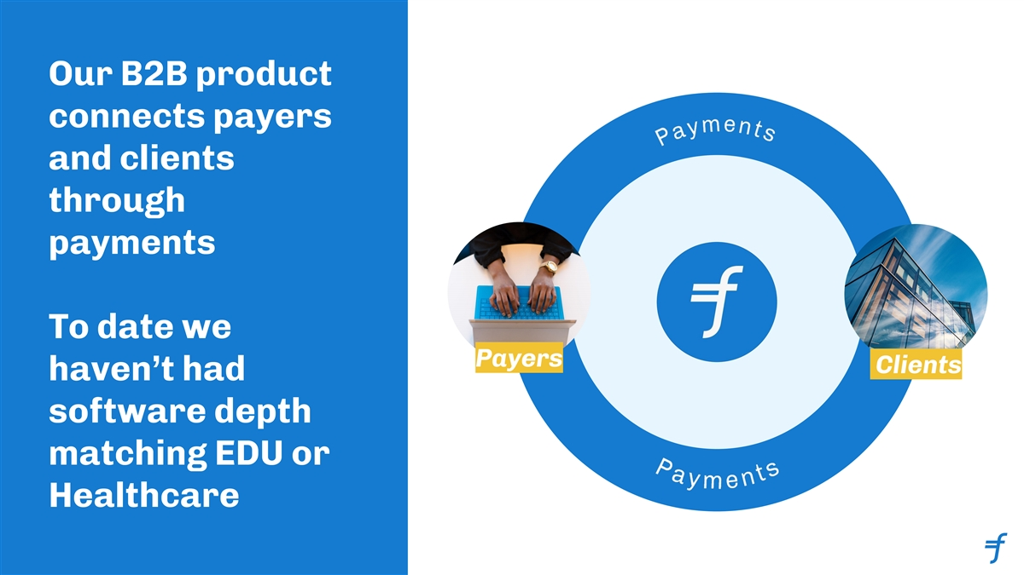
Our B2B product connects payers and clients through payments To date we Payers Clients haven’t had software depth matching EDU or Healthcare

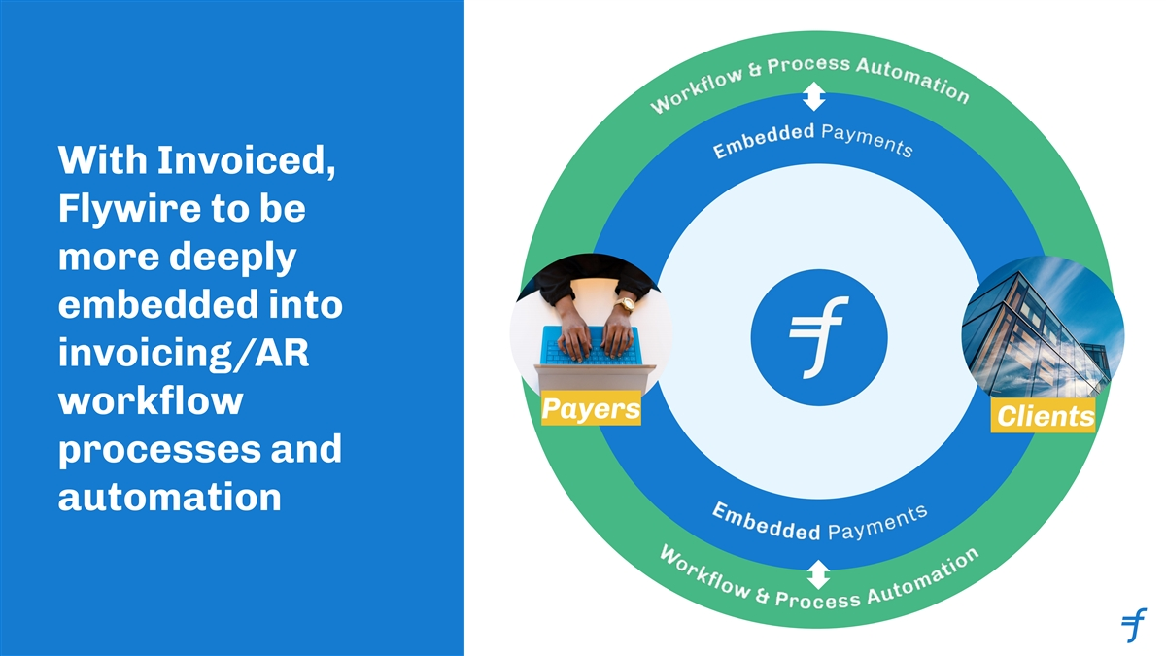
With Invoiced, Flywire to be more deeply embedded into invoicing/AR workﬂow Payers Clients processes and automation

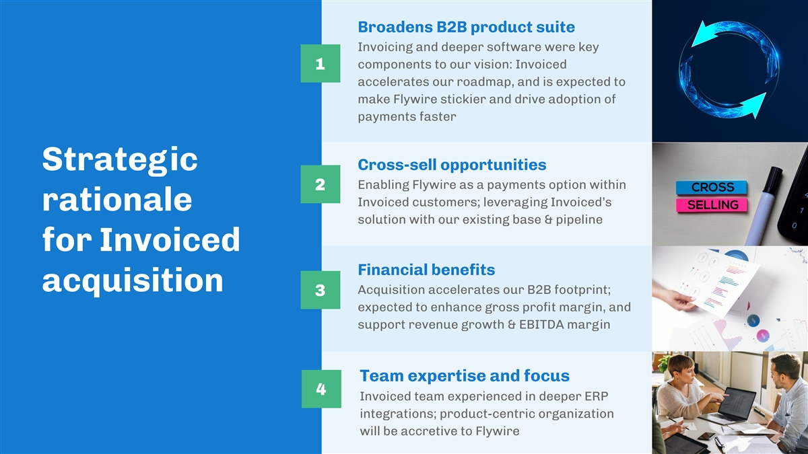
Broadens B2B product suite Invoicing and deeper software were key components to our vision: Invoiced 1 accelerates our roadmap, and is expected to make Flywire stickier and drive adoption of payments faster Cross-sell opportunities Strategic Enabling Flywire as a payments option within 2 Invoiced customers; leveraging Invoiced’s rationale solution with our existing base & pipeline for Invoiced Financial beneﬁts acquisition Acquisition accelerates our B2B footprint; 3 expected to enhance gross proﬁt margin, and support revenue growth & EBITDA margin Team expertise and focus 4 Invoiced team experienced in deeper ERP integrations; product-centric organization will be accretive to Flywire

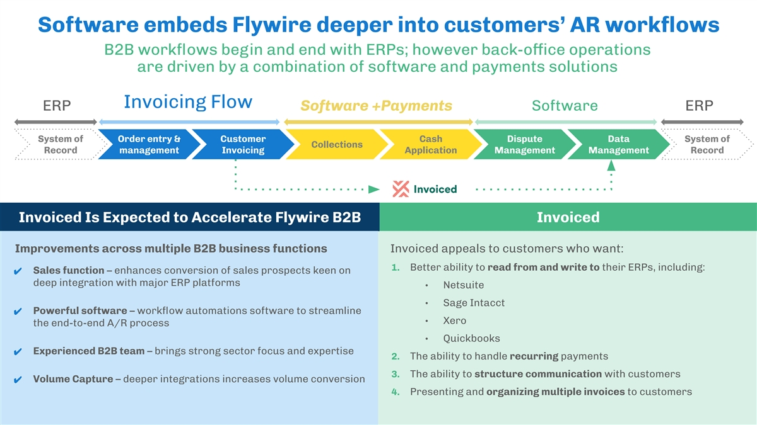
Software embeds Flywire deeper into customers’ AR workﬂows B2B workﬂows begin and end with ERPs; however back-office operations are driven by a combination of software and payments solutions Invoicing Flow ERP Software +Payments Software ERP System of Order entry & Customer Cash Dispute Data System of Collections Record management Invoicing Application Management Management Record Invoiced Is Expected to Accelerate Flywire B2B Invoiced Improvements across multiple B2B business functions Invoiced appeals to customers who want: 1. Better ability to read from and write to their ERPs, including: ✔ Sales function – enhances conversion of sales prospects keen on deep integration with major ERP platforms • Netsuite • Sage Intacct ✔ Powerful software – workﬂow automations software to streamline • Xero the end-to-end A/R process • Quickbooks ✔ Experienced B2B team – brings strong sector focus and expertise 2. The ability to handle recurring payments 3. The ability to structure communication with customers ✔ Volume Capture – deeper integrations increases volume conversion 4. Presenting and organizing multiple invoices to customers


Financial Outlook

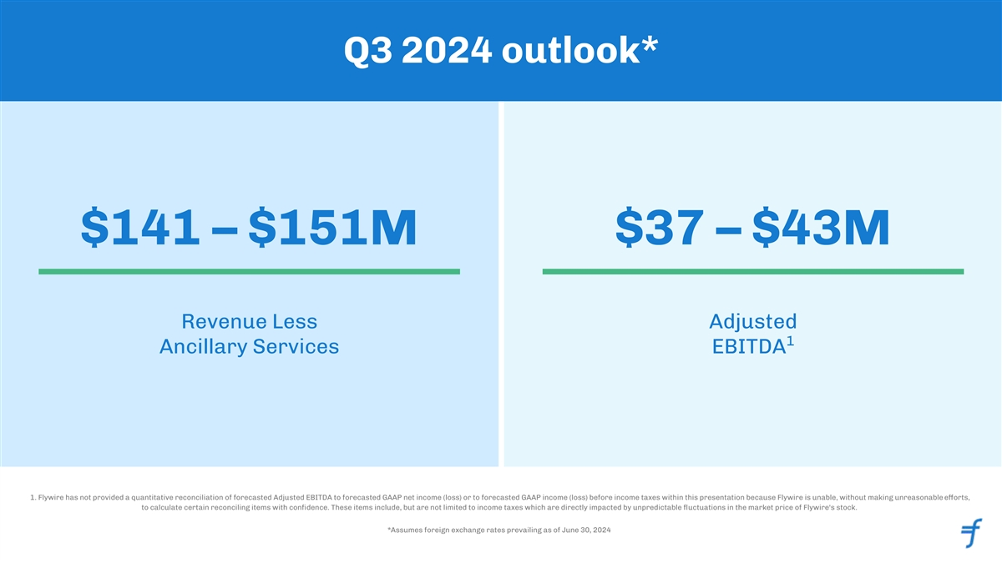
Q3 2024 outlook* $141 – $151M $37 – $43M Revenue Less Adjusted 1 Ancillary Services EBITDA 1. Flywire has not provided a quantitative reconciliation of forecasted Adjusted EBITDA to forecasted GAAP net income (loss) or to forecasted GAAP income (loss) before income taxes within this presentation because Flywire is unable, without making unreasonable eorts, ff to calculate certain reconciling items with conﬁdence. These items include, but are not limited to income taxes which are directly impacted by unpredictable ﬂuctuations in the market price of Flywire's stock. *Assumes foreign exchange rates prevailing as of June 30, 2024 22

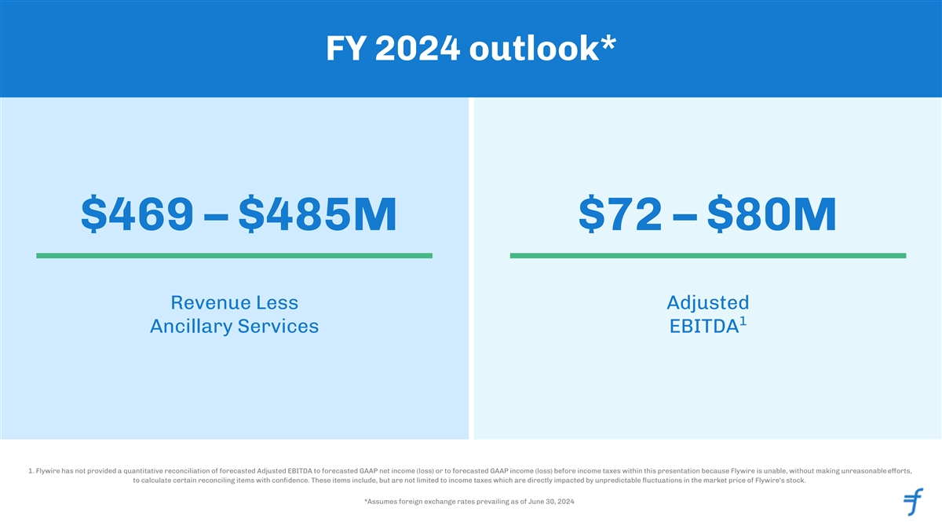
FY 2024 outlook* $469 – $485M $72 – $80M Revenue Less Adjusted 1 Ancillary Services EBITDA 1. Flywire has not provided a quantitative reconciliation of forecasted Adjusted EBITDA to forecasted GAAP net income (loss) or to forecasted GAAP income (loss) before income taxes within this presentation because Flywire is unable, without making unreasonable eorts, ff to calculate certain reconciling items with conﬁdence. These items include, but are not limited to income taxes which are directly impacted by unpredictable ﬂuctuations in the market price of Flywire's stock. *Assumes foreign exchange rates prevailing as of June 30, 2024 23


Appendix

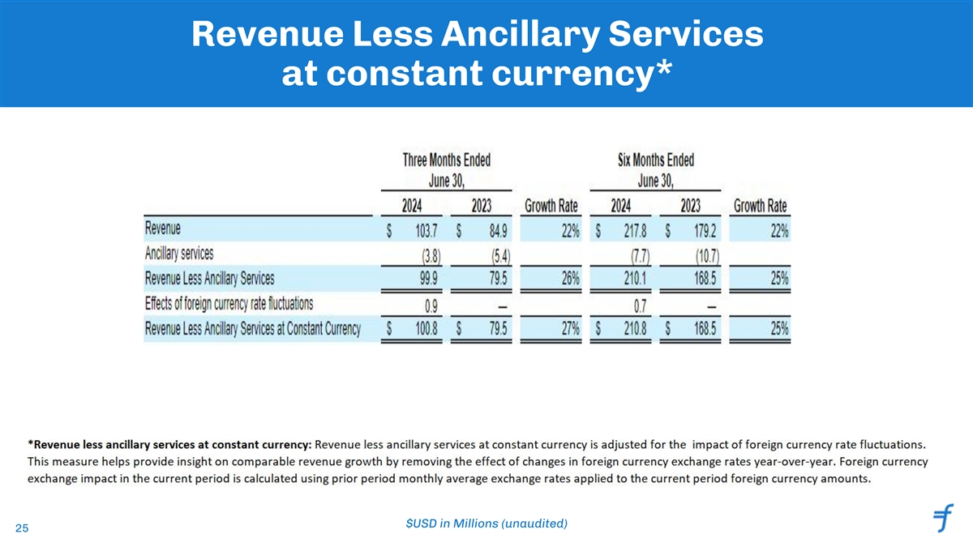
Revenue Less Ancillary Services at constant currency* $USD in Millions (unaudited) 25

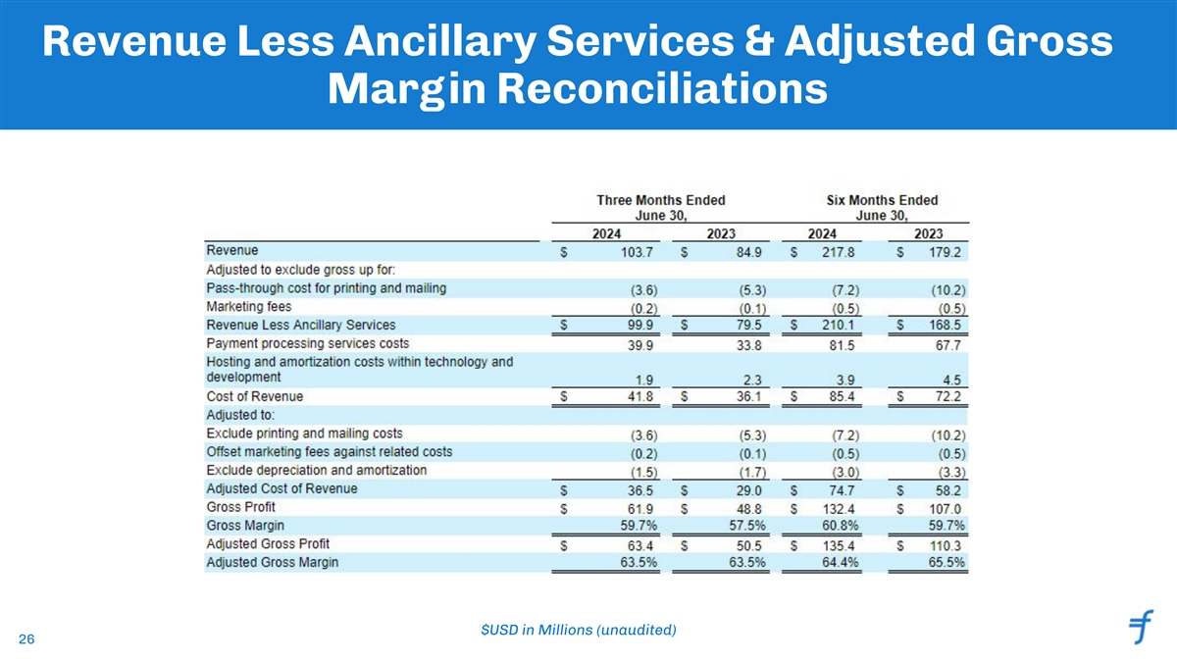
Revenue Less Ancillary Services & Adjusted Gross Margin Reconciliations $USD in Millions (unaudited) 26

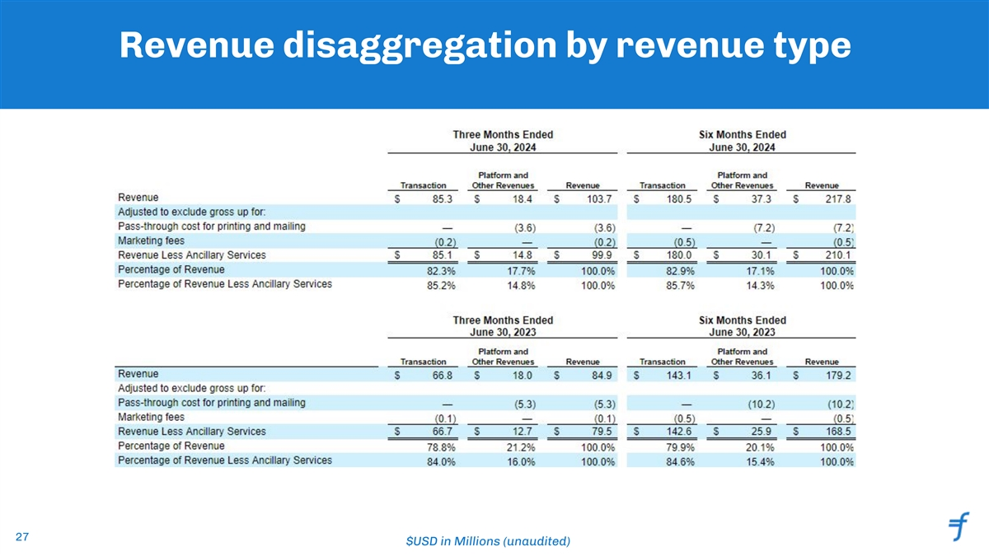
Revenue disaggregation by revenue type 27 $USD in Millions (unaudited)

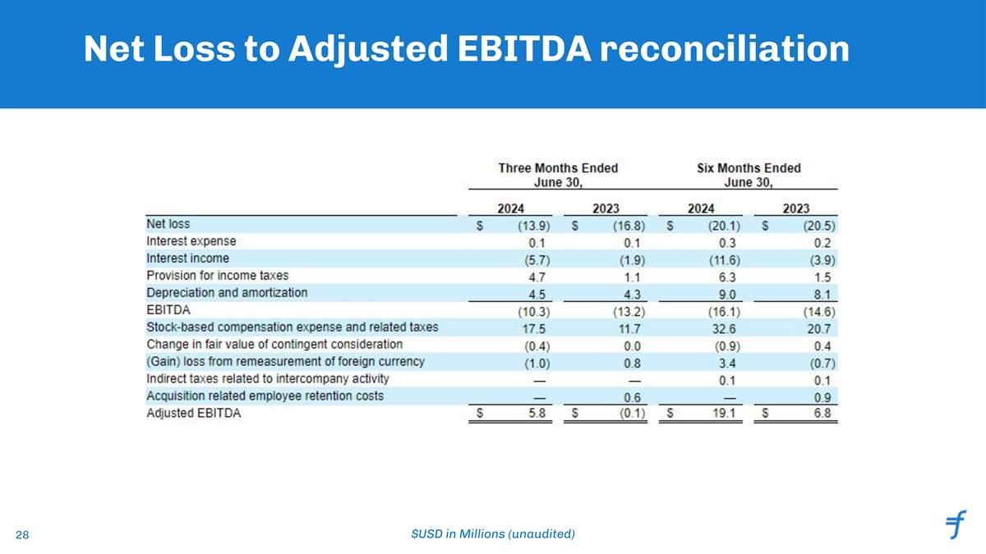
Net Loss to Adjusted EBITDA reconciliation 28 $USD in Millions (unaudited)

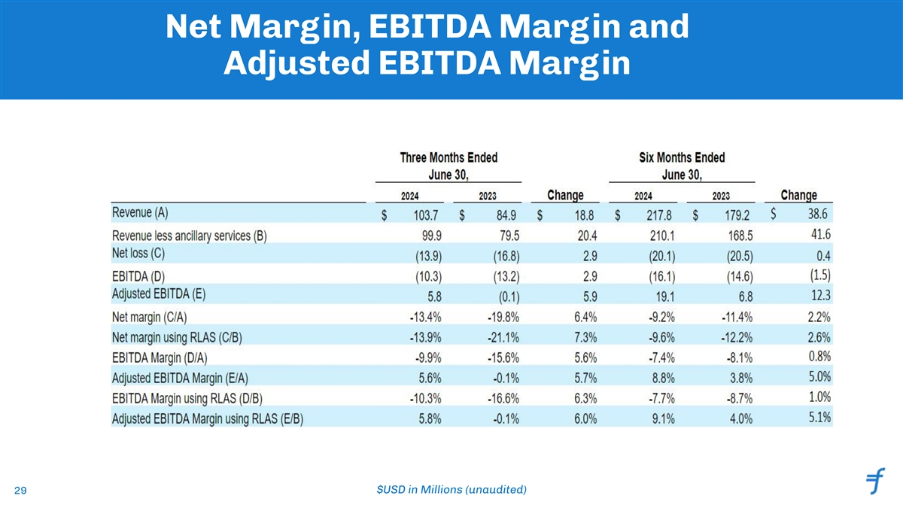
Net Margin, EBITDA Margin and Adjusted EBITDA Margin 29 $USD in Millions (unaudited)

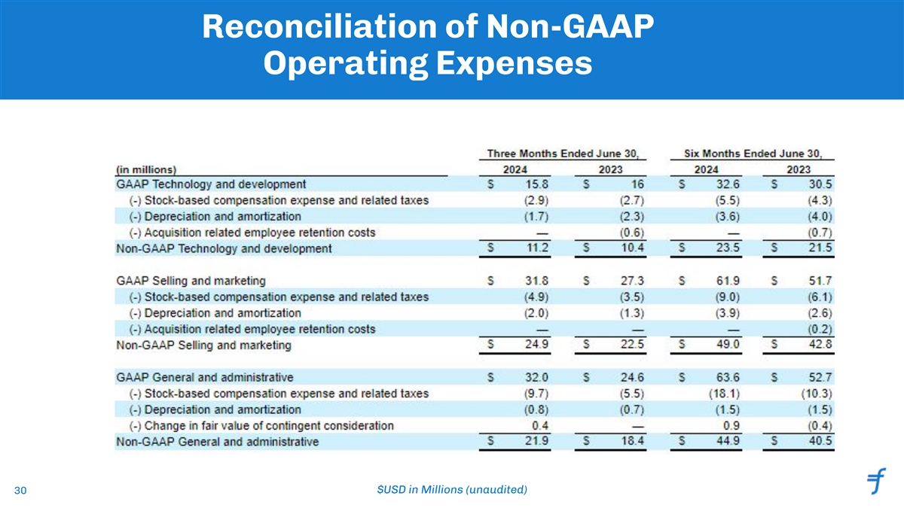
Reconciliation of Non-GAAP Operating Expenses 30 $USD in Millions (unaudited)

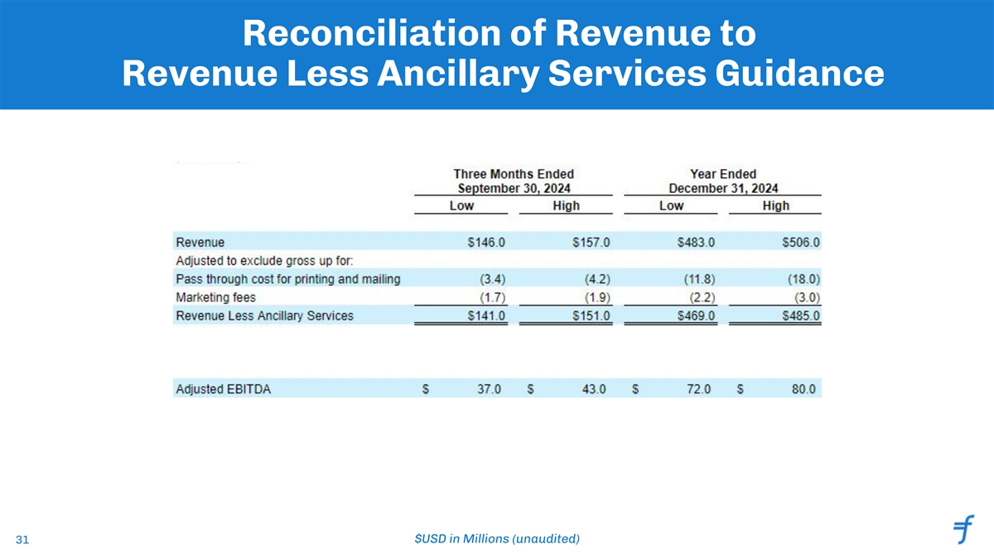
Reconciliation of Revenue to Revenue Less Ancillary Services Guidance 31 $USD in Millions (unaudited)

